Query for Problem:

UPDATE LOCATION SET LOCNAME = ‘Gate’
WHERE LOCNAME = ‘Door’;

Snapshot for the Problem:

- Before Updating the query

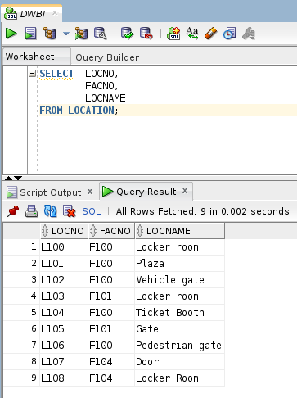

- Executing the Update query

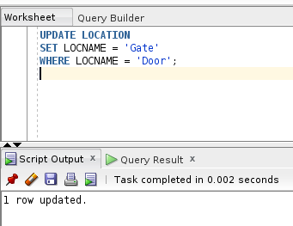

- After executing the query
