Query for Problem:

DELETE FROM LOCATION
WHERE LOCNO = ‘L108’;

Snapshot for the Problem:

- Before Updating the query

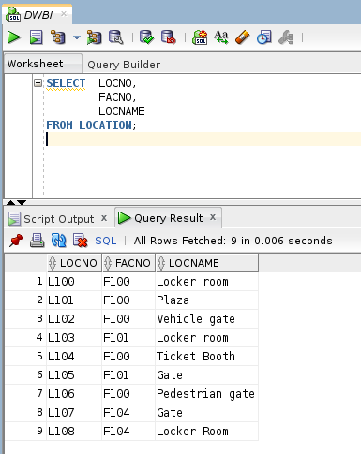
- Executing the Delete query
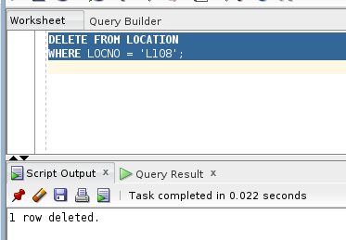

- After executing the query
