Query for Problem:

INSERT INTO FACILITY (FACNO,FACNAME) VALUES (‘F104’,’Swimming Pool’);

Snapshot for the Problem:
- Before Inserting

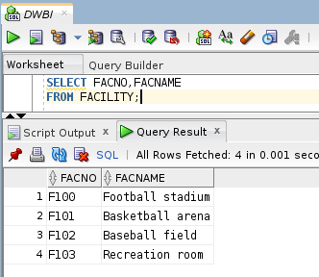
- Executing Insert Statement

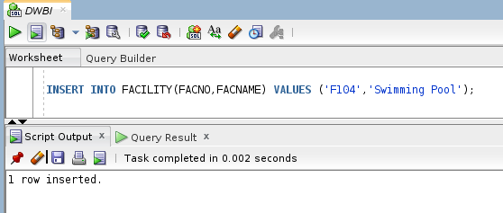

- After inserting

