Query for Problem:

INSERT INTO LOCATION (LOCNO, FACNO, LOCNAME)
VALUES (‘L108’,’F104’,’Locker Room’);

Snapshot for the Problem:

- Before inserting

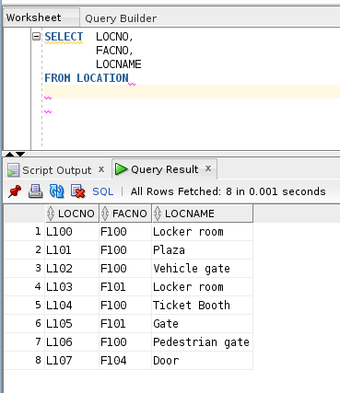

- Executing the insert query

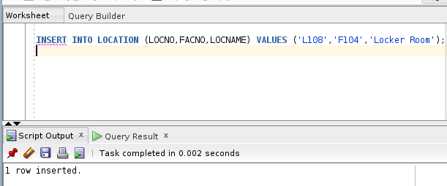

- After executing
