Problem 1:

Initial ERD:

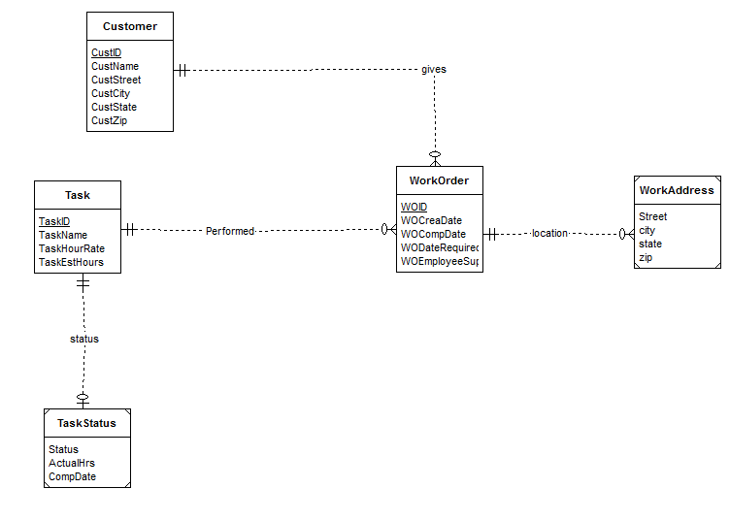
weak entities Work Address and Task Status help to specify additional information about each Work Order and Task, respectively.

Identifying relationships used to connect these weak entities. Each Work order has one customer although a customer may specify multiple work orders so I use a M-1 relationship to connect Work Orders to customers. Since a single task may satisfy multiple work orders, I use a 1-M relationship from Task to Work Order entities.

The more difficult part of this design involves accounting for the status of the Tasks. To accomplish this I used a weak entity entitled TaskStatus which connects to each Task via an identifying relationship.

Revised ERD:

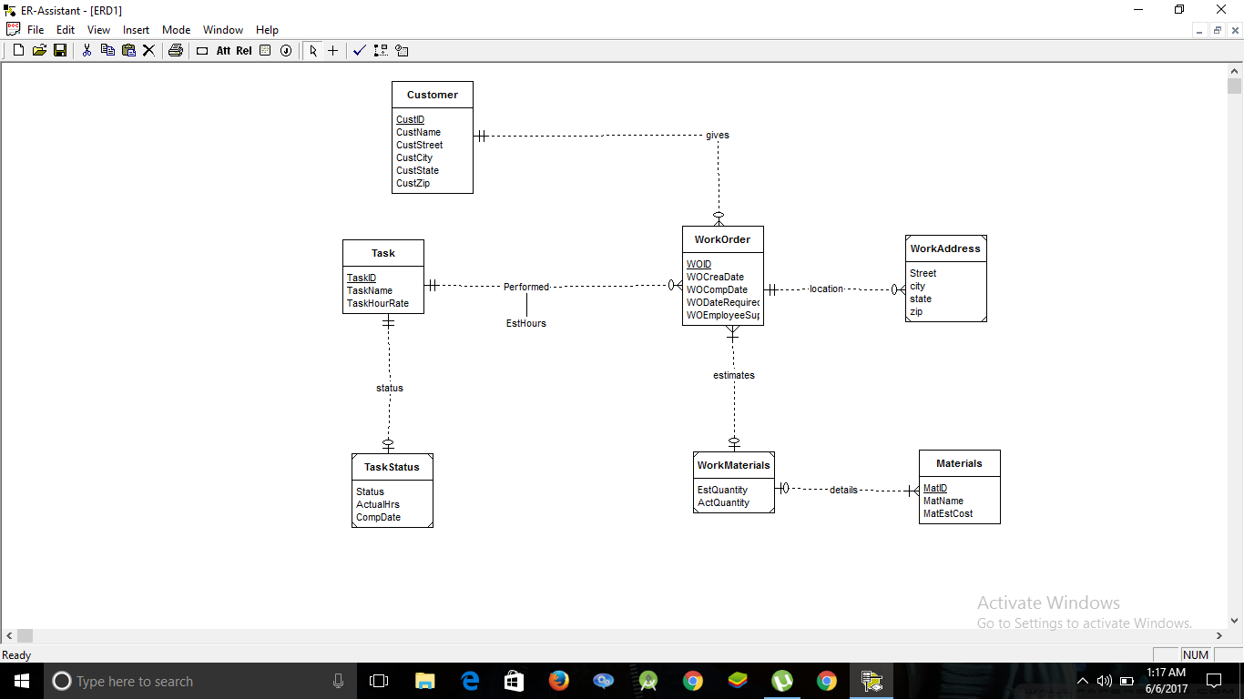

- The additional entity, Materials has been added which connects to Work Orders indirectly via the weak entity WorkMaterials and identifying relationships.
- Because the estimated number of hours for a task depends both on the work order and task, I change the relationship “Performed” connecting Task and Work Orders to include the attribute of ‘Est Hours’.

