Problem 2:

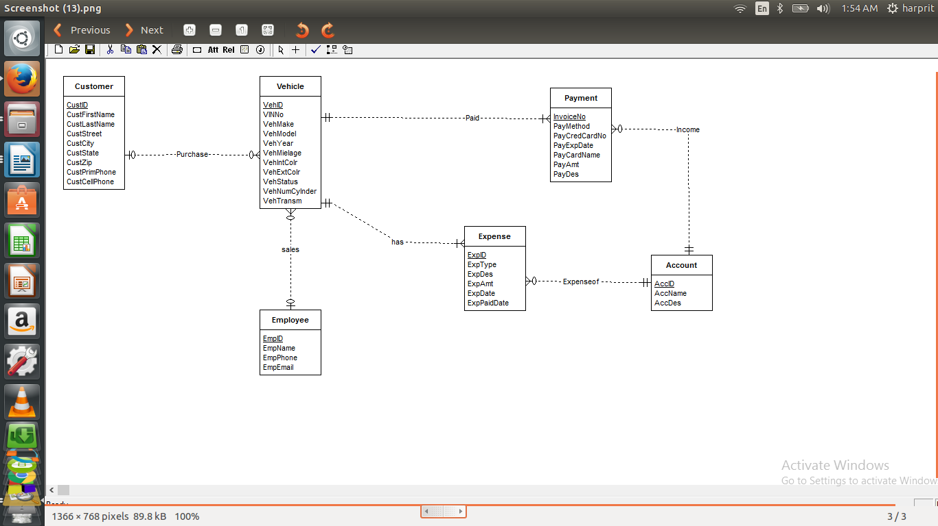

Errors:
- Vehicle Entity requires additional attribute ‘Transmission type’.
- Customer entity requires both primary phone and cell phone number attributes.
- Purchases relationship should not have a mandatory customer (should be an oval notation) as the narrative indicates vehicles may not be sold for a while.
- Sales relationship should also not have a mandatory employee (should be oval notation) because vehicles tend not to be sold instantly.
- ExpenseOf relationship has several errors. First, the connection to Expense entity should be multiple and optional. Second, the connection to Account should be mandatory and single.

