PENETRATION TESTING PROJECT REPORT
WEEK 3 - PASSWORD CRACKING
W3-PM1: John the Ripper (JTR)
W3-PM2: Networkwalks Password Cracking Tools

Pentester Name | Mwanamuke Mwiya
Program / Batch | Networkwalks Cybersecurity Internship - B083
Week | Week 3
Date | 27 September 2026
Modules completed | W3-PM1 and W3-PM2
Target File | My Locked PDF1.pdf
Recovered Password | good-luck

Authorized educational lab activity only

1. Introduction
Week 3 focused on password recovery from a protected PDF file. I completed both required project modules: W3-PM1 using John the Ripper with the Johnny graphical interface, and W3-PM2 using the Networkwalks Hash Calculator and Password Cracker. I used the same locked file in both activities so that I could compare the workflow and results from two different approaches.
The target was My Locked PDF1.pdf. In both modules, the password was recovered as 'good-luck' and the result was confirmed by successfully opening the protected PDF. I kept screenshots and output files throughout the practical so that each important step could be supported by evidence.

2. Tools Used
Tool | Purpose
John the Ripper 1.9.0-jumbo-1 | Password auditing and recovery engine used in PM1.
Johnny GUI | Graphical front end used to load the PDF hash and run John the Ripper on Windows.
Networkwalks Hash Calculator | Browser-based tool used to extract the $pdf$ hash from the locked PDF in PM2.
Networkwalks Password Cracker | Browser-based tool used to test wordlists against the extracted PDF hash.
Notepad | Used to save the extracted hash as hash1.txt and to prepare a custom wordlist.
Windows 10/11 | Main operating system used for the Week 3 project work.

3. W3-PM1 - Password Cracking with JTR
For PM1, I used John the Ripper and Johnny on Windows. I first prepared the target PDF and extracted its PDF hash. The hash was saved as hash1.txt, then loaded into Johnny. Johnny initially could not start the attack because the John executable had not yet been configured. I installed the Windows build of John the Ripper, pointed Johnny to the correct john.exe file in the run folder, and restarted the attack.
Once Johnny was correctly configured, the attack completed successfully. The password column showed 'good-luck', and the status bar confirmed that one out of one password had been cracked. I then used the recovered password to open My Locked PDF1.pdf successfully.
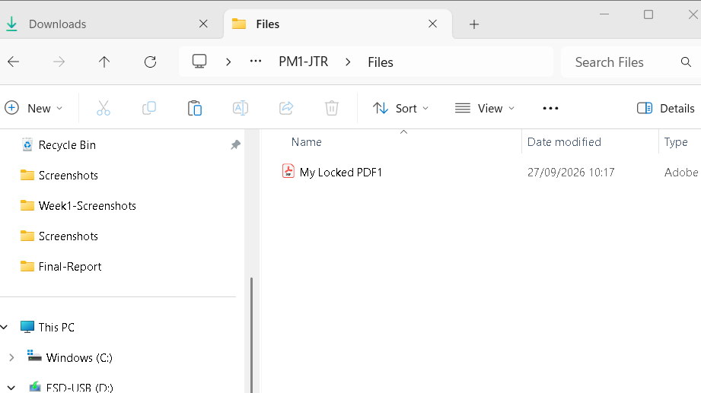
Figure 1 - Target file prepared for PM1.
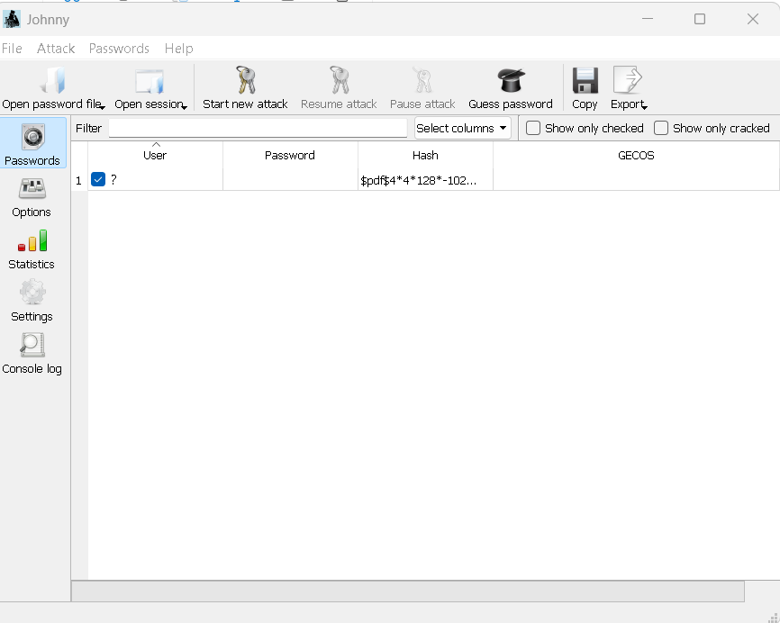
Figure 2 - Correct $pdf$ hash loaded into Johnny.
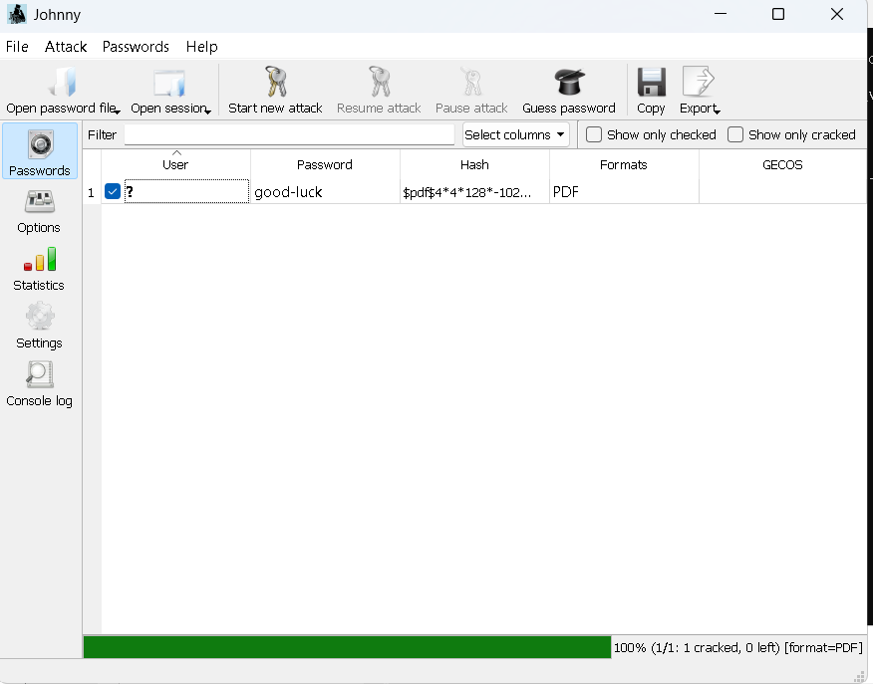
Figure 3 - Johnny successfully cracked the PDF password as good-luck.

4. W3-PM2 - Password Cracking with Networkwalks Tools
For PM2, I uploaded the same locked PDF to the Networkwalks Hash Calculator and copied the complete hash beginning with $pdf$. I then pasted the hash into the Networkwalks Password Cracker.
The first attempt used the built-in list of 100 passwords. The tool tested the full list but returned 'Exhausted wordlist. No match.' This was a useful part of the exercise because it showed that a cracking attempt can fail when the candidate list does not contain the correct password.
To continue, I created a small custom wordlist and included several realistic candidate passwords. When I uploaded the custom list and ran the attack again, the tool found a match at 'good-luck' and displayed 'PASSWORD CRACKED SUCCESSFULLY'. I confirmed the result by opening the locked PDF with that password.
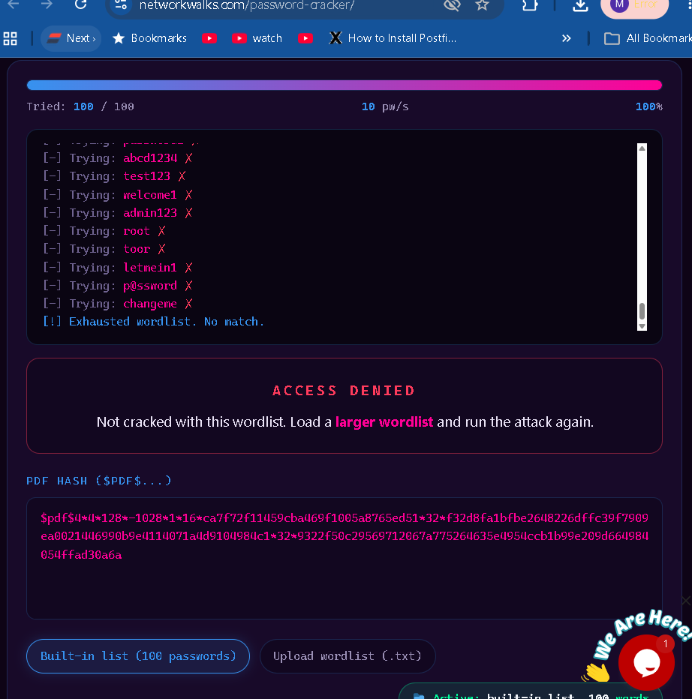
Figure 4 - Built-in Networkwalks wordlist exhausted with no match.
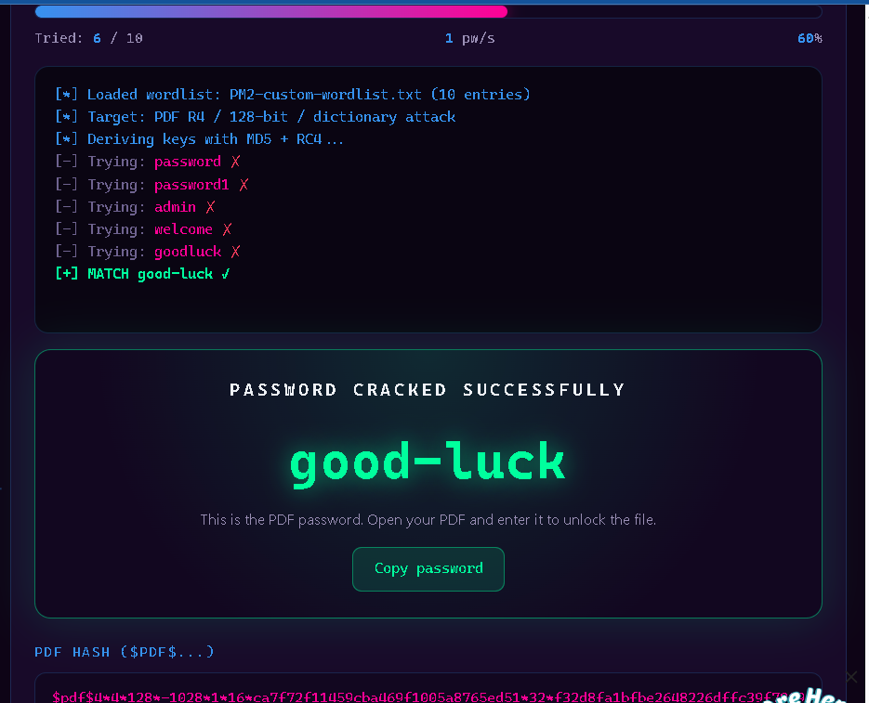
Figure 5 - Custom wordlist recovered the password good-luck.

5. Results Summary
Module | Method | Result | Status
W3-PM1 | John the Ripper + Johnny | Password: good-luck | Completed
W3-PM2 | Networkwalks Hash Calculator + Password Cracker | Password: good-luck | Completed

6. Challenges Encountered
Johnny could not find John the Ripper: Johnny was installed before the Windows John binaries, so the attack could not start. I downloaded the Windows 64-bit John package and configured Johnny to use the john.exe file from the run folder.
Qt/platform error while starting the attack: The error appeared while Johnny was not correctly linked to John. After the John executable was installed and the correct path was configured, the attack ran normally.
Wrong file loaded into Johnny during an early attempt: The interface displayed raw PDF objects such as %PDF, obj and endobj. I checked hash1.txt, confirmed that it contained one $pdf$ hash line, and reopened the correct file in Johnny.
Networkwalks built-in wordlist returned no match: The built-in list of 100 passwords did not contain the correct password. I created and uploaded a custom wordlist, then ran the attack again and recovered good-luck.

7. What I Learned
- How a password-protected PDF can be represented by a crackable $pdf$ hash for password auditing.
- How John the Ripper and the Johnny GUI work together on Windows.
- Why configuring the correct executable path matters when a GUI depends on a separate cracking engine.
- Why the quality of a wordlist matters: a cracking tool cannot find a password that is not among its candidates.
- Why screenshots, output files and verification of the recovered password are important when documenting practical cybersecurity work.

8. Security Observation
The lab demonstrated that password strength depends not only on encryption but also on the predictability of the password itself. A password that appears in a relevant wordlist can be recovered quickly. In real environments, stronger and less predictable passwords, combined with appropriate access controls and encryption settings, reduce the chance of successful password guessing or dictionary attacks.

9. Conclusion
Week 3 gave me practical experience with two password recovery workflows. PM1 required more setup because Johnny had to be connected to the John the Ripper executable, while PM2 provided a browser-based workflow. Both methods recovered the same password, good-luck, and I verified the result by opening the protected PDF.
The most useful lesson for me was that troubleshooting is part of the practical work. The first attempt did not always work immediately: Johnny needed the correct John path, and the Networkwalks built-in wordlist did not contain the correct password. Working through those problems made the final result more meaningful and helped me understand how the tools operate rather than only following the expected answer.

10. Evidence Inventory
The following evidence files were collected during the project and are stored with the Week 3 submission:
- PM1-T1-Target-PDF.png
- PM1-T2-JTR-Version.png
- PM1-T2-JTR-Windows-Working.png
- PM1-T3-PDF-Hash.png
- PM1-T4-Hash-Saved.png
- PM1-T5-Johnny-Hash-Loaded.png
- PM1-T5-Johnny-Configured.png
- PM1-T6-Password-Cracked.png
- PM1-T7-PDF-Opened.png
- hash1.txt
- PM2-T1-Hash-Calculator.png
- PM2-T2-Builtin-Wordlist-No-Match.png
- PM2-T3-Password-Cracked.png
- PM2-T4-PDF-Opened.png
- PM2-custom-wordlist.txt
End of Week 3 Report

