PENETRATION TESTING REPORT
FOOTPRINTING & NETWORK SCANNING PHASES
W2-PM-FINAL | CYBERSECURITY | NETWORKWALKS

Pentester Name  (Cybersecurity Professional) | Mwanamuke Mwiya
Program/Batch | B083-Networkwalks
Date | 18 September 2026 (testing performed on 15 and 18 September 2026)
Modules completed | W2-PM1 (Multiple Kali Tools)  W2-PM5 (Zenmap Scanning)
Client/Target | 1. Networkwalks – networkwalks.com (written authorization ref. NW-LOA-B082-017)  2. My own local lab network (10.0.0.0/24)
Permission secured from client? | Yes
Phases covered | Phase 1: Reconnaissance & Footprinting  Phase 2: Scanning & Network Discovery  Phase 3-5: In Progress

1. Liability Disclaimer
I have performed these activities only on the systems & devices where I had secured written permission or the devices/systems that I own myself. All these materials are for education and research purpose only. Do not use anything from here to break the law. The instructor, the authors and Networkwalks are not responsible for what you do with this knowledge. Every action you take is your own responsibility. Misuse can lead to criminal charges, heavy fines, loss of your job and a permanent record. In most countries unauthorised access is a crime even when nothing is damaged.

2. Introduction
For Week 2, I worked on two practical activities. In W2-PM1, I used several Kali Linux tools to gather public information about networkwalks.com. In W2-PM5, I used Zenmap to scan my own lab network and identify active devices. These two exercises helped me understand the difference between gathering information about a target and discovering devices that are active on a network.
I carried out the footprinting tasks in Kali Linux on 15 and 18 September 2026. The Zenmap work was done on a Windows 10 virtual machine on 18 September 2026. I recorded the commands I used, the results I received and screenshots of the work so that each step could be supported by evidence.

3. Tools Used
The table below lists each tool used in this report and its purpose.
Tool | Purpose
Kali Linux & Windows 10 | Operating systems (VirtualBox virtual machines) used for the reconnaissance and scanning activities
WHOIS | Find domain registration details (owner, dates, name servers).
whatweb | Fingerprint web technologies (server, CMS, plugins, IP).
nslookup | Resolve the domain name to its IP address using DNS.
curl -I | Read the HTTP response headers of the website.
wafw00f | Detect whether a Web Application Firewall protects the site.
dnsrecon | Enumerate all DNS records (NS, MX, SPF, TXT, SRV).
Zenmap (Nmap GUI) | Scan the local subnet to find live hosts, IPs and MAC addresses.
Windows CMD | Local IP and MAC address identification (ipconfig /all)
ping | Test connectivity to the live hosts discovered on the local network.

4. Activities Performed

4.1 Footprinting & Reconnaissance

For the reconnaissance activity, I used six Kali Linux tools: WHOIS, WhatWeb, Nslookup, Curl, Wafw00f and DNSRecon. I used each tool for a different purpose so that I could build a clearer picture of the target. WHOIS, WhatWeb, Nslookup and Wafw00f were run on 15 September 2026, while Curl and DNSRecon were run on 18 September 2026. Where possible, I also saved the command output to text files using tee.
First, I used WHOIS to obtain publicly available domain registration information. The domain is registered through GoDaddy.com, LLC, was created on 6 November 2019 and is set to expire on 6 November 2027. Its name servers are NS6135.HOSTGATOR.COM and NS6136.HOSTGATOR.COM, which shows that the domain uses HostGator name servers. The record also shows that DNSSEC is unsigned.
I then used WhatWeb to identify technologies used by the website. The results identified WordPress 7.1 and WP Download Manager 3.3.58, running on an Apache web server together with jQuery 3.7.1 and Google Tag Manager. WhatWeb also showed that HTTP requests are redirected (301) to HTTPS, and it exposed the server IP address 192.232.216.135 and the contact email address info@networkwalks.com.
Using Nslookup (with the DNS resolver 1.1.1.1), I resolved the domain name to its IP address. The result identified 192.232.216.135.
I used Curl with the -I option to inspect the HTTP response headers. The server answered with HTTP/2 200 and identified itself as Apache. The headers also exposed the WordPress REST API endpoint /wp-json/, the caching information (x-nginx-cache: WordPress) and a cookie (__wpdm_client) that is set with the Secure and HttpOnly flags.
Next, I used Wafw00f to determine whether a Web Application Firewall was protecting the website. After 2 requests, the result identified ModSecurity (SpiderLabs).
Finally, I used DNSRecon to enumerate DNS records. The results listed the SOA and name server records (ns6135.hostgator.com – 50.87.144.87 and ns6136.hostgator.com – 192.232.216.131), both running BIND 9.16.23-RH; the mail server record (mail.networkwalks.com – 192.232.216.135); the A record (192.232.216.135); a Google site-verification TXT record; an SPF record (v=spf1 +a +mx +ip4:50.87.144.87 +include:websitewelcome.com ~all); and seven _autodiscover._tcp SRV records pointing to cpanelemaildiscovery.cpanel.net on port 443. DNSRecon also reported that it received no answer to its DNSSEC query.

4.2 Network Scanning with Zenmap
For the second activity, I used Zenmap on my own lab network. I first needed to confirm my IP address and subnet, then scan the subnet to see which hosts were active. After that, I checked the available IP and MAC address information and used Zenmap to view the network topology.
I first used the Windows ipconfig /all command on my Windows 10 lab machine (Windows10-Lab) to identify my local IP address and LAN subnet. It showed the IPv4 address 10.0.0.4, subnet mask 255.255.255.0 and default gateway 10.0.0.1, so my LAN subnet is 10.0.0.0/24. I then entered the subnet into Zenmap, selected the Ping Scan profile (command: nmap -sn 10.0.0.0/24) and ran the scan on 18 September 2026 at 22:21.
The scan covered 256 IP addresses and found four live hosts in 3.31 seconds:
- 10.0.0.1 – MAC 52:54:00:12:35:00 (QEMU virtual NIC) – default gateway
- 10.0.0.2 – MAC 08:00:27:5D:C2:80 (Oracle VirtualBox virtual NIC)
- 10.0.0.9 – MAC 08:00:27:E9:FE:B1 (Oracle VirtualBox virtual NIC)
- 10.0.0.4 – MAC 08-00-27-70-FB-AC – my own Windows 10 machine (from ipconfig /all)
Nmap does not display a MAC address for the machine it is running on, so the MAC address of my own machine (10.0.0.4) is not shown in the scan output. I found it with ipconfig /all (Physical Address 08-00-27-70-FB-AC). The 08:00:27 prefix identifies VirtualBox virtual network adapters, which confirms that this is a virtual lab environment.
To confirm that the discovered hosts respond on the network, I also tested connectivity with ping -n 4 to 10.0.0.1, 10.0.0.2 and 10.0.0.9 on 15 September 2026. All three hosts replied to every packet (0% packet loss).
After completing the scan, I opened the Topology tab in Zenmap, enabled the legend and saved the network topology in PDF format (W2-PM5-Zenmap-Topology.pdf). The topology shows localhost at the centre with the four discovered hosts (10.0.0.1, 10.0.0.2, 10.0.0.4 and 10.0.0.9) around it. The full graphic is included in Section 8.

5. Risk Analysis / Impact
After reviewing the results from both activities, I noted a number of security observations that could be important in a real environment. These are listed below as potential risks rather than confirmed vulnerabilities.
# | Risk / Finding | Evidence / Observation | Potential Impact | Risk Level
1 | Web technology information exposed | WhatWeb identified WordPress 7.1, WP Download Manager 3.3.58 and Apache | Attackers may use exposed technology/version information to identify software requiring further security review | ● Medium
2 | Server IP address identifiable | Nslookup resolved the domain to 192.232.216.135 (also the mail server IP) | Provides information about the network location of the web service | ● Low
3 | HTTP technical information exposed | Curl returned HTTP response headers and exposed /wp-json/ and caching details | May assist technology fingerprinting and further enumeration | ● Low
4 | WAF technology identifiable | Wafw00f identified ModSecurity (SpiderLabs) | Reveals information about the web application’s security architecture | ● Low
5 | DNS infrastructure information exposed | DNSRecon identified NS, MX, SPF/TXT and SRV records and BIND 9.16.23-RH on both name servers | DNS information can help build a broader infrastructure profile | ● Medium
6 | Multiple live hosts visible on local network | Zenmap identified four live hosts (10.0.0.1, 10.0.0.2, 10.0.0.4, 10.0.0.9) on 10.0.0.0/24 | Unknown or unauthorized devices may potentially be present on a network | ● Medium
7 | Contact email address exposed | WhatWeb exposed info@networkwalks.com | Public email addresses can be harvested and used for spam or phishing attempts | ● Low
8 | DNSSEC not enabled | WHOIS showed DNSSEC as unsigned and DNSRecon received no answer to its DNSSEC query | Without DNSSEC, DNS responses cannot be cryptographically validated, which can make DNS spoofing easier | ● Low

Risk level key: ● Critical ● Medium ● Low
The risks above are observations from the footprinting and scanning exercises, not confirmed vulnerabilities.
The practical exercises primarily involved information gathering and host discovery. No exploitation or vulnerability validation was performed as part of these two modules.
Therefore, the presence of information such as a software version, IP address or DNS record does not by itself mean that the system is vulnerable. Further authorized security testing would be required to confirm any actual vulnerability.

6. Recommendations
Based on what I observed during the exercises, the following steps would help reduce unnecessary exposure and improve general security:
- Review publicly exposed technology information
Regularly check what information about the website, CMS and plugins can be seen publicly, and remove unnecessary exposure where possible.
- Keep software updated
Keep the CMS, plugins and other web components updated, and check security advisories for the versions that are in use.
- Review HTTP headers
Review HTTP response headers and avoid exposing technical details that are not needed.
- Review DNS records regularly
Review DNS records from time to time to make sure they are still required. Where possible, avoid exposing unnecessary server version details such as the BIND version.
- Consider enabling DNSSEC
Consider enabling DNSSEC so that DNS responses can be validated and are better protected against tampering.
- Properly configure and monitor the WAF
Keep ModSecurity enabled, properly configured and monitored. Its effectiveness should be checked through authorized testing rather than assumed from detection alone.
- Perform regular internal network discovery
Carry out authorized internal network scans from time to time so that active devices are known and documented.
- Investigate unknown devices
If an unfamiliar device appears during an internal scan, confirm what it is and whether it is supposed to be connected.
- Maintain network documentation
Keep basic network diagrams and device information up to date so that changes are easier to notice.
- Perform security testing with authorization
Only perform reconnaissance and scanning where clear authorization has been given or on systems that you own.

7. Conclusion
During Week 2 of the Cybersecurity & Ethical Hacking internship, I completed practical work on reconnaissance, footprinting and network scanning.
The footprinting activity gave me hands-on practice with six Kali Linux tools. WHOIS helped me check domain registration information, WhatWeb showed the technologies used by the website, Nslookup resolved the domain name, Curl displayed HTTP headers, Wafw00f checked for a WAF, and DNSRecon gave me more detail about DNS records.
For the network scanning activity, I confirmed that my Windows lab machine was using 10.0.0.4 on the 10.0.0.0/24 subnet. I then used Zenmap to find four active hosts, reviewed their IP and MAC address information, and created a simple topology of the lab network.
One thing I took from these exercises is how much useful information can be collected before any exploitation takes place. Public records, DNS responses, web headers and basic network scans can already reveal a lot about an environment.
I also saw the importance of keeping clear evidence. It is easier to explain a finding when the command, result and screenshot are recorded at the time the work is done.
Most importantly, this work reinforced that reconnaissance and scanning must stay within the approved scope. The activities in this report were completed as part of the assigned educational lab and on systems I was authorized to test.

8. Evidences Collected

8.1 Footprinting and reconnaissance (W2-PM1)
Figure 1 – Task 1: whois networkwalks.com (run 15 September 2026)
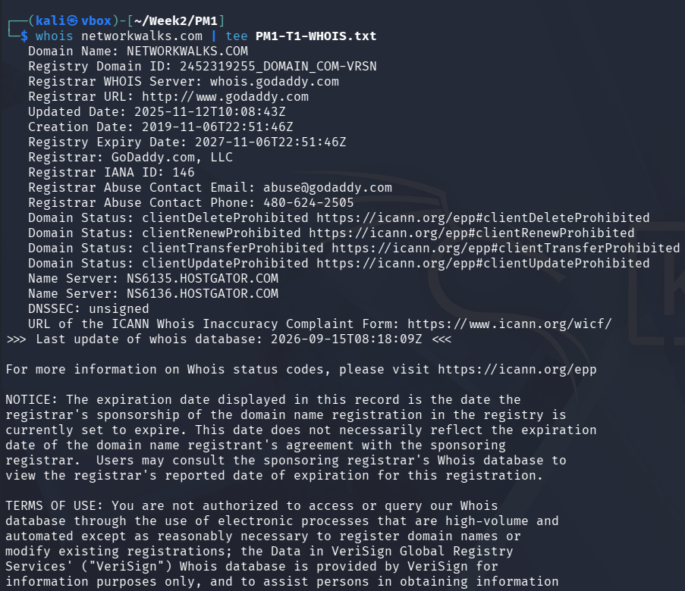
Figure 2 – Task 2: whatweb networkwalks.com (run 15 September 2026)
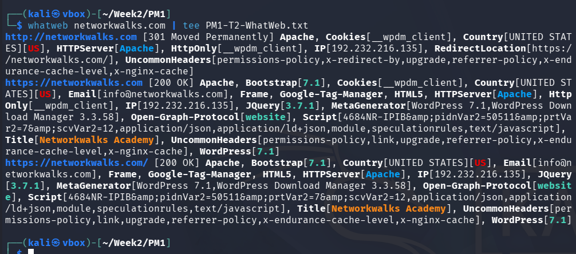
Figure 3 – Task 3: nslookup networkwalks.com (run 15 September 2026)
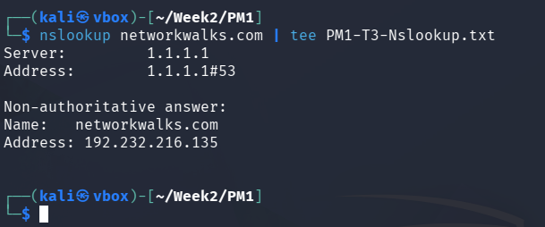
Figure 4 – Task 4: curl -I https://networkwalks.com (run 18 September 2026)
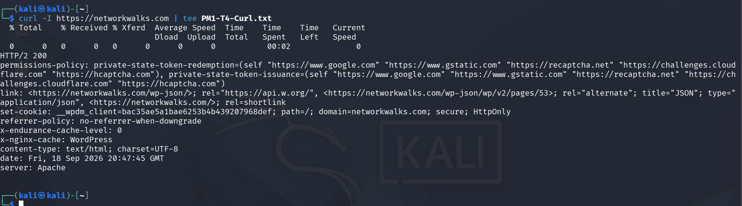
Figure 5 – Task 5: wafw00f networkwalks.com (run 15 September 2026)
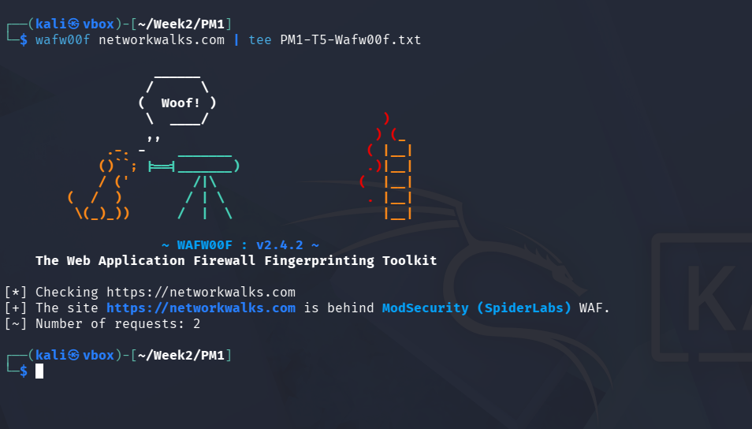
Figure 6 – Task 6: dnsrecon -d networkwalks.com (run 18 September 2026)
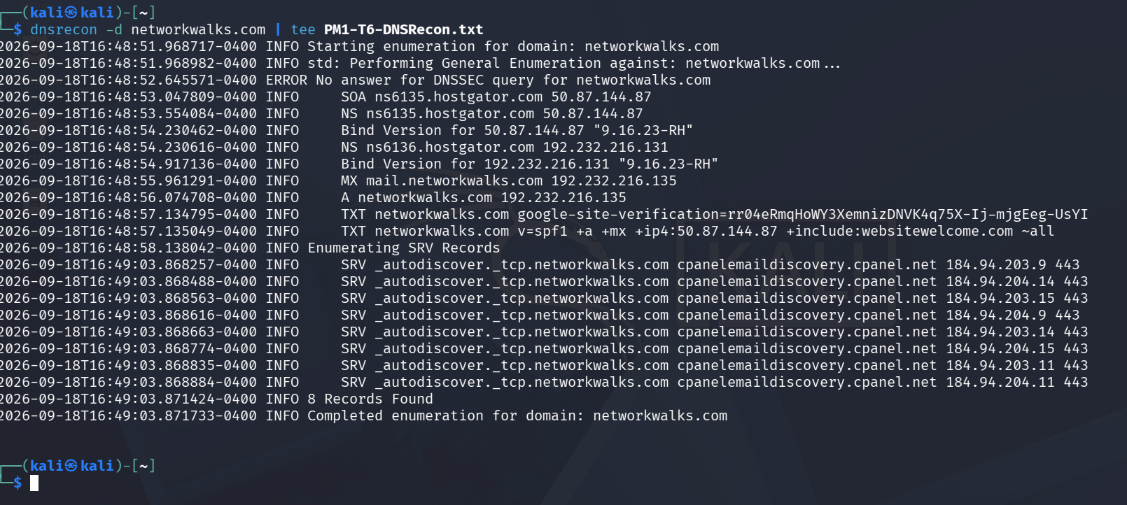

8.2 Network scanning with Zenmap (W2-PM5)
Figure 7 – Task 2 and Task 6: ipconfig /all on Windows10-Lab (IPv4 10.0.0.4, mask 255.255.255.0, gateway 10.0.0.1, MAC 08-00-27-70-FB-AC)
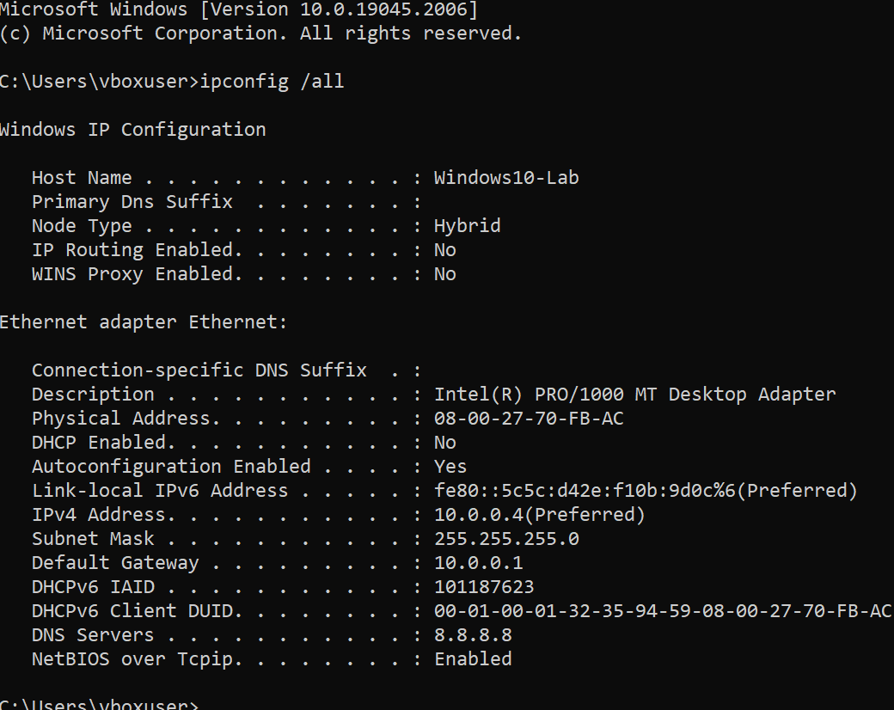
Figure 8 – Tasks 3 to 6: Zenmap ping scan of 10.0.0.0/24 (nmap -sn), 18 September 2026
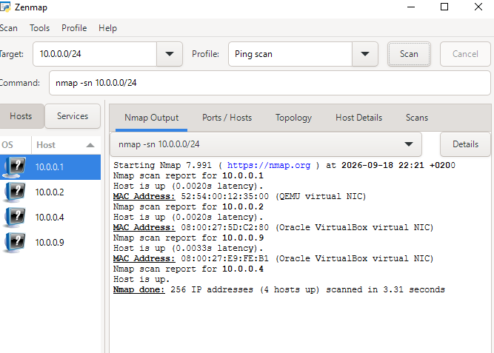
Figure 9 – Connectivity check: ping -n 4 to 10.0.0.1, 10.0.0.2 and 10.0.0.9 (15 September 2026)
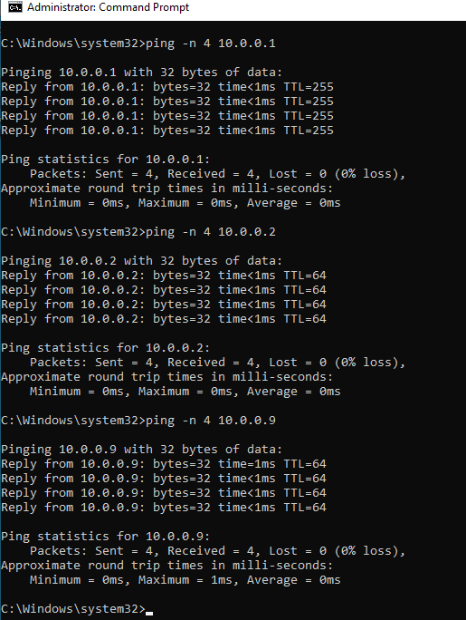
Figure 10 – Task 7: Zenmap network topology (also saved as W2-PM5-Zenmap-Topology.pdf)
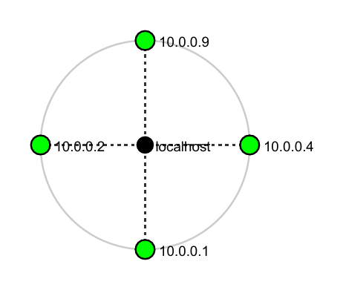

-End-

👤 Author
Mwanamuke Mwiya
Cybersecurity Intern B083

📌 Project Information
Program Name: Cybersecurity program at Networkwalks | Week: 02 | Repository: GitHub

