MySQL database installation
Windows

Date: 30 April 30, 2010

1 Introduction 2
1.1 Minimum hardware configuration 2
1.2 Recommended Hardware Configuration 2
2 Installation of MySql Server version 5.1 3
2.1 MySQL Download 3
2.2 MySQL Installation 4
2.3 MySQL Server configuration 8
2.4 Verification and possible problems 12
2.4.1 Verification 12
2.4.2 Possible problems 12

Introduction

Minimum hardware configuration

For acceptable performances, the Galaxy server holding and managing the MySql database should at least be the following:

Computer type | PC
OS | Windows XP
Processor speed | 2 GHertz
RAM | 1 Gb
Hard disk | 100 Gb

Recommended Hardware Configuration

We recommend the following configuration for the Galaxy server holding and managing the MySql database:

Computer type | PC
OS | Windows XP
Processor speed | 3 GHertz single-core OR  2 GHertz dual-core
RAM | 4 Gb
Hard disk | 250 Gb

Installation of MySql Server version 5.1

MySQL Download

Download the latest 5.1 official release of MySQL:

- http://www.mysql.com/downloads/mysql/
- Select platform: Microsoft Windows
- Click the “Download” button for following package:
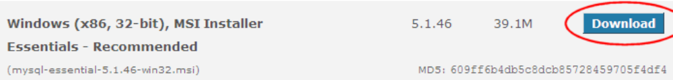

- In the download page, you can login if you have a MySQL login, or register if you want to register, or click » No thanks, just take me to the downloads!
- Select a mirror and click on the link to download the file (HTTP or FTP)
- Save the .msi file into a temporary folder.

Note: the release may be a more recent one than the one displayed on this document. Simply download the latest available release.

MySQL Installation

Launch the downloaded .msi installation program, and follow instructions as detailed hereafter:

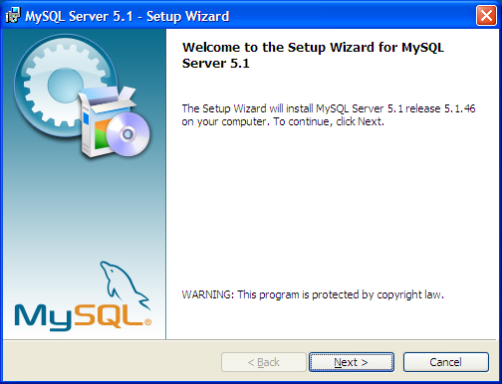
Click the ‘Next’ button

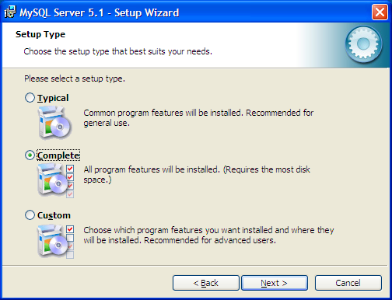
Select ‘Complete’ installation mode, and click the ‘Next’ button.

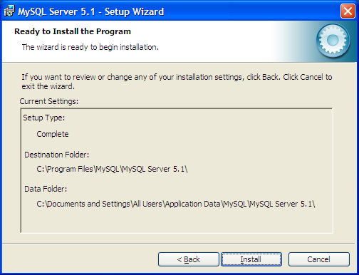
Install into the default folder ‘C:\Program Files\MySql\MySQL Server 5.1\’
You can select a different folder if this makes sense to you.
Then, click the ‘Install’ button.

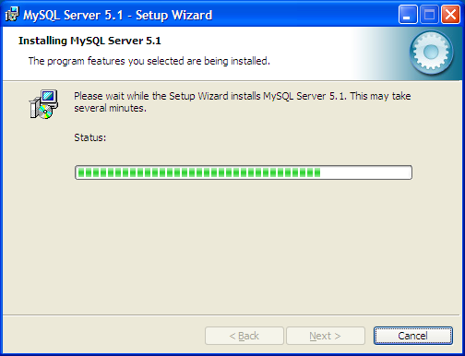

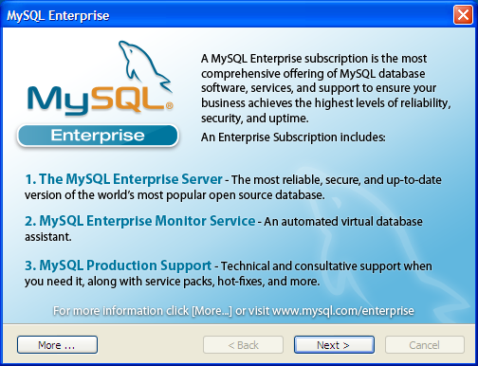
Click the ‘Next’ button.

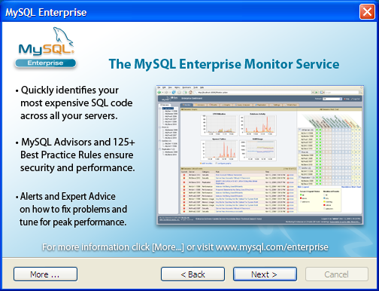
Click the ‘Next’ button.

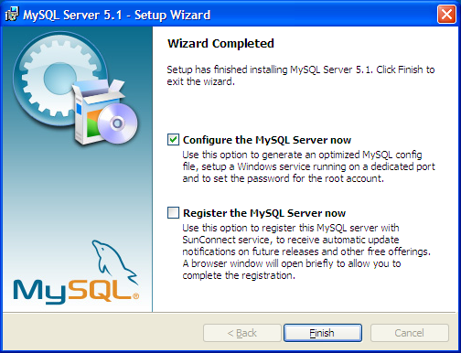

The installation of the MySQL server is now done!

You may register the MySQL server if you wish to receive automatic update notifications.

The next step is to setup the MySQL server, which can be done either by checking the ‘Configure the MySQL Server now’ button before clicking the ‘Finish’ button, or at a later time by using the link:

‘Windows Start menu->All Programs->MySQL->MySQL Server 5.1->MySQL Server Instance Config Wizard’

MySQL Server configuration

Unless the MySQL Server Instance configuration wizard automatically starts because you clicked the ‘Configure the MySQL Server now’ check box at the end of the installation process, launch it using the following Windows link:

‘Windows Start menu->Programs->MySQL->MySQL Server 5.1->MySQL Server Instance Config Wizard’

The following configuration wizard will enable you to configure your MySQL server instance (options, root password), and install it as a Windows service.

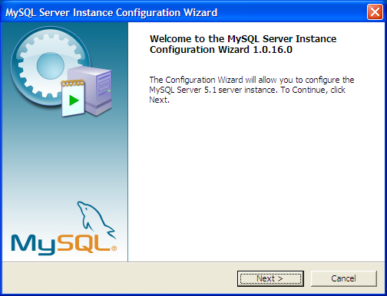
Click the ‘Next’ button

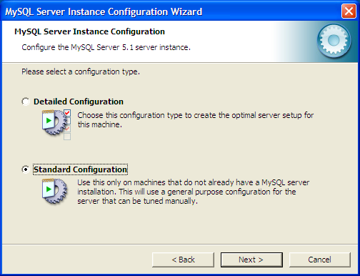
Select ‘Standard Configuration’, and click the ‘Next’ button

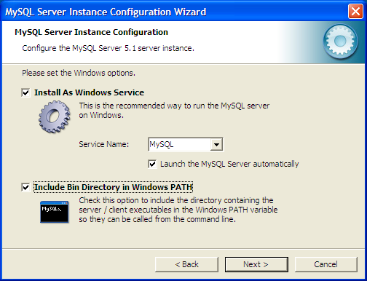
Select the options as shown in the above snapshot and click the ‘Next’ button.

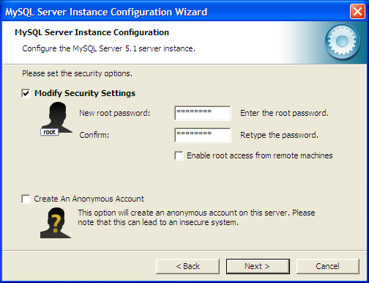
Enter the root password of your choice, and click the ‘Next’ button

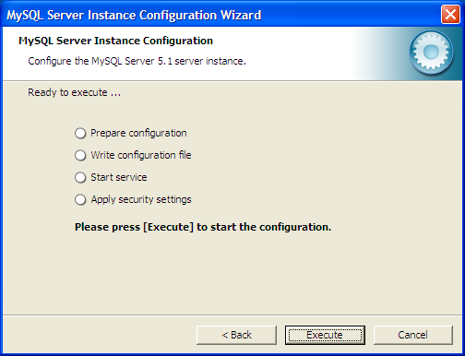
Click the ‘Execute’ button
If the error 2003 is thrown, click the ‘Retry’ button.

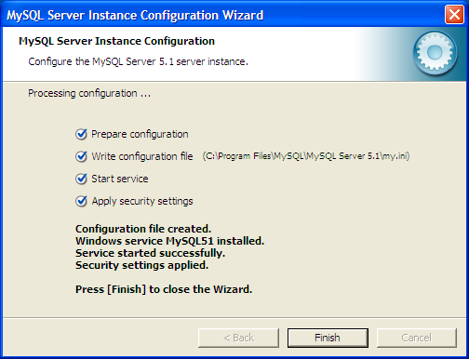
The configuration is completed, click the ‘Finish’ button.

Verification and possible problems

Verification

To make sure the MySQL Server service started as expected, launch the Windows Services control panel:
‘Windows Control Panel->Administrative Tools->Services’

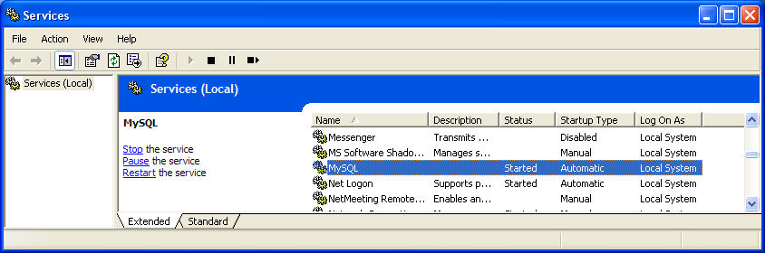
Make sure you see the ‘MySQL’ service in the list, and that the ‘Status’ column says ‘Started’.

Possible problems

The installation may fail on trying to start the service. If so, click the ‘Back’ button to start again the service. If the service still doesn’t start, the my.ini file may be incorrect or corrupted (eg: datadir entry missing, or invalid option).

Error 1045 or Error 106 :

Check the access paths specified in the my.ini file:
#Path to installation directory. All paths are usually resolved relative to this.
basedir="C:/Program Files/MySQL/MySQL Server 5.1/"
#Path to the database root
datadir="C:/Program Files/MySQL/MySQL Server 5.1/Data/"
Check user names & passwords

Error 2003

Under the ‘MySQL Server Instance Config Wizard‘, the error 2003 may be seen while executing the ‘Apply Security Settings’. Start over this step usually fixes the problem.

Fail starting SQL server at first launch

Check your firewall settings (it may bloc the socket port used).

Manually start and stop the server

To manually start the MySQL Server service, open a command window and type command ‘net start mysql’
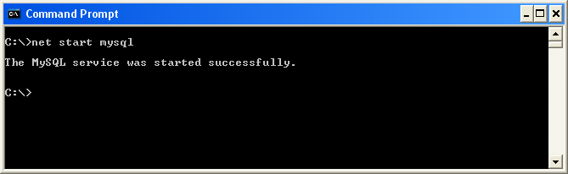

To stop the MySQL Server service, type command ‘net stop mysql‘
