MySQL Performance Tuning Questionnaire

Objective
In order to effectively provide service for clients, our consultants need information about the software and systems as well as some high level requirements, as necessary when evaluating a performance tuning engagement. Please answer as many questions as possible, but it is fine if not all questions are answered fully.

Customer / Contact Information
Company Name
Galaxy Semiconductors
Who is the primary contact for this assignment (Name, Phone, Email)
GARROS Bernard, +33 1 64595325, Bernard.garros@galaxysemi.com
Where should this assignment be performed (Address)
Galaxy
Z.A. du Madre
Rue d’Orsonville
91410 Dourdan
FRANCE

Overview
What are the main objectives which this engagement should achieve?
Review overall schema
Optimize database insertion/extraction (schema, database setup, queries)

What are the basic functions of the software that will be using the database system?
Data analysis on semiconductor test data, characterization, reporting, yield management.
What performance problems currently exist, if any?
Data extraction.

What are the desired performance requirements to achieve success in this engagement?
TDB.

Timeframes
What is the time frame being considered currently for the performance tuning engagement?
Q1 2009.

Ideally, how quickly would you like to start the project?
February 2009.

Are there any deadlines that are known at this time that must be considered for the project timeline?

Resources
What are the tools and methodologies used to measure existing performance?
Trace messages in our application with query execution/iteration performance measurements.
Same queries executed with a SQL tool (MySQL Browser, mysql command line, Navicat…).

What internal resources will be made available to MySQL during this engagement?
1 software engineer working on this project.

Will test systems be available, or will tuning be done on production systems directly?
Test systems only, mainly 1 test system with a real database replicated from one of our customers.

Current database
Approximately how large is the database? Please provide size of database (in MB,GB,TB), as well as row counts of some of the larger tables.
With one big table in terms of volume:

What is the output of running the command “show table status” on each MySQL database or schema that is being used?
See attached Gexdb_Mysql_table_status.txt

What is your schema definition for your database from running “mysqldump –no-data [database]”?
See attached Gexdb_Mysql_schema_dump.txt

What is the E/R diagram for your database schema? Please provide as an image or PDF.
See attached GEXDB_Tables_WT.doc (can be clarified if need be)

Performance metrics
Approximately what number of concurrent users and SQL queries per second, at peak usage?
Very low.

On UNIX or Linux, what is the output given by “vmstat 10” run for a few minutes, at peak usage?
On Windows, what is the peak % CPU & Disk utilization reported by the Performance console, perfmon.exe? Please attach graph if possible.

What is the output of running “mysqladmin extended -i10 -r” from the command line for a minute?
If unavailable, what is the output of running the commands “show status” on your MySQL system(s)?

If you are using the InnoDB storage engine, what is the output from “show innodb status”?

What is the output of running the command “show variables” on your MySQL system(s)?
See attached Gexdb_Mysql_variables.txt

Systems
What software and systems configurations are used for the following tiers:

Tier | Configuration
Database | MySQL 5.0.67 running on:  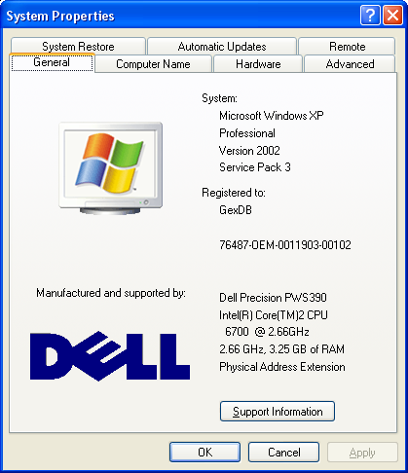
Middle Tier(s)

Client Application(s) | Our application developed with Visual Studio, and using the QT cross-platform libraries. Connection to the database, and query execution is made using QT dedicated objects, which in turn rely on the MySQL API (libmysql.dll)
3rd Party Software | QT.

