Galaxy PAT-MAN
Production Recipes

June 2010

Introduction
This document details how to create/edit production recipes and also how to administrate recipes (upload engineering and production recipes, etc).

With the Production Recipe Editor application, you can:
- Create a production recipe editor: define its name, version#, flows, etc
- Edit a production recipe
- Save production recipe (incrementing or not its version#)

With the Production Recipe Admin application, you can:
- Create Users
- Create Groups
- Upload Engineering recipes (Enable or Delete if privileges granted)
- Upload Production recipes (Enable or Delete if privileges granted)

Production Recipe Editor

Overview
The pat_prod_recipe.exe software can be used by production engineers or administrator.
Installation:
- Have the pat_prod_recipe.exe executable and its DLL installed on your computer, and ensure this folder includes the pat_server.ini file as detailed below.

Configuration file
The pat_server.ini configuration file is mandatory and must be located in the installation folder of the Production Recipe editor. This is a configuration file read by pat_prod_recipe.exe at launch and that includes paths to the PAT-MAN server holding the production and engineering recipes.

Important fields in the [global] section:
- ‘eng_path’ : points to the folder where Engineering recipes are uploaded (using the Recipe Admin tool)
- ‘prod-path’ : points to the folder where Production recipes are uploaded (using the Recipe Admin tool). This folder also included other production-related info (list of Groups, Users)
- ‘auto_increment’ : If set to ‘1’, then recipe version is auto-incremented each time it is saved
- ‘flows’ : defines the list of flows available under the recipe editor. Each flow string is separated with a space character.

Example of .ini file:

[global]
eng_path=c:/data/recipe_eng
prod_path=c:/data/recipe_prod
auto_increment=0
flows=EWS1 EWS2 EWS3 EWS4

Running Recipe Editor
To launch the Production recipe editor, simply launch the pat_prod_recipe.exe executable.
The application will be as following:

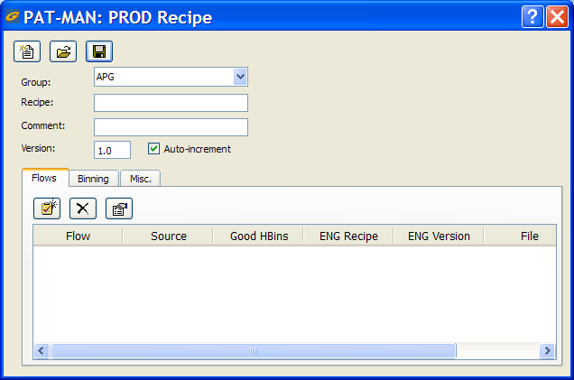

Note: When creating a production recipe, it belongs to a user group (eg: APG in above example). Groups are created under the Administration tool (pat_prod_admin.exe executable)

: Lets you create a new production recipe

Lets you load an existing production recipe file (for editing or review its settings).
Note that you can also Drag & Drop your production recipe file over the application for the same effect.

Lets you save your production recipe. If ‘Auto-increment’ is selected, the recipe version string is automatically incremented from X.Y to X.Y+1; if ‘Auto-increment’ is unchecked, then the current version string is used as-is. The application will refuse to save a recipe if it doesn’t include at least one flow definition.
Flows definition

Each recipe can include one or more flows.

Lets you add a flow to the list

Lets you remove selected flow from the list

Lets you edit an existing flow

When creating or editing a flow, the following dialog box appears:

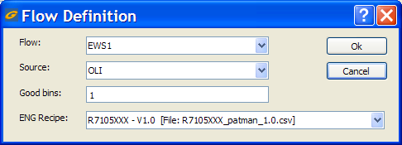

Flow: select the flow name wanted
Source: Tells which data source should be used for this flow; you can select OLI (this is for the wafermap input file); STDF (this is for STDF data file) or both.
Good bins: this is the list Hard Bin considered good
ENG Recipe: select which engineering recipe name and version to use for this flow. Note: only engineering recipe uploaded to the server and ENABLED can be found in this list.

Production Recipes Admin.

Overview
The pat_prod_admin.exe software is used by production engineers or administrator for releasing recipes.

Installation:
- Have the pat_prod_ admin.exe executable and its DLL installed on your computer, and ensure this folder includes the pat_server.ini file as detailed in first section of this manual.

Running Admin tool
To launch the Admin software, simply launch the pat_prod_admin.exe executable. If never launched before, the default login and password is admin . This login remains available as long as no users are created. As soon as users are created, this login is disabled (tip: ensure first user you create is the new Administrator profile!).

At launch, the application will be as following:
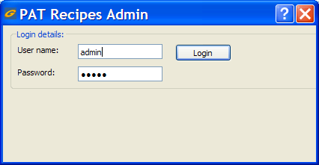

After login, it will be like this:
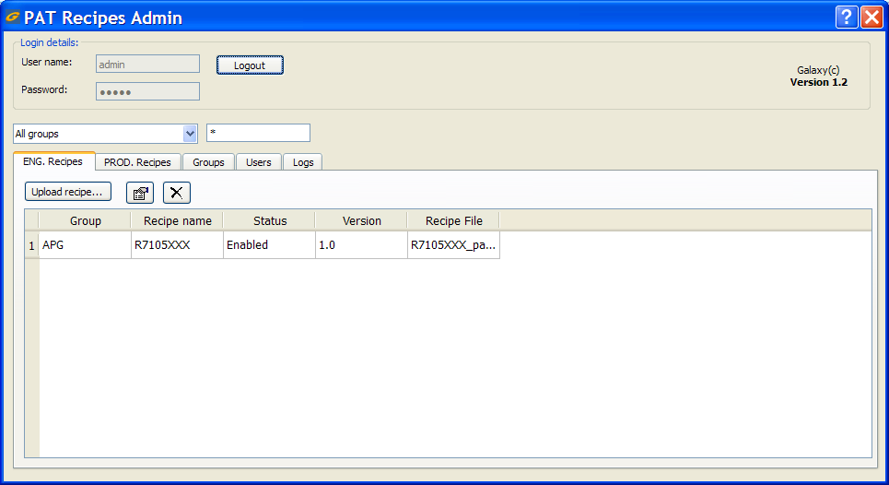
The application includes following tabs:
- ENG Recipes: from this tab, you can click the Upload button to upload an engineering recipe (created using Examinator-PAT), or simply Drag & Drop your engineering recipe over the Admin window. When uploaded, recipes are by default disabled, and only if you have enough privileges can you enable it. Use the other icons to edit (or double-click the line of your choice) or remove a recipe from the list. You can’t upload the same recipe file twice.
- PROD Recipes: from this tab, you can click the Upload button to upload an engineering recipe (created using pat_prod_recipe.exe as detailed earlier in this manual), or simply Drag & Drop your production recipe over the Admin window. When uploaded, recipes are by default disabled, and only if you have enough privileges can you enable it. Use the other icons to edit (or double-click the line of your choice) or remove a recipe from the list. You can’t upload the same recipe file twice. Only one version of a recipe name can be enabled at a time; the Admin tool fixes this automatically by toggling all the other entries of the same recipe name.
- Groups: lets administrator create groups. Since each recipe can only belong to one group at a time, ensure you create the right group list
- Users: lets administrator create user profiles. Users can be Engineering (can only upload recipes in disabled more), Production (can upload, edit, remove recipes), Administrator (have full access to Admin tool functions)
- Logs: lets you review the activity history.

To reduce the amount of Recipes entries listed in the software, you can filter over a specific group, and also enter a recipe name using wildchar (* and ?):

