BACSE344 - Cloud Infrastructure and Architecture
Digital Assignment - 3

Name: Mukesh Raj Sakthi Thangaraj
Reg No: 25BCE5059

Question 1
A) One peak demand scenario for GathreAround would be during exams when students rush to view the notes and pyqs they have pooled together with their peers and friends in a short window of time. The endpoints that will be hit the hardest will be the ones that list all the files in a directory(GET /files/room/{room_id}) and the endpoint that allows viewing and downloading of individual files(GET /files/{file_id}/download), and also the common health ping endpoint(GET /healthz) that every user, device and client initiate.
Request distribution viewed via grafana dashboard:
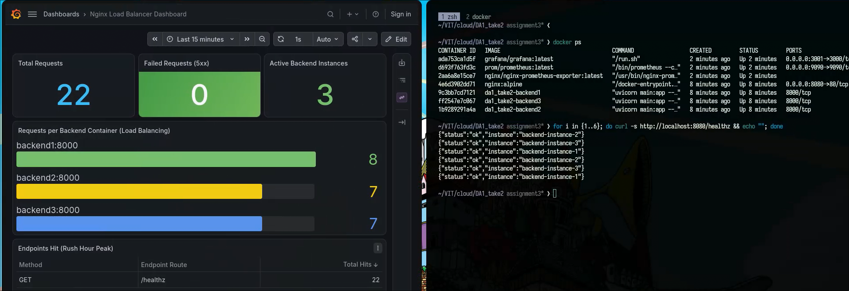

B) Backend instances are benchmarked using k6. The k6/load_test.js script was used to test in both scenarios across the 3 mentioned endpoints from section a.
One backend instance:
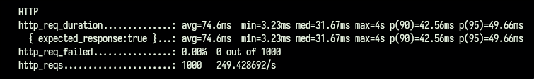
Three backend instances:
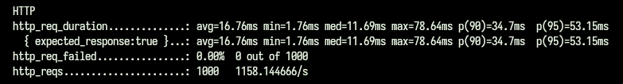
We observed:
Requests processed: 249.4 req/s -> 1,158.1 req/s (4.64x improvement or +364% increase)
Latency: 74.6 ms -> 16.8 ms (4.5x faster / 77.5% latency reduction)

C) Nginx is tested with and without rerouting after a failed request. The startup and configuration swap scripts are in run_failover_before.sh and run_failover_after.sh
Without failed requests rerouting:
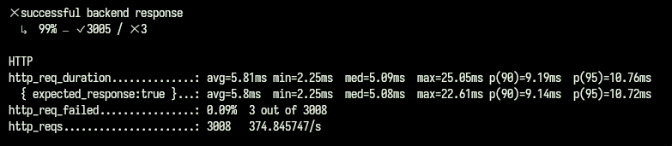
With fail requests rerouting:
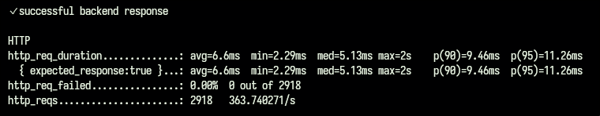
D) Architecture diagram:
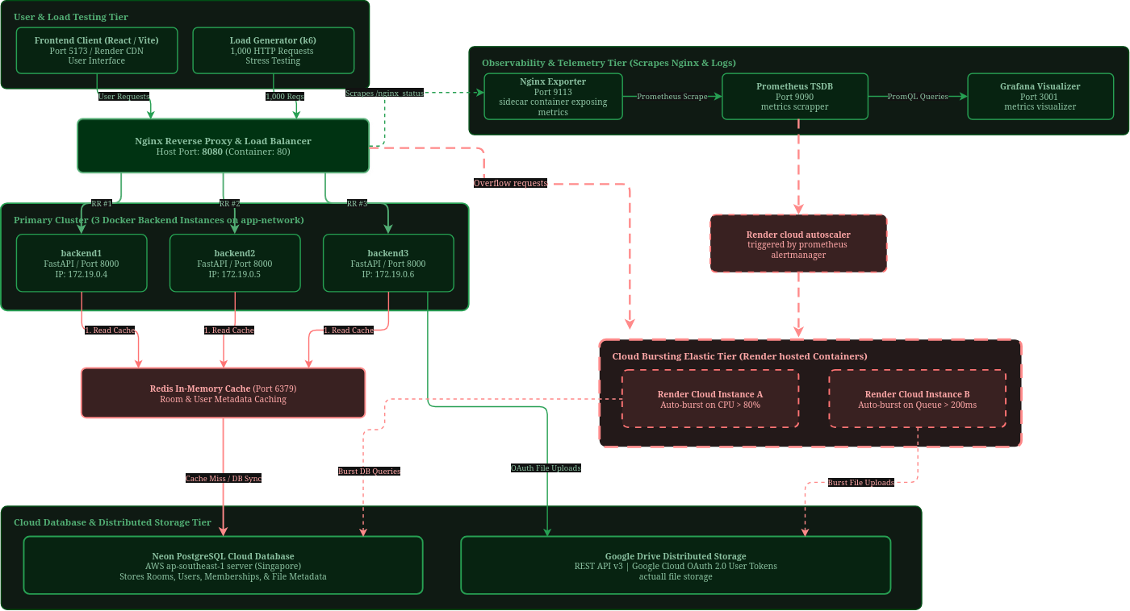
*green - current modules present
*red – modules required for cloud busting
GatherAround’s traffic is spiky and deadline driven, so under normal circumstances no additional resources will be needed, but during exam weeks and assignment submission deadlines, the traffic spikes due to concurrent browsing and file viewing. Since the traffic is localized, cloud busting is used.
It is triggered when prometheus detects high cpu utilization or high request latency. During this time Nginx sends the overflow requests to the extra cloud containers that are provisioned.

Question 2:
A) The most sensitive data currently stored are the room password which can let any user access files in that room.
Before salted hash:
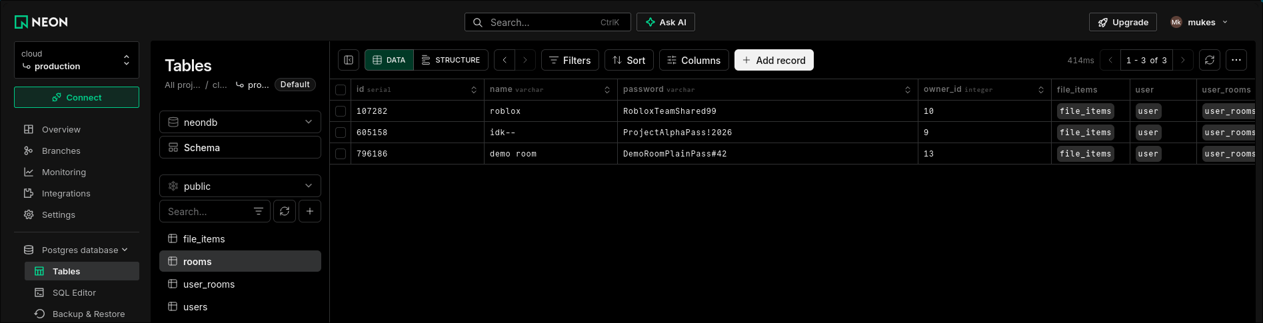
After salted hash:
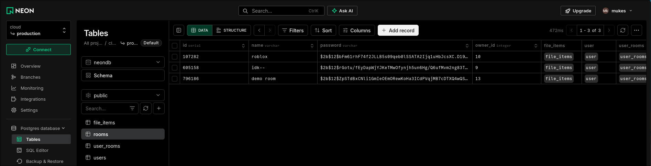
Other sensitive data include the google access token and refresh token per account/user

B) Multifactor authentication using TOTP authenticator app demo:
URL generation for authenticator app:
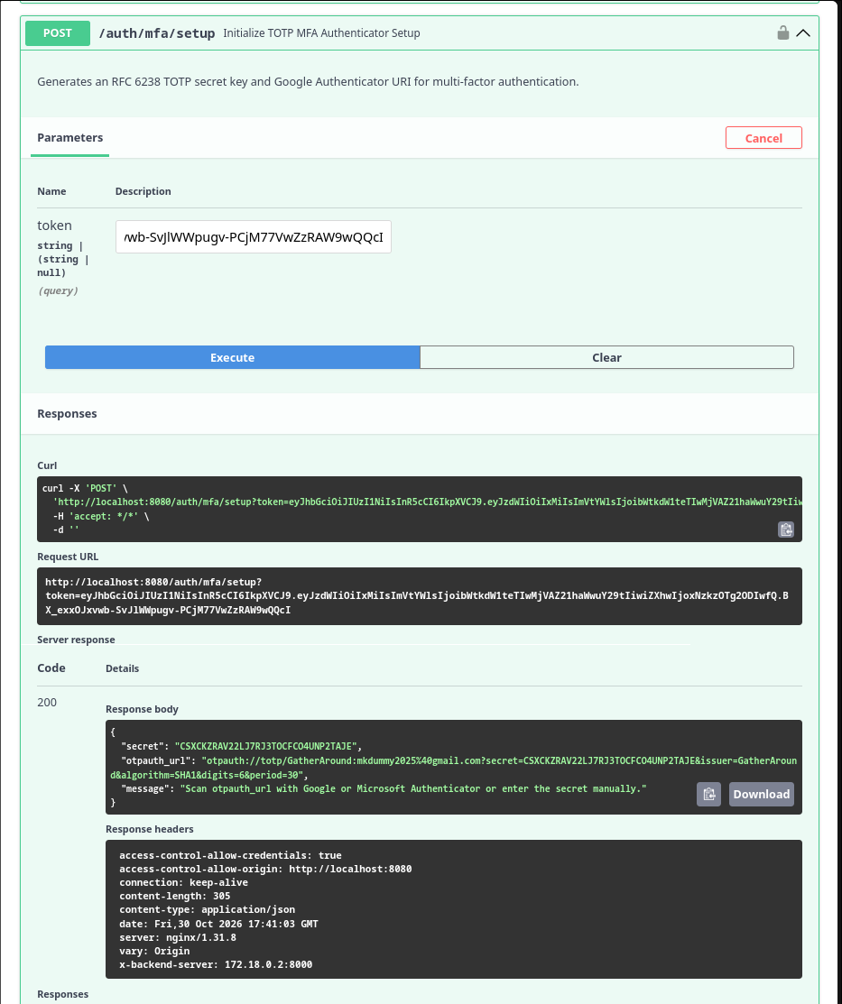

401 unauthorized error due to wrong code:
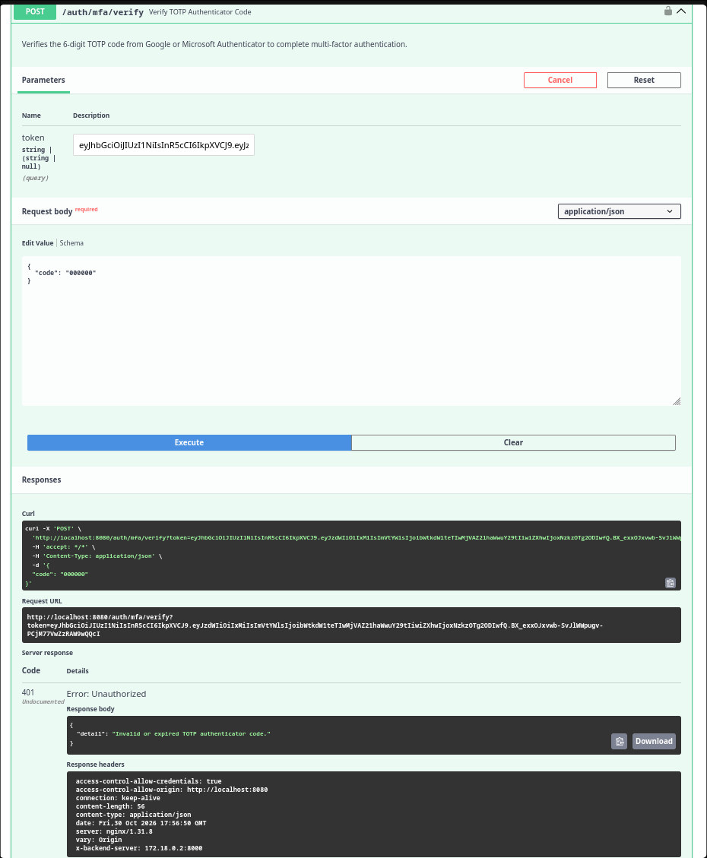

200 authorized using code from google authenticator app:
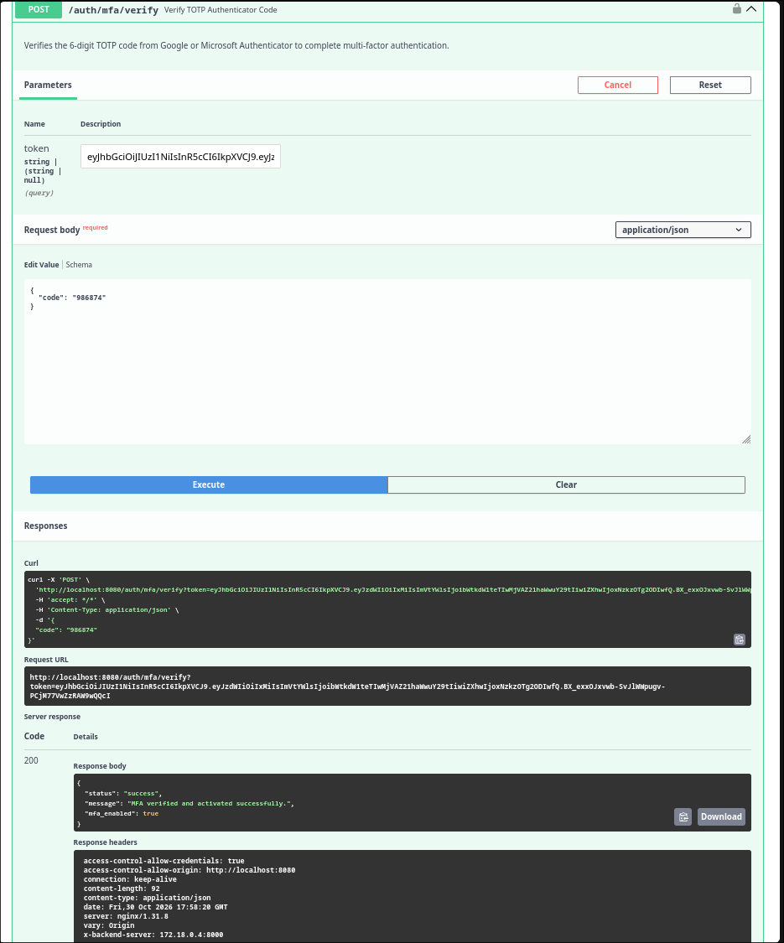

Delete user from room restricted endpoint accessible only to room owners:
Users in room and the room owner:
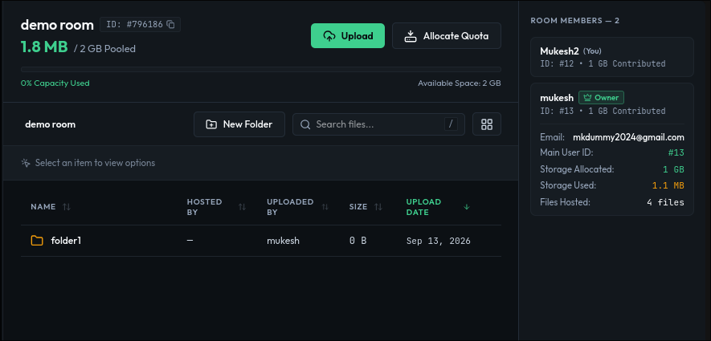

401 unauthorized due to no JWT access token:
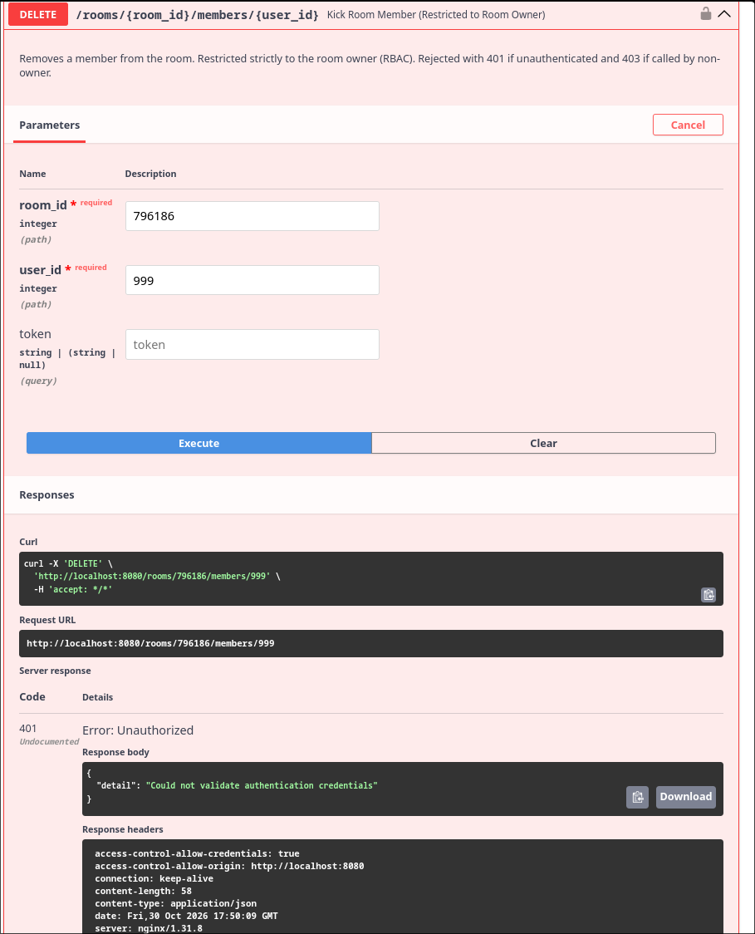

403 forbidden as room members cant kick other users out of the room:
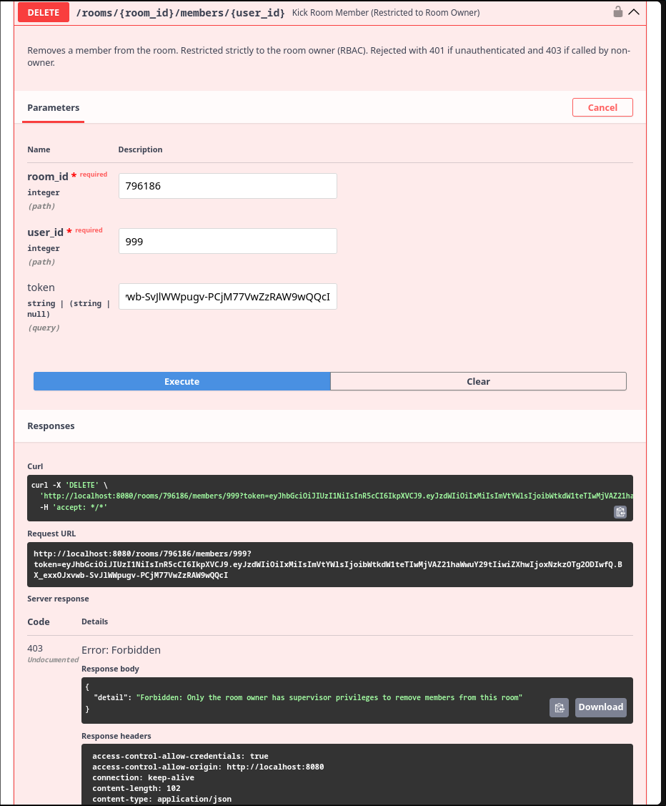

C) Scan results before trivy harden:
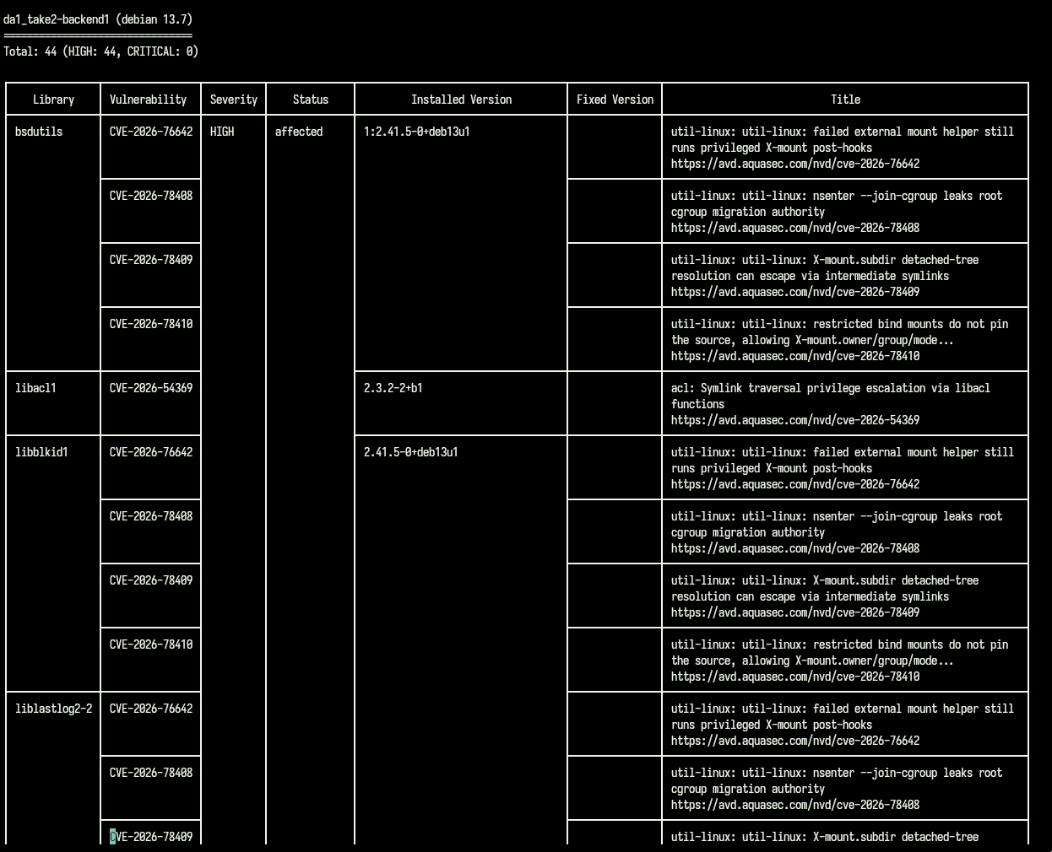
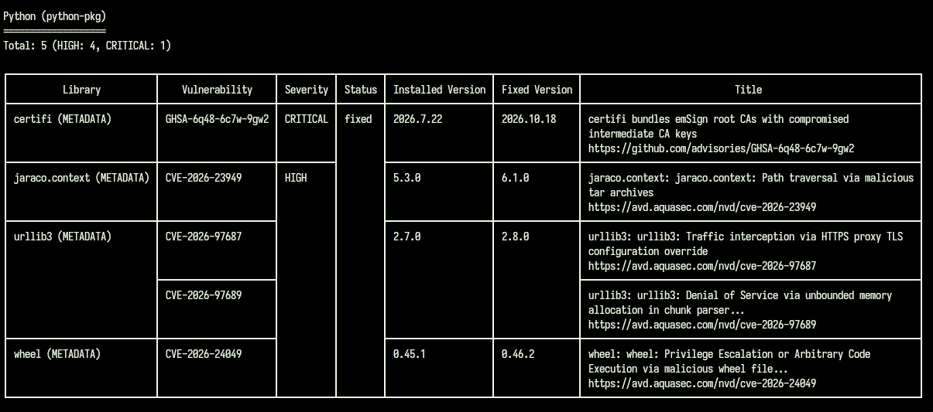

After trivy harden:
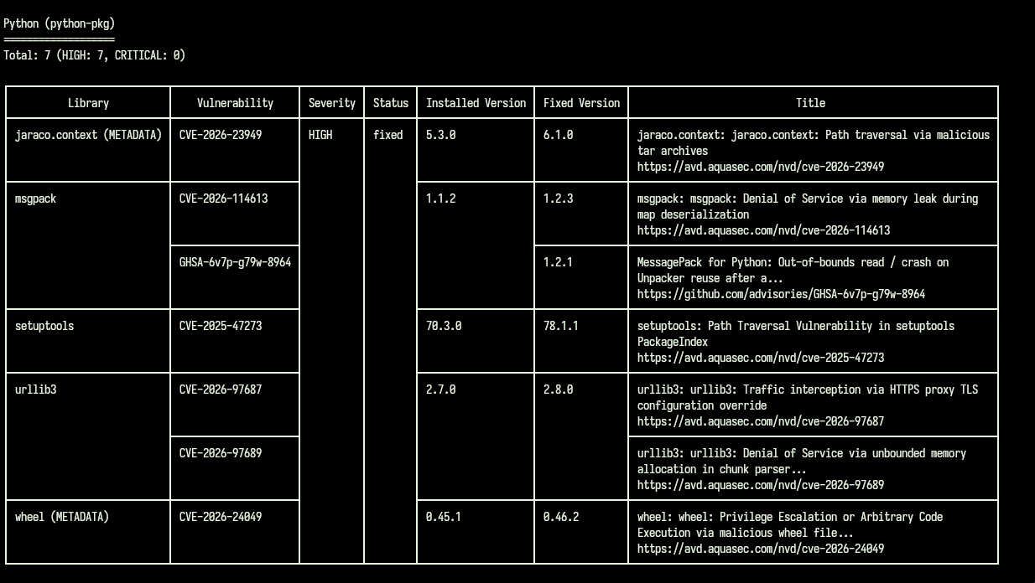
Summary:
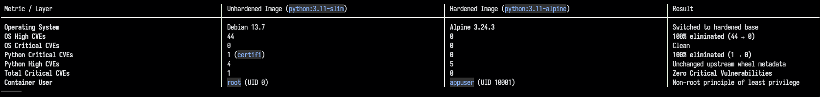
D) Threat agent:
1) Malicious attacker trying to sniff credentials:
Implemented salted password and token hashing and multifactor authentication
Applicable Regulation & Requirement:
GDPR Article 32(1)(a) & (b) — Security of Processing: Mandates that controllers and processors implement technical measures, including the encryption and pseudonymization of personal data, to ensure a level of security appropriate to the risk.
Why GDPR Applies:
GatherAround processes personal data (user email addresses, full names, account IDs, and Google Drive account linkages) belonging to real individuals across public networks.

2) authenticated user who legitimately joined a room, but attempts to sabotage it by deleting files and tampering with storage quotas:
Implemented Role Based Access Control so not every user has full control over the room. This also gives control over to the room owner to moderate the room
Applicable Regulation & Requirement:
GDPR Article 25(1) & (2) — Data Protection by Design and by Default: Requires implementing appropriate technical and organizational measures to ensure that, by default, only personal data necessary for each specific purpose is accessible, preventing unauthorized alteration, disclosure, or destruction.
Why GDPR Applies: Under GDPR, collaborative platforms handling personal contributions and shared assets must protect data subjects from unauthorized alteration, loss, or destructive deletion by third parties within the platform.

