**Media Streaming with IBM Cloud Video Streaming**

**Phase5: Project documentation and submission**

The landscape of media streaming is undergoing a profound transformation, and IBM Cloud Video Streaming emerges as a leading player in this dynamic environment. This project delves deeply into the realm of media streaming, with a specific focus on IBM's cloud service. IBM Cloud Video Streaming provides an extensive suite of features and capabilities, offering organizations the means to seamlessly deliver, manage, and protect high-quality video content to audiences around the globe. Within this exploration, we thoroughly examine the key components and functionalities of IBM Cloud Video Streaming, encompassing comprehensive content management tools, live streaming capabilities, and the dynamic realm of video-on-demand services.

We shed light on the platform's user-friendly interfaces and advanced analytics tools, empowering content providers to gain invaluable insights into viewer engagement patterns and preferences, thus allowing for the refinement of content delivery strategies. Furthermore, we highlight the paramount importance of the robust security measures and content protection mechanisms implemented by IBM Cloud Video Streaming. These measures ensure that sensitive content remains safeguarded in an increasingly interconnected digital landscape, offering peace of mind to content creators and distributors. Through a comprehensive analysis of real-world case studies and practical implementations, this project underscores how IBM Cloud Video Streaming can be a transformative force for organizations seeking to deliver captivating media content efficiently and securely, ultimately enhancing their digital presence and engagement with audiences worldwide.

**Project Objectives:**

* In this part we will document our project and prepare it for submission.
* Aim is to document the virtual cinema platform project and prepare it for submission.

**Introduction:**

Media Streaming with IBM Cloud Video Streaming represents a cutting-edge approach to delivering high-quality, on-demand video content to a global audience. With the ambition to create an application, IBM Cloud Video Streaming offers a robust platform that integrates a suite of tools and services tailored to the complex demands of modern media consumption. At its core, this technology leverages the power of IBM's cloud infrastructure to ensure seamless streaming experiences, from anywhere and on any device, be it a smartphone, smart TV, or computer. IBM Cloud Video Streaming provides an array of features that are paramount for building an application. These encompass personalized content. recommendations, and sophisticated user profiles, ensuring that users can discover, access, and enjoy content tailored to their preferences.

The platform's intuitive user interface design and responsive layout guarantee an enjoyable and user-centric experience, Further, content creators benefit from an efficient video upload process, with quality verification checks, metadata enhancements, and thumbnail selections to maximize content discoverability. Streaming integration through IBM's Content Delivery Network and support for live events empowers content diversity and fosters real-time interactions. Lastly, robust data analytics tools are employed to track user engagement and content performance, thereby enabling data-driven decisions and continuous platform enhancements. In summary, Media Streaming with IBM Cloud Video Streaming stands as a formidable foundation for crafting an application that caters to the evolvin**g** expectations of today's media consumers.

**Design Thinking:**

* **User Cantered Design:** User research involves collecting in-depth information about the interests, habits, and pain points of your user’s audience. thoughts. This can be done through research, interviews, and user testing to understand users' likes, dislikes, and expectations of streaming services.

User research guides the design process to ensure the platform,

meets customers' needs and preferences, making it useful and efficient.

* **Prototyping Testing**: Prototyping involves creating interactive visual representations of the streaming platform. Usability testing is then conducted to obtain user feedback and identify usability issues. This iterative process helps keep the platform running.

Prototyping and testing to ensure the user interface are attractive and effective, ultimately improving user experience and satisfaction with streaming services.

**Development Phase:**

1. **streaming Platform Development:**

* **Backend Infrastructure**: The backend infrastructure includes setting up server clusters, databases, and integrating content delivery networks (CDN). It ensures that the system can handle concurrent user requests efficiently and provides low-latency content delivery.
* **Frontend framework:** Frontend development focuses on creating an attractive and user-friendly user interface. It integrates the recommendation algorithms into the frontend, allowing users to receive personalized content suggestions. Functions such as search, user profile and integration are also used.

1. **Quality Assurance and Testing:**

* **Load Testing:** Load testing requires a system to simulate high loads to evaluate performance in the busiest ambulance. It identifies conflicts and ensures that the platform processes large streams without interruption.
* **User Testing:** User testing involves the interaction of real users with the platform to verify set usability issues, issues, or performance issues. Feedback from users is collected and used to make necessary improvements to the platform.

**User Interface:**

The user interface is designed with a user-centric approach and Favors easy and intuitive navigation. It uses a well-structured menu system, clear labels, and logical flow to help users find and access content easily. Users can quickly browse genres, search for specific titles, and manage their profiles. Intuitive navigation design minimizes user frustration and makes the platform more accessible, leading to increased user engagement and satisfaction.

**1**.**Video Upload Process:** The video upload process is designed to be user-friendly and efficient. Creators are guided step by step with clear instructions and a progress tracking system that ensures the process is straightforward and efficient. The user-friendly upload process encourages content creators to contribute to the platform, which is essential for growing the content library. Video Quality Verification Uploaded videos go through strict quality checks to ensure they meet platform standards. These checks evaluate factors such as video resolution, audio quality, format compatibility, and content suitability. Videos that meet these standards are made available to users.

**2.Metadata and Thumbnail selection:** Creators have the option to provide metadata, including titles, descriptions, and genre tags, to optimize the visibility of their video. They can also choose a thumbnail image to represent their content. This metadata improves content search, and an attractive thumbnail can attract more viewers.

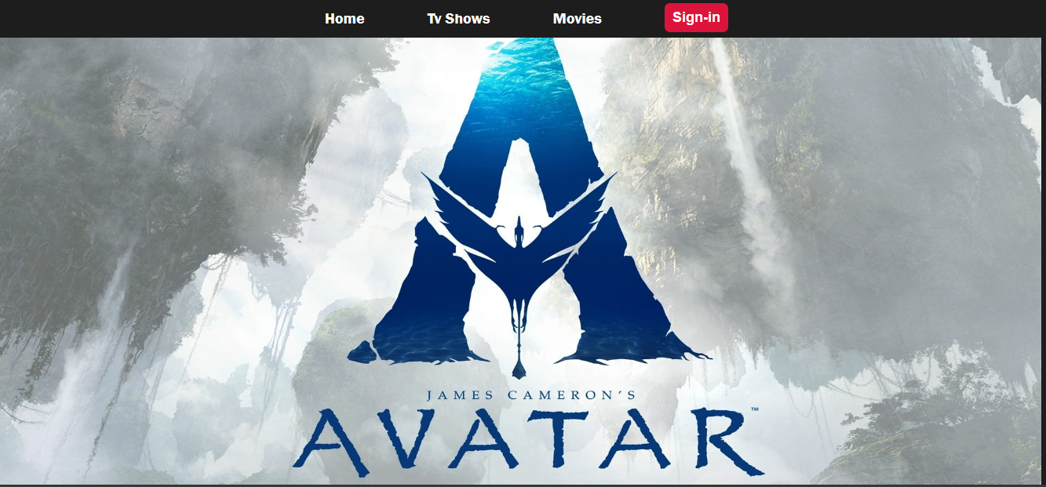

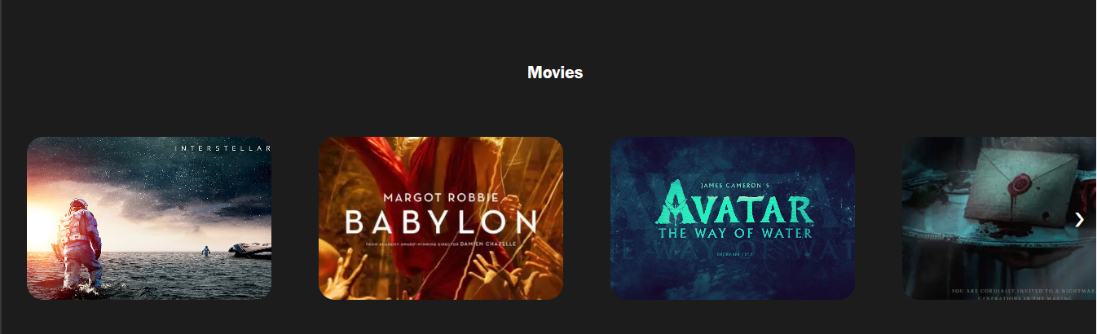

**Features of Platform:**

* **Content recommendations:** The platform uses advanced machine learning algorithms to analyse user data. This includes historical tracking data, likes, dislikes, ratings, and demographic information. These algorithms generate personalized content recommendations, making it easier for users to discover new content that aligns with their interests. Additionally, content recommendations are continuously updated, ensuring users receive fresh and relevant suggestions.
* **Multidevice Support:** In the era of multi-screen consumption, the platform offers a consistent user experience across devices. For example, when a user switches from a smartphone to a smart TV, the platform automatically optimizes the user interface and video quality for the specific device, ensuring a seamless viewing experience for users.

**Streaming Integration:**

* **Content Delivery Network (CDN):** The platform uses IBM Cloud Content Delivery Network (CDN) capabilities to optimize content delivery. IBM's global network of edge servers minimizes latency, reduces buffering, and ensures fast and reliable streaming of content to users around the world.

CDN integration is essential to improve the overall streaming experience by reducing load times and ensuring consistent, high-quality video playback.

* **Live Streaming Support**: In addition to on-demand content, the platform offers support for live streaming of events. Creators can host live broadcasts, Q&A sessions, premieres, or live chats with their audience. Chat features and real-time interactions are available to engage users during live broadcasts. Use for the project: Support for live streaming expands the platform's content palette and user engagement. It enables real-time interaction between creators and their audience, fostering a sense of community and increasing user engagement.
* **Social Media Integration**: Users can seamlessly share their favourite content, comments, and recommendations on various social media platforms. Sharing capabilities are integrated into the platform so users can easily spread the word about their favourite shows or movies. This social media integration also allows users to follow content creators and interact with them on social channels. Social media integration improves the reach of the platform and the promotion of user-generated content. Users become advocates for the platform, increasing its visibility and user engagement.

**Monitorization strategies:**

**Subscription Plans**: Explanation: The platform offers subscription plans that give users access to premium features, including ad-free viewing, early access to new content, and exclusive shows or movies. Subscription plans are available on a monthly or annual basis. Subscription plans provide the platform with a consistent revenue stream while offering users an enhanced experience. Subscribers can enjoy content uninterrupted by advertisements.

* **Ad Integration:** Explanation: The platform incorporates advertising as a monetization strategy. Advertisements are strategically placed within the platform's content, including pre-roll and mid-roll ads during video playback. A free, ad-supported tier is also available. Usage for Project: Ad integration generates revenue while providing a free option for users. This approach strikes a balance between monetization and accessibility, allowing a broader user base.

**Data Analytics:**

* **User Engagement Tracking:** The platform employs sophisticated analytics tools to track user engagement metrics. These metrics include watch time, likes, shares, comments, and user interactions. This data is used to gain insights into user behaviour, preferences, and content popularity. User engagement data informs content recommendations and platform improvements. It helps content creators and platform administrators understand what resonates with the audience.
* **Content Performance Metrics:** The platform also provides content creators with detailed metrics on how their content is performing. Creators can access data on views, user engagement, audience demographics, and the impact of their content on user retention. Content performance metrics empower content creators to make data-driven decisions to optimize their content, increasing its appeal and user engagement.

**Project Inspiration for Media Streaming with IBM Cloud Video Streaming:**

**Introduction:**

Selecting Netflix as the primary source of inspiration for the "Media Streaming with IBM Cloud Video Streaming" project is a strategic decision driven by several compelling factors. Netflix's success, innovative strategies, and impact on the global entertainment landscape make it a quintessential choice to model a streaming platform. The project draws inspiration from Netflix's achievements and aims to replicate and enhance key aspects of its offering while leveraging IBM Cloud Video Streaming's capabilities for a dynamic and competitive media streaming service.

**1.Global Success and Market Dominance:**

Market Leadership: Netflix's remarkable journey to becoming a global streaming giant sets a remarkable benchmark. With over 200 million subscribers worldwide, it dominates the streaming industry and serves as a prime example of how to capture a vast market share.

**2. Data-Driven Personalization:** Leveraging IBM Cloud Video Streaming's capabilities, the project intends to implement similar recommendation algorithms. This will provide users with personalized content suggestions, enhancing their engagement and satisfaction.

**3. Original Content Production:**

The project takes inspiration from Netflix's content production strategy. It aims to allocate resources for creating exclusive and high-quality content, enabling it to attract and retain users through a unique and compelling content library.

**4. User-Centric Design:** The project emphasizes an intuitive user interface design, with responsive layouts, straightforward navigation, and personalized profiles to enhance user satisfaction. It also aims to ensure a consistent experience on diverse devices.

**5. Content Delivery and Streaming Quality:**

IBM Cloud Video Streaming's CDN capabilities will be a critical component, ensuring fast and reliable content streaming. It will focus on reducing load times and offering uninterrupted high-quality video playback.

**6. Monetization Strategies:**

The project aims to emulate these monetization strategies, offering subscription plans for enhanced experiences and an ad-supported tier to reach a broader user base while generating revenue.

**7. Data Analytics and User Engagement:**

The project places significant importance on data analytics to track user behaviour and preferences. It will use this data to inform content recommendations, platform improvements, and content performance metrics.

**Conclusion:**

The project's inspiration is founded on its global success, data-driven personalization, original content production, user centric design, content delivery, monetization strategies, and data analytics. These aspects reflect the media streaming industry and serve as a blueprint for the "Media Streaming with IBM Cloud Video Streaming" project, which aims to replicate and enhance these key elements. Finally, in the last phase, we made our project accessible on GitHub using Git and This project represents a blend of creativity, technology, and planning, giving users an engaging media streaming experience like Netflix, and marks the successful completion of our project.