**Media Streaming with IBM Cloud Video Streaming**

**Phase 3: Development**

1. **Problem Definition:** Buffering problems streaming video occur when your internet speed or bandwidth is not enough to support the video quality that you are streaming. IBM cloud handles well in the case of the streaming problems.
2. **User interface:** The Home Page offers a dynamic featured content slider for highlighting premier movies or shows. Additionally, it provides organized categories for users to navigate effortlessly and discover diverse content.

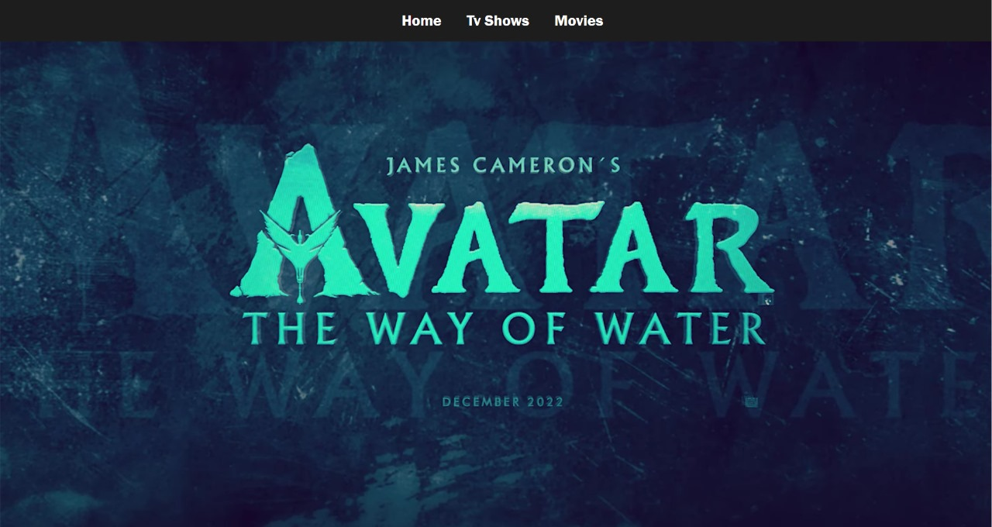

Fig.1

1. **User Authentication:** Session Management ensures that user sessions terminate after periods of inactivity, enhancing security. Users can monitor and control their active sessions, providing transparency and control. The Privacy and Consent segment emphasizes adherence to GDPR or applicable data protection norms. It mandates transparent privacy policies and robust mechanisms for users to provide or withdraw consent, safeguarding their data rights and ensuring ethical data handling.
2. **User Registration:** The platform provides a versatile sign-up mechanism, allowing users to register either with their email addresses or via their existing social media profiles, ensuring user convenience. To combat the proliferation of spam accounts, the system implements an email verification process, a pivotal step to confirm genuine users. For the critical aspect of authentication, the platform integrates IBM Cloud App ID, a sophisticated solution that not only facilitates seamless authentication but also offers intrinsic features like user profile storage, streamlined registration, and an intuitive password recovery system. Augmenting security, the authentication process harnesses OAuth 2.0, a globally recognized protocol, ensuring that user credentials are managed securely, and authorization processes are conducted with utmost reliability.
3. **Development:** IBM Watson Media now offers enhanced playlist features for its simulated live streaming events. This improvement enables event managers to set up fully produced broadcasts without relying on encoders or live production teams. Both live and on-demand platform capabilities have been merged to streamline the experience for broadcasters and content creators. The updated system offers two main types of playlists: manual, where users personally add and order videos, and dynamic, which auto-populates based on video metadata. This provides flexibility for event managers to loop live broadcasts, fill channels with continuous content, or run fully pre-recorded live events. The content management system update also simplifies the process of adding and removing videos from playlists and offers easy video searching and sorting capabilities. This enhancement is timely, as many firms are slowly transitioning back to in-person events. Playlists help optimize the viewer experience while conserving production resources. For detailed guidance, refer to the Watson Media Knowledge Base.

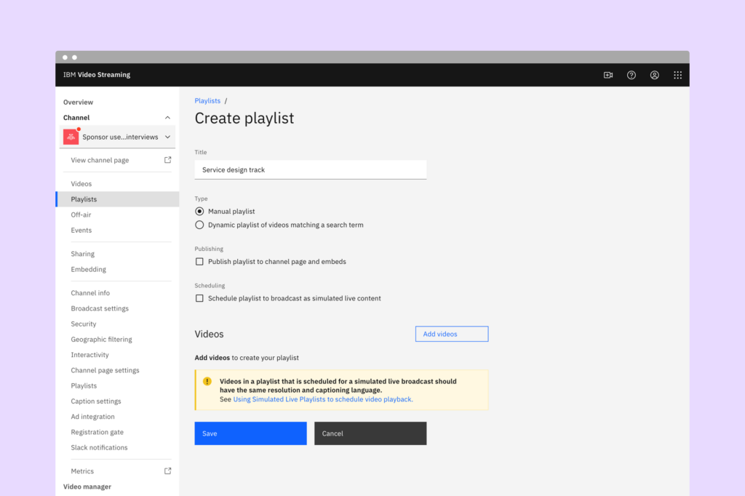

Fig 2

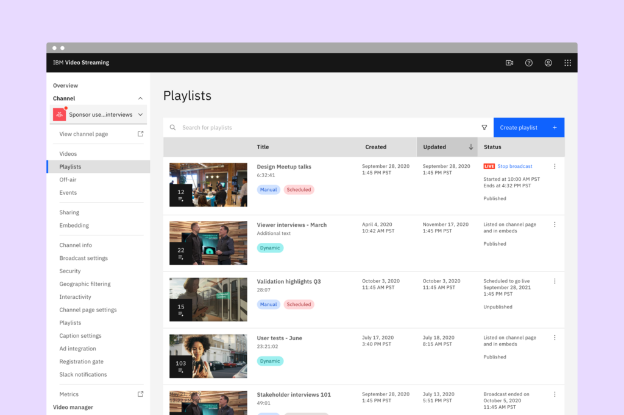

Fig3

**Program for UI:**

<!DOCTYPE html>

<html lang="en">

<head>

    <meta charset="UTF-8">

    <meta name="viewport" content="width=device-width, initial-scale=1.0">

    <title>Phase 2</title>

    <link rel="stylesheet" href="style.css">

    <script src="https://kit.fontawesome.com/a076d05399.js" crossorigin="anonymous"></script>

</head>

<body style="background-color: #1d1d1d;">

    <div class="nav">

        <ul>

            <li><a href="#home" style="color: white;">Home</a></li>

            <li><a href="#tv" style="color: white;">Tv Shows</a></li>

            <li><a href="#movies" style="color: white;">Movies</a></li>

            <li><button>Sign-in</button></li>

        </ul>

    </div>

    <div class="slideshow-container" id="home">

        <div class="mySlides fade">

            <img src="img/peakpx.jpg" style="width:1340px; height: 672px;padding: 5px;">

        </div>

        <a href="#"><i class="fa-solid fa-play"></i></a>

        <div class="mySlides fade">

            <img src="img/wallpaperflare.com_wallpaper (1).jpg" style="width:1340px; height: 672px;padding: 5px;">

        </div>

        <div class="mySlides fade">

            <img src="img/wallpaperflare.com_wallpaper (2).jpg" style="width: 1340px; height: 672px;">

        </div>

    </div>

    <br>

    <div style="text-align:center">

        <span class="dot"></span>

        <span class="dot"></span>

        <span class="dot"></span>

    </div>

    <div class="tea" id="tv">

        <a>Tv Shows</a>

        <div class="cards-slider">

            <div class="cards-container">

                <div class="cards">

                    <a href="https://www.bing.com/search?q=next+js+install+command&form=ANNTH1&refig=4c2bbd3bbda841d7ba255245b6791fb3&pc=EDBBAN" target="_blank"><img src="img/65-poster-400x600.webp" width="100px"></a>

                </div>

                <div class="cards">

                    <a href="https://www.bing.com/search?q=next+js+install+command&form=ANNTH1&refig=4c2bbd3bbda841d7ba255245b6791fb3&pc=EDBBAN" target="_blank"><img src="img/amazing-spider-man-new-marvel-s-the-amazing-spider-man-movie-poster-wallpaper-preview.jpg" width="300px" height="200px"></a>x

                </div>

                <div class="cards">

                    <img src="img/babylon-poster-1-400x600.jpg">

                </div>

                <div class="cards">

                    <img src="img/godzilla-movies-digital-art-movie-poster-wallpaper-preview.jpg">

                </div>

                <div class="cards">

                    <img src="img/interstellar-movie-movies-wallpaper-preview.jpg">

                </div>

                <div class="cards">

                    <img src="img/silent-night-poster-2-400x600.jpg">

                </div>

                <div class="cards">

                    <img src="img/the-invitation-poster-400x600.jpg">

                </div>

                <div class="cards">

                    <img src="img/wallpaperflare.com_wallpaper (1).jpg">

                </div>

                <div class="cards">

                    <img src="img/oppen.jpg">

                </div>

            </div>

            <button class="prev-button" style="color: white;">&#10094;</button>

            <button class="next-button" style="color: white;">&#10095;</button>

        </div>

    </div>

    <div class="tea" id="movies">

        <a>Movies</a>

        <div class="cards-slider">

            <div class="cards-container">

                <div class="cards">

                    <img src="img/interstellar-movie-movies-wallpaper-preview.jpg" width="100px">

                </div>

                <div class="cards">

                    <img src="img/babylon-poster-1-400x600.jpg" width="300px" height="200px">

                </div>

                <div class="cards">

                    <img src="img/peakpx.jpg">

                </div>

                <div class="cards">

                    <img src="img/the-invitation-poster-400x600.jpg">

                </div>

                <div class="cards">

                    <img src="img/dead-reckoning-poster-1-400x600.jpg">

                </div>

                <div class="cards">

                    <img src="img/silent-night-poster-2-400x600.jpg">

                </div>

                <div class="cards">

                    <img src="img/the-invitation-poster-400x600.jpg">

                </div>

                <div class="cards">

                    <img src="img/wallpaperflare.com_wallpaper (1).jpg">

                </div>

                <div class="cards">

                    <img src="img/oppen.jpg">

                </div>

            </div>

            <button class="prev-button" style="color: white;">&#10094;</button>

            <button class="next-button" style="color: white;">&#10095;</button>

        </div>

    </div>

    <script>

        let slideIndex = 0;

        showSlides();

        function showSlides() {

            let i;

            let slides = document.getElementsByClassName("mySlides");

            let dots = document.getElementsByClassName("dot");

            for (i = 0; i < slides.length; i++) {

            slides[i].style.display = "none";

        }

        slideIndex++;

        if (slideIndex > slides.length) {slideIndex = 1}

        for (i = 0; i < dots.length; i++) {

            dots[i].className = dots[i].className.replace(" active", "");

        }

        slides[slideIndex-1].style.display = "block";

        dots[slideIndex-1].className += " active";

        setTimeout(showSlides, 6000);

        }

        const cardsContainer = document.querySelector('.cards-container');

        const cards = document.querySelectorAll('.cards');

        const prevButton = document.querySelector('.prev-button');

        const nextButton = document.querySelector('.next-button');

        let currentIndex = 0;

        function updateSliderPosition() {

            cardsContainer.style.transform = `translateX(-${currentIndex * 370}px)`;

        }

        function prevCard() {

            currentIndex = (currentIndex - 1 + cards.length) % cards.length;

            updateSliderPosition();

        }

        function nextCard() {

            currentIndex = (currentIndex + 1) % cards.length;

            updateSliderPosition();

        }

prevButton.addEventListener('click', prevCard);

nextButton.addEventListener('click', nextCard);

    </script>

</body>

</html>

**Conclusion:**

In Phase 3 of Media streaming app project, our objective is to achieve these milestones through the successful completion of tasks. These innovative features will provide users with a more engaging and personalized show watching experience, leading to increased user satisfaction and retention.