**Media Streaming with IBM Cloud Video Streaming**

**Phase 4: Development Part 2**

IBM Watson Media to support simulated live streaming events using the live playlist feature. Event managers love this capability as it allows them to set up fully produced broadcasts without the need for encoders or live production staff. Additionally, content owners create dynamic playlists associated with on-demand content. As of today, we’ve combined the live and on-demand platform capabilities for playlists to unify the experience more closely for broadcasters and content creators. Now, there is a single place to manage all types of playlists.

1. **Video Upload:**

IBM Watson Media has enhanced its video uploading capabilities through the integration of Aspera Connect, benefiting those managing video assets. This collaboration provides faster upload speeds by tapping into Aspera’s FASP® transfer technology, optimized for various network conditions. FASP prioritizes efficient bandwidth use and incorporates a rate control mechanism, ensuring swift transfers without disrupting other online activities. Furthermore, the integration enables large file uploads, supporting files up to 20 GB, a significant leap from the previous 4 GB limit. Users can also enjoy bulk video uploading, a streamlined process where multiple videos can be selected and uploaded simultaneously without compromising speed. For security-conscious users, Aspera ensures encrypted file transfers, enhancing protection during uploads. 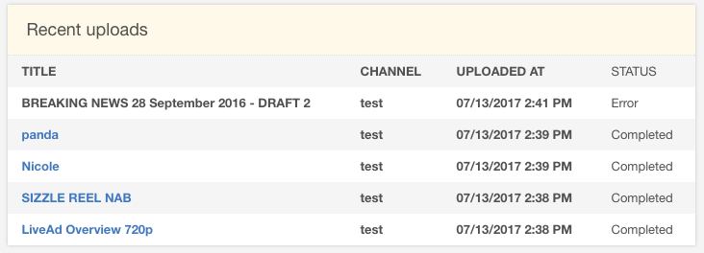

Fig.1

To utilize this accelerated uploading, users within an IBM video streaming account can opt for the Aspera Upload method, which requires the Aspera Connect program. This program offers a familiar interface for file selection, making bulk uploads convenient. The first file in a batch might take longer to appear, but subsequent files are processed more swiftly. After uploading, content remains unpublished until the user decides to make it viewable, ensuring content privacy and control.



Fig.2

1. **Streaming Integration:**

IBM Cloud Video Streaming offers a comprehensive solution for delivering both live and on-demand video content. This service ensures high-quality, adaptive video playback suited to the viewer's device and network, enhancing user experience. The global Content Delivery Network (CDN) ensures swift content delivery by selecting the nearest geographical node, minimizing latency. One of its notable features is its security, ensuring videos are encrypted during both upload and playback. Post-streaming, broadcasters can harness detailed analytics, gaining insights into viewer habits, locations, and devices, which aids in content strategy refineme

Fig.3

For seamless integration into existing platforms, IBM provides a set of APIs, simplifying the development process. The service is enriched with interactive features like live chats and polls, fostering audience engagement. Importantly, IBM's solution is scalable, effortlessly accommodating whether you're streaming to a few individuals or a vast audience. Organizational tools enable efficient content categorization and management, and for those seeking monetization, options like pay-per-view and subscription models are available. In essence, IBM Cloud Video Streaming is a versatile solution tailored to provide superior video broadcasting, packed with features that enhance content delivery and viewer experience.

**Conclusion**:

In Phase 4 of Media streaming app project, our objective is to achieve these milestones through the successful completion of tasks. These innovative features will provide users with a more engaging and personalized show watching experience, leading to increased user satisfaction and retention.