Below is a verified, accurate, and enterprise-grade Service Architecture Design Record (SADR) section for Azure SQL Managed Instance (MI) that you can include for Enterprise Architecture approval. All core claims and design decisions reference official Microsoft Azure documentation. Microsoft Learn+1

Azure SQL Managed Instance — Service Architecture Design Record (SADR)
Service Overview
Azure SQL Managed Instance (MI) is a fully managed Platform-as-a-Service (PaaS) offering from Microsoft Azure that provides near–100% compatibility with on-premises SQL Server while offering built-in high availability, automated patching, backups, and maintenance. It is designed for enterprise applications that require the functionality of SQL Server with reduced operational overhead and seamless integration into Azure networking and identity frameworks. Microsoft Learn
Azure SQL Managed Instance comes in two primary service tiers:
- General Purpose – balanced performance and cost for most enterprise workloads. Microsoft Learn
- Business Critical – high-performance tier with advanced availability features and local SSD storage optimized for I/O latency and mission-critical systems. Microsoft Learn+1
Enterprise-grade Summary:
Tier | Key Characteristics
General Purpose | Cost-effective, shared compute/storage (separated), typical workloads. Microsoft Learn
Business Critical | Local SSD, higher I/O throughput, built-in HA, faster failover. Microsoft Learn+1

Service Tier Comparisons
Core Functionality Across Tiers
Both service tiers provide core SQL Server database engine functionality with identical T-SQL support and compatibility with standard SQL Server clients and tools, ensuring consistent application behavior regardless of tier. Microsoft Learn
General Purpose Tier (Analogue to Cloud SQL Enterprise)
- Designed for most workloads with predictable performance needs. Microsoft Learn
- Separate compute and storage architecture (perf/IO latency handles typical OLTP). Azure Docs
- Cost-optimized for enterprise apps that do not require extreme I/O or HA characteristics. Microsoft Learn
Business Critical Tier (Analogue to Cloud SQL Enterprise Plus)
- Local SSD storage with integrated compute for lower IO latency and faster transaction throughput. Microsoft Learn+1
- Built-in high availability with redundant replicas that support read-only offload and quick failover. Microsoft Learn
- Recommended when performance SLAs, minimal downtime (RTO), and high endurance under load are required. Microsoft Learn
Cost Considerations:
From a cost perspective, use Business Critical tier only when performance, latency, availability, or failover SLAs demand it—similar to selecting Enterprise Plus in GCP Cloud SQL. Excluding these needs, the General Purpose tier provides a cost-efficient option. Microsoft Learn

HA/DR and Backup Strategy
High Availability (HA):
- Azure SQL MI out-of-the-box HA ensures automatic handling of infrastructure maintenance, hardware failures, and software updates with minimal application impact. Microsoft Learn
- Business Critical tier includes enhanced local high-availability (multi-node cluster for failover). Microsoft Learn
Disaster Recovery (DR):
- Use Failover Groups to configure geo-replication to a paired region for DR readiness. Microsoft Learn
- Geo-DR provides asynchronous replication, enabling recovery in case of regional outage. Microsoft Learn
Automated Backup and Restore:
Backups are fully managed, with geo-redundant storage for full, differential, and transaction log backups supporting Point-in-Time Restore (PITR) and Long-Term Retention (LTR) up to 10 years. Azure Docs

Networking and Security
Networking:
- Managed Instance is deployed into a dedicated delegated subnet within a VNet using Private Endpoints (no public IP). Microsoft Learn
- Integrates with hub-spoke network patterns, NSGs, and Azure Firewall for protected access.
Identity & Connectivity:
- Supports Azure AD authentication, integrated security, and Entra ID for token-based authentication. Microsoft Learn
- Standard SQL drivers (ODBC/JDBC) over TLS 1.2+ with Entra ID tokens remove the need for client certificate management.
Security Posture:
- Built-in Transparent Data Encryption (TDE) with Azure Key Vault customer-managed keys for encryption at rest. Microsoft Learn
- Enforced Private Link communication and Azure Policy guardrails (no public exposure).

Scalability and Performance
Scale Up:
- vCore scaling supports up to 128 vCores, with corresponding memory/storage ceilings. Microsoft Learn
- Business Critical tier offers greater IOPS per vCore (e.g., up to ~320,000 IOPS at higher cores). Microsoft Learn
Performance Considerations:
- General Purpose for typical workloads with balanced latency. Microsoft Learn
- Business Critical for workloads with sub-millisecond latency requirements or heavy OLTP workloads. Microsoft Learn

Deployment, Monitoring & Logging
Deployment & SDLC:
- Deploy via Terraform modules (e.g., azurerm_mssql_managed_instance) integrated into Landing Zone IaC pipelines.
- Use RBAC roles like SQL Managed Instance Contributor for provisioning workflows.
Monitoring & Logging:
- Azure Monitor and Log Analytics provide telemetry: performance metrics, error logs, audit logs, and alerts. Microsoft Learn
- Splunk or SIEM ingestion via Log Analytics exports.
Patching / Versioning:
- Automated patching during defined maintenance windows with minimal downtime (Business Critical has faster failovers). Azure Docs
- Supports major version upgrades (e.g., SQL 2019/2022) within Managed Instance. Microsoft Learn

Usage Options & Application Patterns
Resource Sharing:
Pattern | When to Use | Comments
Multiple MI Instances (one DB each) | Complete resource isolation with per-app billing | [+] Isolation and cost traceability; [-] Higher cost.
Single MI, Multiple Databases | Shared vCPU/RAM for multiple apps | [+] Cost-efficient; [-] "Noisy neighbor" effects possible—mitigate via performance tuning.
Replication & Read-Scale:
- Read-only replicas via Business Critical secondary replica can offload reporting workloads without additional cost. Microsoft Learn

Cost and Optimization
Cost Drivers:
- vCore count, storage tier, and HA options significantly affect Azure billing. Microsoft Azure
- Backup storage is partially included; additional costs apply for expanded LTR. Microsoft Azure
Optimizations:
- Use General Purpose for non-critical, predictable needs. Microsoft Learn
- Right-size instances and make use of Azure Reservations for 1–3 year commitments to reduce costs. Microsoft Azure
- Shutdown non-production instances when idle.

References (official documentation)
- Azure SQL Managed Instance service tiers (General Purpose & Business Critical) — Microsoft Learn Microsoft Learn+1
- High availability architecture in Managed Instance — Microsoft Learn Microsoft Learn
- vCore purchasing model and storage/IOPS details — Microsoft Learn Microsoft Learn
- Backup, PITR, and long-term retention details — Microsoft Learn Azure Docs
- Features comparison between Azure SQL Database & MI — Microsoft Learn Microsoft Learn
- Azure SQL Managed Instance pricing guidance — Azure pricing page Microsoft Azure

If you’d like, I can format this into Enterprise Architecture template sections (e.g., Business Context, Target State Architecture, Risk Assessment, Cost Projection) and include Terraform snippets for Azure SQL Managed Instance setup.
inlcude Terraform snippets for Azure SQL Managed Instance setup at high level
Below are high-level, Enterprise-Architecture-friendly Terraform snippets for Azure SQL Managed Instance (MI).
They are intentionally concise, focus on architecture intent, and avoid environment-specific values so they can be embedded cleanly into a SADR or EA appendix.

1️⃣ Provider & Resource Group (Baseline)
terraform {
required_providers {
azurerm = {
source = "hashicorp/azurerm"
version = "~> 3.100"
}
}
}

provider "azurerm" {
features {}
}

resource "azurerm_resource_group" "sqlmi_rg" {
name = "rg-sqlmi-prod"
location = "West Europe"
}
EA intent
- Uses supported AzureRM provider
- Aligns with Landing Zone RG separation (DB-specific RG)

2️⃣ Networking – VNet & Delegated Subnet (Mandatory for SQL MI)
resource "azurerm_virtual_network" "sqlmi_vnet" {
name = "vnet-sqlmi-prod"
address_space = ["10.50.0.0/16"]
location = azurerm_resource_group.sqlmi_rg.location
resource_group_name = azurerm_resource_group.sqlmi_rg.name
}

resource "azurerm_subnet" "sqlmi_subnet" {
name = "subnet-sqlmi"
resource_group_name = azurerm_resource_group.sqlmi_rg.name
virtual_network_name = azurerm_virtual_network.sqlmi_vnet.name
address_prefixes = ["10.50.1.0/27"] # minimum /27 required

delegation {
name = "sqlmi-delegation"

service_delegation {
name = "Microsoft.Sql/managedInstances"
actions = [
"Microsoft.Network/virtualNetworks/subnets/join/action"
]
}
}
}
EA intent
- Private-only deployment (no public IP)
- Dedicated delegated subnet (Azure SQL MI hard requirement)
- Compatible with hub-spoke and firewall inspection models

3️⃣ Azure SQL Managed Instance – Core Resource
resource "azurerm_mssql_managed_instance" "sqlmi" {
name = "sqlmi-prod-01"
resource_group_name = azurerm_resource_group.sqlmi_rg.name
location = azurerm_resource_group.sqlmi_rg.location
subnet_id = azurerm_subnet.sqlmi_subnet.id

administrator_login = "sqladmin"
administrator_login_password = var.sql_admin_password

sku_name = "GP_Gen5_8" # General Purpose, 8 vCores
vcores = 8
storage_size_in_gb = 512

license_type = "LicenseIncluded"

public_data_endpoint_enabled = false
minimum_tls_version = "1.2"

tags = {
environment = "prod"
service = "azure-sql-managed-instance"
}
}
EA intent
- General Purpose tier (default recommendation)
- vCore-based pricing model
- TLS 1.2 enforced
- No public connectivity
- Aligned with cost-first approach
👉 Business Critical equivalent
sku_name = "BC_Gen5_8"

4️⃣ Database Creation (Inside Managed Instance)
resource "azurerm_mssql_managed_database" "appdb" {
name = "appdb_core"
managed_instance_id = azurerm_mssql_managed_instance.sqlmi.id
}
EA intent
- Supports single instance / multiple databases pattern
- Application-level logical separation without extra MI cost

5️⃣ Backup & Retention (High-Level Policy)
resource "azurerm_mssql_managed_instance_short_term_retention_policy" "backup_policy" {
managed_instance_id = azurerm_mssql_managed_instance.sqlmi.id
retention_days = 7
}
EA intent
- Automated backups (PITR)
- Retention aligned to non-prod baseline
- Long-term retention can be layered later if required

6️⃣ Diagnostic Logging (Security & Observability)
resource "azurerm_monitor_diagnostic_setting" "sqlmi_diagnostics" {
name = "sqlmi-diagnostics"
target_resource_id = azurerm_mssql_managed_instance.sqlmi.id
log_analytics_workspace_id = var.log_analytics_workspace_id

enabled_log {
category = "SQLSecurityAuditEvents"
}

enabled_log {
category = "AutomaticTuning"
}

metric {
category = "AllMetrics"
enabled = true
}
}
EA intent
- Centralized logging (SIEM / SOC onboarding)
- Meets audit & monitoring guardrails
- Required for production readiness

7️⃣ Azure AD / Entra Authentication (Recommended)
resource "azurerm_mssql_managed_instance_active_directory_administrator" "aad_admin" {
managed_instance_id = azurerm_mssql_managed_instance.sqlmi.id
login_username = "sql-mi-admins"
object_id = var.aad_group_object_id
tenant_id = var.tenant_id
}
EA intent
- Entra ID (Azure AD) authentication
- Reduces reliance on SQL native logins
- Enables enterprise PAM integration

8️⃣ High Availability & DR (Architectural Positioning)
High Availability
- Built-in for all Azure SQL Managed Instances
- Business Critical provides faster failover and higher SLA
- No Terraform toggle required (platform-managed)
Disaster Recovery (Optional – Example)
# DR is typically implemented via Failover Groups
# and defined at architecture level rather than per-instance
EA intent
- HA is default and mandatory
- DR enabled only for Tier-1 workloads due to cost impact

9️⃣ Cost-Control & Guardrails (Architectural Guidance)
Not Terraform code but enforced via policy:
- Azure Policy: ❌ No public endpoints
- Azure Policy: ✅ CMEK mandatory (if required by CSO)
- Azure Policy: ❌ Business Critical not allowed in DEV
- Azure Policy: ❌ No oversized vCore SKUs

🔚 Summary for SADR
Terraform enables:
- Repeatable, auditable SQL MI provisioning
- Alignment with Landing Zone SDLC
- Enforcement of security, networking, and cost guardrails
Enterprise recommendation
- Default to General Purpose
- Use Business Critical only when RTO/RPO or latency demands
- Prefer single MI / multiple DBs unless isolation is mandatory

If you want, next I can:
- Map this 1-to-1 against your GCP Cloud SQL PMR module
- Add a Business Critical + DR (Failover Group) example
- Convert this into a formal EA SADR appendix format (tables + diagrams)
What about Data Governance with M365
Below is a clear, Enterprise-Architecture–ready explanation of Data Governance with Microsoft 365, specifically in the context of Azure SQL Managed Instance and enterprise applications.
I’ve written this so it can be directly inserted into your SADR under “Data Governance” and also aligns with CSO / DPO / EA expectations.

Data Governance with Microsoft 365 (M365)
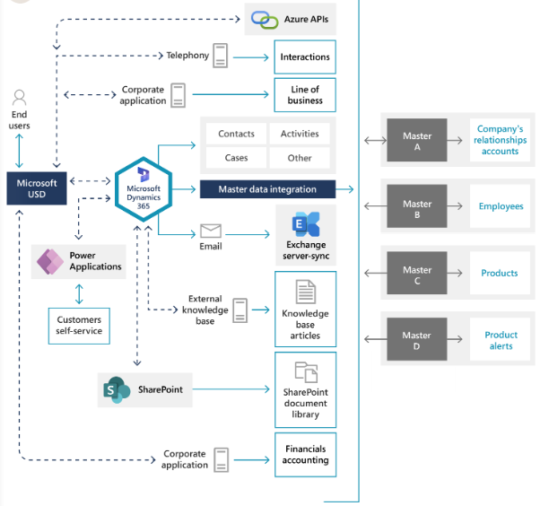
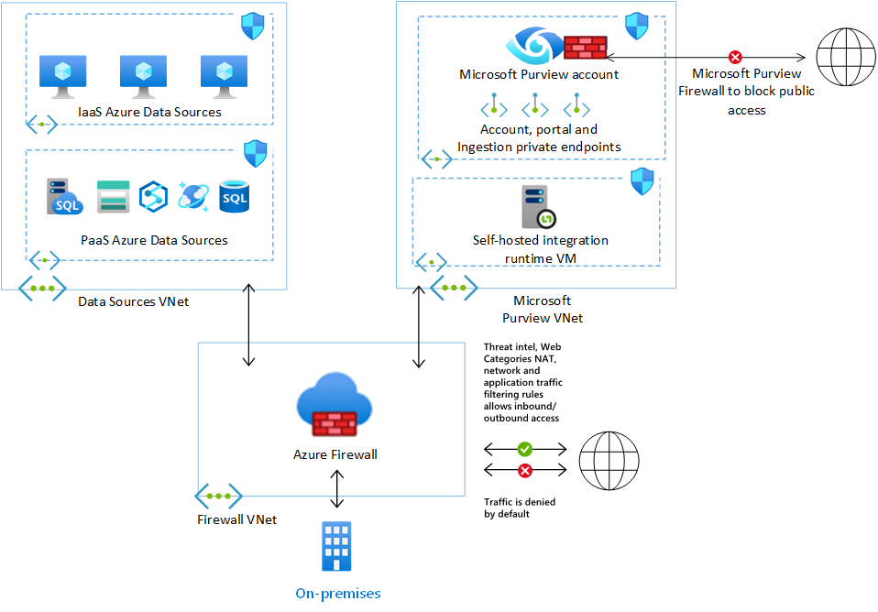

4
Overview
Microsoft 365 provides a centralized enterprise data governance framework through Microsoft Purview, enabling organizations to classify, protect, retain, audit, and govern data consistently across collaboration platforms and integrated workloads.
While Azure SQL Managed Instance (MI) stores application data at the database layer, M365 governs business, user-generated, and extracted data (reports, exports, documents, emails, Teams artifacts) that interact with or originate from SQL workloads.
Key principle:
Azure SQL MI governs operational data; M365 governs information lifecycle, user access, and compliance artifacts.

Governance Scope Alignment
Layer | Responsibility
Azure SQL Managed Instance | Data storage, encryption, backup, HA/DR
Microsoft 365 / Purview | Classification, retention, eDiscovery, DLP, audit
Enterprise IAM (Entra ID) | Identity, access governance, recertification

Core M365 Data Governance Capabilities
1️⃣ Data Classification & Sensitivity Labels
Microsoft Purview enables Sensitivity Labels that classify data such as:
- Public
- Internal
- Confidential
- Strictly Confidential
These labels apply to:
- SharePoint Online documents
- OneDrive files
- Teams files and chats
- Emails
- Power BI datasets (often sourced from Azure SQL MI)
Enterprise relevance
- Ensures consistent classification when data is exported from SQL MI
- Enforces encryption, watermarking, and access restrictions
- Supports Schrems II and data residency controls
Azure SQL MI metadata and extracted datasets used in M365 must inherit the same classification level as the source system.

2️⃣ Data Loss Prevention (DLP)
DLP policies in M365 prevent unauthorized data movement:
- Blocking exports of sensitive SQL data to email or external sharing
- Preventing upload of regulated data to unmanaged devices
- Controlling copy/paste and download actions
Example
- SQL report exported to Excel → uploaded to SharePoint
- DLP enforces no external sharing if labeled “Confidential”

3️⃣ Retention & Records Management
M365 supports Retention Policies and Retention Labels to govern:
- Emails
- Teams chats
- SharePoint documents
- OneDrive files
- Audit logs
Important distinction
- SQL MI backups ≠ records retention
- M365 governs business records, not database backups
Enterprise requirement
- Retention periods must align with:
  - Legal hold obligations
  - Business retention policies
  - Regulatory requirements (e.g., financial records)

4️⃣ eDiscovery & Legal Hold
Microsoft Purview eDiscovery enables:
- Legal hold on documents and communications
- Case-based investigation
- Search across Exchange, SharePoint, OneDrive, Teams
SQL MI relationship
- SQL data exported into M365 formats becomes discoverable
- SQL MI itself remains governed via DB audit & backup policies

5️⃣ Audit & Compliance Reporting
M365 provides unified audit logging for:
- File access
- Sharing events
- Label changes
- Admin actions
This complements:
- Azure SQL MI audit logs
- Azure Monitor & Log Analytics
- SIEM ingestion (Splunk, Sentinel)
EA position
- M365 audit logs cover user activity
- Azure SQL MI logs cover data engine activity
Together they provide end-to-end traceability.

Identity & Access Governance (Shared Responsibility)
M365 governance is tightly integrated with Entra ID:
- Conditional Access
- Access Reviews
- Privileged Identity Management (PIM)
Best practice
- Human access to sensitive SQL-derived data occurs only via:
  - M365 governed platforms
  - Entra ID groups
  - Time-bound access approvals

Data Residency & Domiciling
Microsoft 365 supports:
- Regional data residency
- Multi-geo configurations
- Policy-driven enforcement
Enterprise alignment
- SQL MI region selection must align with M365 tenant geo
- Cross-region exports require CSO/DPO approval

Recommended Enterprise Governance Model
Area | Ownership
SQL MI schema & data | Application / DB team
Classification & labeling | Information Governance
Retention & records | Legal / Compliance
DLP & sharing controls | Security (CSO)
Identity & access | IAM / Entra team

SADR-Ready Statement (You can copy this)
Data Governance for Azure SQL Managed Instance workloads is enforced through Microsoft 365 and Microsoft Purview for all business, reporting, and user-accessible data. While SQL MI ensures encryption, backup, and database-level controls, Microsoft 365 governs data classification, retention, audit, legal hold, and data loss prevention once information is consumed or exported into collaboration platforms. This layered governance model ensures regulatory compliance, data residency adherence, and end-to-end auditability in line with enterprise security and data protection policies.

Would you like next?
I can:
- Map GCP Cloud SQL governance vs M365 governance
- Create a one-page EA Data Governance diagram
- Add a RACI table for CSO / DPO / App Teams
- Convert this into formal SADR wording with policy references
Just tell me 👍
Data Governance for Azure SQL Managed instance be very specific
Below is a very specific, Azure-SQL-Managed-Instance–focused Data Governance section, written in SADR-ready language with clear boundaries, controls, and ownership. This avoids generic M365 statements and explicitly defines what is governed where and how.

Data Governance for Azure SQL Managed Instance

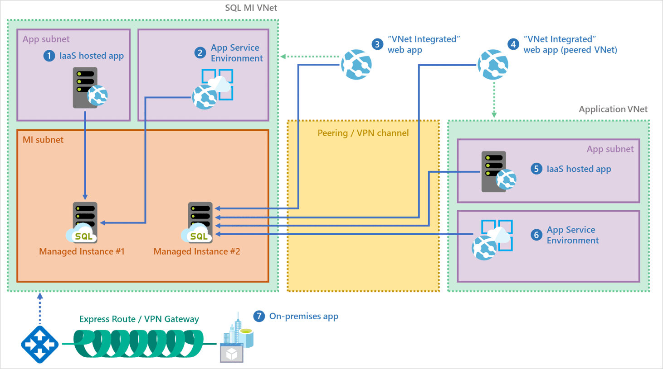
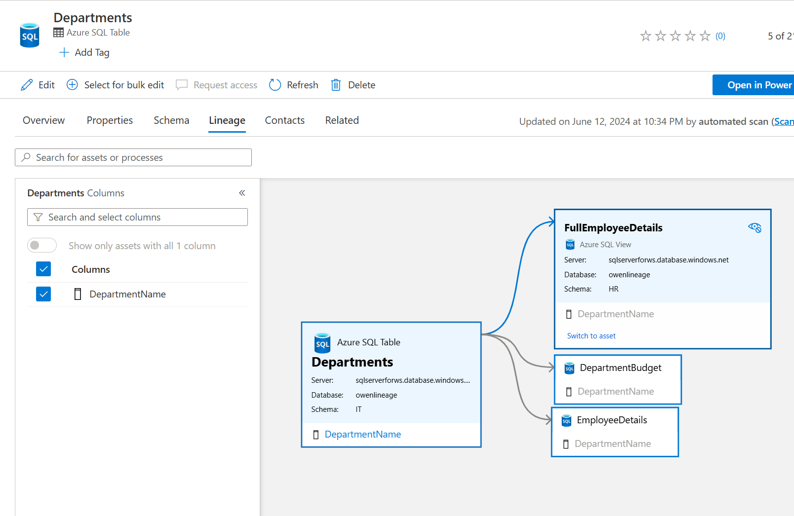
4
Scope Definition (Very Important)
Data Governance for Azure SQL Managed Instance (MI) applies to:
- Operational data stored inside the SQL engine
- Metadata, audit, and access logs generated by SQL MI
- Data extracted from SQL MI into enterprise platforms (e.g. reports, files, APIs)
Governance is layered and not centralized in a single service.

1. Data Classification (SQL MI Layer)
What is governed
- Tables, schemas, columns, and views containing business data
- Especially PII, PCI, financial, or customer-identifiable attributes
How it is governed
- SQL column-level classification using built-in SQL metadata
(e.g. sys.sensitivity_classifications)
- Classification labels aligned to enterprise taxonomy:
  - Public
  - Internal
  - Confidential
  - Strictly Confidential
Enforcement
- Classification is informational but mandatory
- Used to:
  - Drive audit policy
  - Trigger downstream controls in Microsoft Purview
  - Support regulatory reporting
Ownership
- Application / DB Team defines and maintains classifications
- Data Governance Office approves taxonomy

2. Data Access Governance (Identity & Authorization)
Authentication
- Primary authentication via Microsoft Entra ID
- SQL authentication allowed only for:
  - System/service accounts
  - Approved break-glass scenarios
Authorization
- Access granted at least privilege:
  - Database roles
  - Schema-level permissions
  - No direct table access for users where avoidable
Controls
- No public endpoints
- Private VNet access only
- Conditional Access enforced at identity layer
- Privileged access via PIM / CyberArk (where applicable)
Governance Rule
Human interactive access to production SQL MI is restricted and time-bound.

3. Data Encryption & Key Management
Encryption at Rest
- Transparent Data Encryption (TDE) enabled by default
- Customer-Managed Keys (CMK) via Azure Key Vault when required by policy
Encryption in Transit
- TLS 1.2+ enforced
- No unencrypted connections allowed
Key Governance
- Key rotation, revocation, and access logging enforced via Key Vault
- Separation of duties:
  - DB teams → data
  - Security / Crypto team → keys

4. Backup, Restore & Data Retention (Database Layer)
What Azure SQL MI governs
- Full, differential, and transaction log backups
- Point-in-Time Restore (PITR)
What it does NOT govern
- Business record retention
- Legal holds
- Archival compliance
Retention Policy
- Short-term backup retention: 7–35 days
- Long-term retention (if enabled): per regulatory need
Key Governance Statement
SQL backups are a resilience mechanism, not a records management solution.

5. Auditing & Monitoring (Database Activity)
Audited Events
- Login attempts
- Permission changes
- DDL operations
- Data access (where required)
Log Destination
- Azure Monitor / Log Analytics
- Forwarded to SIEM (e.g., Splunk / Sentinel)
Governance Purpose
- Security investigations
- Compliance evidence
- Forensic analysis
Responsibility
- Security Operations monitors
- DB team remediates findings

6. Data Export & Downstream Governance (Critical Boundary)
Key Rule
Once data leaves Azure SQL Managed Instance, SQL governance ENDS and enterprise information governance BEGINS.
Examples
Data Movement | Governance Owner
SQL → Power BI | Purview / M365
SQL → Excel | Purview DLP
SQL → API | Application controls
SQL → Data Lake | Data Platform governance
Mandatory Controls
- Exported data must:
  - Inherit original classification
  - Be labeled in M365 / Purview
  - Respect DLP and sharing policies

7. Data Residency & Domiciling
SQL MI Controls
- Data stored in selected Azure region only
- Backups stored in paired geography
Enterprise Rule
- SQL MI region must align with:
  - Regulatory domicile
  - Tenant geo strategy
- Cross-region replication requires DPO/CSO approval

8. Data Lifecycle & Decommissioning
End-of-Life Controls
- Secure deletion of databases
- Key revocation (CMK)
- Backup expiry verification
Audit Requirement
- Evidence of data destruction retained
- Logged approval for decommissioning

RACI – Data Governance for Azure SQL MI
Area | Owner
Data classification | Application / DB Team
Encryption & keys | Security / Crypto
Access & identity | IAM / Entra Team
Audit & monitoring | SecOps
Retention & legal hold | Legal / Compliance
Exported data governance | M365 / Purview

SADR-Ready Governance Statement (Final)
Azure SQL Managed Instance enforces data governance at the database layer through identity-based access, encryption, auditing, backup, and classification metadata. Governance responsibility is clearly bounded: SQL MI governs operational data integrity and security, while enterprise platforms govern information lifecycle once data is exported or consumed. This layered governance approach ensures regulatory compliance, traceability, and controlled data usage without duplicating responsibilities across platforms.

If you want, I can next:
- Map this exactly to your GCP Cloud SQL governance section (side-by-side)
- Produce a 1-page EA Data Governance diagram
- Convert this into formal policy language with MUST / SHOULD / MAY controls

