1:1 Tutoring Helping Your Child Excel Anywhere
Experience personalized learning through live sessions with our expert tutors, designed exclusively to address a child’s academic needs.

- ABOUT US:
Expert help and personalised live online training for kids all over the world.
Our personalized coaching Improve your child's academic performance with customised 1-on-1 live sessions that fulfils to their particular learning preferences.
- Personalized coaching
- 55 Minute Sessions Aligned to Their School Curriculum
- Flexible Scheduling to Fit Busy Family Life
- Real-time doubt clearing
- 24/7 support system
--------------------------------------------------------------------------------------------
OUR SERVICES
Services We Provide
Clear concepts. Confident students. Higher scores — with our personalized online tutoring that adapts to you.

01 Personalized Learning Plans
Every student learns differently — that’s why we create personalized study plans that match their strengths, improve weaknesses, and accelerate results.
02 Expert & Qualified Tutors
Our expert subject-specialist tutors who simplify complex topics through clear explanations, practical examples, and step-by-step guidance.

03 Interactive Live Classes
Engaging live sessions with real-time doubt solving, interactive discussions, and regular assessments keep students actively involved in learning.

04 Regular Tests & Performance Tracking
Smart progress tracking through weekly tests, assignments, and detailed reports to help students continuously improve and stay ahead.

-----------------------------------------------------------------------------------------------------------------------

HOW DO WE
Unlock Every Student’s True Potential?
We believe every student has the potential to excel. Our expert tutors combine personalized study plans, interactive learning, and continuous progress tracking to help students understand deeply, learn confidently, and achieve their best results.
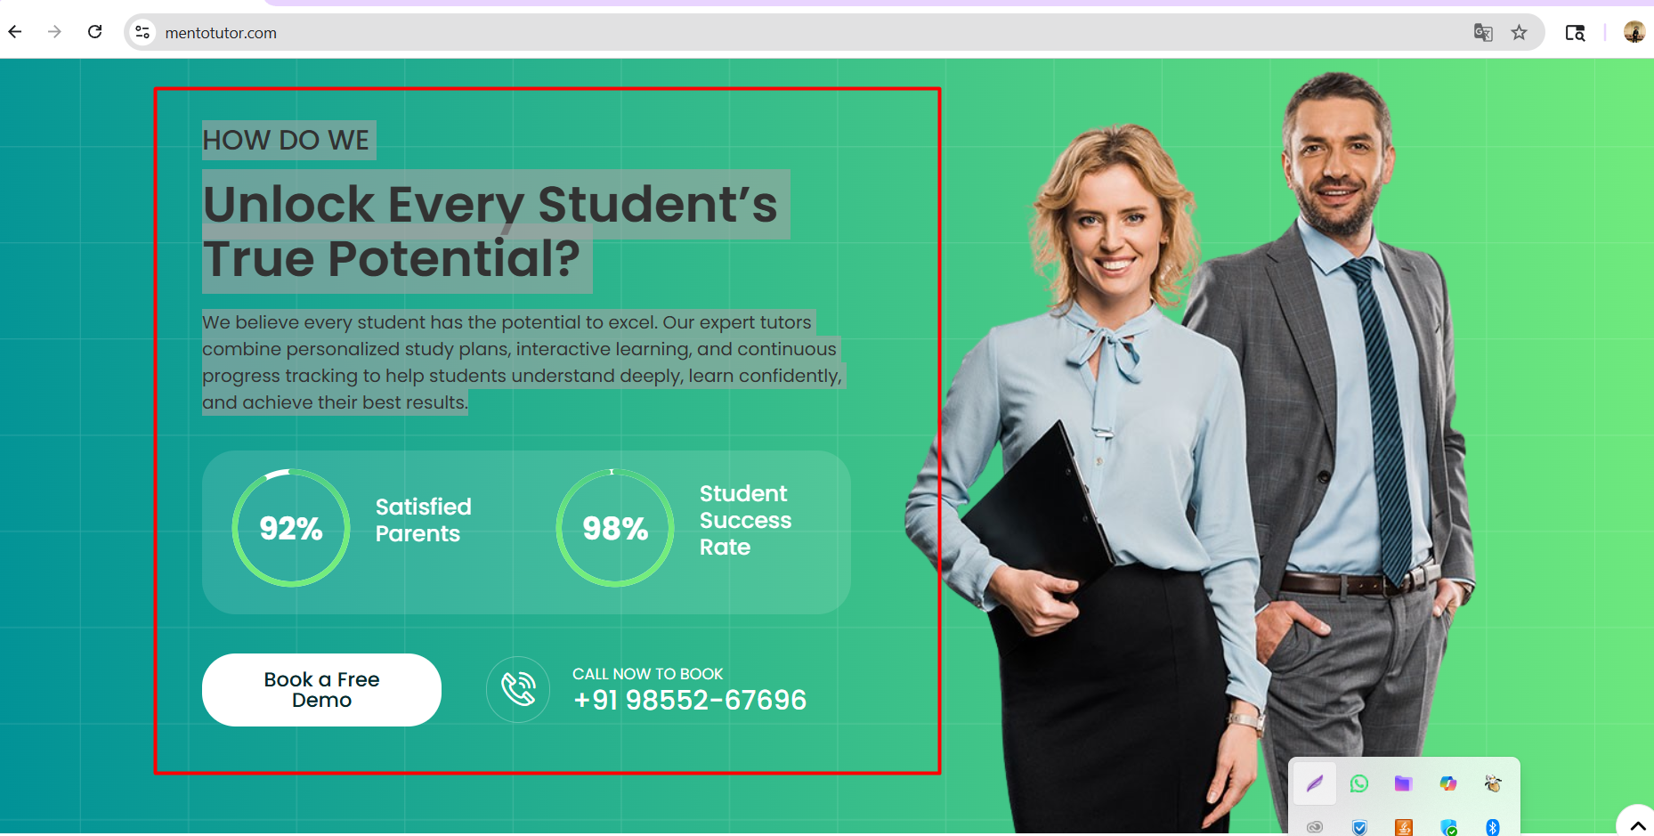

Our Student's Review
Discover real feedback from students who achieved better grades and confidence through our personalized, expert tutoring support.
