**SmartSDLC – AI-Enhanced Software Development Lifecycle**

***Generative AI with IBM***

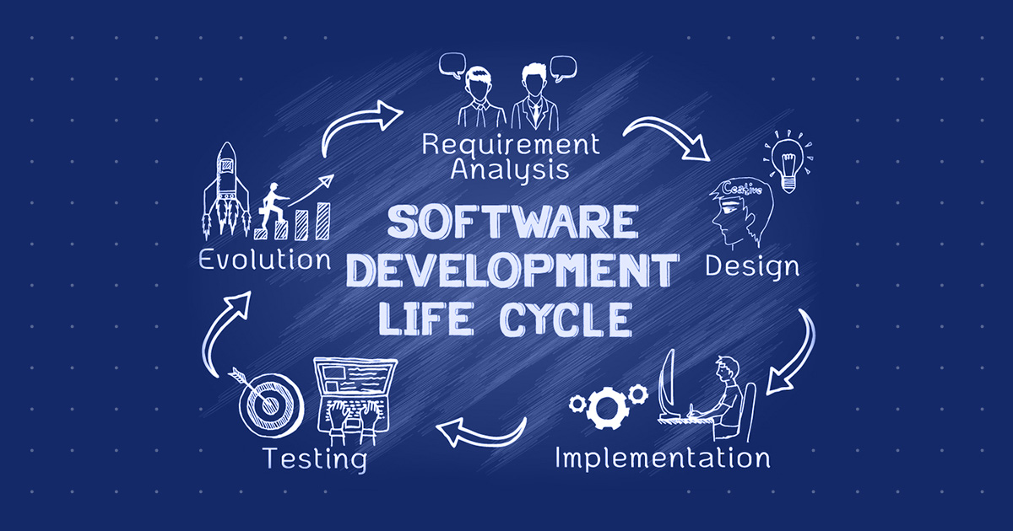

**Project Description:**

SmartSDLC uses the Granite model from Hugging Face to speed up software development. It lets users upload PDFs, generate clear requirements, turn prompts into code, create tests, fix bugs, write docs, and chat with an AI helper. This project will be deployed in Google Colab using Granite for easy setup and reliable performance.

**Pre-requisites:**

1. Gradio Framework Knowledge: Gradio Documentation

2. IBM Granite Models (Hugging Face): IBM Granite models

3. Python Programming Proficiency: Python Documentation

4. Version Control with Git: Git Documentation

5. Google Collab’s T4 GPU Knowledge: Google collab

**Project Workflow:**

Step1: To write a code for SmartSDLC in GoogleColab.

Step2: Choosing a IBM Granite Model From Hugging Face.

Step3: Running Application In Google Colab.

*.Open Google Colab and save it as SmartSDLC.ipynb and open a new notebook in Google Colab

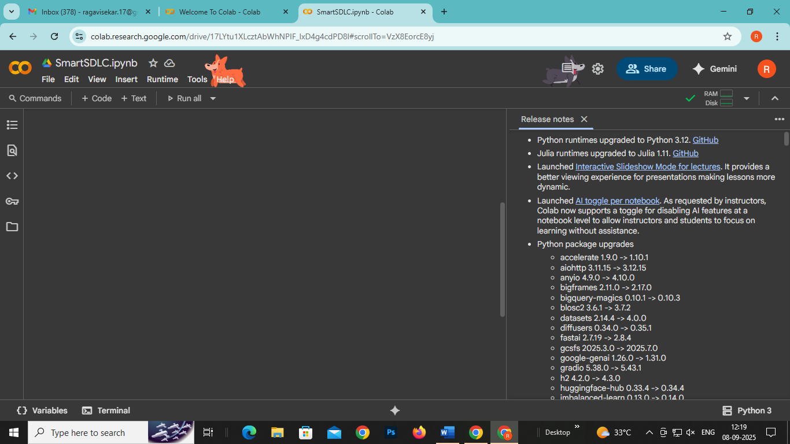

● Search for “Hugging face” in any browser.

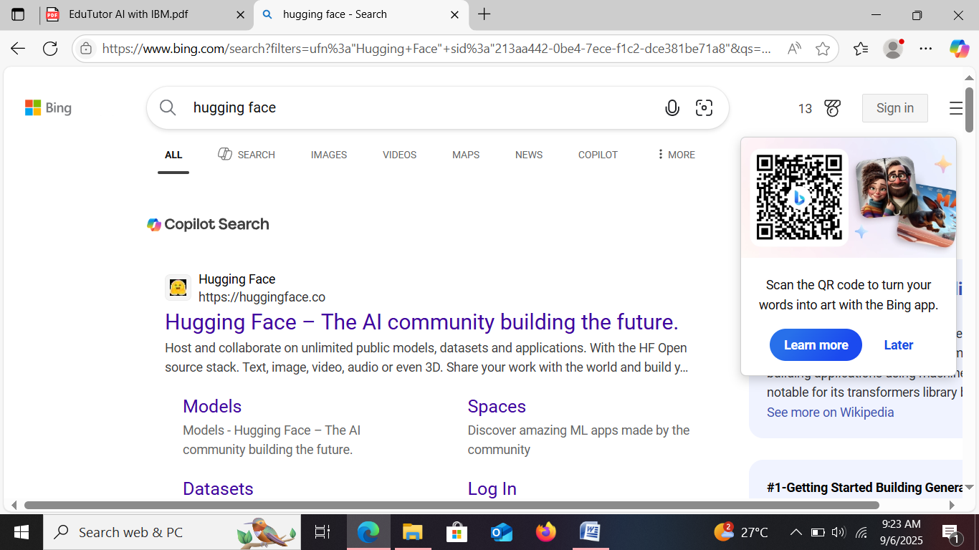

● Then click on the first link (Hugging Face), then click on signup and create your own account in Hugging Face. Then search for “IBM-Granite models” and choose any model.

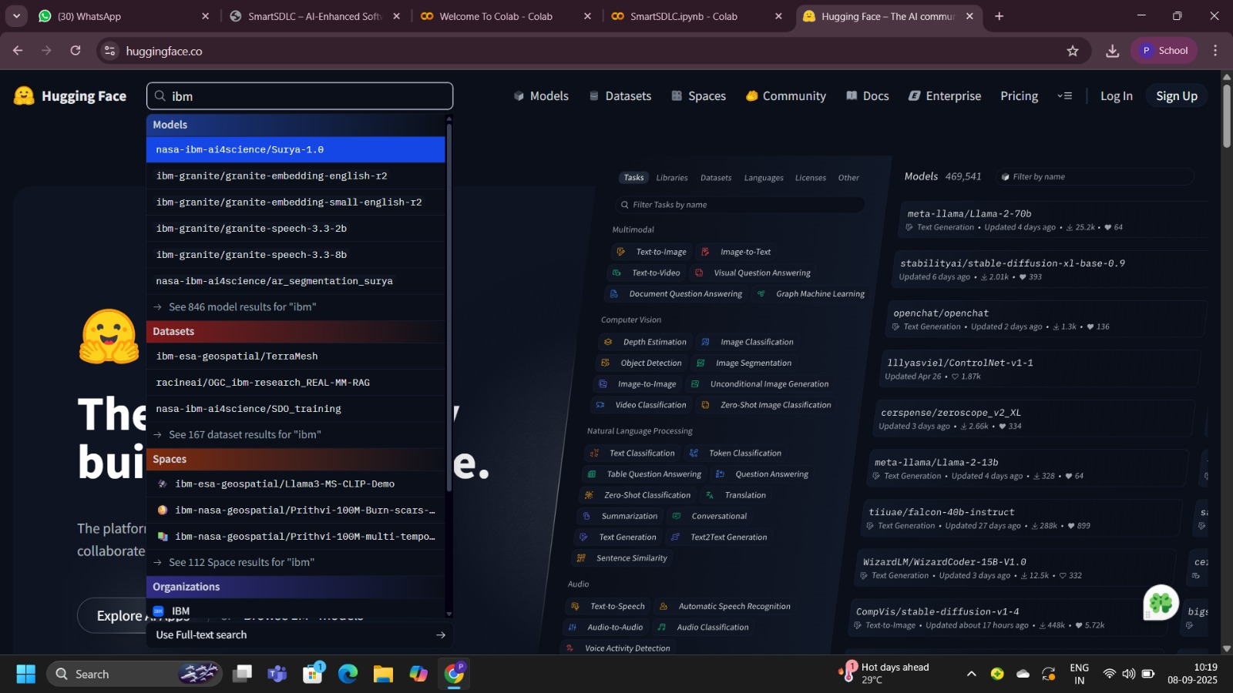

● Here for this project we are using “granite-3.2-2b-instruct” which is compatible fast and light weight.

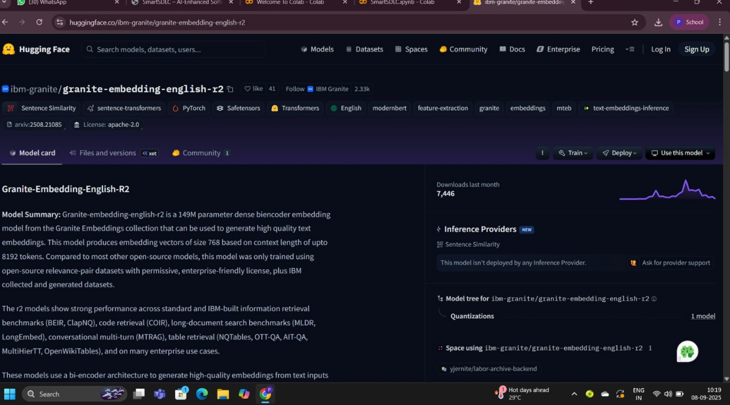

● Now we will start building our project in Google collab.

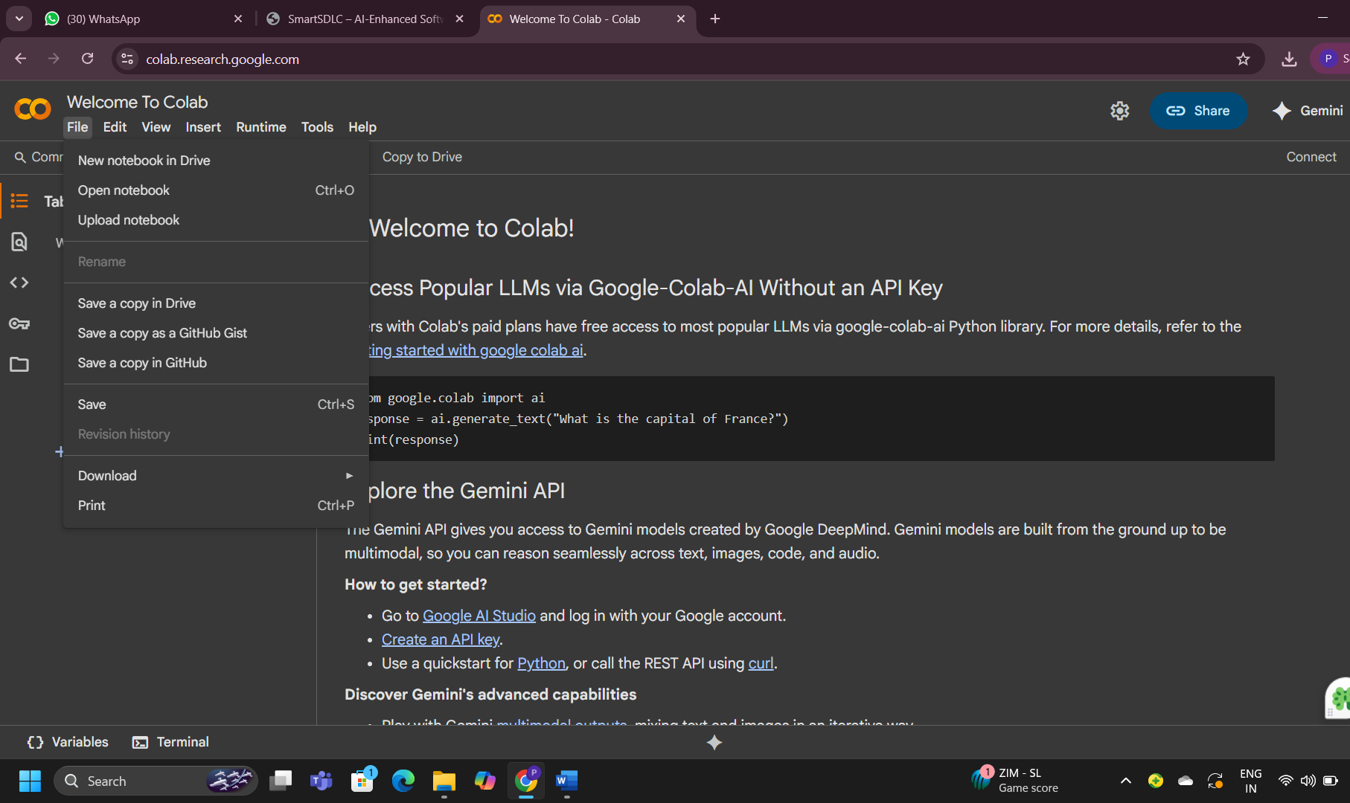

*.Choose “T4 GPU” and click on save.

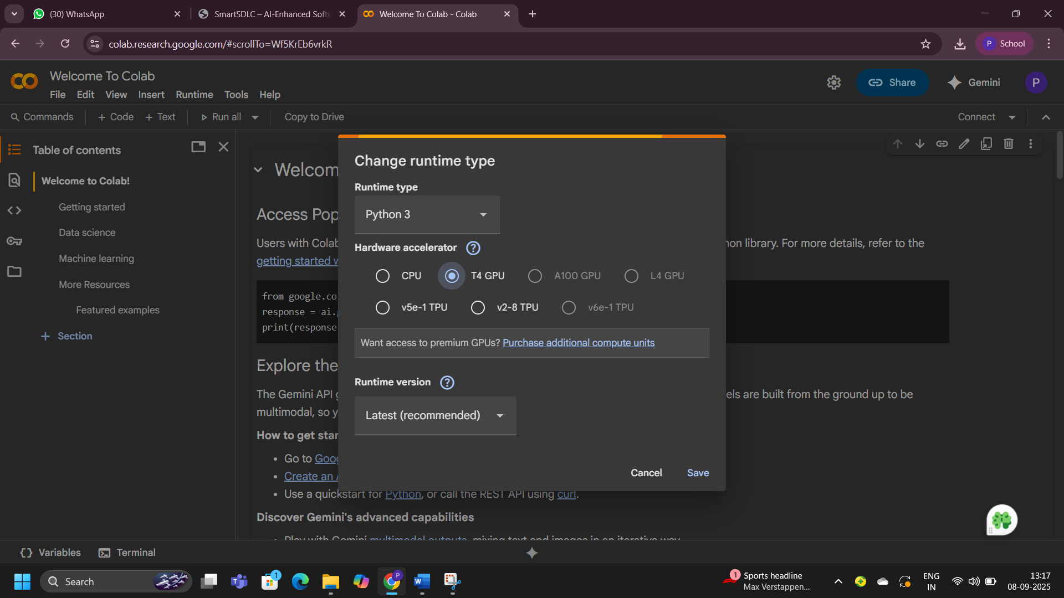

●Then start doing the code for “SmartSDLC”.

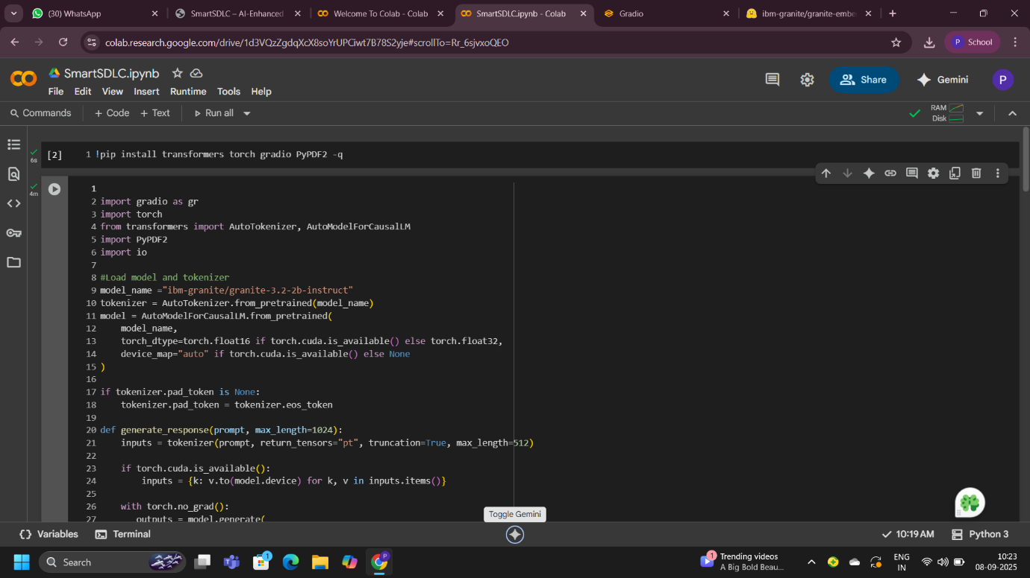

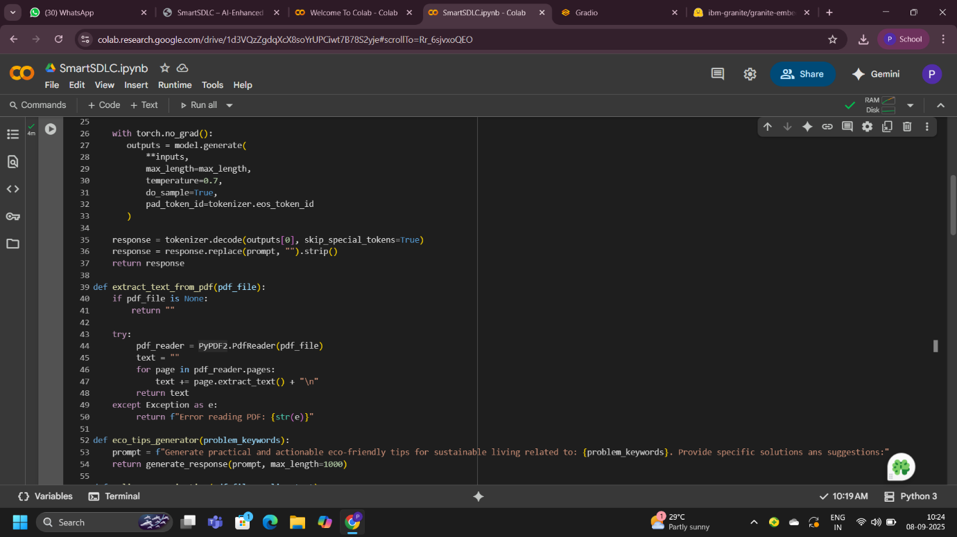

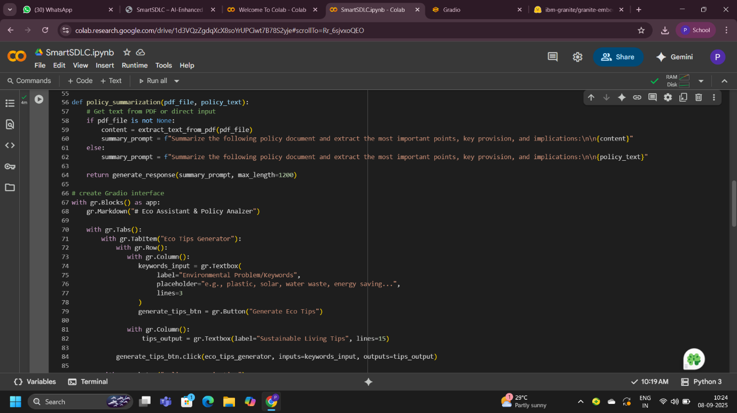

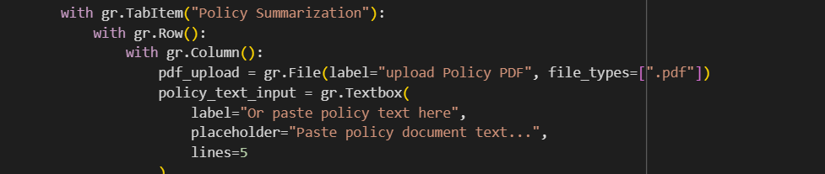

**Output:**

