# WASTE DISPOSAL MANAGEMENT SYSTEM

Narration:

The waste disposal management system is a complex and essential process that operates seamlessly across multiple locations, prioritizing the efficient and responsible handling of waste. It all starts at the source, where households produce a variety of waste, including general garbage, leftovers, and recyclables. Apartment complexes often provide designated collection points for residents to conveniently deposit their waste.

Sanitation workers, play a vital role as they collect the waste from homes and transport it to a central collection point using specialized trucks. At this central hub, waste is sorted independently into different categories. Recyclable materials, such as paper, plastic, glass, and metal, are separated for recycling. Meanwhile, organic waste, which includes food scraps is set aside for composting. Non-organic waste is categorized for further processing.

The sorted recyclable materials are then sent to recycling facilities for processing, where they undergo various methods to be transformed into usable materials. The organic waste goes through a composting process, ultimately resulting in nutrient-rich compost that can enrich soil and support sustainable agriculture. Non-organic waste is subjected to specialized methods.

Throughout this intricate process, waste management authorities play a pivotal role in ensuring compliance with environmental regulations. They monitor waste quantities, emissions, and responsible waste disposal practices to safeguard the environment and the well-being of the community.

There are 4 types of drawing:

1. Use case:

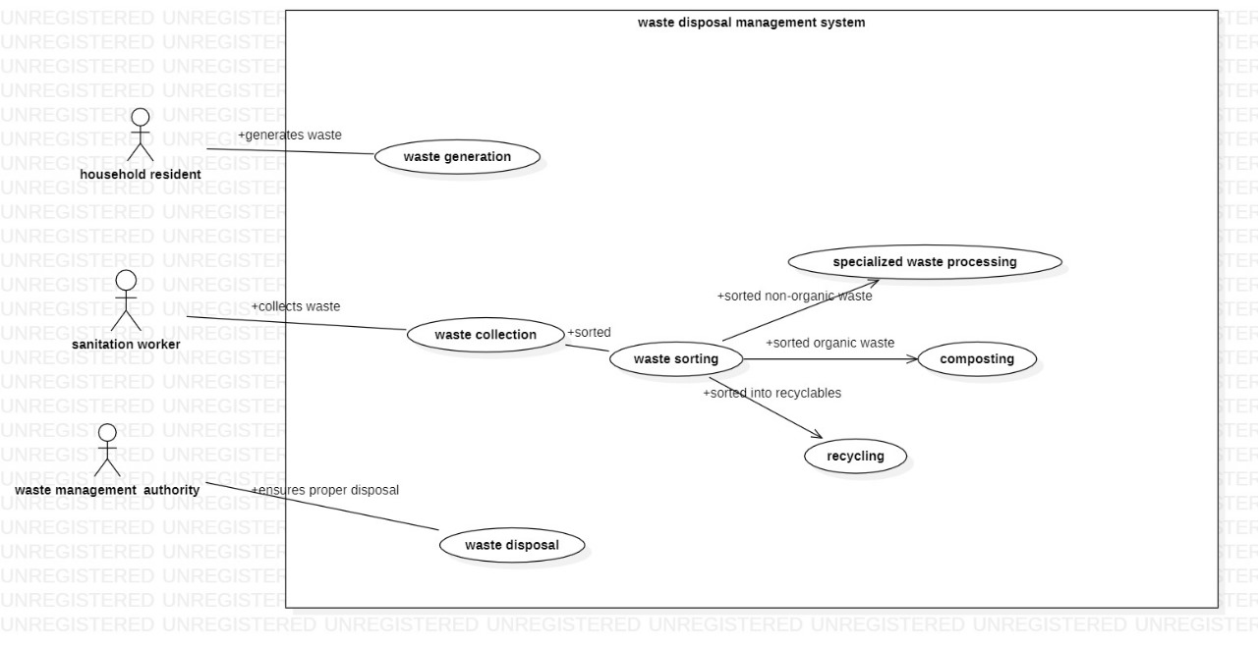

2.  
Class diagram:  
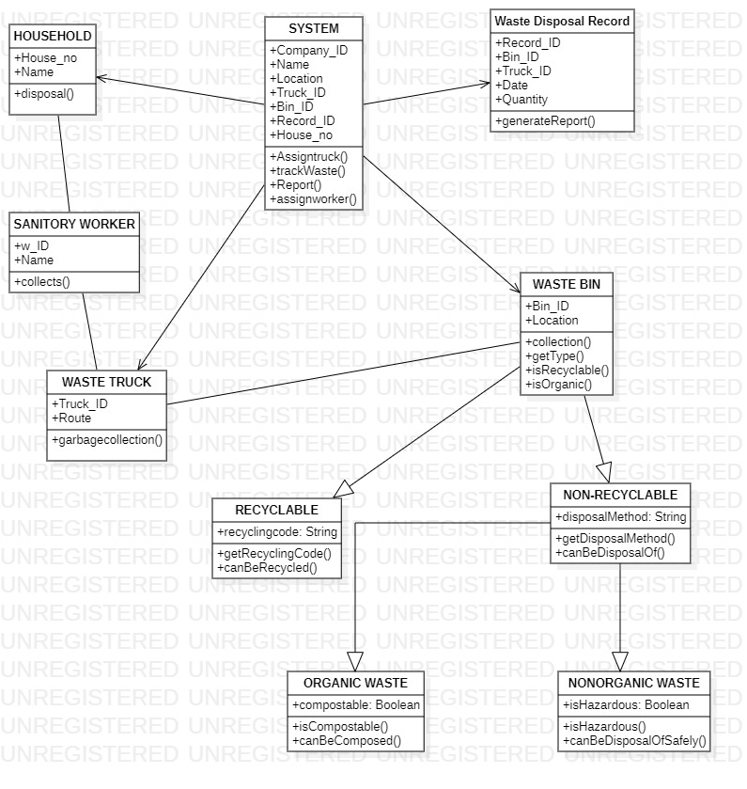

3.  
Time Sequence diagram:  
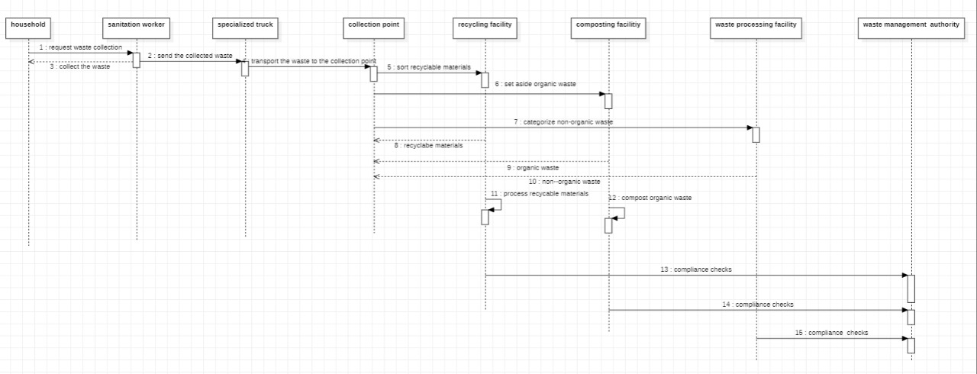

4.  
Activity diagram:  
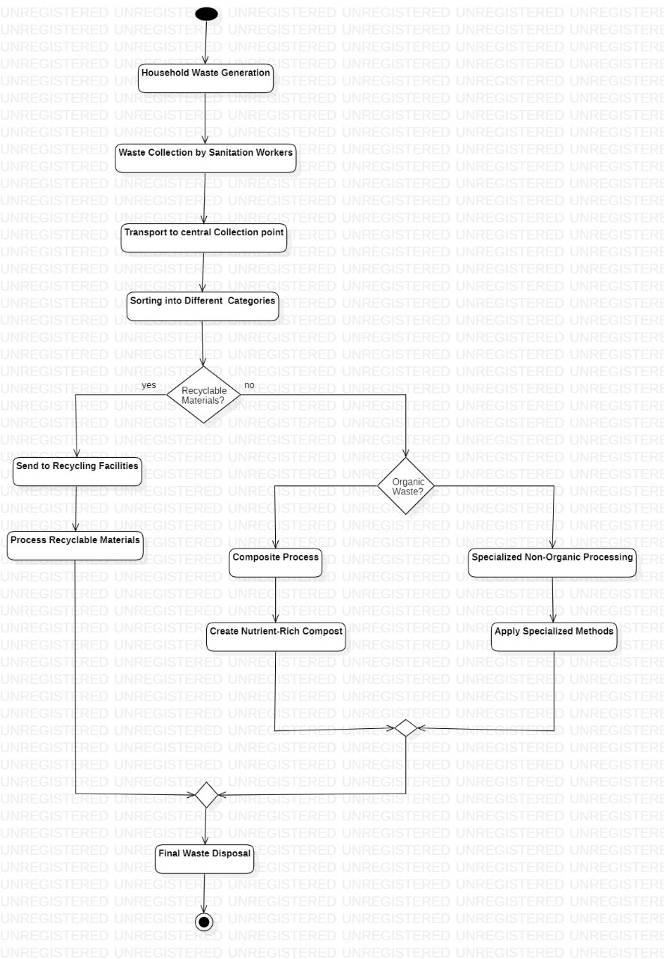

5.