1. In the below elements which of them are values or an expression? eg:- values can be integer or string and expressions will be mathematical operators.

* (Multiplication operator it’s an expression)

'hello'(String it’s an values)

-87.8( integer it’s an values )

- (Subtraction operator it’s an expression)

/ (Division operator it’s an expression)

* (Addition operator it’s an expression)

6 (integer it’s an values)

2. What is the difference between string and variable?

String: A string is any value i.e. written with the help of alphabets and placed under “ ” or ‘ ’.

Eg: “Mukesh”

Variables: These are the local instance of any data, they a used to store the data value in our memory.

Eg: a = 10 where a is the variable and 10 is the data

3. Describe three different data types.

Integer data type: It hold all the value in numerical format only without decimal point .

Eg: 1,2,4..

String data type: It hold the values in alphabets and placed in between “” or ‘’.

Eg: ‘Mukesh’ or “Mukesh”

Floating data type: It hold all the values In numerical format along with decimal points.

Eg: 125.25

4. What is an expression made up of? What do all expressions do?

An expression is nothing but a statement consists of values with variables along with datatypes. All expressions in together they perform a specific task.

5. This assignment statements, like spam = 10. What is the difference between an expression and a statement?

From the statement we can say that spam is a variable which is holding a data value i.e. 10.

6. After running the following code, what does the variable bacon contain?

bacon = 22

bacon + 1

23

7. What should the values of the following two terms be?

'spam' + 'spamspam' = 'spamspamspam'

'spam' * 3 = 'spamspamspam'

8. Why is eggs a valid variable name while 100 is invalid?

We know that whenever a variable name is assigned to a data it can only be a alphabet or string and also some special character are also allowed such as underscore (_) but numerical character are not allowed.

9. What three functions can be used to get the integer, floating-point number, or string version of a value?

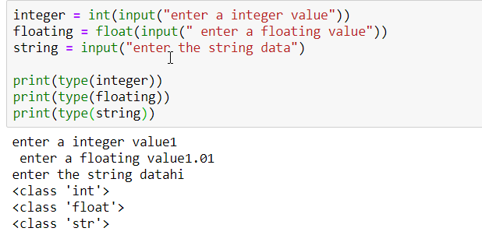

10. Why does this expression cause an error? How can you fix it?

'I have eaten ' + 99 + ' burritos.'

The above expression indicate an error i.e. TypeError: Can't convert 'int' object to str implicitly

To over come we can use strong typing casting method i.e. shown below

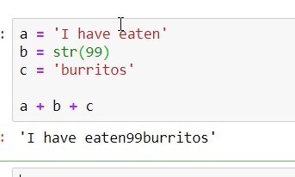

Any suggestions pls let me know: