1.What are the two values of the Boolean data type? How do you write them?

True = 1

False = 0

2. What are the three different types of Boolean operators?

AND, OR, NOT

3. Make a list of each Boolean operator's truth tables (i.e. every possible combination of Boolean values for the operator and what it evaluate).

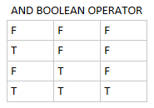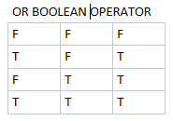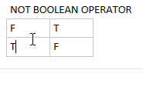

4. What are the values of the following expressions?

(5 > 4) and (3 == 5) value is False

not (5 > 4) value is False

(5 > 4) or (3 == 5) value is True

not ((5 > 4) or (3 == 5)) value Is False

(True and True) and (True == False) value is False

(not False) or (not True) value is True

5. What are the six comparison operators?

== equal to

!=not equal to

< less than

<= less than equal to

> greater than

>=greater than equal to

6. How do you tell the difference between the equal to and assignment operators?Describe a condition and when you would use one.

Equal to is the operator where is used to assign a value to the variable i.e. a = 10 and assignment operator i.e. == equal to is used to compare two values.

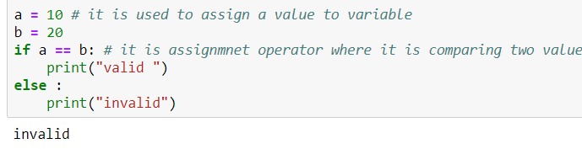

7. Identify the three blocks in this code:

spam = 0

if spam == 10: 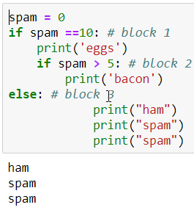

print('eggs')

if spam > 5:

print('bacon')

else:

print('ham')

print('spam')

print('spam')

8. Write code that prints Hello if 1 is stored in spam, prints Howdy if 2 is stored in spam, and prints Greetings! if anything else is stored in spam.

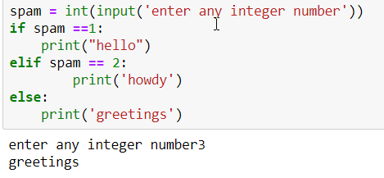

9.If your programme is stuck in an endless loop, what keys you’ll press?

In jupyter nootbook I will first click the kernel, then interrupt it and restart it again.

10. How can you tell the difference between break and continue?

Both break and continue is a keyword, the basic difference is continue will help in continuing the loop by skipping the condition whereas break will directly break the loop.

11. In a for loop, what is the difference between range(10), range(0, 10), and range(0, 10, 1)?

Every thing indicate is indexing of the data.

Difference between

range(10): sequence of numberes

range(0,10): indicate starting point and ending point

,range(0,10,1) : indicate starting point and ending point along with jump

12. Write a short program that prints the numbers 1 to 10 using a for loop. Then write an equivalent program that prints the numbers 1 to 10 using a while loop.

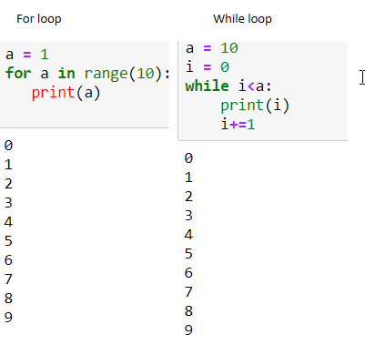

13. If you had a function named bacon() inside a module named spam, how would you call it after importing spam?