1. What exactly is []?

List function

2. In a list of values stored in a variable called spam, how would you assign the value 'hello' as the third value? (Assume [2, 4, 6, 8, 10] are in spam.)

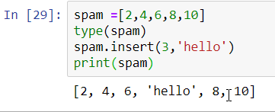

Let's pretend the spam includes the list ['a', 'b', 'c', 'd'] for the next three queries.

3. What is the value of spam[int(int('3' \* 2) / 11)]?

4. What is the value of spam[-1]?

5. What is the value of spam[:2]?

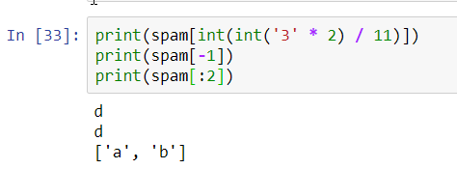

Let's pretend bacon has the list [3.14, 'cat,' 11, 'cat,' True] for the next three questions.

6. What is the value of bacon.index('cat')?

7. How does bacon.append(99) change the look of the list value in bacon?

8. How does bacon.remove('cat') change the look of the list in bacon?

Answer for all the above question is

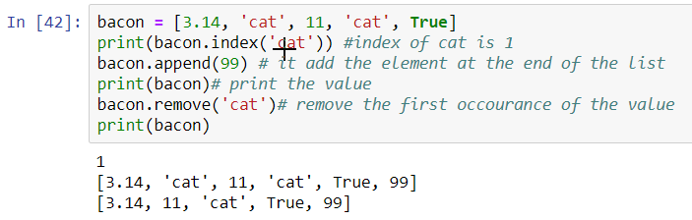

9. What are the list concatenation and list replication operators?

List concatenation is nothing but adding two different list into a single list. And replication operators is multiplication operator i.e. (\*) which is used to replicate the element.

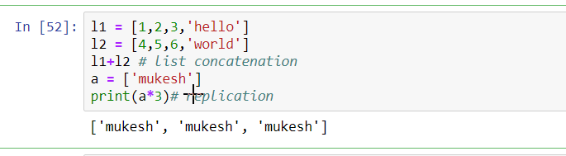

10. What is difference between the list methods append() and insert()?

Append() function will insert the data at the very ending position where as insert() function will insert the value at the desired location.

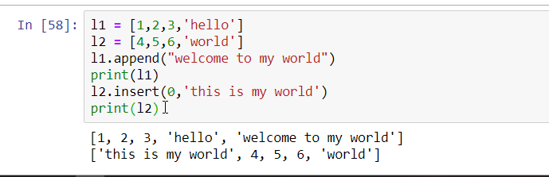

11. What are the two methods for removing items from a list?

The two method are clear() where clear will clear entire list at one shot and pop() will clear the element based on desired index.

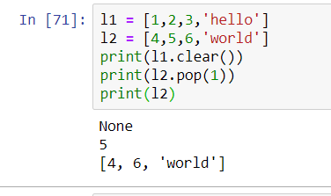

12. Describe how list values and string values are identical.

A string values is a sequence of character whereas list values are sequence of integer, character, floating point etc.

13. What's the difference between tuples and lists?

The only difference between list and tuple is the list are mutable entity whereas tuple are immutable entity.

14. How do you type a tuple value that only contains the integer 42?

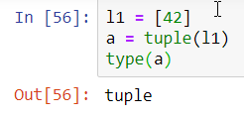

15. How do you get a list value's tuple form? How do you get a tuple value's list form?

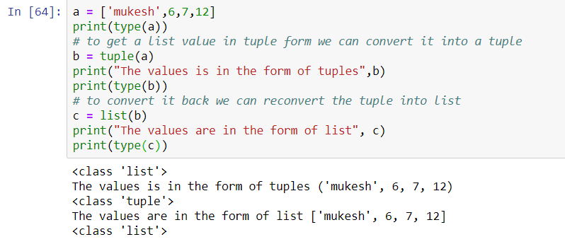

16. Variables that "contain" list values are not necessarily lists themselves. Instead, what do they contain?

Variables will contain the references to the list values.

17. How do you distinguish between copy.copy() and copy.deepcopy()?

Copy.copy() will construct a new object and will insert the reference of the object whereas copy.deepcopy() will also construct a new object and then insert copies into the object found into the original.