1. What does an empty dictionary's code look like?

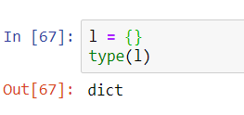

2. What is the value of a dictionary value with the key 'foo' and the value 42?

It means that ‘foo’ will act as key index for value 42

3. What is the most significant distinction between a dictionary and a list?

The most common difference between a dictionary and list is that “In list we can access the element based on index whereas in dictionary element can be accessed with the help of key.”

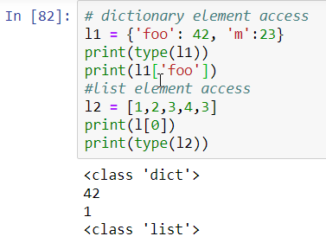

4. What happens if you try to access spam['foo'] if spam is {'bar': 100}?

It will indicate an error ‘foo’

5. If a dictionary is stored in spam, what is the difference between the expressions 'cat' in spam and 'cat' in spam.keys()?

spam = {'cat': 'dog', 'pet': 'cat'}

from the above statement we can see that one 'cat' act as key to the value 'dog ' and the other 'cat' will act as value to key 'pet' and the statement spam.keys() will print all the keys present

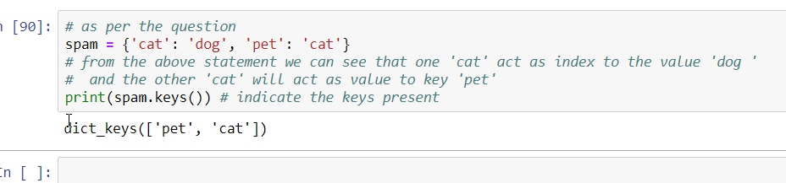

6. If a dictionary is stored in spam, what is the difference between the expressions 'cat' in spam and 'cat' in spam.values()?

spam = {'cat': 'dog', 'pet': 'cat'}

from the above statement we can see that one 'cat' act as key to the value 'dog ' and the other 'cat' will act as value to key 'pet' and the statement spam.values() will print all the values present

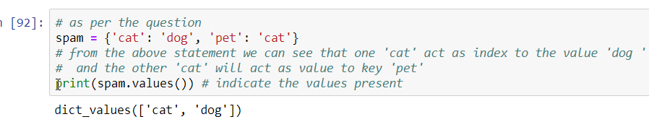

7. What is a shortcut for the following code?

if 'color' not in spam:

spam['color'] = 'black'

8. How do you "pretty print" dictionary values using which module and function?