1. What are escape characters, and how do you use them?

The escape character are [\\(backslash)](file:///\\(backslash)) , \n(newline), \r(carriage return), \t(tab), \b (back space)

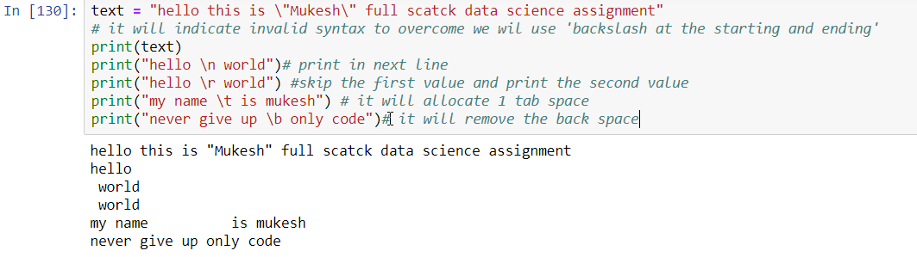

2. What do the escape characters n and t stand for?

N stands for newline and t stands for tab

3. What is the way to include backslash characters in a string?

Forward backslash is used

4. The string "Howl's Moving Castle" is a correct value. Why isn't the single quote character in the word Howl's not escaped a problem?

According to the concept of string the given statement i.e. "Howl's Moving Castle" correct as the entire string is into “double quotes” the interpreter will understand that the entire string is in “double quotes” and will execute it.

5. How do you write a string of newlines if you don't want to use the n character?

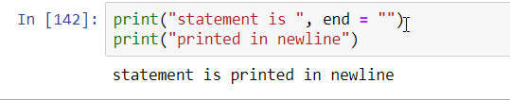

6. What are the values of the given expressions?

'Hello, world!'[1] = e

'Hello, world!'[0:5] = Hello

'Hello, world!'[:5]= Hello

'Hello, world!'[3:] = lo, world!

7. What are the values of the following expressions?

'Hello'.upper() = HELLO

'Hello'.upper().isupper() = True {check the condition is in upper case}

'Hello'.upper().lower() = hello

8. What are the values of the following expressions?

'Remember, remember, the fifth of July.'.split() = ['Remember,', 'remember,', 'the', 'fifth', 'of', 'July.']

'-'.join('There can only one.'.split()) = '-T-h-e-r-e- -c-a-n- -o-n-l-y- -o-n-e-.-'-.-s-p-l-i

9. What are the methods for right-justifying, left-justifying, and centering a string?

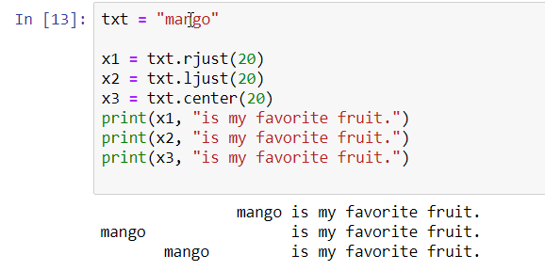

10. What is the best way to remove whitespace characters from the start or end?

Strip() method Is best method to remove whitespace character from starting and ending.