Please explain me step by step with one example
☸️ Kubernetes in Data Pipeline — Step-by-Step Example (Hindi)
अब हम एक real telecom-style data pipeline example से समझेंगे कि Kubernetes कैसे use होता है।
🎯 Scenario
Suppose Comcast-like company daily customer data process करती है।
Requirement
Daily:
- Customer data SQL Server से आए
- Spark process करे
- S3 में store हो
- Airflow schedule करे
- Kubernetes सब manage करे

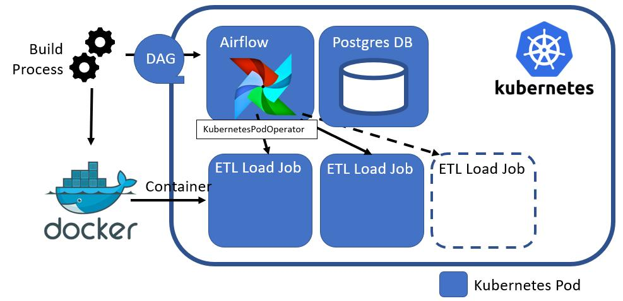
🏗️ Final Architecture

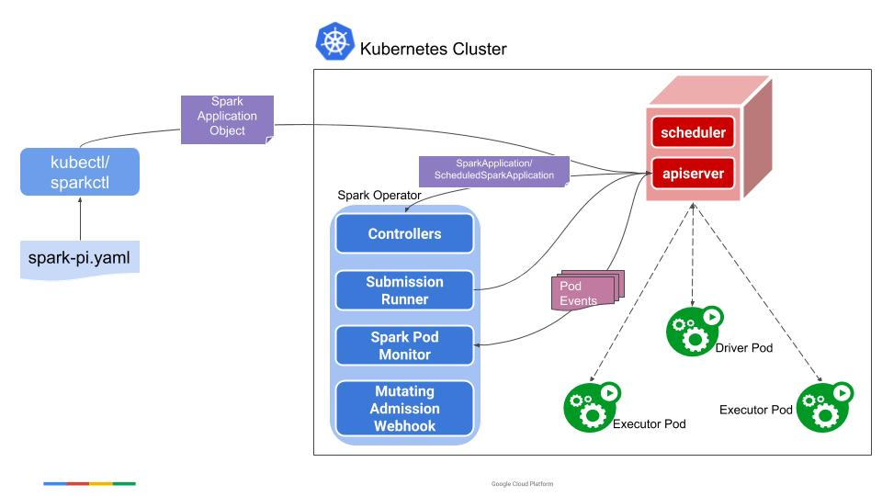

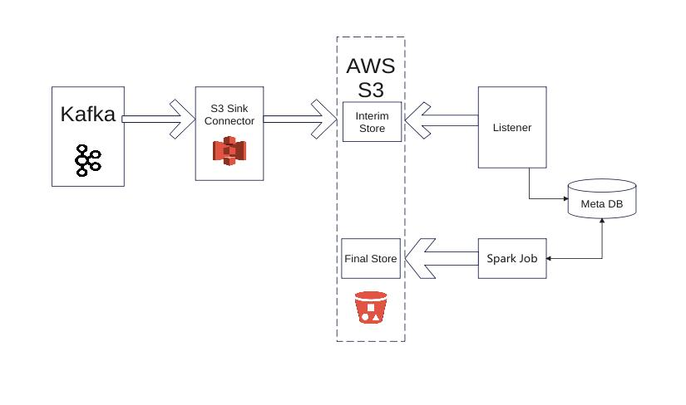

SQL Server
↓
Airflow DAG
↓
Kubernetes Pod
↓
Spark Job
↓
Transform Data
↓
AWS S3
↓
Hive Table

🧠 STEP 1 — Create Spark Application
Suppose customer data process करना है।

customer_etl.py
from pyspark.sql import SparkSession
spark = SparkSession.builder.appName("customer-etl").getOrCreate()
df = spark.read.csv("/data/customer.csv", header=True)
filtered_df = df.filter(df["status"] == "ACTIVE")
filtered_df.write.mode("overwrite").parquet("s3://telecom-data/gold/customer/")
print("Spark job completed")
📌 What This Job Does
✅ Reads customer data
✅ Filters ACTIVE customers
✅ Stores output into S3

🧠 STEP 2 — Create Dockerfile
अब Spark app को container बनाना है।

Dockerfile
FROM apache/spark-py:v3.5.0
COPY step1_spark_job.py /app/
CMD ["spark-submit", "/app/step1_spark_job.py"]
📌 Meaning
Docker image में:
- Spark runtime
- Python code
- Dependencies
सब package हो गए।

🧠 STEP 3 — Build Docker Image
Command:
docker build -t telecom-customer-etl .

📌 Result
Docker image create हो गई:
telecom-customer-etl

🧠 STEP 4 — Push Image to Registry
Example:
- Docker Hub
- AWS ECR

Command
docker push telecom-customer-etl

📌 Why?
Kubernetes image वहीं से download करेगा।

🧠 STEP 5 — Create Kubernetes Deployment
अब Kubernetes को बोलेंगे:
👉 “इस image को run करो”

spark-deployment.yaml
apiVersion: apps/v1
kind: Deployment

metadata:
name: customer-etl

spec:
replicas: 2

selector:
matchLabels:
app: customer-etl

template:
metadata:
labels:
app: customer-etl

spec:
containers:
- name: customer-etl-container
image: telecom-customer-etl:latest
📌 Important Meaning
Line | Meaning
replicas: 2 | 2 containers run होंगे
image | Docker image
Deployment | Kubernetes management

🧠 STEP 6 — Deploy to Kubernetes
Command:
kubectl apply -f spark-deployment.yaml

📌 What Happens?
Kubernetes:
✅ Creates pods
✅ Pulls Docker image
✅ Starts Spark job

🧠 STEP 7 — Kubernetes Creates Pods
customer-etl-pod-1
customer-etl-pod-2
Pods = Running containers.

📌 If Pod Crashes?
Kubernetes automatically:
- restarts pod
- creates new pod
👉 Auto-healing.

🧠 STEP 8 — Airflow Triggers Kubernetes Job
अब scheduler चाहिए।
Airflow DAG job trigger करेगा।

airflow_dag.py
from airflow import DAG
from airflow.providers.cncf.kubernetes.operators.pod import KubernetesPodOperator
from datetime import datetime

with DAG(
dag_id="customer_pipeline",
start_date=datetime(2026, 1, 1),
schedule="@daily",
catchup=False
) as dag:

run_spark = KubernetesPodOperator(
namespace="default",
image="telecom-customer-etl:latest",
name="customer-etl",
task_id="spark_k8s_job"
)
📌 What Happens?
At 10 PM daily:
Airflow DAG
↓
Creates Kubernetes Pod
↓
Runs Spark Job
↓
Stores Data in S3

🧠 STEP 9 — Data Stored in S3
Output:
s3://telecom-data/gold/customer/

🧠 STEP 10 — Hive External Table
Now business users query data.
Hive Table
CREATE EXTERNAL TABLE customer_gold (
customer_id STRING,
name STRING
)
STORED AS PARQUET
LOCATION 's3://telecom-data/gold/customer/';

🧠 STEP 11 — Query Using Presto
SELECT * FROM customer_gold;
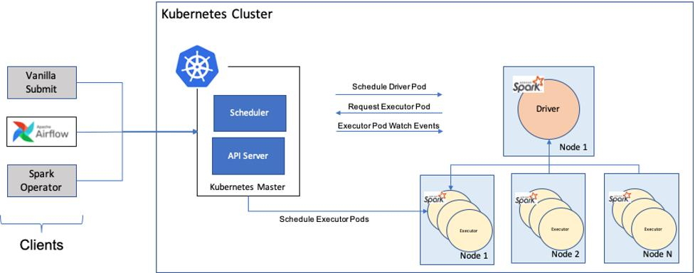
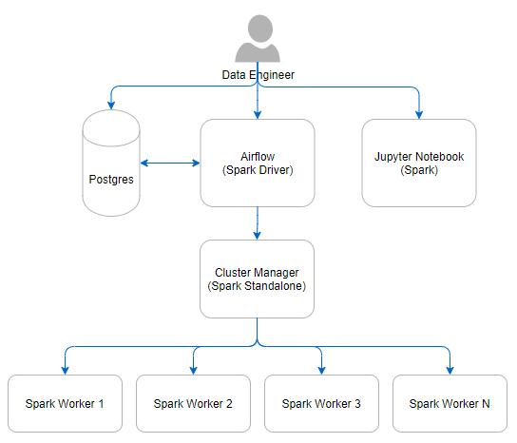
🔥 Complete End-to-End Flow

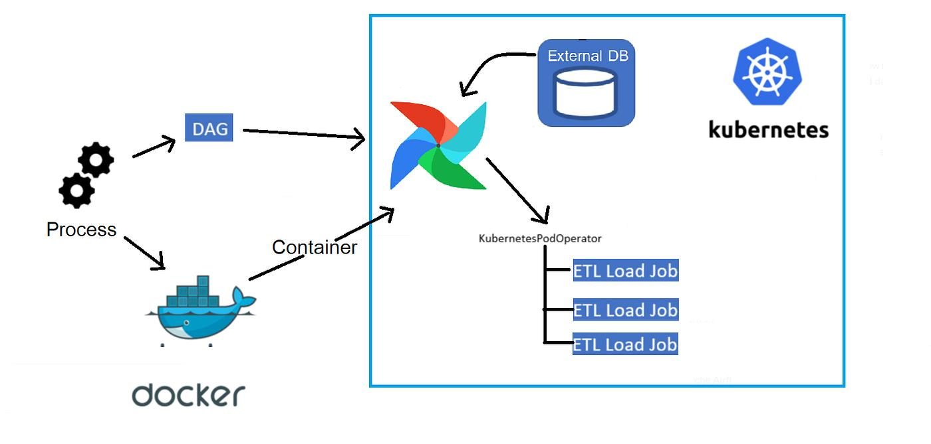

SQL Server
↓
Airflow Scheduler
↓
Kubernetes Pod
↓
Spark Processing
↓
S3 Data Lake
↓
Hive Table
↓
Presto/Tableau

☸️ Kubernetes Role in This Pipeline
Task | Kubernetes Does
Run containers | ✅
Scale jobs | ✅
Restart failures | ✅
Manage resources | ✅
Deploy applications | ✅
High availability | ✅

🧠 Real Production Benefits
Without Kubernetes:
❌ Manual server management
❌ Hard scaling
❌ Downtime risk
With Kubernetes:
✅ Auto-scaling
✅ Auto-healing
✅ Cloud-native
✅ Efficient resource usage

👨‍💻 Real Data Engineer Activities
You may:
- Check pod logs
- Restart failed jobs
- Monitor CPU/memory
- Scale deployments
- Debug Spark containers
📌 Important Commands
View Pods
kubectl get pods
View Logs
kubectl logs pod-name
Delete Pod
kubectl delete pod pod-name
Kubernetes automatically recreates it.
🎯 Final Understanding
Docker
👉 Application package करता है
Kubernetes
👉 Thousands of containers automatically manage करता है
In Data Pipeline
👉 Spark, Kafka, Airflow सब Kubernetes पर run हो सकते हैं।

README.txt
KUBERNETES DATA PIPELINE - STEP BY STEP

STEP 1:
Spark job reads customer data and filters ACTIVE customers.
STEP 2:
Dockerfile packages Spark job into container image.
STEP 3:
Kubernetes deployment runs container as pods (replicas=2).
STEP 4:
Airflow triggers Kubernetes pod daily to run ETL job.
FINAL FLOW:
SQL/Data Source -> Airflow -> Kubernetes -> Spark -> S3 -> Hive

