ls -ltr ${DIF_FTH_SBIN_DIR}/compaction_app.sh ${CST MEDALLIA_SBIN_DIR}/../config/cst_medallia_olb_eed_compact.conf
3. Prod
ssh pthnrt-edge.sdi.corp.bankofamerica.com
Commands: pbrun pbhcstpz "zscstl1p-less"
/project/haas/cst/cst_1h/app/medallia/sched/sbin/../config/compaction_cst_medallia_stg_file_to_hdp_audit.conf
Commands: pbrun pbhcstpz "zscstl1p-hadoop fs -text"
/haas/cst/cst 1h/app/medallia/compaction cst medallia stg file to hdp_audit.cfg
pbrun pbhcstpz "zscstl1p-hadoop fs -text" /haas/cst/db/cst 1h/enc/datafiles/cst 1h authhub sec/
pbrun pbhflcpz zsflcl1p-less /project/haas/flc/flc_1h/app/eeh fw/kafka streaming tier0/current/
pbrun pbhflcpz zsflcllp=1s -ltr /project/haas/flc/flc_1h/app/eeh_fw/kafka_streaming_tier0/current/
pbrun pbhcstpz zscstl1p-1s -ltr /project/haas/cst/cst_1h/app/
Links list:
1. Autosys
DEV http://amrs-autosys-d.bankofamerica.com/
UAT/SIT http://amrs-autosys-q.bankofamerica.com/
2.Hive
dcon : Dev https://dcons-hue.bankofamerica.com/hue/editor/?type=hive
ucon: UAT/SIT https://ucons-hue.bankofamerica.com/hue/editor/?type=hive
Prod https://pthnrt-hue.bankofamerica.com/hue/accounts/login?next-/hue/editor/%3Feditor 3D1229727

3. Bit Bucket
https://scm.horizon.bankofamerica.com/projects/ONEHREPO/repos/evt
https://scm.horizon.bankofamerica.com/projects/ONEHREPO/repos/<AIF>
https://scm.horizon.bankofamerica.com/projects/ONEHREPO/repos/<lh_AIF>
https://deploynp.horizon.bankofamerica.com/#/login
Beeline Login:
source/common/CDH/system/conf/EnvHadoopGlobal.sh
beeline -u $beeline connection
5.Impala Login:
source
/common/CDH/system/conf/EnvHadoopGlobal.sh
impala-shell -k-ssl-i $ImpalaVIP
5. ICD Job
pbrun pbhcstuz zscstl1u-su==> UCONS -CST
pbrun pbhicdd zsicdlld-su==> DCONS -ICD
pbrun pbhicdu zsicdllu-su==> UCONS -ICD
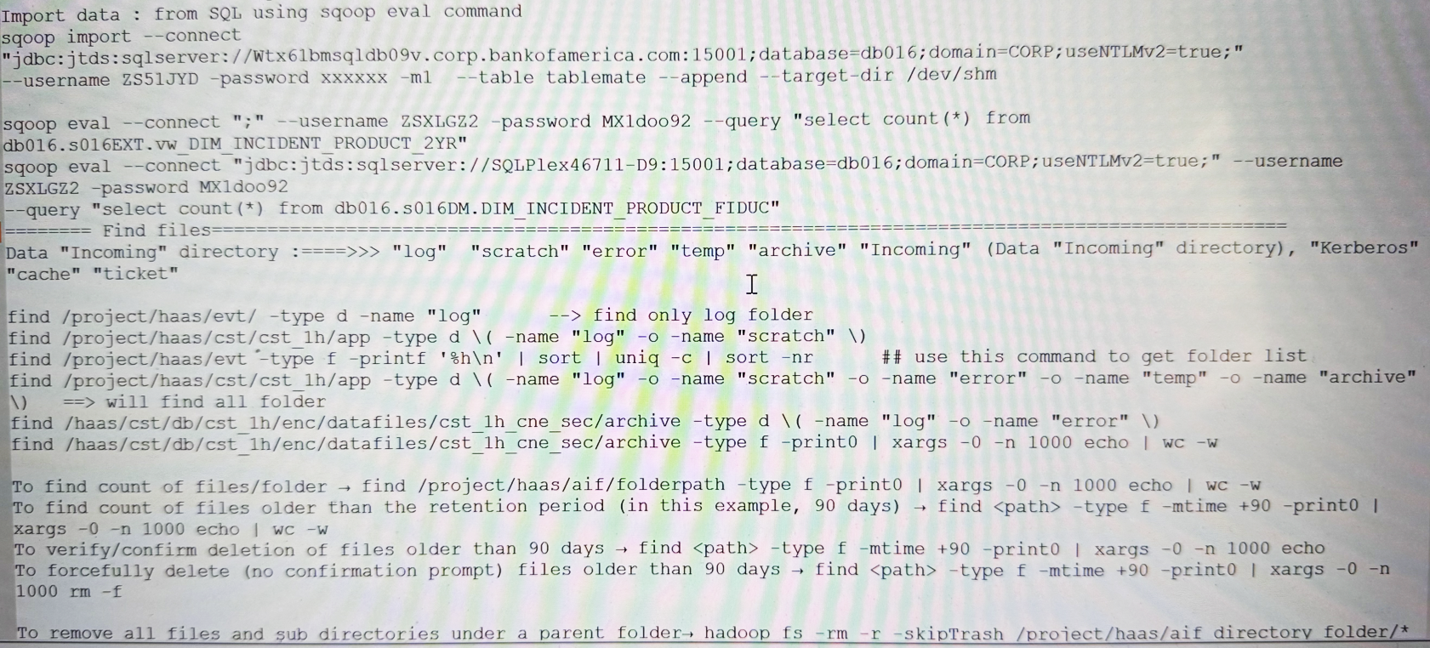
pbrun pbhicdpz zsicdl1pz-su ==> prod -ICD

