Event -1
TEAM MEMBERS:
1. Poshika Bhatnagar (12312037) - IT
2. Swati (12311060) - CSE A
3. Aniket Rajak (12312013) - IT
4. Nitish Kumar Choubey (12312031) - IT

Hackathon Details: " Hack The Winter - The Second Wave (Angry Bird Edition)
Graphic Era Hill University (GEHU), Bhimtal "

Winning Title : BEST REVENUE MODEL

Project Details :
Project Name : " Elite Engineers "
A full-stack platform that helps you discover and evaluate top software engineers using real GitHub data, AI-powered compatibility scoring, and trust metrics.
Core Capabilities:
GitHub Integration: Automatically fetch and analyze real GitHub profiles
AI Scoring: Intelligent compatibility and trust score calculations
Real-Time Data: Live integration between frontend and backend (no dummy data)
Advanced Search: Filter engineers by skills, experience, and compatibility
Side-by-Side Comparison: Compare up to 3 engineers with visual analytics
Explainable AI: Understand why each engineer is recommended."

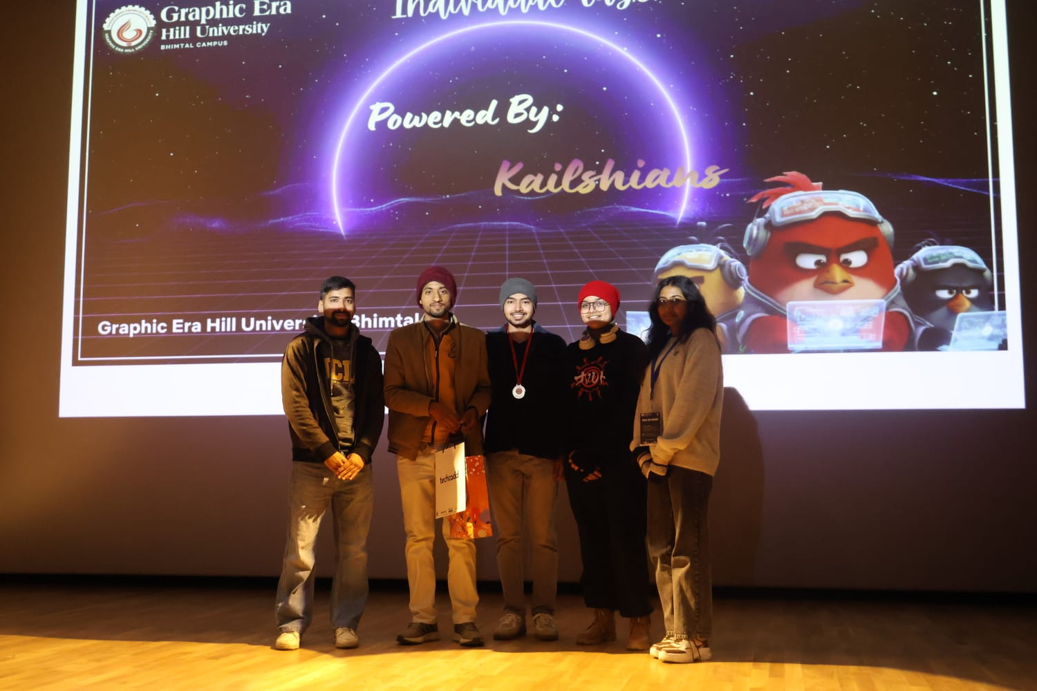

Event-2

TEAM MEMBERS:
Rohan Tewari (12412031) – IT
Siddharth Sahai (12412036) – IT
Nayan Prakash (12413042) – DSA

Hackathon Details:
Hack The Winter – The Second Wave
Graphic Era Hill University (GEHU), Bhimtal

Winning Title:
First Prize Winner

Project Details:
Project Name:
Ratelift
Description:
Ratelift is a causal inference–based problem practice platform designed to improve learning efficiency. The system analyzes learning patterns and suggests practice problems that help users focus on their conceptual gaps.

Core Capabilities:
* Learning Pattern Analysis: Identifies relationships between practice behavior and performance among many users.
* Targeted Practice Recommendation: Suggests problems based on conceptual weaknesses
* Adaptive Learning Flow: Guides users toward areas needing improvement
* Data-Driven Insights: Uses learning data to support more effective practice sessions

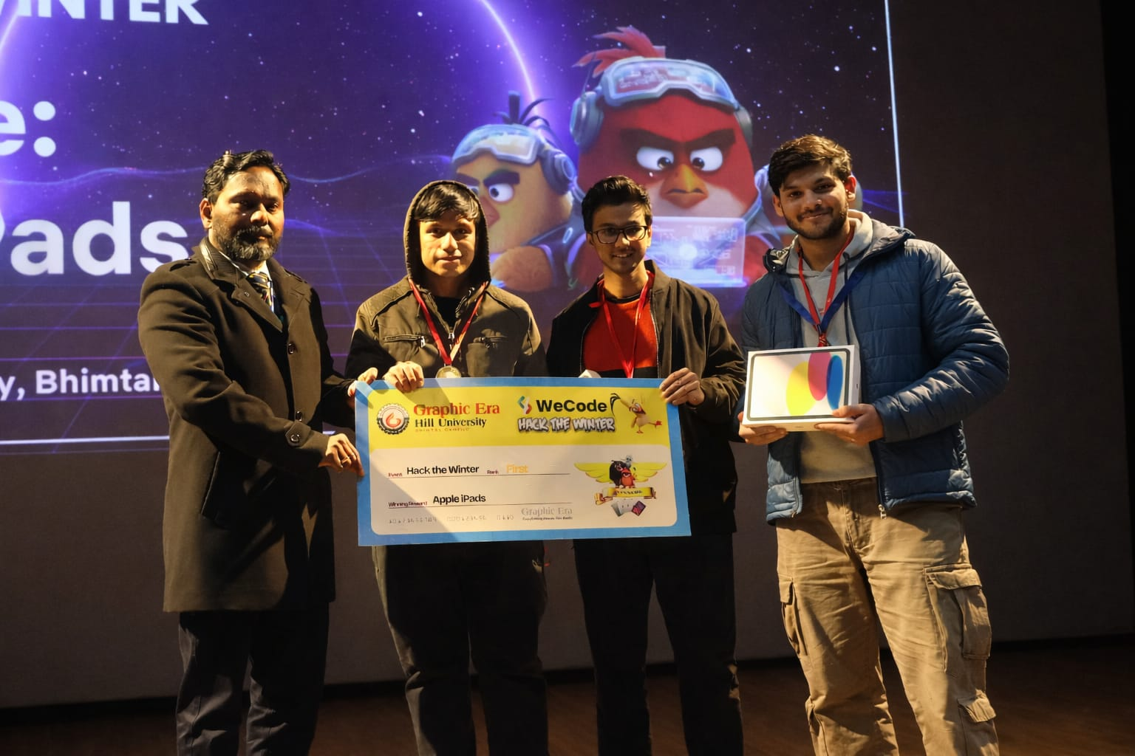

Event-3

TEAM MEMBERS:
Aditya Kumar – CSE

Kashish Nandwani (12312039) – IT

Lovish Singla – CSE

Shivansh Agrawal(12312003) – IT

Hackathon Details:
" Hack The Winter – The Second Wave (Angry Bird Edition)
Graphic Era Hill University (GEHU), Bhimtal "

Winning Title:
ZERO TO DEPLOY AWARD

Project Details:
Project Name : " FlashSeat – High-Concurrency Ticket Booking System "

A high-throughput ticket booking platform designed to handle extreme flash-sale traffic using distributed locking, async workflows, and real-time reservation management.

Core Capabilities:
Redis-based Distributed Locking: Prevents duplicate seat allocation under heavy traffic
Time-Bound Reservations: Automatically releases seats if payment is not completed
High Concurrency Handling: Designed to handle thousands of simultaneous requests
Idempotent Payment System: Prevents multiple charges for the same booking
Async Event Processing: Smooth performance during traffic spikes
Fair Allocation Logic: Ensures equal chance for users during flash sales
Scalable Backend Design: Built to support real-world event booking platforms
Revenue-Ready Architecture: Supports commission models and organizer analytics

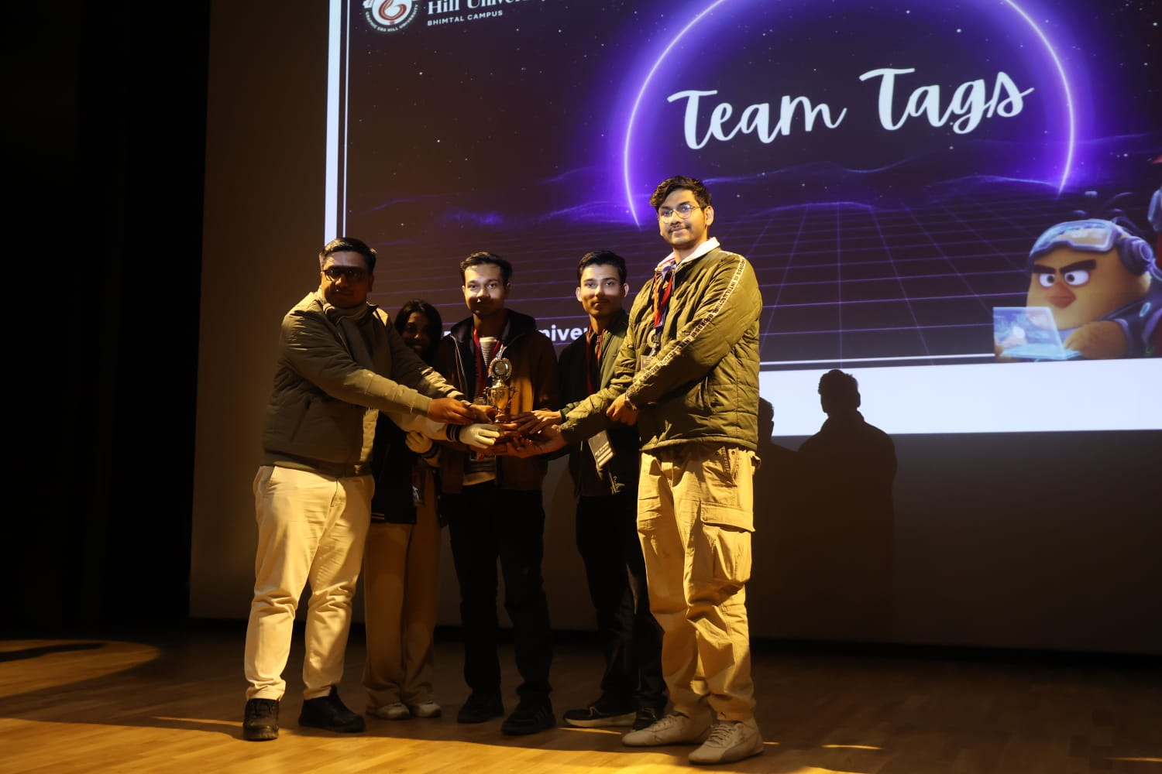

Event-4

Proud to share that Team Kanyarasi India secured 3rd Place at Bit By Bit, a 36-hour flagship National hackathon organized by IIIT Bhagalpur, winning a cash prize of ₹25,000.
🏅 Winning Title :
3rd Place – Bit By Bit Hackathon
📍 Hackathon Details :
Bit By Bit – 36 Hour Flagship Hackathon
Organized by IIIT Bhagalpur
💡 Project Details :
Project Name : "MindSight"
A complete digital mental wellness ecosystem designed to provide accessible, secure, and intelligent mental healthcare solutions.
🚀 Core Capabilities:
* SDA-Based Mental Health Assessments
Personalized mental health courses, stress-free games, and therapy recommendations based on assessment results.
* Integrated Therapist Booking System
Video / Chat / Call sessions with therapist ratings, availability tracking, and secure payment integration.
* Emotional Voice Logging
Web-based emotional journaling and a custom one-click hardware device for instant emotional recording.
* ML-Based Risk Detection System
Analyzes emotional voice recordings to detect high-risk patterns.
Automatically triggers alerts to:
Assigned therapists
Registered family members
National helplines
* Secure QR-Based Prescription System
After each session, therapists generate digital prescriptions containing:
Patient photo
Medication details
When scanned, the QR displays:
“Please hand over medicines to the person in the photo only.”
This ensures identity verification, prevents misuse, and strengthens trust in the care process.
* Full-Stack + ML + IoT Integration
Complete architecture, ML pipelines, secure workflows, and IoT integration — all built, tested, and presented within 36 hours.
👥 Team Members :
Ritheesh Reddy(cse)
Yuvan Sai Yegireddi(cse)
Charan Y(it)
Harshith Kanna(it)
Varun K R(cse)
Supradeep Reddy(cse)

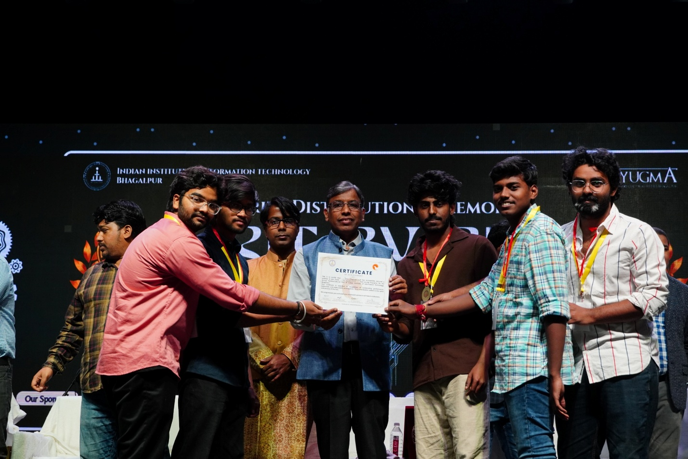

Event-5

Problem Statement Title :
Hand Held Radio Set with Satellite Personal Tracking System
📍 Hackathon Details :
Smart India Hackathon (SIH)
Problem Statement ID : SIH25255
Organization : Ministry of Home Affairs (MHA)
Department : Border Security Force (BSF)
Category : Hardware
💡 Project Details :
We developed a multi-network handheld communication and tracking device designed to assist security personnel operating in remote and challenging terrains where traditional communication systems may fail.
🚀 Core Capabilities :
* Integrated Communication and Tracking Device
Combines VHF radio communication and GPS-based location tracking into a single compact device, reducing the need to carry multiple equipment.
* Real-Time GPS Location Monitoring
Continuously tracks and transmits the exact location of field personnel during operations.
* Satellite-Based Location Transmission
When troops move beyond the VHF communication range, the device automatically sends location data using satellite communication, ensuring uninterrupted tracking.
* GSM Network Backup
In areas where cellular networks are available, the system can transmit location data via GSM, providing an additional layer of connectivity.
* Seamless Network Switching
The device intelligently switches between VHF, satellite, and GSM networks to maintain continuous communication and tracking.
* Operational Safety and Coordination
Enables command centers to monitor troop locations in real time, improving situational awareness, coordination, and response time during critical missions.
🎯 Impact :
This solution aims to enhance operational efficiency and safety for BSF personnel by integrating communication and tracking into a single reliable device, especially useful in remote border areas and challenging terrains.
👥 Team Members :
Harshith Kanna (IT)(12312004)
Yuvan Sai Y(cse)(12311049)
Ritheesh Reddy (cse)(12311025)
Y Sri Charan (it)(12312043)
E Tarun Kumar (it)(12312032)
Sai Prathiksha D(12411027)(cse)(2024-2028)

