This document will help you to setup the prerequisites for running the automation scripts for iOS and Android SDKs. It’s a one-time setup.

Step 1: Install appium:
On MAC System:

2a. Make sure your Mac system has the latest version of Xcode. Lower version will not detect the attached iPhones and iPads.

Also download and install the Xcode Command Line Tools. Go to Xcode > Preferences > Downloads > Command Line Tools
or
Execute command on terminal: xcode-select –install

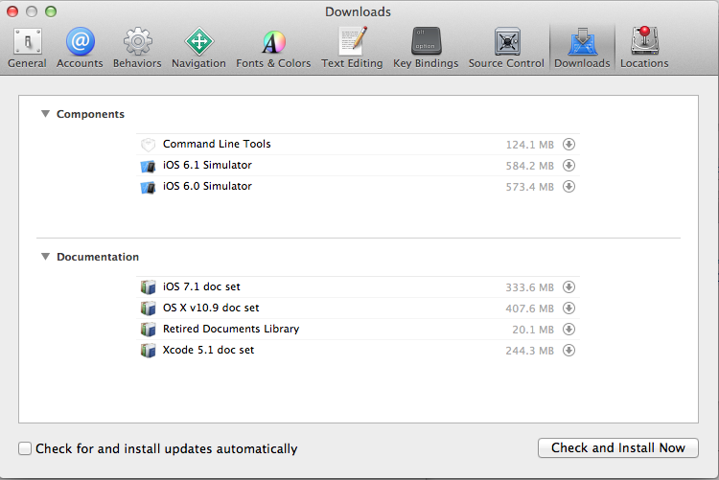

2b. Install homebrew by running this command in terminal:
ruby -e "$(curl -fsSL https://raw.githubusercontent.com/Homebrew/install/master/install)"

Just in case – uninstall brew using command:
/usr/bin/ruby -e "$(curl -fsSL https://raw.githubusercontent.com/Homebrew/install/master/uninstall)"

2c. Install node and npm by running this command in terminal:
brew install node

2d. Install appium by running this command in terminal:
npm install -g appium

2e. Download Android SDK for Mac and Windows. Setup is available at:
https://drive.google.com/a/vdopia.com/?tab=mo#folders/0B2dXTwsmn7VRbml2eXpQbWlnd2c
#1. Extract the downloaded zip file.

#2. Change the values of AndroidSDK_Windows and AndroidSDK_Mac in Config file (qaconf.properies - located at XXX/Vdopia_Automation/conf/ in your download zip) with the root directory path (in case of mac - xxx/android_sdk_mac/sdk and in case windows - xxx/android_sdk_windows/sdk ) of extracted zip.

On Windows System:

2f. Download and extract zip file - AppiumForWindows.zip from location
https://drive.google.com/a/vdopia.com/?tab=mo#folders/0B5YZvytgKlAbY0NPdUpFZk9WMGc

2g. Open command prompt and go to AppiumForWindwos directory. Run this command: npm install –g appium

2h: Update the folder location of AppiumForWindows in qaconf.properties file.

Step 3: Install iOS provisioning profile and certificate in Mac.

3a. Download and extract Vdopia_Automation_XXX.zip, go to folder XXX/Vdopia_Automation/tpt/ios_provisioning_profile.

3b. Add this Certificates.p12 to System Keychain by double clicking on it. It’ll ask your credential, enter your credential and click Modify Keychain.

3c. Add all the provided provisioning profiles: iOS_Team_Provisioning_Profile_1.mobileprovision, iOS_Team_Provisioning_Profile_2.mobileprovision and iOS_Team_Provisioning_Profile_3.mobileprovision by double clicking them.

