**Assignment-1**

1. **5G NR Architecture**

* NR refers to the radio access technology. Which is used in the 5G network.
* NR can be used in the both NSA and SA architecture.
* NR is a radio technology.

4G eNB

5G gNB

(Secondary Node)

4G EPC

(Evolved Packet Core)

* UE: - UE stand for User Equipment. And mobile device or modem connecting to the network.
* 4G eNB: - It is referred to the master node. Handle the control plane and connects to the core network.
* 5G gNB: - It is referred to the secondary node. And it is providing high speed data transfer.
* 4G EPC: - It is referred to the Evolved Packet Core. And it is managing the data and control the signals.

**Workflow: -**

* Control signal goes through 4G eNB. And the data transmission happened over the 4G and 5G.

**SBA Networking Architecture: -**

* SBA stand for the Service Based Architecture. And it is a cloud-native network design used in 5G Core (5GC) where network functions (NFs) communicate via APIs instead of traditional interfaces.
* Reduces network complexity and enhances performance.

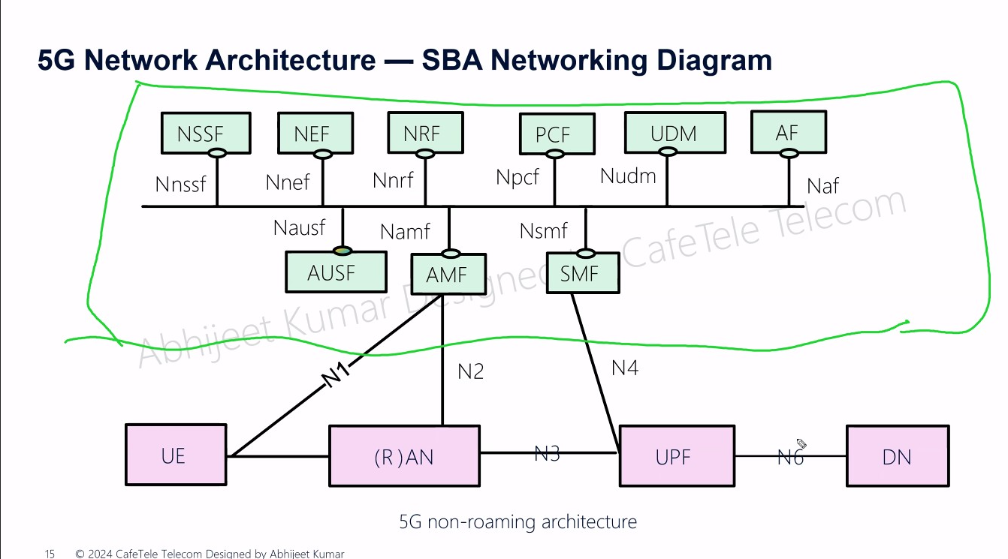

* **UE** (User Equipment): Mobile devices that connect to the network.
* **AN** (Radio Access Network): Handles radio communication between UE and core network.
* **AMF** (Access and Mobility Management Function): Manages user registration, authentication, mobility, and session control.
* **AUSF** (Authentication Server Function): Handles user authentication and security.
* **NRF** (Network Repository Function): Maintains a list of available network functions and their services.
* SMF (Session Management Function): Manages user sessions and IP address allocation.
* **UPF** (User Plane Function): Routes user data between the core network and external networks.
* **PCF** (Policy Control Function): Enforces policies for Quality of Service (QoS) and data prioritization.
* **NSSF** (Network Slice Selection Function): Selects appropriate network slices for different applications.
* **NEF** (Network Exposure Function): Provides APIs for third-party applications to interact with the network.
* **AF** (Application Function): Supports services such as video streaming, IoT, or enterprise applications.
* **DN** (Data Network): External networks like the internet, cloud services, or private networks.

**5G RAN**

* RAN stand for the Radio Access Network and it is crucial part of the mobile communication system that connects to the user devices (smart phone).
* 5G RAN support higher speed and better connectivity in the smart IOT.
* Supports both Non-Standalone (NSA) and Standalone (SA) architectures. 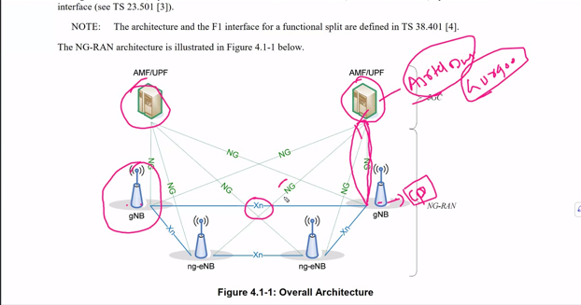
* **gNB** (Next-Generation NodeB): 5G base stations that provide connectivity to user devices.
* **ng-eNB** (Next-Generation eNodeB): LTE-based base stations adapted for 5G operation.
* **AMF** (Access and Mobility Management Function): Manages UE (User Equipment) registration, mobility, and authentication.
* **UPF** (User Plane Function): Handles data traffic and packet routing in the 5G core.

**Interfaces:**

* **NG Interface:** Connects gNB to the 5G Core (AMF/UPF).
* **Xn Interface:** Connects different gNBs and ng-eNBs for coordination and handover support.

**Functionality:**

* The **AMF/UPF** manages signaling (control plane) and data forwarding (user plane).
* **Multiple gNBs and ng-eNBs** communicate via Xn interfaces for seamless connectivity.
* **NG connections** link the RAN to the 5G core network.

**Radio Access Network (RAN) Components & Protocols in 5G**

**1. gNodeB (gNB) and Its Functional Split**

**gNodeB (gNB) Overview:**

* **gNB** is the **5G base station** that connects User Equipment (UE) to the 5G Core (5GC).
* It is responsible for **radio signal transmission, resource allocation, and connection management**.
* Unlike 4G eNodeB, 5G **gNB can be split into multiple units** for better performance and flexibility.

**gNB Functional Split:**

1. **CU (Centralized Unit)** – Handles higher-layer processing and is split into:
   * **CU-CP (Control Plane):** Manages signaling, mobility, and RRC functions.
   * **CU-UP (User Plane):** Handles user data transmission (data packets).
2. **DU (Distributed Unit):**
   * Handles real-time processing, including scheduling and lower-layer functions.
   * It connects to **multiple CUs** and is closer to the radio antennas for low-latency processing.

**2. 5G RAN Protocols & Their Roles**

**1 RRC (Radio Resource Control)**

* **Layer:** Control Plane
* **Role:**
  + Manages connection setup, handovers, and security.
  + Controls UE states (Idle, Connected, Inactive).

**2️ SDAP (Service Data Adaptation Protocol)**

* **Layer:** User Plane
* **Role:**
  + Manages Quality of Service (QoS).
  + Maps data flows to radio bearers.

**3️ PDCP (Packet Data Convergence Protocol)**

* **Layer:** Both Control & User Plane
* **Role:**
  + **Data encryption & integrity protection.**
  + **Header compression** (for efficiency).
  + **Reordering & retransmission of packets** (for reliability).

**4️ RLC (Radio Link Control)**

* **Layer:** Between MAC and PDCP
* **Role:**
  + Ensures reliable data transmission with **error correction & segmentation**.
  + Operates in **3 modes**:
    - **Acknowledged Mode (AM)** – Reliable, retransmission-enabled.
    - **Unacknowledged Mode (UM)** – Fast, no retransmissions.
    - **Transparent Mode (TM)** – Direct data forwarding.

**5️ MAC (Medium Access Control)**

* **Layer:** Between RLC and Physical Layer
* **Role:**
  + **Resource scheduling** (allocates spectrum to UEs).
  + **Multiplexing/demultiplexing of data streams**.
  + **Error detection & correction using Hybrid Automatic Repeat Request (HARQ)**.

**6️ Physical Layer (PHY)**

* **Layer:** Lowest Layer (Hardware Level)
* **Role:**
  + **Modulation & demodulation** of radio signals.
  + **Beamforming & MIMO operations** for improved coverage and capacity.