**Assignment-2**

**1.Radio Link Control (RLC)**

Radio Link Control (RLC) is a layer 2 (data link layer) protocol within the Universal Mobile Telecommunications System (UMTS) and Long-Term Evolution (LTE) wireless communication standards. It is responsible for managing the reliable and efficient transfer of data between the Radio Resource Control (RRC) layer and the Medium Access Control (MAC) layer.

**Here is a technical overview of Radio Link Control (RLC):**

1. **Role in Protocol Stack:**
   * RLC operates in the data link layer, which is Layer 2 of the OSI (Open Systems Interconnection) model.
   * It sits above the Physical layer and below the Radio Resource Control (RRC) layer in the UMTS and LTE protocol stacks.
2. **Functions of RLC:**
   * **Segmentation and Reassembly:** RLC divides the data received from higher layers into smaller units called Protocol Data Units (PDUs) during the transmission and reassembles them at the receiving end.
   * **Error Correction:** RLC provides error correction mechanisms to ensure the reliability of data transmission. This involves adding sequence numbers to PDUs, allowing the receiver to detect and correct errors.
3. **RLC Modes:**
   * RLC operates in three different modes: Transparent Mode, Unacknowledged Mode (UM), and Acknowledged Mode (AM).
     + **Transparent Mode:** This mode is used when no error correction or retransmission is required.
     + **Unacknowledged Mode (UM):** In UM, data is transmitted without requiring acknowledgment from the receiver.
     + **Acknowledged Mode (AM):** In AM, data is transmitted with acknowledgment, and the sender retransmits any lost or corrupted packets.
4. **PDU Formats:**
   * RLC PDUs come in different formats depending on the RLC mode.
   * For AM, PDUs include the header with sequence numbers, status information, and the actual data.
   * For UM, PDUs contain only the data without sequence numbers or acknowledgment information.
5. **Flow Control:**
   * RLC implements flow control mechanisms to ensure that the sender does not overwhelm the receiver or the network. It uses techniques like window-based flow control to manage the rate of data transmission.
6. **Status Reporting:**
   * In Acknowledged Mode (AM), the receiver sends status reports to the sender indicating which packets were received successfully and which need to be retransmitted.
7. **Timer-Based Retransmission:**
   * RLC uses timers to manage retransmission in AM. If an acknowledgment is not received within a specified time, the sender retransmits the data.
8. **Priority Handling:**
   * RLC supports priority handling for different types of data, allowing for differentiated quality of service.

Radio Link Control (RLC) is a crucial protocol within the UMTS and LTE wireless communication standards, providing segmentation, error correction, flow control, and reliable data transmission between the RRC and MAC layers. The choice of RLC mode (Transparent, Unacknowledged, or Acknowledged) depends on the specific requirements of the communication scenario.

**2️ PDCP (Packet Data Convergence Protocol)**

The Packet Data Convergence Protocol (PDCP) is an important component of the LTE protocol stack. As a sublayer within the LTE architecture, PDCP plays a critical role in enabling efficient and secure data transmission. Situated between the Radio Resource Control (RRC) layer and the Radio Link Control (RLC) layer, PDCP handles tasks such as header compression, ciphering, and integrity protection.

**3gpp Specification number for PDCP Layer is 36.323.**

In the context of LTE, which is designed to support high-speed data communication, PDCP’s functions are essential for optimizing the network’s performance and maintaining the security of user data.

Overview of PDCP ArchitectureThe PDCP layer’s architecture can be divided into two primary components: the PDCP structure and the PDCP entities. These components work together to manage the flow of data and signaling messages within the LTE network.

**PDCP Structure**

The PDCP structure consists of several PDCP entities, each associated with a specific Radio Bearer (RB). These entities are responsible for managing the data flow for their respective bearers. The PDCP layer is designed to be flexible, allowing it to handle different types of bearers, including split bearers and LTE-WLAN Aggregation (LWA) bearers.

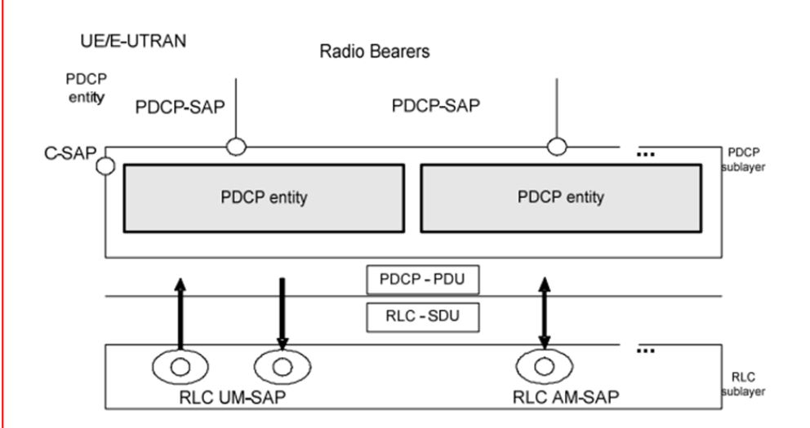

For each RB, there is a corresponding PDCP entity, which interacts with one or more RLC entities depending on the direction of data flow (uplink or downlink) and the mode of operation (acknowledged or unacknowledged mode). The PDCP entities are configured by the RRC layer, ensuring that they operate in accordance with the overall network configuration.

**PDCP Entity:**

* The PDCP entity is the central component in the PDCP sublayer. Each PDCP entity is associated with a specific radio bearer. The PDCP entity is responsible for functions like header compression, ciphering, integrity protection, and more.
* In the figure, two PDCP entities are shown, each linked to a different type of RLC SAP (Service Access Point).

**Service Access Points (SAPs):**

* PDCP-SAP: This is the interface between the PDCP sublayer and the RLC sublayer. It handles the transfer of PDUs (Protocol Data Units) from PDCP to RLC.
* C-SAP (Control SAP): The C-SAP is used for control signalling between the upper layers and the PDCP layer.
* RLC UM-SAP (Unacknowledged Mode Service Access Point): This SAP connects the PDCP entity to the RLC entity operating in unacknowledged mode (UM), where data is sent without requiring acknowledgment from the receiving side.
* RLC AM-SAP (Acknowledged Mode Service Access Point): This SAP connects the PDCP entity to the RLC entity operating in acknowledged mode (AM), where data transmission is acknowledged by the receiver to ensure reliable delivery.

**Radio Bearers:**

* Radio bearers are the logical channels that carry data between the UE (User Equipment) and the eNB. Each PDCP entity is associated with a specific radio bearer.

**PDCP-PDU and RLC-SDU:**

* PDCP-PDU: This represents the data units processed by the PDCP layer. These PDUs are passed down to the RLC sublayer through the PDCP-SAP.
* RLC-SDU: This represents the data units received by the RLC sublayer from the PDCP sublayer. The RLC layer processes these SDUs for transmission over the air interface.

**Consolidated procedure:**

* Data from the upper layers is passed down to the PDCP entity through the control SAP (C-SAP) or directly to the PDCP entity.
* The PDCP entity processes the data according to its functions (e.g., header compression, encryption) and prepares PDCP PDUs.
* These PDCP PDUs are then passed to the RLC sublayer via the PDCP-SAP.
* The RLC sublayer receives the PDCP PDUs as RLC SDUs. Depending on whether the RLC entity is in Unacknowledged Mode (UM) or Acknowledged Mode (AM), the data is processed differently:
* In RLC UM: Data is sent without acknowledgment, useful for real-time services where timely delivery is more critical than reliability.
* In RLC AM: Data is sent with acknowledgments, ensuring reliability by retransmitting lost or erroneous data.

**PDCP Entities and Functions**

The PDCP layer’s entities and functions are designed to manage the various tasks involved in data transmission within the LTE network. These functions are essential for ensuring that data is transmitted efficiently, securely, and in the correct order.

Control Plane PDCP Entities

Control plane PDCP entities are responsible for handling signaling messages, which are critical for maintaining the connection between the UE and the eNB. These entities provide functions such as integrity protection and ciphering, ensuring that signaling messages are transmitted securely.

The integrity protection function ensures that signaling messages have not been tampered with during transmission, while the ciphering function protects the confidentiality of these messages. Together, these functions ensure the secure and reliable transmission of control plane data within the LTE network.

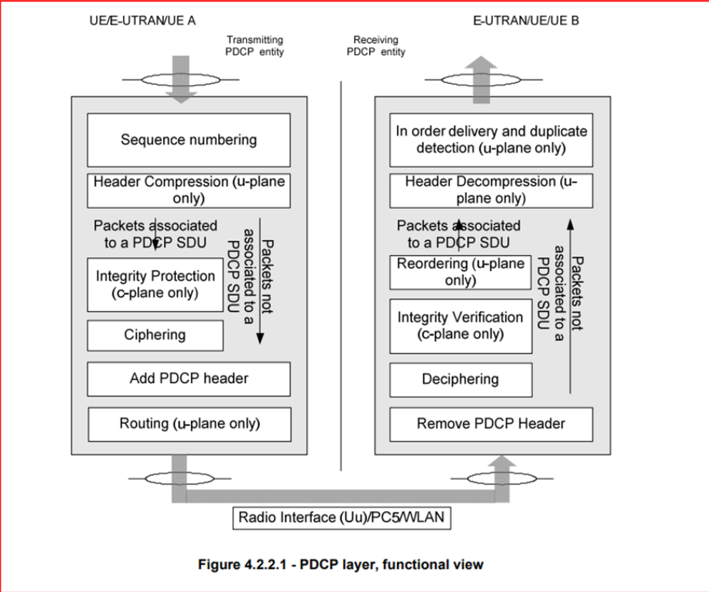

**User Plane PDCP Entities**

User plane PDCP entities manage the transmission of user data, performing tasks such as header compression, ciphering, and sequence number management. These entities are crucial for optimizing the use of network resources and ensuring the efficient transmission of data.

The header compression function reduces the overhead associated with transmitting IP packets over the LTE air interface, while the ciphering function protects the confidentiality of user data. Sequence number management ensures that data packets are transmitted in the correct order, preventing issues such as data duplication or loss.

**Functions of PDCP**

The PDCP layer performs several key functions that are essential for the efficient operation of the LTE network. These functions include header compression and decompression, ciphering and deciphering, integrity protection and verification, sequence number handling, in-sequence delivery and reordering, duplicate elimination, timer-based discard, and routing and reordering for split and LWA bearers.

**Header Compression and Decompression:**

* Uses Robust Header Compression (ROHC) protocol to compress IP packet headers.
* Reduces data transmission size over the air, important for small-packet applications like VoIP.
* Decompression at the receiving end restores headers before passing data to upper layers, ensuring efficiency and data integrity.

**Ciphering and Deciphering:**

* Encrypts user and control plane data before transmission to ensure security.
* Deciphering at the receiving end decrypts the data, maintaining its confidentiality and integrity.
* Utilizes a key provided by upper layers to protect against security threats.

**Integrity Protection and Verification:**

* Provides integrity protection for control plane data to prevent tampering during transmission.
* Integrity verification checks data integrity at the receiving end; data is discarded if verification fails.

**Sequence Number Handling:**

* Assigns unique sequence numbers (SNs) to each data packet for tracking and reordering.
* Ensures packets are transmitted and received in the correct order, critical for scenarios with delays or retransmissions.
* Manages ciphering by using SNs to encrypt packets with unique keys.

**In-sequence Delivery and Reordering:**

* Ensures data packets are delivered to upper layers in the correct order.
* Reorders packets received out of sequence before passing them on, preventing data loss or duplication.

**Duplicate Elimination:**

* Identifies and eliminates duplicate packets to ensure only unique packets reach the upper layers.
* Prevents issues such as data duplication, particularly in retransmission scenarios.

**Timer-based Discard:**

* Discards data packets not transmitted within a configured time frame, preventing unnecessary retransmissions and buffer overflows.
* Ensures network efficiency by controlling the timing of packet discard.

**Routing and Reordering for Split and LWA Bearers:**

* Manages the routing and reordering of data packets across multiple paths in split bearer or LTE-WLAN Aggregation (LWA) scenarios.
* Uses sequence numbers to ensure packets are delivered in order, even when distributed across multiple RLC entities or technologies.

**PDCP Procedures**

The PDCP layer is crucial in managing data transmission within the LTE network, ensuring data is processed, transmitted, and received securely and efficiently.

**Uplink (UL) Data Transfer Procedures**

* Header Compression: Utilizes the ROHC protocol to compress IP packet headers, reducing data size for transmission.
* Ciphering: Encrypts data before transmission to prevent unauthorized access, using a key provided by the upper layers.
* Sequence Number Assignment: Assigns unique sequence numbers to each data packet, ensuring correct order during transmission.

**Downlink (DL) Data Transfer Procedures**

* Deciphering: Decrypts received data to maintain confidentiality and integrity.
* Header Decompression: Restores compressed headers at the receiving end before passing data to upper layers.
* Reordering: Rearranges out-of-order packets using sequence numbers to ensure correct data delivery.

**PDCP Re-establishment Procedures**

* Uplink and Downlink Considerations: Manages re-establishment differently for UL and DL; UL may involve retransmission; DL may require reordering.
* Handling PDCP Re-establishment after Handover: Ensures seamless data transmission during handovers by resetting state variables and reconfiguring operations.

**PDCP Status Report**

* Transmit Operation: Compiles and sends status reports, indicating missing packets and the status of subsequent packets.
* Receive Operation: Processes received status reports to confirm data delivery, retransmitting packets if necessary.

**PDCP Discard Procedures**

* Uses a discard timer to remove packets not transmitted within a set timeframe, preventing buffer overflows and unnecessary retransmissions.
* Discards corrupted or unrecognized packets and may generate error reports for upper layers.

**PDCP Parameters**

* **Sequence Numbers (SNs):** Used to track and maintain the correct order of data packets during transmission.

**COUNT Parameter:**

Combines PDCP SN with Hyper Frame Number (HFN) to ensure secure ciphering and deciphering of data.

**3. MAC Protocol**

The MAC layer is responsible for controlling access to the shared radio resources, scheduling transmissions, and managing various services and functions within the 5G network.

Simplified Protocol Architecture:

In 5G, the MAC layer features a simplified protocol architecture compared to previous generations. It interacts closely with the PHY layer to optimize resource utilization.

**Key Functions:**

* Resource Allocation: The MAC layer allocates resources (e.g., time, frequency, and code resources) to connected User Equipment (UEs) to facilitate efficient data transmission.
* Scheduling: It determines which UEs can transmit data and when, taking into account various factors like Quality of Service (QoS) requirements, traffic types, and channel conditions.
* HARQ (Hybrid Automatic Repeat reQuest): The MAC layer handles HARQ processes, enabling retransmissions of data packets in case of errors.
* Logical Channels: It manages logical channels for control information exchange between the MAC layer and higher-layer protocols.
* Multiplexing and De-Multiplexing: MAC layer multiplexes and de-multiplexes data flows from different UEs onto the shared radio resources.
* PDCCH (Physical Downlink Control Channel): MAC plays a role in the allocation and signaling of PDCCH resources for control information transmission.

**User Plane and Control Plane MAC Functions:**

* MAC functions are divided into User Plane (UP) and Control Plane (CP) categories, each serving specific purposes.
* The UP MAC manages the transmission and reception of user data, while the CP MAC handles control signalling and coordination between the UE and the network.

**Dynamic Adaptation:**

* The MAC layer adapts dynamically to changing radio conditions, traffic patterns, and network requirements, ensuring efficient resource utilization and QoS provision.

**Interactions with Higher Layers:**

* The MAC layer interacts with higher layers, such as the RLC and PDCP layers, to ensure end-to-end data delivery and protocol convergence.

**Efficiency and Low Latency:**

* 5G MAC is designed for low-latency communication, making it suitable for applications like IoT, autonomous vehicles, and augmented reality, where timely data transmission is critical.

**Enhancements in 5G:**

* 3GPP 5G specifications introduce several enhancements to the MAC layer, including support for massive MIMO, beamforming, and advanced scheduling techniques.

**Shows a potential arrangement of the MAC entity when SCG remains unconfigured and when MCG and SCG are configured.**

When the UE is configured with SCG, it involves the setup of two distinct MAC entities within the UE: one dedicated to the MCG and another for the SCG. These MAC entities function independently unless otherwise specified. Additionally, the timers and parameters for each of these MAC entities are configured independently unless there are specific instructions to the contrary. The characteristics of each MAC entity, including Serving Cells, CRNTI, radio bearers, logical channels, upper- and lower-layer entities, LCGs, and HARQ entities, pertain exclusively to those assigned to that

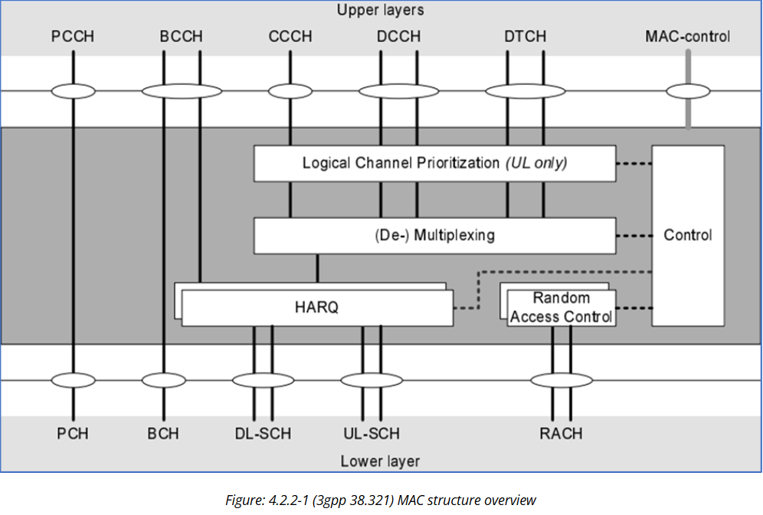

Furthermore, if the MAC entity is configured with one or more SCells, it introduces the possibility of multiple DL-SCHs, potentially multiple ULSCHs, and the potential for multiple RACHs per MAC entity. Specifically, there would be one DL-SCH, one UL-SCH, and one RACH designated for the SpCell, and for each additional SCell, there would be one DLSCH, a possibility of zero or one UL-SCH, and the possibility of zero or one RACH.

On the other hand, if the MAC entity is not configured with any SCell, each MAC entity will consist of a single DL-SCH, a single UL-SCH, and a single RACH.

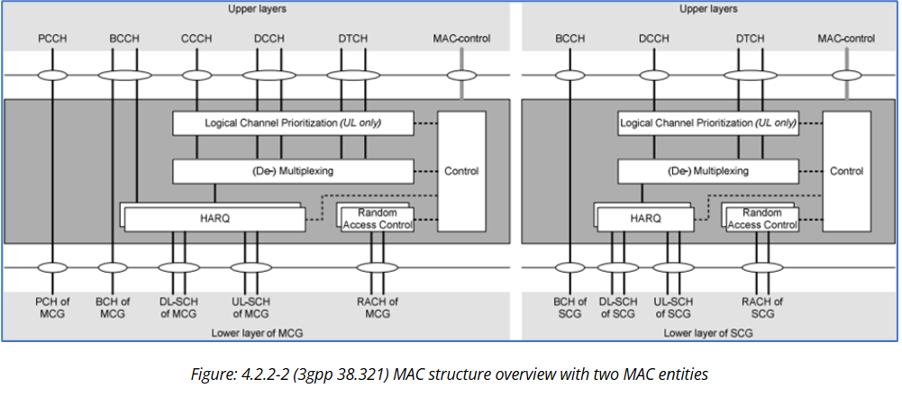

**MAC functions for uplink and downlink**

Table 4.4-1 in 3GPP Technical Specification 38.321 provides an overview of the MAC (Medium Access Control) functions for both the uplink (UL) and downlink (DL) directions in a 5G NR (New Radio) network. Here are the MAC functions for UL and DL, as per 3GPP 38.321:

**Uplink (UL) MAC Functions:**

* **Buffer Management:**

Manages the data buffers for Uplink Shared Channel (UL-SCH) transmissions from the UE.

* **Multiplexing:**

Multiplexes Logical Channels onto one or more UL-SCH transport channels for transmission.

* **PUSCH Transport Channel Processing:**

Handles the processing of the Physical Uplink Shared Channel (PUSCH), including encoding, modulation, and resource allocation.

* **Activation/Deactivation of SCells**

When the MAC entity is set up with one or more SCells, the network has the capability to enable or disable these configured SCells. Initially, upon configuring an SCell, it is in a deactivated state.

* **PUCCH Transport Channel Processing:**

Manages the Physical Uplink Control Channel (PUCCH) transport channel for control signalling.

* **Harq-ACK Processing:**

Handles the acknowledgment (ACK) or negative acknowledgment (NACK) signaling for uplink HARQ processes.

* **Random Access Handling:**

Manages the Random-Access Channel (RACH) for initial access and contention resolution.

* **UL Grant Reception:**

Receives UL grant information from the network for resource allocation.

* **Scheduling Request Handling:**

Manages scheduling requests from the UE to request UL resources for uplink transmission

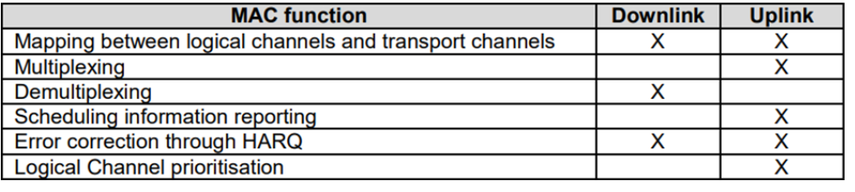

**Downlink (DL) MAC Functions:**

* **Buffer Management:**

Manages the data buffers for Downlink Shared Channel (DL-SCH) receptions at the UE.

* **Power Headroom Reporting**

The Power Headroom reporting procedure provides the serving gNB with information about three types of power headroom: Type 1 for UL-SCH transmission on the activated Serving Cell, Type 2 for UL-SCH and PUCCH transmission on the other MAC entity (in EN-DC case), and Type 3 for SRS transmission on the activated Serving Cell

* **Logical Channel Demultiplexing:**

De-multiplexes incoming data streams from one or more DL-SCH transport channels onto corresponding logical channels.

* **Bandwidth Part (BWP) operation**

A Serving Cell can be equipped with one or multiple BWPs, with the maximum allowable number outlined in TS 38.213. BWP switching within a Serving Cell serves the purpose of enabling an inactive BWP while simultaneously deactivating an active one. This switching process is managed through various mechanisms, including PDCCH signals indicating downlink assignments or uplink grants, the bwpInactivityTimer, RRC signalling, or initiation by the MAC entity itself during Random Access procedures.