**1. UPF Architecture (3GPP TS 23.501 Rel-16)**

* **Content**: This image provides an overview of the 5G System Architecture, specifically focusing on the User Plane Function (UPF). Key components include:
  + **gNB (Next Gen Node B)**: The base station in 5G.
  + **UPF (User Plane Function)**: Handles user plane data routing and forwarding.
  + **Interfaces**:
    - **N3 (UPF-gNB)**: GTP-U tunnel for user plane data, QoS flow handling, and packet routing.
    - **N9 (UPF-UPF)**: Inter-UPF transport, multi-UPF PDU session support, and local breakout.
    - **N4 (UPF-SMF)**: PFCP-based session management, packet detection, and usage reporting.
  + **Core Functions**: Packet routing, inspection, QoS handling, lawful intercept, and traffic detection.
  + **N6 (UPF-DN)**: IP-based interconnection with external data networks, NAT, and firewall functions.
* **Importance**: This image sets the foundation by detailing the UPF's role and its interfaces within the 5G architecture.

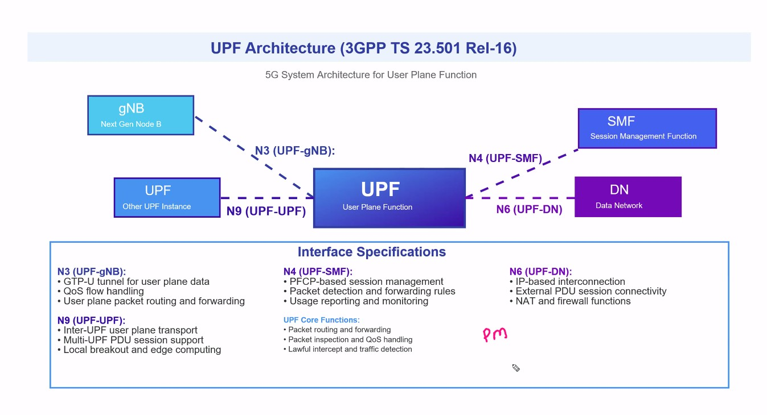

**2. SMF Function Inheritance from 4G Core**

* **Content**: This image explains the Session Management Function (SMF) in 5G and how it inherits functions from 4G core elements:
  + **MME (Mobility Management Entity)**: Handles NAS signaling and mobility management.
  + **SGW-C (Serving Gateway Control)**: Manages UE selection and control.
  + **PGW-C (PDN Gateway Control)**: Handles IP address allocation and session management.
  + **SMF (Session Management Function)**: Inherits functions like session management, UE selection, and IP address management from the 4G core.
* **Importance**: It highlights the continuity and evolution of core network functions from 4G to 5G.

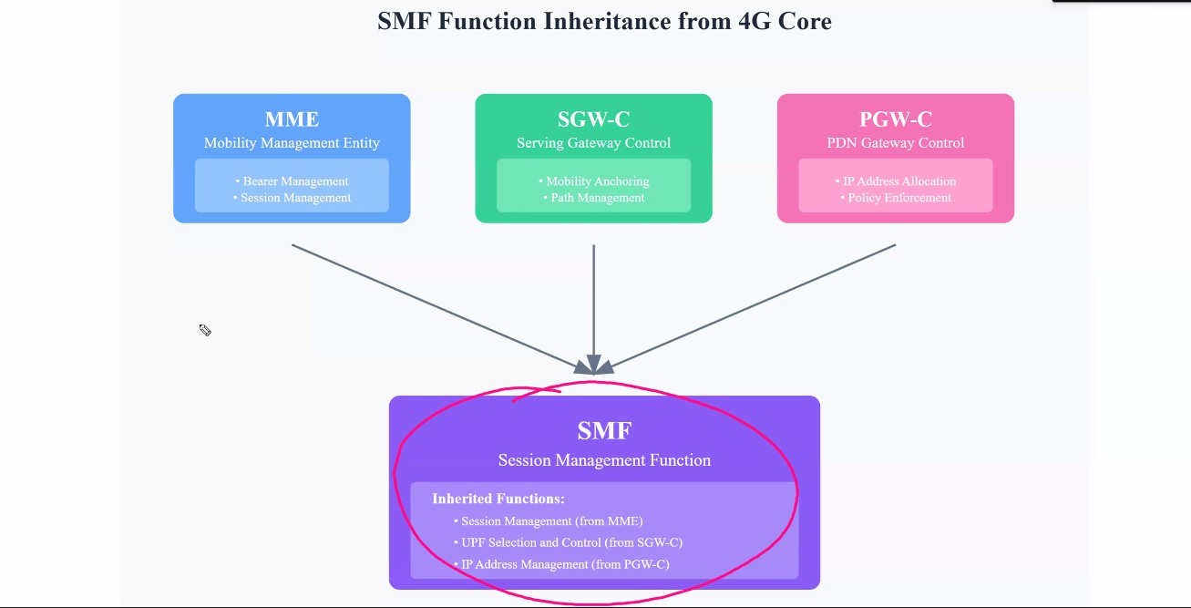

**3. MME vs AMF: Architecture Evolution**

* **Content**: This image compares the 4G MME with the 5G AMF (Access and Mobility Management Function):
  + **MME**: Handles NAS signaling, mobility management, and is tightly coupled with SGW via the S11 interface.
  + **AMF**: Focuses on pure mobility management, with session management handled by SMF. It uses a service-based architecture with N1/N2 interfaces.
  + **Key Differences**: AMF decouples mobility and session management, offering a more flexible and scalable architecture.
* **Importance**: This comparison underscores the architectural advancements in 5G, emphasizing the separation of concerns and enhanced scalability.

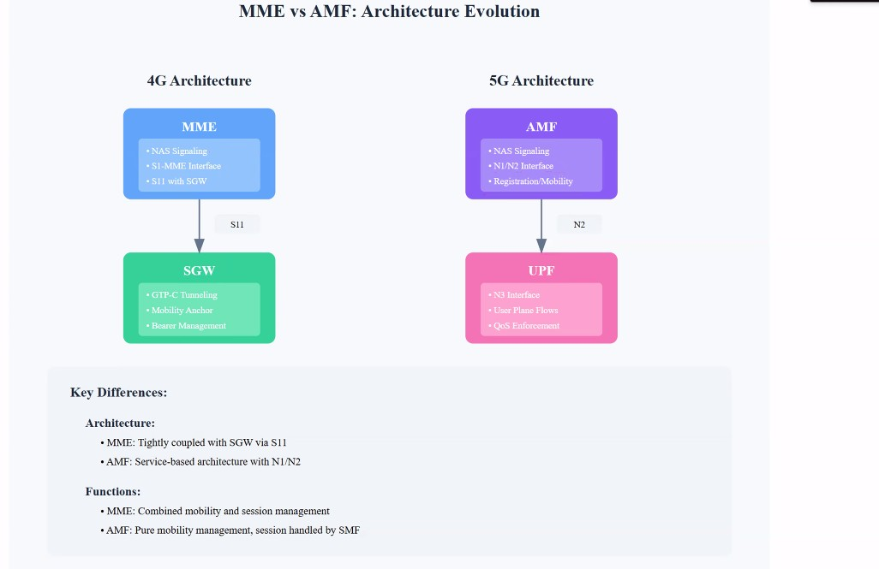

**4.5G Core Compared to EPC**

* **Content**: This image maps the Evolved Packet Core (EPC) of 4G to the 5G Core (5GC):
  + **EPC Components**: MME, SGW, PGW, HSS, PCRF.
  + **5GC Components**: AMF, SMF, UPF, AUSF, UDM, NRF.
  + **Function Mapping**: Shows how 4G functions are transitioned or replaced in 5G, such as MME functions being split between AMF and SMF.
* **Importance**: It provides a clear transition roadmap from 4G to 5G, illustrating the evolution and new components introduced in 5G.

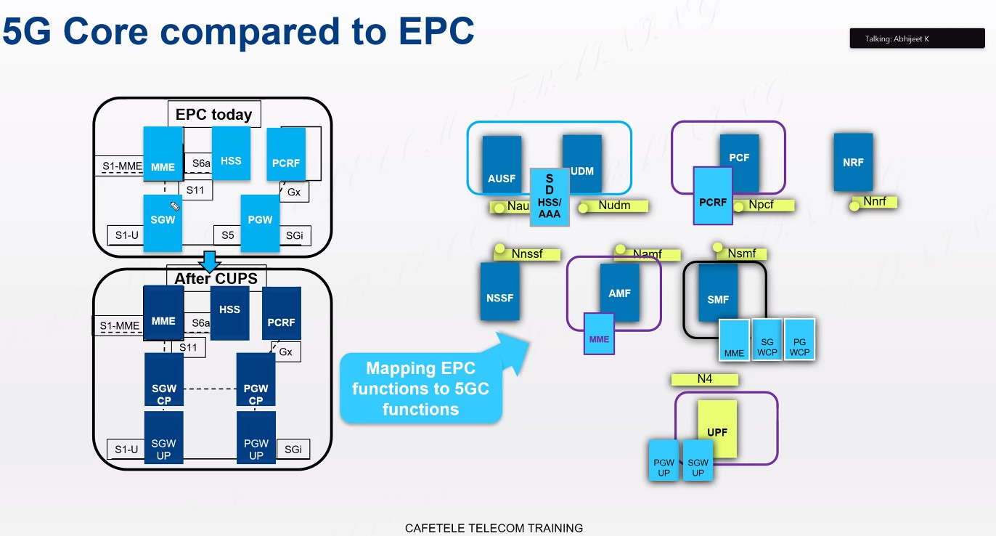

**5. UPF Evolution: Inherited Functions from SGW-U and PGW-U**

* **Content**: This image details the evolution of the UPF by inheriting functions from 4G's SGW-U and PGW-U:
  + **SGW-U Functions**: GTP-U tunneling, packet filtering, mobility anchoring, QoS enforcement.
  + **PGW-U Functions**: Packet forwarding, external connectivity.
  + **New UPF Features**: Network slicing, edge computing, service-based interfaces, enhanced QoS framework, local breakout, and multi-access support.
* **Importance**: It highlights the continuity and enhancement of user plane functions in 5G, showcasing new capabilities that support advanced 5G use cases.

**6. 307.jpg: MR-DC: Using 4G + 5G Together!**

* **Content**: This image illustrates Multi-Radio Dual Connectivity (MR-DC), which allows devices to connect simultaneously to 4G and 5G networks:
  + **4G Tower (Master)**: Primary connection.
  + **5G Tower (Secondary)**: Secondary connection.
  + **Your Phone**: Utilizes both connections for enhanced performance and reliability.
* **Importance**: It demonstrates a practical application of the discussed architectures, showing how 4G and 5G can coexist and complement each other to provide better service.

