**ARQ (Automatic Repeat request)**

The purpose of ARQ (Automatic Repeat reQuest) is to ensure reliable data communication by detecting errors in transmitted packets and requesting retransmission of lost or corrupted packets.

These mechanisms work in tandem to meet the diverse requirements of 5G use cases, such as **URLLC** (ultra-reliable low latency) and **eMBB** (enhanced mobile broadband).

**How ARQ Works:**

1. **Data Transmission**: The sender transmits a data packet.
2. **Acknowledgement**: The receiver sends an acknowledgment (ACK) back to the sender to confirm successful receipt of the packet.
3. **Error Detection**: If the receiver detects an error in the received packet (e.g., using checksums or CRC), it sends a negative acknowledgment (NAK).
4. **Retransmission**: The sender retransmits the packet upon receiving a NAK or if no acknowledgment is received within a certain time frame.

**Types of ARQ:**

There are several types of ARQ mechanisms, each with varying levels of complexity and performance:

1. **Stop-and-Wait ARQ**:
   * **How it works**: The sender sends one packet and waits for an acknowledgment (ACK) before sending the next packet. If no ACK is received (or a NAK is received), the packet is retransmitted.
   * **Advantages**: Simple to implement.
   * **Disadvantages**: Inefficient in high-latency networks, as the sender must wait for an acknowledgment after each packet.
2. **Go-Back-N ARQ**:
   * **How it works**: The sender can send multiple packets (up to a specified window size) before needing an acknowledgment. If a packet is lost or has an error, the receiver requests a retransmission of the lost or erroneous packet and all subsequent packets.
   * **Advantages**: Better throughput compared to Stop-and-Wait.
   * **Disadvantages**: Requires more buffer space and can lead to unnecessary retransmissions if only a single packet is lost.
3. **Selective Repeat ARQ**:
   * **How it works**: Similar to Go-Back-N ARQ, but only the erroneous or lost packets are retransmitted, rather than all subsequent packets. The receiver can store out-of-order packets and only requests retransmission of the specific missing ones.
   * **Advantages**: More efficient than Go-Back-N, as it avoids retransmitting packets that were received correctly.
   * **Disadvantages**: More complex to implement, requiring a buffer for storing out-of-order packets.

**ARQ Process: RLC Layer Reliability**

**RLC Acknowledged Mode (AM)**

ARQ operates in the RLC AM entity, providing:

* **In-Order Delivery**: Ensures packets are delivered sequentially.
* **Sequence Numbering**: Each RLC PDU (Protocol Data Unit) has a unique sequence number (SN).
* **Sliding Window**: Manages transmitter/receiver buffers (default window size = 512).

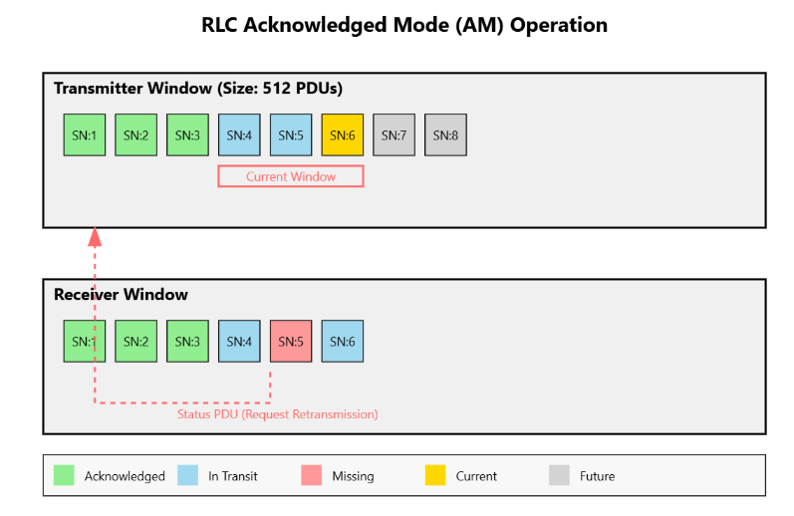

**ARQ Mechanisms**

* **Status Reports**: Receiver sends NACKs for missing PDUs. Triggered by missing SNs or periodic polling.
* **Retransmission Buffer**: Stores unacknowledged PDUs until ACK is received.
* **Timer-Based Triggers**: **t-PollRetransmit**: Triggers status reports if ACKs are delayed. **t-Reordering**: Reorders out-of-sequence PDUs before delivery to PDCP.

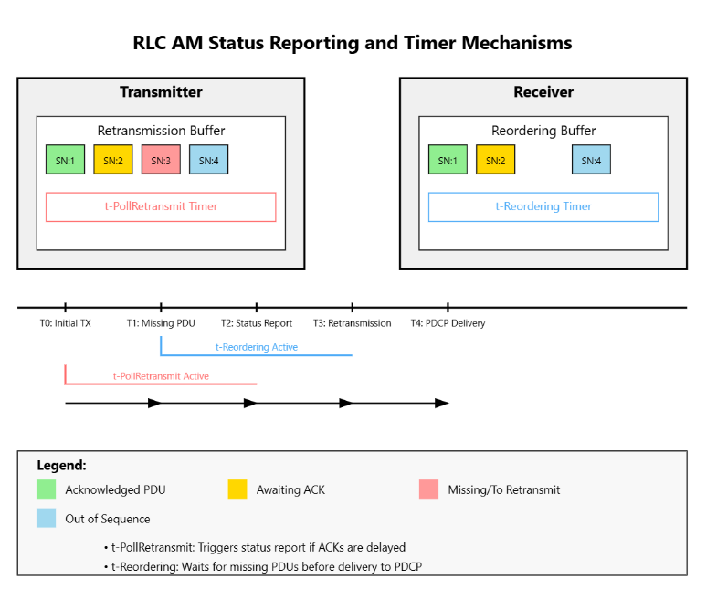

**ARQ Workflow**

1. **Transmitter Side**: Segments PDCP PDUs into RLC PDUs with SNs. Maintains a send window (e.g., SN 0–511).
2. **Receiver Side**: Detects gaps in SNs (e.g., missing SN=5). Sends a **STATUS PDU** listing missing SNs.
3. **Retransmission**: Transmitter resends missing RLC PDUs. Receiver updates the window and delivers in-order data to PDCP.

**ARQ Optimizations**

* **Reduced Status Report Size**: Compressed SN feedback (e.g., bitmap formats).
* **Enhanced Polling Mechanisms**: Smarter triggers to avoid unnecessary signaling.

**Conclusion**

* • **ARQ (Automatic Repeat reQuest)** ensures reliable data transmission by requesting retransmissions of lost or corrupted packets.
* • **Error detection** is done using mechanisms like **checksums** and **CRC**.
* • **ACKs (Acknowledgments)** and **sequence numbers** help manage retransmissions.
* • Different **ARQ types** include **Stop-and-Wait**, **Go-Back-N**, and **Selective Repeat**.
* • **Efficiency** can be impacted by retransmissions, but techniques like **sliding windows** help reduce delays.
* • ARQ is essential in **networking** and **telecommunications** for data integrity.
* • It is used in applications requiring **high reliability** in data transfer.