**Content: Models and Protocols - OSI model**

* **History of OSI (Open System Interconnect Model)** 
  + The OSI model was created in the late 1970s by the International Organization for Standardization (ISO).
  + At that time, vendors like IBM, DEC, and Xerox were developing computer networking technologies, but their products were largely incompatible.
  + The ISO aimed to create a standard reference model to enable interoperability between different vendors and technologies.
  + This reference model became known as the Open Systems Interconnection (OSI) model.
  + The official OSI model with 7 layers was published in 1984.
  + While modern networks like the internet do not strictly follow the OSI model, it provides a useful conceptual framework for understanding network communication steps.

**Content: Models and Protocols - OSI model – Data**

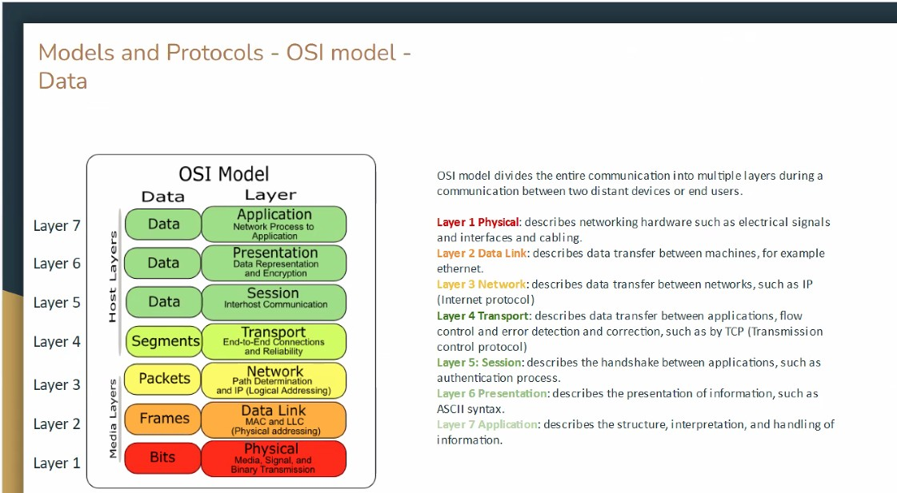

* **OSI Model Layers and Functions**
  + **Layer 7: Application**
    - Describes the structure, interpretation, and handling of information.
  + **Layer 6: Presentation**
    - Describes data representation and encryption, such as ASCII syntax.
  + **Layer 5: Session**
    - Describes the handshake between applications, such as the authentication process.
  + **Layer 4: Transport**
    - Describes data transfer between applications, flow control, and error detection and correction, such as by TCP (Transmission Control Protocol).
  + **Layer 3: Network**
    - Describes data transfer between networks, such as IP (Internet Protocol).
  + **Layer 2: Data Link**
    - Describes data transfer between machines, for example, Ethernet.
    - Includes MAC (Media Access Control) and LLC (Logical Link Control) for physical addressing.
  + **Layer 1: Physical**
    - Describes networking hardware such as electrical signals, interfaces, and cabling.
* **OSI Model Overview**
  + The OSI model divides the entire communication process into multiple layers during communication between two distant devices or end users.
  + Each layer has a specific function, contributing to the overall process of data transmission and network communication.