**Definition of EIGRP:**

**EIGRP (Enhanced Interior Gateway Routing Protocol)** is an **advanced distance-vector routing protocol** developed by **Cisco**, designed for fast convergence, scalability, and efficient routing in IP-based networks.

**Key Points of EIGRP:**

1. **Hybrid Protocol** – Combines features of both **distance-vector** and **link-state** protocols.
2. **Uses DUAL Algorithm** – Ensures **loop-free** paths and **fast convergence**.
3. **Supports VLSM & CIDR** – Works with **classless** IP addressing.
4. **Multicast & Unicast Updates** – Uses **224.0.0.10** for multicast updates.
5. **Uses RTP (Reliable Transport Protocol)** – Ensures reliable routing updates.
6. **Metric Based on Multiple Factors** – Uses **Bandwidth, Delay, Reliability, and Load**.
7. **Unequal Cost Load Balancing** – Can balance traffic over multiple paths with different costs.
8. **Maintains Three Tables** – **Neighbor Table, Topology Table, and Routing Table**.
9. **Partial Updates** – Sends updates **only when necessary**, reducing bandwidth usag

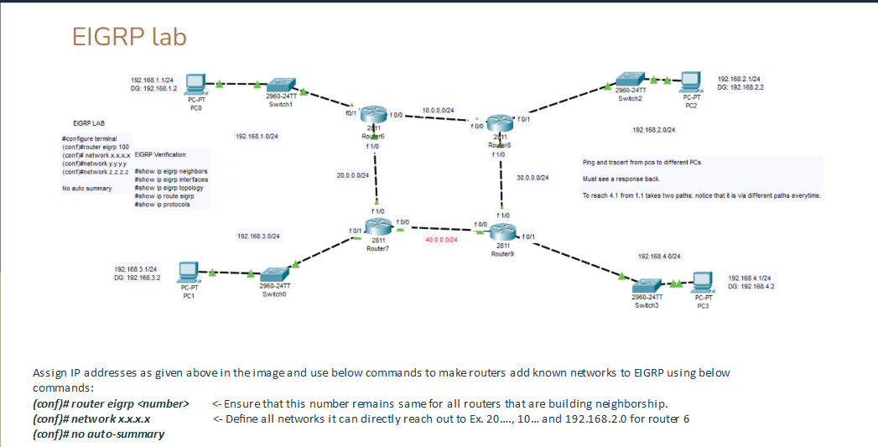

**Basic Difference Between Routing Information and EIGRP**

1. **Routing Information:**
   * Refers to data about network paths that routers use to forward packets.
   * Includes details like destination networks, next-hop addresses, and metrics.
   * Can be obtained through static routing (manually configured) or dynamic routing protocols.
2. **EIGRP (Enhanced Interior Gateway Routing Protocol):**
   * A specific type of **dynamic routing protocol** developed by Cisco.
   * Helps routers automatically share and update routing information.
   * Uses metrics like bandwidth and delay to find the best path.
   * Faster and more efficient than older protocols like RIP.