Top 50 JavaScript Interview Questions & Answers

- What is JavaScript?

Javascript is a scripting language that allow us to create dynamically updating content animation, text, images. We can write here completely object oriented code. It’s a browser independently scripting languages so we can run any of browser.

What are JavaScript Data Types?
String
Number
Boolean
Function
Undefined
Object

What is isNaN function?
isNaN if a predefine function in javascript. It will return true if value is not a Number.
Exp:-
alert ( isNaN('abcd')); // alerts true
alert ( isNaN('2.0')); // alerts false
alert ( isNaN(2.0)); // alerts false

what are undefined and undeclared variables in javascript?
Undefined variable which is declared but not assign any value. When we will execute the programs it will show error undefined variable.
Exp:- document.write(c);
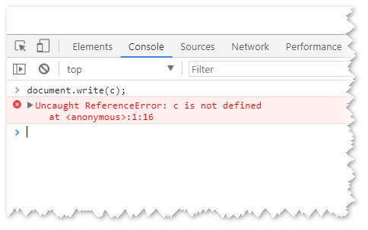
Undeclared variable means variable is not define in programs. But we try to use it. So it will give run time error.
Exp:-
var a = b, b = 'B';
console.log(a+ b); // undefined B
What is local and global variable in javascript?
Local variable we use inside the function scope. It can create and destroyed at any time. It cannot accessed by outside of the function.
Exp:-
function checkname(){
alert(myname);
var myname = "Ram";
alert(myname);
}
checkname();
here we given 2 alert first before declare the var myname so it will come myname is undefine. But after that we have declared myname is a Ram. And alert is display Ram. So here var myname is a local variable.
Global variable:-
A variable that is define outside of function know as global variable. This variable we can use throughout the programs.
Exp:-
var myname = "Ram";
function checkname(){
alert(myname);
}
checkname();
Here myname we declare outside of function and we are able to use this variable in side of the function and get some value.
What would be the result of 1+2+”7″?
Here 1 and 2 is an integer value and 7 is a string value. So 1+3 it will come 3 and 7 as a string so result will would be 37.

What are all the types of Pop up boxes available in JavaScript?
There are 3 type of popup available in javascript.
- Alert
- Prompt
- Confirm

What are escape characters?
Escape characters in javascript know as Backslash (\) . When we want to display any single quotes, double quotes ampersands or apostrophes we can use backslash and able to display.
Ex-
document.write( "India is a "Great" Country")
document.write( "India is a \"Great\" Country" )
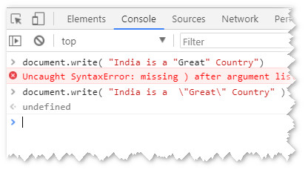
Here first statement it will give error its not allow double quotes. But when we use backslash it will allow to print the value.
===========================
What is push() pop() Splice, shift() and unshift() method.
Push: - Push is a predefine method it’s going to add or append one more element in an array. It will add element always in last.
Exp:-
var myfruits = ["Banana", "Orange", "Apple", "Mango"];
myfruits.push("Kiwi");
output:-
var myfruits = ["Banana", "Orange", "Apple", "Mango", "Kiwi"];

Pop:- Pop is predefined method for javascript. It’s going to remove last element of the array.
Exp:-
var myfruits = ["Banana", "Orange", "Apple", "Mango"];
myfruits.pop();
output:-
var myfruits = ["Banana", "Orange", "Apple"];
Splice:- This method adds or Remove elements from an array. This is also a predefined array. Once we used this array it will going to change structure of the array.
Exp:-
var myfruits = ["Banana", "Orange", "Apple", "Mango"];
myfruits.splice(2, 0, "Lemon", "Kiwi");
Output:-
var myfruits = ["Banana", "Orange", "Lemon", "Kiwi", "Apple", "Mango"];
Shift():- This method is going to remove first element of the array. If we use this method its going to change the length of the array because we are going to remove element from first.
Exp:-
var myfruits = ["Banana", "Orange", "Apple", "Mango"];
myfruits.shift();
output:-
var myfruits = ["Orange", "Apple", "Mango"];
unshift:- This method is opposite of shift, it’s going to add element first place of the array.
Exp:-
var myfruits = ["Banana", "Orange", "Apple", "Mango"];
myfruits.unshift("Lemon","Grapes");
output:-
var myfruits = ["Lemon", "Grapes", "Orange", "Apple", "Mango"];

What is charAt and charCodeAt in javascript?
charAt:- it will give the position of the character in the word.
Exp:- var mystring = "my love";
var result = mystring.charAt(5);
Output: - V
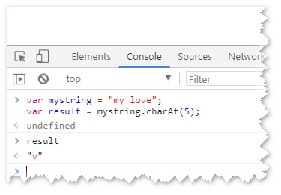
charCodeAt:- This method will return the Unicode of the character in the string.
Exp:-
var str = "MY INDIA";
var n = str.charCodeAt(4);
output:- 78
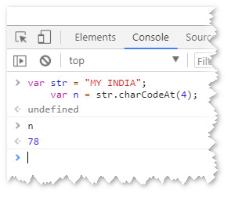

What is indexOf and lastIndexOf in javascript?
IndexOf method return the place of first occurrence in the string (word).
Exp:-
var mytext = “Ram is a good boy”;
var result = mytext.indexOf(“good”);
output:- 9
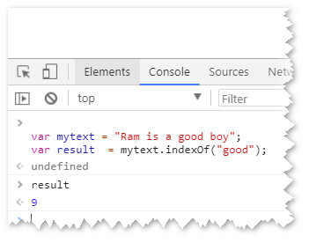
lastIndexOf:- This method will returns the position of the last occurrence in string.
Exp:-
var myfruits = ["Apple", "Banana", "Orange", "Mango"];
var a = myfruits.lastIndexOf("Mango");
output:- 3
