1) What is Reactjs.

Reactjs is open source javascript library powered by facebook. It’s a component based framework. Its manly work on component and virtual dom concept. It is user to work on view layer for web and mobile app. we are able to create reusable component becouse it’s based on component. React was first created by jordan walke a software engineer working for facebook in 2011. It’s used to devlop complex, interactive web application. It has a strong foundation and large community.

We can create large application and change the content without reloading the page. We are only able to refresh changes component of the page through virtual Dom. When we use virtial dom our site will fast and its take less memory consumption.

2) What is advantace of ReactJS

a) Easy to know how a component is rendered, to check render function.
b) It’s easy to check the layout, JSX makes it easy to read the code of your components.
c) We can render React on server side.
d) It’s easy to test using mocha, Jsdom, mockey.
e) It ensures readability and makes maintainability easier.
f) We can use react with any framework like Angular or Backbone.js.
i) Its increase the application performance
j) Code Reusability
k) Easy to integrate
l) Easy to write UI test cases

3) What is disadvantage of Reactjs

a) It is only a view layer. We need to plug our code for Ajax request and events.
b) This library is very large.
c) javascript and jquery most of the plugins are unused.
d) Not frindly with HTML

4) What is jsx?
jsx is a preprocessor which adds XML tp javascript. It can write concise HTML/XML- like (Dom tree structure). Parent child structure. In the same file we are able to write javascript code also. jsx file not open directly on browser. Babel is the compiler to compile the jsx code to javascript. Jsx allows us to put HTML into javascript. We can embed javascript expression in jsx by wrapping it in curly braces. After compilation, JSX expressions become regular javascript function calls and evaluate to javascript objects.

5) What is virtual Dom in ReactJS?
Virtual Dom is not invented by ReactJS. But Reactjs is using it. The virtial Dom is an abstraction of the HTML DOM. When we load the page Dom (Document object Model) load directly. But its slow becouse its load complete DOM again and again. Changing this approch in React we used virtual DOM.

6) How React syntax changed from ES5 to ES6

In ES5 we can use create class like:
var Mycomp = React.createClass({})

and in ES6 we use class like:
class Mycomp extends React.Component{}

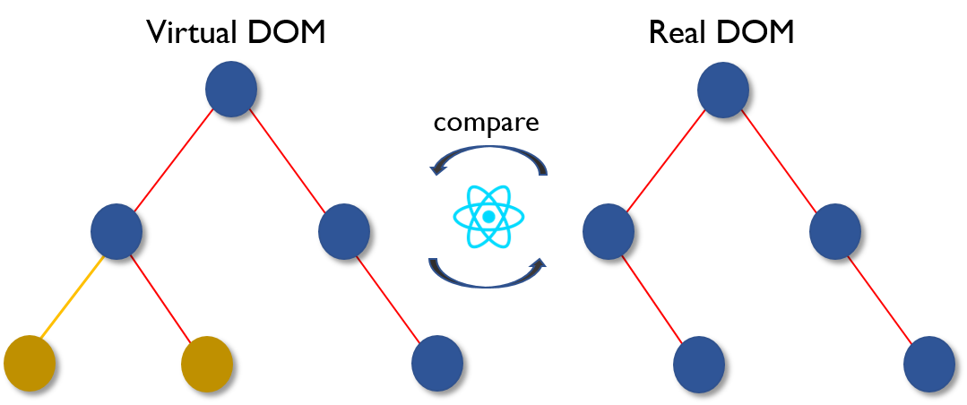

Here actual DOM and Virtual DOM is a node tree that listed node elements. Here the browser DOM is a tree-step process on React.

1) Whenever anything changed in UI will re-rendered in a virtual DOM representation.
2) The difference between previous virtual Dom representation and the new one will be calculated
3) The Real Dom will be update with only what actually changed.

6) What deferent between ES5 and ES6?

In ES5 :-
var MyComponent = React.createClass({

})

In ES6

Class Mycomponent extends React.Component();

In ES5 we start with “createClass” and in ES6 we use extends React.Component this is the first basic difference.

const: ES6 allows for “immutable variables”
ES6 allows arrow function,
class definition
class inheritance

7) What is component in Reactjs?
Component are heart and soul of React. Its reusable elements in react. Component should must implement render method. Render is going to tell the component what to render.
A React component can be of two types.
1) Functional component
exp:-
var MyComponent = React.createClass({

})

2) Class component
exp:-
Class Mycomponent extends React.Component();

8) What are the top 10 future of ES6?

1) Arrows function
2) var to const/let
3) String interpolation, Multi-line string
4) Default parameters
5) Template literals
6) Destructing Assignment
7) Enhanced object
8) Promises
9) Block-Scoped
10 Modules

9) What is arrows function?
Arrow function - also called “fat arrow” function. It will repersante => this symbles. Its look like fat arrow. It interduce tin ES6. For example:-

//ES5
var Add = function(a,b)
{
return a+b;
}

//ES6

var Add = (a,y) => {return a+b};

As we can see here in place of function we are using => arrow function.

Object Literal Syntax

In Arrow function, like function can be used to return an object literal expression.
Example:-
//ES5

var empname = function setName(firstname, lastname)
{
return{
firstname: firstname,
lastname:lastname
};
};

//ES6

var empname = (firstname, lastname) => ({firstname: firstname, lastname:lastname });
(empname (“silpan”, “doga”));

parantheses are required even no parameters are present.
2nd example:-

//ES5
var doclog = function doc(){
console.log(document);
};

//ES6

var doclog = () => {console.log(document);}

10) var to const/let in ES6?

In place of var in ES6 we are using let and const let is a variable after use assign value it will clear the memory space.

11) What is String interpolation?
React(or JSX) does not support variable inside an attribute value. But we can put any JS expression inside curly braces as the entire attribute value.

Example:-
<img className=”newimage” src={“images/” + this.props.image} />

12) What is Multi-line string?

multi-line string in ES5 is

var mytest = ’This is first line, \n\t’
+ ‘This is second line, \n\t’
+ ‘This is third line, \n\t’
+ ‘This is fourth line, \n\t’

In ES6

var mytest = ‘This is first line,
This is second line,
This is third line,
This is fourth line.’

13) What is Default parameters?

Default parameters in ES5

var empdetails = function(height, color, url){
var height = height || 50
var color = color || ’green’
var url = url || ’http://ab.com’
}

Now in ES6

var empdetails = function(height = 50, color = ’red’, url = ’http://ab.com’){
}

14) What is Template literals?
In ES6 has two new kinds of literals: template literals and tagged template literals. Both look similar but small diffrence

1) Template literals are multi-line string.
2) Tagged template literals are functional calls

Template literals example:-
const firstname = ’miranda’
console.log(‘Hello ${firstname})!
I love you’);

output
// Hello miranda!
// I love you

Tagged template literals:- Its created by mentionning a function before a template literal.

`string text line 1
string text line 2`

15) What is Destructing Assignment?
Destructuring is a way to extract multiple value from data store in object and Arrays.

example:- object destruction

const obj = {fname: ’mukesh’, lname: ‘singh’}
const {fname: f, lname: l} = obj;

// f = ’mukesh’; l = ‘singh’;

Array destructuring

const iterable = [‘a’, ‘b’];
const [x, y] = iterable;
// x = ‘a’; y = ‘b’

16) What is Enhanced object?

17) What is Promises in ES6?
Promises provide the way to handle asynchronous processing in a more synchronous way. Promise is immutable. No other register handlers to change the value.

// an immediately resolved promise
var M2 = Promise.resolve("foo");

// can get it after the fact
M2.then((res) => console.log(res));
var p = new Promise(function(resolve, reject) {
setTimeout(() => resolve(4), 2000);
});

// handler can't change promise, just value
p.then((res) => {
res += 2;
console.log(res);
});

// still gets 4
p.then((res) => console.log(res));

17) What is Block-Scoped?
If we want variable cannot be changed by accident or on purpose. We use curly braces and make it Block-Scoped.

Const myname = ‘John’;

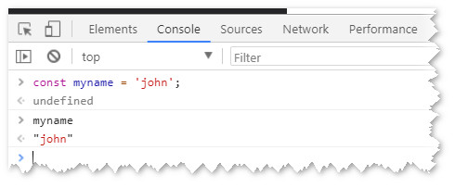
If we call on console myname it will come John.

But when we use curly brackets it then const is going to be scoped to that block.

Example:-
{
Const myname = ‘john’;
Console.log(name);
}

