

# INTRODUCTION

# Overview

# This is an application which we can use to get a daily news update, first the user has to create an account and then the user needs to login. User can click the headlines and see the short note of the news

* 1. Purpose

This project is used to get the latest news of the world. The news information ranges from trending sports, health technology, education, science and entertainment. You don’t need to go outside and buy a newspaper to see the trending news.

1. **PROBLEM DEFINITION & DESIGN THINKING**
   1. Empathy Map

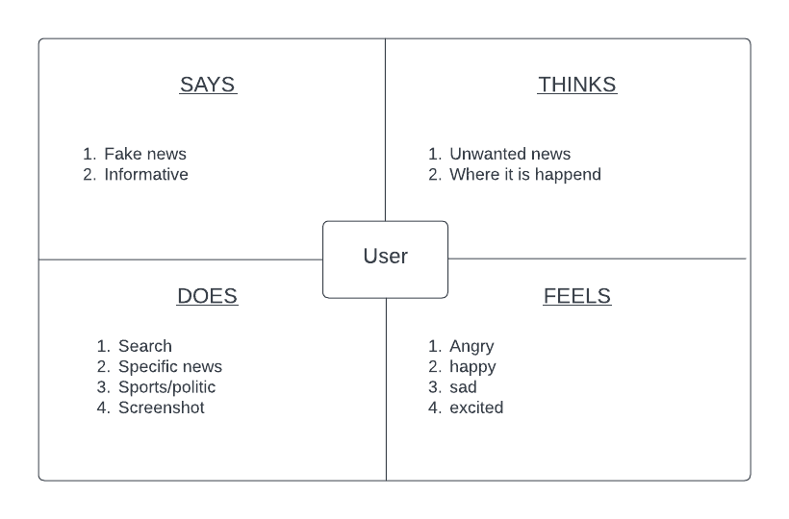

* 1. Ideation & Brainstorming Map

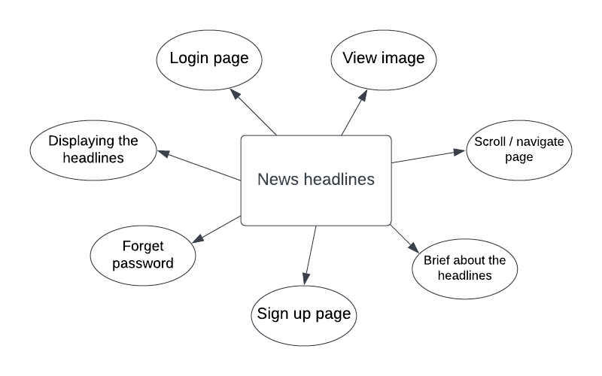

# RESULT

# Data Model

|  |  |
| --- | --- |
| **Object name** | **Fields in the Object** |
| Sign up | |  |  | | --- | --- | | Field label | Data type | | Username | String | | Password | String | | Email | String | |
| Log in | |  |  | | --- | --- | | Field label | Data type | | Username | String | | Password | String | |

# 

# The screenshots of your project activity along with the description.

# 

Sign Up :

It is a page where user have to register for creating new account for them , then only they can log in with that details

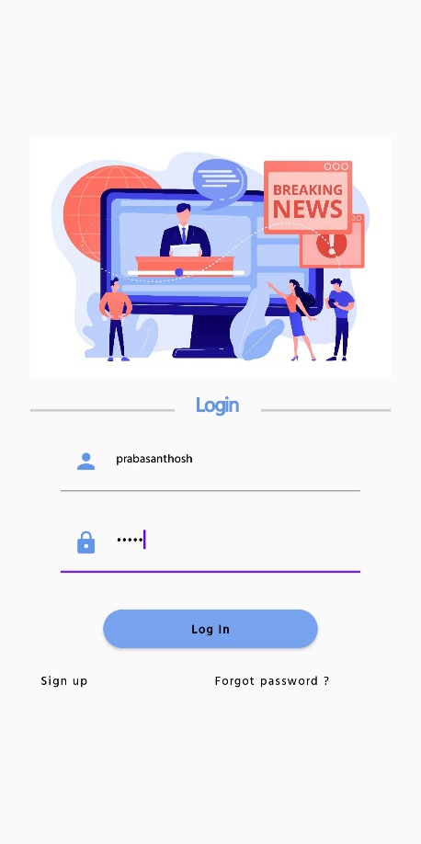

Login :

The user should enter a correct details to login

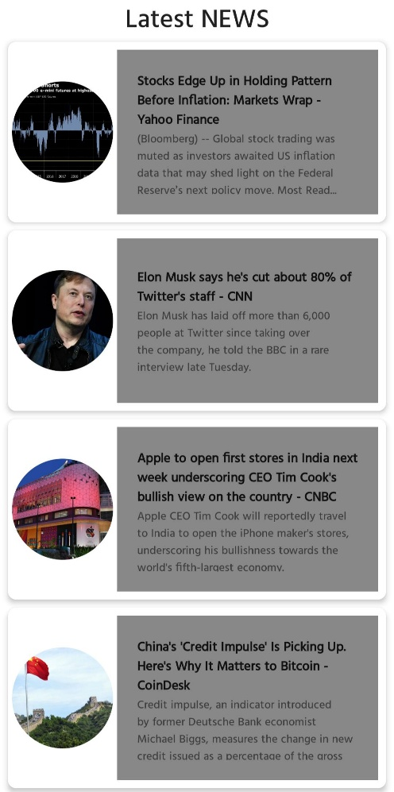

Lastest news :

In this page we can see the latest news headlines and some lines about it

Brief about then news :

In this page we can see the brief detail about the news

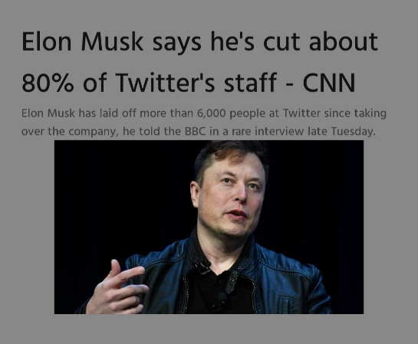

# GOOGLE DEVELOPER PROFILE PUBLIC URL

# Team lead – <https://g.dev/Mukesh31>

# Team member 1 - <https://g.dev/Ashok300>

# Team member 2 –

# <http://g.dev/akash27>

# Team member 3 - <https://g.dev/Sanjay200113>

1. **ADVANTAGES & DISADVANTAGE**

# Advantages :

# It makes the new available news in one place and user doesn’t have to search the news.

# The app is developed using android and hence it will be Userfriendly.

# Disadvantages :

# It doesn’t display a whole detailed news

# This application’s interface is little bad , we can improve it impressively

# APPLICATIONS

This application is used in Publishing online newspapers, news articles or the news sites so that news are available easily without any searches.

1. **CONCLUSION**

# This is an application which we can use to get a daily news update, first the user has to create an account and then the user needs to login. User can click the headlines and see the short note of the news . This project is used to get the latest news of the world. The news information ranges from trending sports, health technology, education, science and entertainment. You don’t need to go outside and buy a newspaper to see the trending news.

1. **FUTURE SCOPE**

We have an idea to improve this application , like display complete information about the news like where , when , how , who etc. . Also having an idea of increasing the user experience and user interface so the user can get a colorfull visuals.