Program 1:
Use Eclipse or Netbean platform and acquaint with the various menus. Create a test project, add a test class and run it. See how you can use auto suggestions, auto fill. Try code formatter and code refactoring like renaming variables, methods and classes. Try debug step by step with a small program of about 10 to 15 lines which contains at least one if else condition and a for loop.
About Eclipse IDE
In the context of computing, Eclipse is an integrated development environment (IDE) for developing applications using the Java programming language and other programming languages such as C/C++, Python, PERL, Ruby etc. The Eclipse platform which provides the foundation for the Eclipse IDE is composed of plug-ins and is designed to be extensible using additional plug-ins. Developed using Java, the Eclipse platform can be used to develop rich client applications, integrated development environments and other tools. Eclipse can be used as an IDE for any programming language for which a plug-in is available.
Opening the New Java Class wizard
You can use the New Java Class wizard to create a Java class. The Java Class wizard can be invoked in different ways:
- By clicking on the File menu and selecting New > Class
- By right clicking in the package explorer and selecting New > Class
- By clicking on the class drop down button ( ) and selecting class ( )
Before bringing up the New Java Class wizard, if possible, select the package in which the class is to be created so that the wizard can automatically fill in the package name for you.
Using the New Java Class wizard
Once the java class wizard comes up:
- Ensure the source folder and package are correct
- Enter the class name
- Select the appropriate class modifier
- Enter the super class name or click on the Browse button to search for an existing class
- Click on the Add button to select the interfaces implemented by this class
- Examine and modify the check boxes related to method stubs and comments
- Click on the Finish button
Program 2:
Write a java program that works as simple calculator . Use a grid layout to arrange buttons for the digits and for the +,-,*,% operations. add a textfield to display the result. Handle any possible exceptions like divide by zero
import java.awt.*;
import java.awt.event.*;
import java.applet.*;
/*
<applet code="Cal" width=300 height=300>
</applet>
*/
public class Cal extends Applet
implements ActionListener
{
String msg=" ";
int v1,v2,result;
TextField t1;
Button b[]=new Button[10];
Button add,sub,mul,div,clear,mod,EQ;
char OP;
public void init()
{
Color k=new Color(120,89,90);
setBackground(k);
t1=new TextField(10);
GridLayout gl=new GridLayout(4,5);
setLayout(gl);
for(int i=0;i<10;i++)
{
b[i]=new Button(""+i);
}
add=new Button("add");
sub=new Button("sub");
mul=new Button("mul");
div=new Button("div");
mod=new Button("mod");
clear=new Button("clear");
EQ=new Button("EQ");
t1.addActionListener(this);
add(t1);
for(int i=0;i<10;i++)
{
add(b[i]);
}
add(add);
add(sub);
add(mul);
add(div);
add(mod);
add(clear);
add(EQ);
for(int i=0;i<10;i++)
{
b[i].addActionListener(this);
}
add.addActionListener(this);
sub.addActionListener(this);
mul.addActionListener(this);
div.addActionListener(this);
mod.addActionListener(this);
clear.addActionListener(this);
EQ.addActionListener(this);
}
public void actionPerformed(ActionEvent ae)
{
String str=ae.getActionCommand();
char ch=str.charAt(0);
try
{
if ( Character.isDigit(ch))
t1.setText(t1.getText()+str);
else if(str.equals("add"))
{
v1=Integer.parseInt(t1.getText());
OP='+';
t1.setText("");
}
else if(str.equals("sub"))
{
v1=Integer.parseInt(t1.getText());
OP='-';
t1.setText("");
}
else if(str.equals("mul"))
{
v1=Integer.parseInt(t1.getText());
OP='*';
t1.setText("");
}
else if(str.equals("div"))
{
v1=Integer.parseInt(t1.getText());
OP='/';
t1.setText("");
}
else if(str.equals("mod"))
{
v1=Integer.parseInt(t1.getText());
OP='%';
t1.setText("");
}
if(str.equals("EQ"))
{
v2=Integer.parseInt(t1.getText());
if(OP=='+')
result=v1+v2;
else if(OP=='-')
result=v1-v2;
else if(OP=='*')
result=v1*v2;
else if(OP=='/')
result=v1/v2;
else if(OP=='%')
result=v1%v2;
t1.setText(""+result);
}
if(str.equals("clear"))
{
t1.setText("");
}
}
catch (Exception e)
{
t1.setText(e.toString());
}

}
}

OUTPUT:
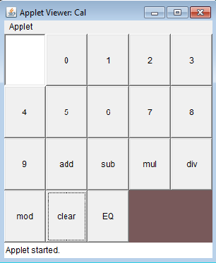 | 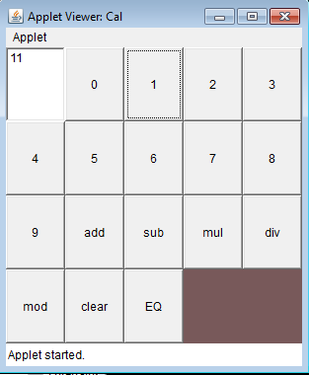
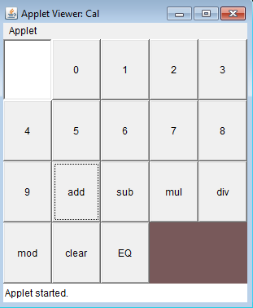 | 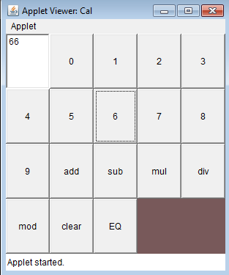
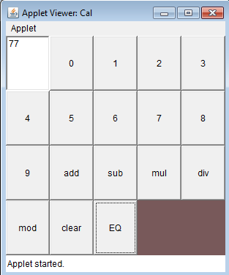

Program 3.
- Develop an applet in Java that displays a simple message
import java.awt.*;
import java.applet.*;
/*
<applet code="MyApplet" height=500 width=500>
</applet>
*/
public class MyApplet extends Applet
{
public void paint(Graphics g)
{
g.setColor(Color.red);
Font font = new Font("Serif", Font.PLAIN, 24);
g.setFont(font);
g.drawString("Welcome to applets",120,120);
}
}

OUTPUT:
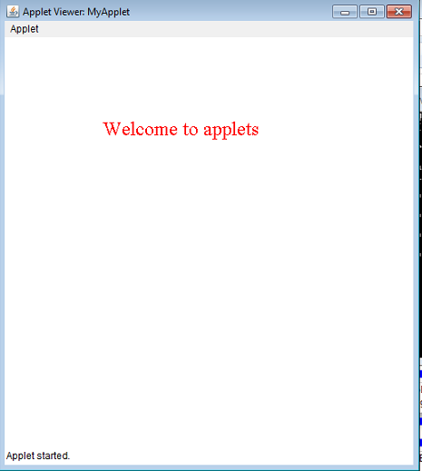

PROGRAM 3
b) Develop an applet in java that receives an integer in one text field, and computes its factorial value and returns it in another text field, when the button named Compute is clicked.
import java.applet.*;
import java.awt.*;
import java.awt.event.*;
public class EventApplet extends Applet implements ActionListener
{
Button b;
TextField tf,tf1;
public void init()
{
tf=new TextField("Eneter a value");
tf1=new TextField("Results will appear here");
tf.setBounds(30,40,150,20);
tf1.setBounds(30,80,150,20);
b=new Button("Compute ");
b.setBounds(80,150,60,50);
add(b);
add(tf);
add(tf1);
b.addActionListener(this);
setLayout(null);
}

public void actionPerformed(ActionEvent e)
{
int n,fact=1;
try
{
n=Integer.parseInt(tf.getText());
}
catch(Exception e1)
{
tf.setText(" Invalid Number Try Again");
return 0;
}
for(int i=1;i<=n;i++)
fact=fact*i;
tf1.setText("factorial is "+fact);
}
}

/*
<applet code="EventApplet" height=500 width=500>
</applet>
*/
OUTPUT: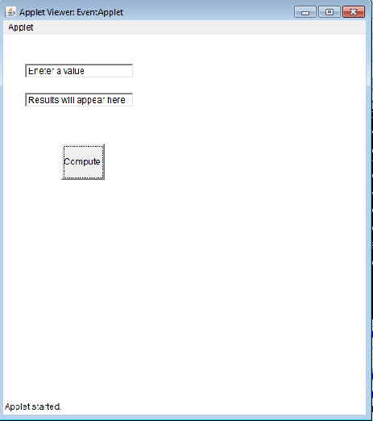 | 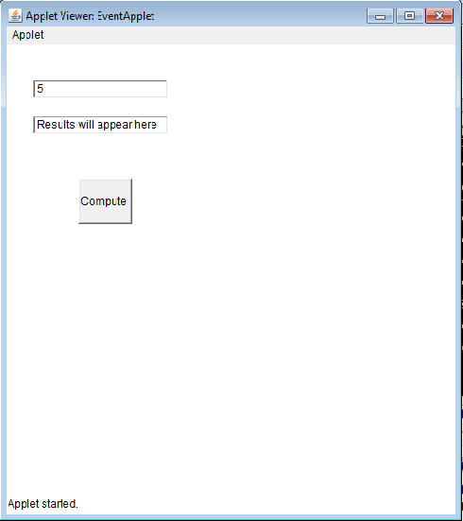
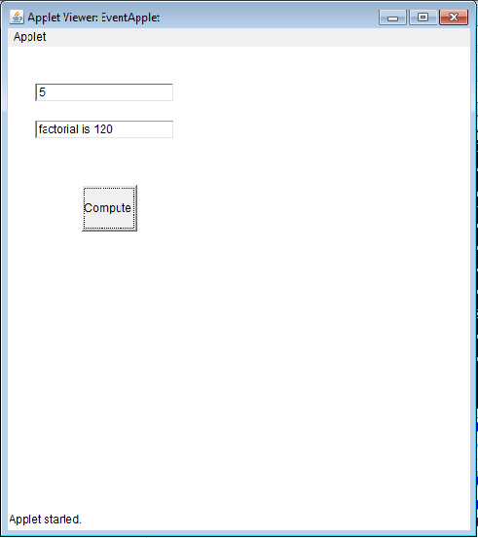

Program 4:
Write a java program that causes a user interface to perform integer divisions. the user enters two numbers in textfields Num1 and Num2 . the division of num1 and num2 is displayed in the result field when the divide button is clicked. if Num1 or num2 were not an integer , the program would through a NumberFormatException . If Num2 were zero , the program would through an arithmeticException . Display the exception in a message dialog box.
import javax.swing.JOptionPane;
import javax.swing.*;
import java.awt.*;

public class NumDiv extends JFrame
{
private JButton jButton1;
private JLabel jLabel1;
private JLabel jLabel2;
private JTextField t1;
private JTextField t2;
public NumDiv()
{
initComponents();
}
private void initComponents()
{
t1 = new JTextField();
t2 = new JTextField();
jLabel1 = new JLabel();
jLabel2 = new JLabel();
jButton1 = new JButton();
setLayout(new FlowLayout());
setSize(200,200);
setDefaultCloseOperation(javax.swing.WindowConstants.EXIT_ON_CLOSE);
t1.setColumns(10);
t2.setColumns(10);
jLabel1.setText("Enter first Number");
jLabel2.setText("Enter Second Number");
jButton1.setText("Divide");
jButton1.addActionListener(new java.awt.event.ActionListener()
{
public void actionPerformed(java.awt.event.ActionEvent evt)
{
jButton1ActionPerformed(evt);
}
}
add(jLabel1);
add(t1);
add(jLabel2);
add(t2);
add(jButton1);
}

private void jButton1ActionPerformed(java.awt.event.ActionEvent evt)
{
try
{
int n1=Integer.parseInt( t1.getText());
int n2=Integer.parseInt( t2.getText());
if(n2==0)
throw new ArithmeticException();
double n3=(double) n1/n2;
JOptionPane.showMessageDialog(rootPane, "Division results is: "+n3);
}
catch(NumberFormatException ne)
{
JOptionPane.showMessageDialog(rootPane, ne);
}
catch(ArithmeticException ne)
{
JOptionPane.showMessageDialog(rootPane, ne);
}
}
public static void main(String args[])
{
java.awt.EventQueue.invokeLater(new Runnable()
{
public void run()
{
new NumDiv().setVisible(true);
}
}
}
}
OUTPUT:
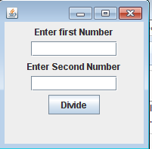 | 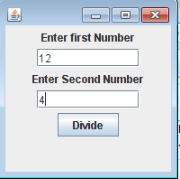
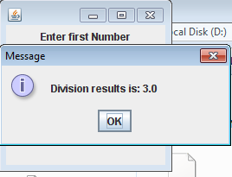 | 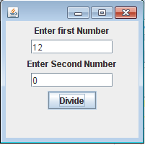
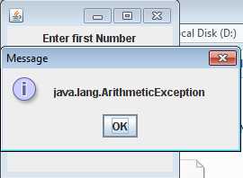 | 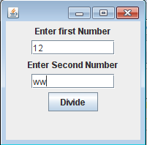
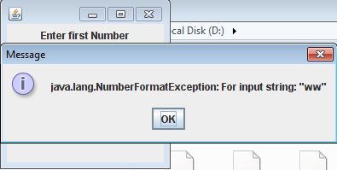

Program 5:
program on multi threading here we create three threads First thread will generate a random no, then second thread will print square of that number if it is Even Number,Third will print cube of given no if it is odd number....
import java.util.*;
class MultiThread
{
int n=0;
boolean n_set=false;
public void n_set()
{
Random r=new Random();
while(n_set==true)
n=r.nextInt(100);
n_set=true;
System.out.println("Random no is "+n);
try
{
Thread.sleep(1000);
}
catch(Exception e){}
}
public void n_sq()
{
if(n_set==true && n%2==0)
{
System.out.println("square of given "+n+" is"+n*n);
n_set=false;
}
}

public void n_cube()
{
if(n_set==true && (n%2)!=0)
{
System.out.println("cube of given "+n+" is"+n*n*n);
n_set=false;
}
}
}
class M11
{
public static void main(String a[])
{
final MultiThread l=new MultiThread();
final Thread t1 = new Thread();
public void run()
{
while(true)
{
l.n_set();
}
}
}

t1.start();
Thread t2 =new Thread();
public void run()
{
while(true)
l.n_sq();
}}
t2.start();
Thread t3 = new Thread();
public void run()
{
while(true)
l.n_cube();
}
}
t3.start();
}
}

OUTPUT: 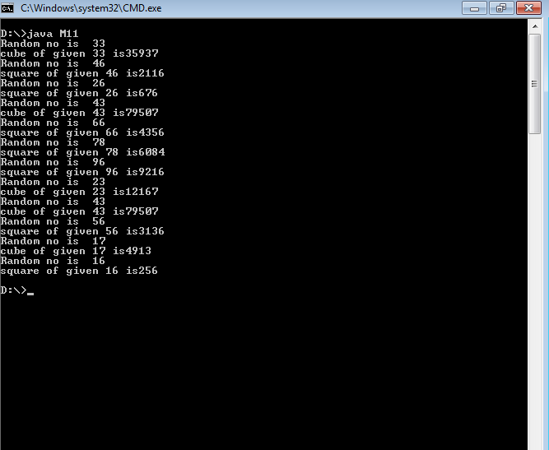
Program 6
Write a Java program for the following:
i) Create a doubly linked list of elements.
ii) Delete a given element from the above list.
iii) Display the contents of the list after deletion.

// Java program to create and delete a node from doubly linked list

class LinkedList {

static Node head = null;

class Node
{
int data;
Node next, prev;

Node(int d)
{
data = d;
next = prev = null;
}
}

/*Function to delete a node in a Doubly Linked List.
head_ref --> pointer to head node pointer.
del --> pointer to node to be deleted. */
void deleteNode(Node head_ref, Node del) {

/* base case */
if (head == null || del == null) {
return;
}

/* If node to be deleted is head node */
if (head == del) {
head = del.next;
}

/* Change next only if node to be deleted is NOT the last node */
if (del.next != null)
{
del.next.prev = del.prev;
}

/* Change prev only if node to be deleted is NOT the first node */
if (del.prev != null)
{
del.prev.next = del.next;
}

/* Finally, free the memory occupied by del*/
return;
}

/* UTILITY FUNCTIONS */
/* Function to insert a node at the beginning of the Doubly Linked List */
void push(Node head_ref, int new_data)
{
/* allocate node */
Node new_node = new Node(new_data);

/* since we are adding at the begining,
prev is always NULL */
new_node.prev = null;

/* link the old list off the new node */
new_node.next = (head);

/* change prev of head node to new node */
if ((head) != null) {
(head).prev = new_node;
}

/* move the head to point to the new node */
(head) = new_node;
}

/*Function to print nodes in a given doubly linked list
This function is same as printList() of singly linked lsit */
void printList(Node node)
{
while (node != null) {
System.out.print(node.data + " ");
node = node.next;
}
}

public static void main(String[] args)
{
LinkedList list = new LinkedList();

/* Let us create the doubly linked list 10<->8<->4<->2 */
list.push(head, 2);
list.push(head, 4);
list.push(head, 8);
list.push(head, 10);

System.out.println("Original Linked list ");
list.printList(head);

/* delete nodes from the doubly linked list */
list.deleteNode(head, head); /*delete first node*/

list.deleteNode(head, head.next); /*delete middle node*/

list.deleteNode(head, head.next); /*delete last node*/
System.out.println("");

/* Modified linked list will be NULL<-8->NULL */
System.out.println("Modified Linked List");
list.printList(head);
}
}

Output:

Original Linked list
10 8 4 2
Modified Linked List
8

Program 7:
Write a java program that simulates a traffic light. the program lets the user select one of the three lights : red,Yellow,Green with radio buttons. On selecting a button, an appropriate message with Stop or Ready Or GO should appear above button in selected color Initially there is no message shown.
import java.applet.*;
import java.awt.event.*;
import java.awt.*;
/*
<applet code="TraficLight" height=500 width=500> </applet>
*/
public class TraficLight extends Applet
implements ItemListener
{
CheckboxGroup cg1 = new CheckboxGroup ();
public void init()
{
Checkbox c1,c2,c3;
setBackground(Color.black);
c1=new Checkbox ("RED", cg1, false);
c1.setBackground(Color.red);
c2=new Checkbox ("GREEN", cg1, false);
c2.setBackground(Color.green);
c3=new Checkbox ("YELLOW", cg1, false);
c3.setBackground(Color.yellow);
c1.addItemListener(this);
c2.addItemListener(this);
c3.addItemListener(this);
add (c1);
add (c2);
add (c3);
}
public void itemStateChanged(ItemEvent e)
{
repaint();
}
public void paint(Graphics g)
{
Checkbox chk = cg1.getSelectedCheckbox();
if(chk.getLabel()=="YELLOW")
{
g.setColor(Color.yellow);
g.drawString(chk.getLabel() + " is selected : READY TO GO", 10 ,70);
}
if(chk.getLabel()=="RED")
{
g.setColor(Color.red);
g.drawString(chk.getLabel() + " is selected : STOP", 10 ,70);
}
if(chk.getLabel()=="GREEN")
{ g.setColor(Color.green);
g.drawString(chk.getLabel() + " is selected : GO ", 10 ,70);
}
g.fillOval(10,100,50,50);
}
}
OUTPUT:
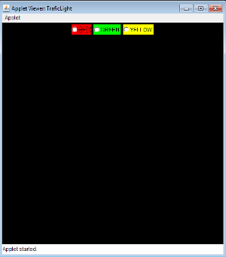 | 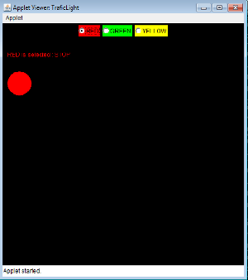
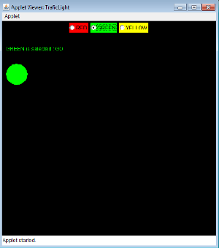 | 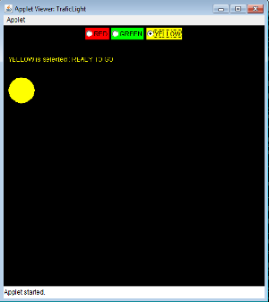

Program 8:
Write a java program to create an abstract class named Shape that contains two integers and empty method named printArea() Provide three classes named rectangle,triangle and circle such that each one of the classes extends the class shape each one of the classes contains only the method printarea() that prints the area of the given shape
abstract class shape
{
int l,b;
abstract public void printArea();
}
class rectangle extends shape
{
rectangle(int l,int b)
{
super.l=l;
super.b=b;
}
public void printArea()
{
System.out.println("area of rectangle is: "+l*b);
}
}
class triangle extends shape
{
triangle(int l,int b)
{
super.l=l;
super.b=b;
}
public void printArea()
{
System.out.println("area of triangle is: "+05.*l*b*b);
}
}
class circle extends shape
{
int r;
circle(int r)
{
this.r=r;
}
public void printArea()
{
System.out.println("area of circle is: "+22.7*r*r);
}
}
class shape1Demo
{
public static void main(String[] a)
{
rectangle ob1=new rectangle(10,20);
triangle ob2=new triangle(10,20);
circle ob3=new circle(20);
ob1.printArea();
ob2.printArea();
ob3.printArea();
}
}

OUTPUT:
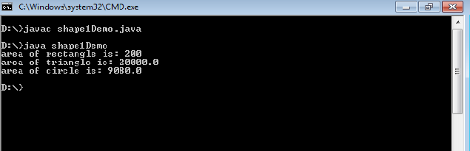
Program 9:
Suppose that a table named Table.txt is stored in a text file. The first line in the file is the header, and the remaining lines correspond to rows in the table. The elements are separated by commas. Write a java program to display the table using Labels in Grid Layout.
import java.awt.* ;
import java.awt.event.* ;
import javax.swing.* ;
public class JTableDemo extends JApplet
{
public void init( )
{
Container c =getContentPane( );
c.setLayout(new BorderLayout( ));
String fields [ ]={"empid "," empname ","empsal"} ;
Object details [][] = {{" 1" ,"Nataraj" ,"4500.50 "} , {"2","ravi" ," 4567.50 "} ,
{"3","raja","2246.30"},{"4","sita","3245.75"},
{"5"," Jyostna " ,"2500.25"}
} ;
JTable jt = new JTable( details, fields ) ;
int v = ScrollPaneConstants.VERTICAL_SCROLLBAR_AS_NEEDED ; // if the rows are more than
int h = ScrollPaneConstants.HORIZONTAL_SCROLLBAR_AS_NEEDED ; // height of the applet,
JScrollPanejsp = new JScrollPane(jt); // scroll bar is added
c.add(jsp , BorderLayout.SOUTH ) ;
}
}
/*
<APPLET ALIGN="CENTER" CODE="JTableDemo.class" WIDTH=500 HEIGHT=500></APPLET>
*/

OUTPUT:
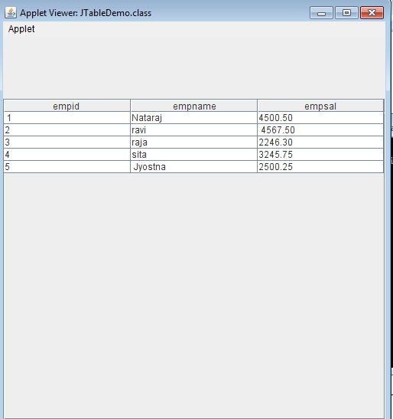
Program 10:
Write a java program that handles all mouse events and shows the event name at the center of the window when a mouse event is fired(Use Adapter classes)
import java.awt.event.*;
import java.awt.*;
import java.applet.*;
public class MouseEv1 extends Applet
{
String msg="welcome";
public void init()
{
addMouseListener(new InnerCls1());
addMouseMotionListener(new InnerCls2());
}
public void paint(Graphics g)
{
Dimension d=getSize();
g.drawString(msg,(getWidth()/2)-msg.length()/2,(getHeight()/2));
}
class InnerCls2 extends MouseMotionAdapter
{
public void mouseMoved(MouseEvent me)
{
msg="mouseMoved"+me.getX()+"'"+me.getY();
repaint();
}

public void mouseDragged(MouseEvent me)
{
msg="mouseDragged"+me.getX()+"'"+me.getY();
repaint();
}
}
class InnerCls1 extends MouseAdapter
{
public void mouseClicked(MouseEvent me)
{
msg="Mouse Clicked at "+me.getX()+"'"+me.getY();
repaint();
}
public void mousePressed(MouseEvent me)
{
msg="Mouse Pressed at "+me.getX()+"'"+me.getY();
repaint();
}
public void mouseReleased(MouseEvent me)
{
msg="Mouse released at "+me.getX()+"'"+me.getY();
repaint();
}
public void mouseEntered(MouseEvent me)
{
msg="mouseEntered"+me.getX()+"'"+me.getY();
repaint();
}
public void mouseExited(MouseEvent me)
{
msg="mouseExited"+me.getX()+"'"+me.getY();
repaint();
}
}
}
/*
<applet code="MouseEv1" height=500 width=500></applet>
*/
OUTPUT:
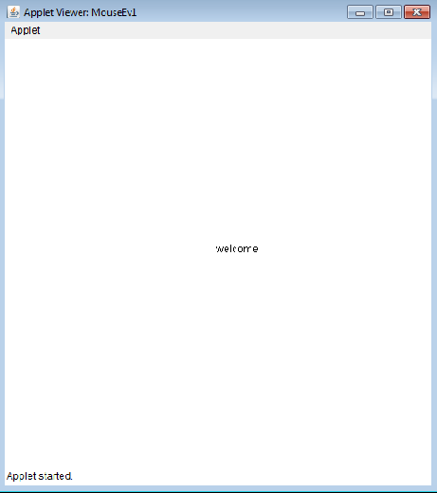
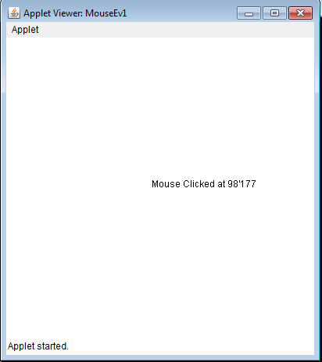
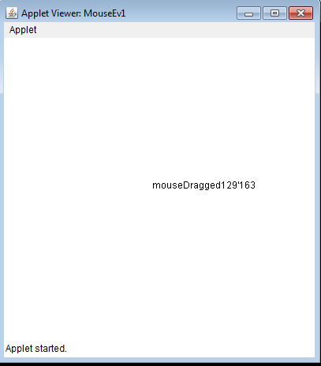
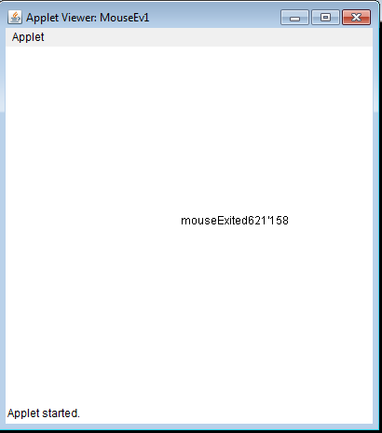
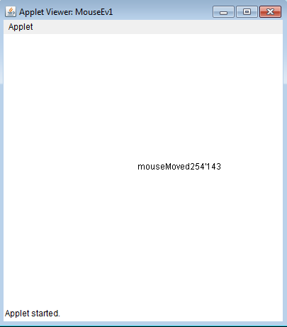
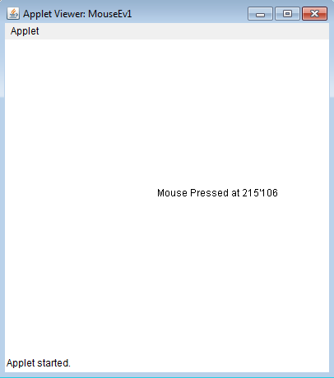

Program 11:
Write a java program that loads names and phone numbers from the text file where data is organized as one line per record and each field in record are separated by a tab(\t).It takes a name or phone number as input and prints corresponding other value from hash table(hint: use Hash Table)
import java.util.*;
import java.io.*;
public class Hashtbl {
public static void main(String[] args)
{
try
{
FileInputStream fs = new FileInputStream("D:\\ph.txt");
Scanner sc = new Scanner(fs).useDelimiter("\\s+");
Hashtable<String, String> ht = new Hashtable<String, String>();
String[] arrayList;
String a;
System.out.println("HASH TABLE IS");
System.out.println("--------------------------");
System.out.println("KEY : VALUE");
while (sc.hasNext())
{
a = sc.nextLine();
arrayList = a.split("\\s+");
ht.put(arrayList[0], arrayList[1]);
System.out.println(arrayList[0] + ":" + arrayList[1]);
}

System.out.println("----MENU------");
System.out.println("----1.Search by Name------");
System.out.println("----2.Search by Mobile------");
System.out.println("----3.Exit------");
String opt = "";
String name, mobile;
Scanner s = new Scanner(System.in);
while (opt != "3")
{
System.out.println("Enter Your Option 1,2,3");
opt = s.next();
switch (opt)
{
case "1":
System.out.println("Enter Name");
name = s.next();
if (ht.containsKey(name))
{
System.out.println("Mobile is " + ht.get(name));
}
else
{
System.out.println("Not Found");
}
break;

case "2":
System.out.println("Enter mobile");
mobile = s.next();
if (ht.containsValue(mobile)) {
for (Map.Entry e : ht.entrySet()) {
if (mobile.equals(e.getValue())) {
System.out.println("Name is " + e.getKey());
}
}
} else {
System.out.println("Not Found");
}
}
break;
case "3": {
opt = "3";
System.out.println("Menu Successfully Exited");
}
break;
default:
System.out.println("Choose Option betwen 1 and Three");
break;
}
}
} catch (Exception ex) {
System.out.println(ex.getMessage());
}}}
OUTPUT:
HASH TABLE IS
KEY : VALUE
PRA 1236
RAP 2034
----MENU------
----1.Search by Name------
----2.Search by Mobile------
----3.Exit------
Enter Your Option 1,2,3
1
Enter Name: PRA
Mobile is 1236
Enter Your Option 1,2,3
2
Enter mobile 2034
Name is RAP

Program 12:

Write a Java program that correctly implements the producer – consumer problem using the concept of interthread communication.

class Q
{
int n;
boolean valueSet=false;
synchronized int get()
{
if(!valueSet)
try
{
wait();
}
catch(InterruptedException e)
{
System.out.println("Interrupted Exception caught");
}
System.out.println("Got:"+n);
valueSet=false;
notify();
return n;
}
synchronized void put(int n)
{
if(valueSet)
try
{
wait();
}
catch(InterruptedException e)
{
System.out.println("Interrupted Exception caught");
}
this.n=n;
valueSet=true;
System.out.println("Put:"+n);
notify();
}
}
class Producer implements Runnable
{
Q q;
Producer(Q q)
{
this.q=q;
new Thread(this,"Producer").start();
}
public void run()
{
int i=0;
while(true)
{
q.put(i++);
}
}
}
class Consumer implements Runnable
{
Q q;
Consumer(Q q)
{
this.q=q;
new Thread(this,"Consumer").start();
}
public void run()
{
while(true)
{
q.get();
}
}
}
class ProdCons
{
public static void main(String[] args)
{
Q q=new Q();
new Producer(q);
new Consumer(q);
System.out.println("Press Control-c to stop");
}
}

Output:
Put:1
Got:1
Put:2
Got:2
Put:3
Got:3
Put:4
Got:4
Put:5
Got:5
Put:6
Got:6
Put:7
Got:7
Put:8
Got:8
Put:9
Got:9
Put:10
Got:10
Program 13:
Write a Java program to list all the files in a directory including the files present in all its subdirectories.
import java.io.File;
public class ListDirectoryRecurisve {
public void listDirectory(String dirPath, int level) {
File dir = new File(dirPath);
File[] firstLevelFiles = dir.listFiles();
if (firstLevelFiles != null && firstLevelFiles.length > 0) {
for (File aFile : firstLevelFiles) {
for (int i = 0; i < level; i++) {
System.out.print("\t");
}
if (aFile.isDirectory()) {
System.out.println("[" + aFile.getName() + "]");
listDirectory(aFile.getAbsolutePath(), level + 1);
} else {
System.out.println(aFile.getName());
}
}
}
}
public static void main(String[] args) {
ListDirectoryRecurisve test = new ListDirectoryRecurisve();
String dirToList = System.getProperty("user.home") + File.separator + "Documents";
test.listDirectory(dirToList, 0);
}}

