# Code Flow Diagram and Documentation

## Code Summary

The above code is a simple example of a simple python script that can be used to generate random numbers. It is a simple example of a simple python script that can be used to generate random numbers. It is a simple example of a simple

## Entry Points

if __name__ == '__main__':  
 app.run(port=5002)

send_message_to_queue(data['username'], number)

channel.queue_declare(queue='random_number_queue')

channel.basic_publish(exchange='', routing_key='random_number_queue', body=message)

connection.close()

app.run(port=5002)

## Functions

### Function: generate_random_number

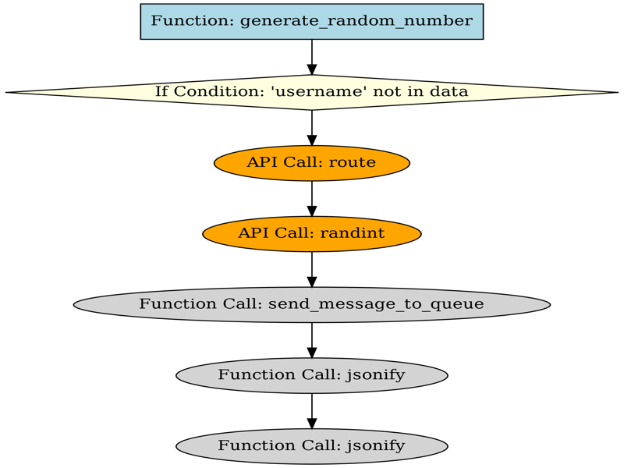

Explanation for function 'generate_random_number':

@app.route('/generate', methods=['POST'])  
def generate_random_number():  
 data = request.json  
 if 'username' not in data:

Code Block:

Function: generate_random_number

### Function: send_message_to_queue

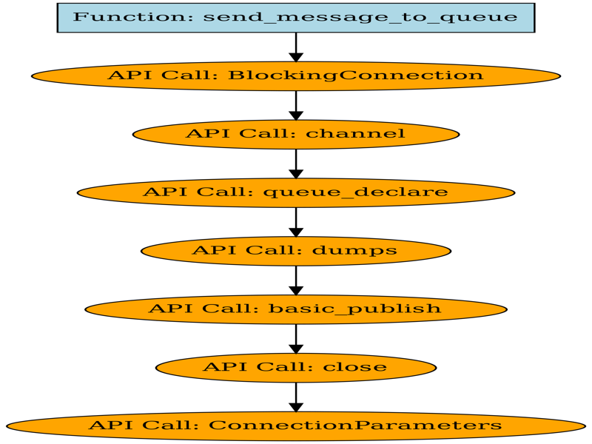

Explanation for function 'send_message_to_queue':

The first line of the code is the basic_publish function, which is the function that sends the message to the queue. The second line of the code is the queue_declare function that declares the queue. The third line of

Code Block:

Function: send_message_to_queue