**Step 1: Log in to the Azure Portal**

1. Open your web browser and go to the [Azure Portal](https://portal.azure.com).
2. Log in with your Azure credentials.

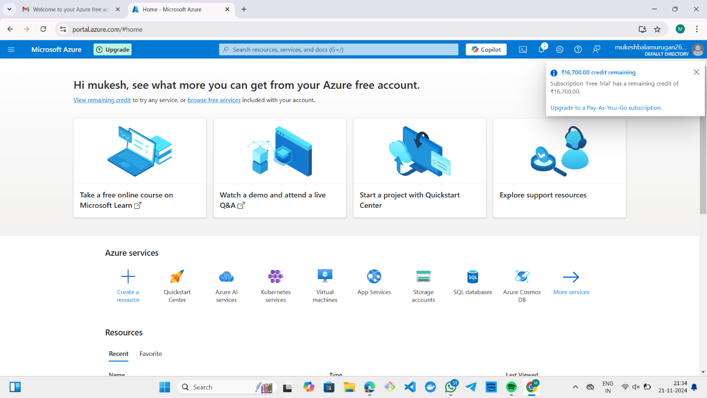

**Step 2: Access the Virtual Machine Service**

1. In the Azure Portal dashboard, click on **"Create a resource"** or search for **"Virtual Machines"** in the search bar.
2. Click on **"Virtual Machines"** from the search results.

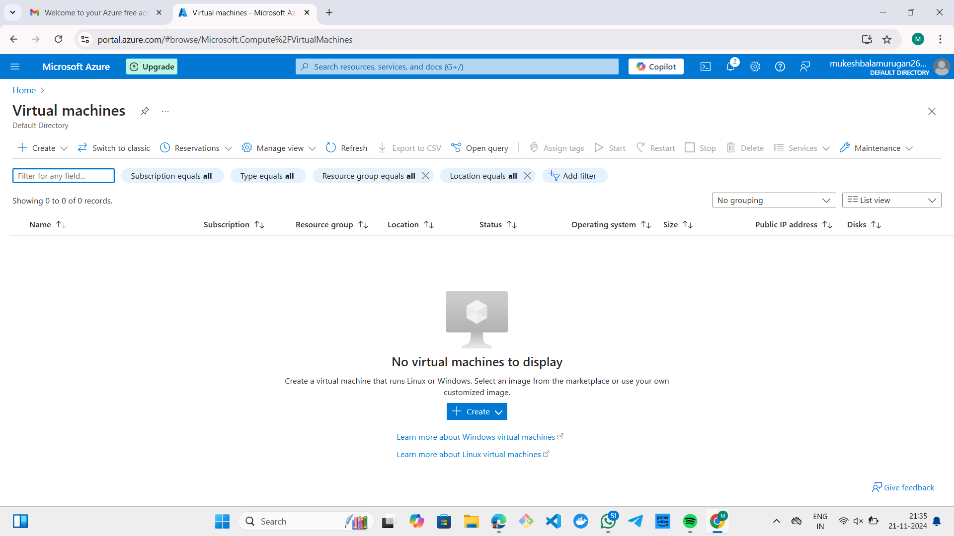

**Step 3: Create a New Virtual Machine**

1. Click the **"Create"** button and choose **"Virtual machine"** to start the creation process.
2. You'll be directed to the **"Create a virtual machine"** page.

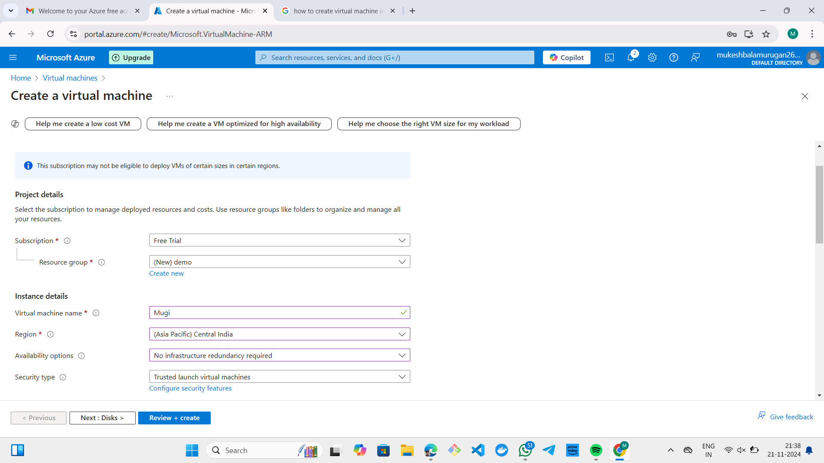

**Step 4: Configure Basic Settings**

1. **Subscription**: Select the appropriate Azure subscription if you have multiple.
2. **Resource Group**: Choose an existing resource group or click **"Create new"** to create a new one.
3. **Virtual Machine Name**: Enter a name for your VM (e.g., "MyFirstVM").
4. **Region**: Select the Azure region where you want to host the VM.
5. **Availability Options**: Choose if you want high availability using Availability sets or Zones.
6. **Image**: Select the operating system image you want for the VM (e.g., Windows Server, Ubuntu, etc.).
7. **Size**: Choose the size (CPU, RAM) of the VM. Click **"Change size"** if you want to explore more configurations.
8. **Authentication Type**: Choose Password or SSH public key for authentication.
   * For **Password**: Enter a username and password.
   * For **SSH public key**: Provide the public key.

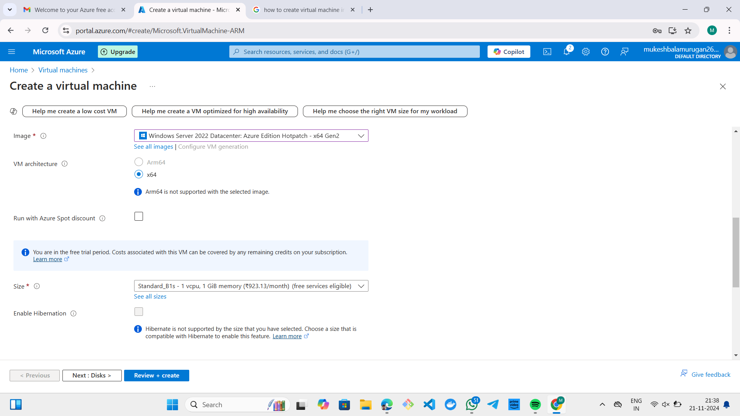

**Step 5: Review and Create**

1. Click the **"Review + create"** button.
2. Azure will validate the configuration. If everything is correct, you’ll see a green check mark.
3. Review the settings and click **"Create"** to start the deployment.

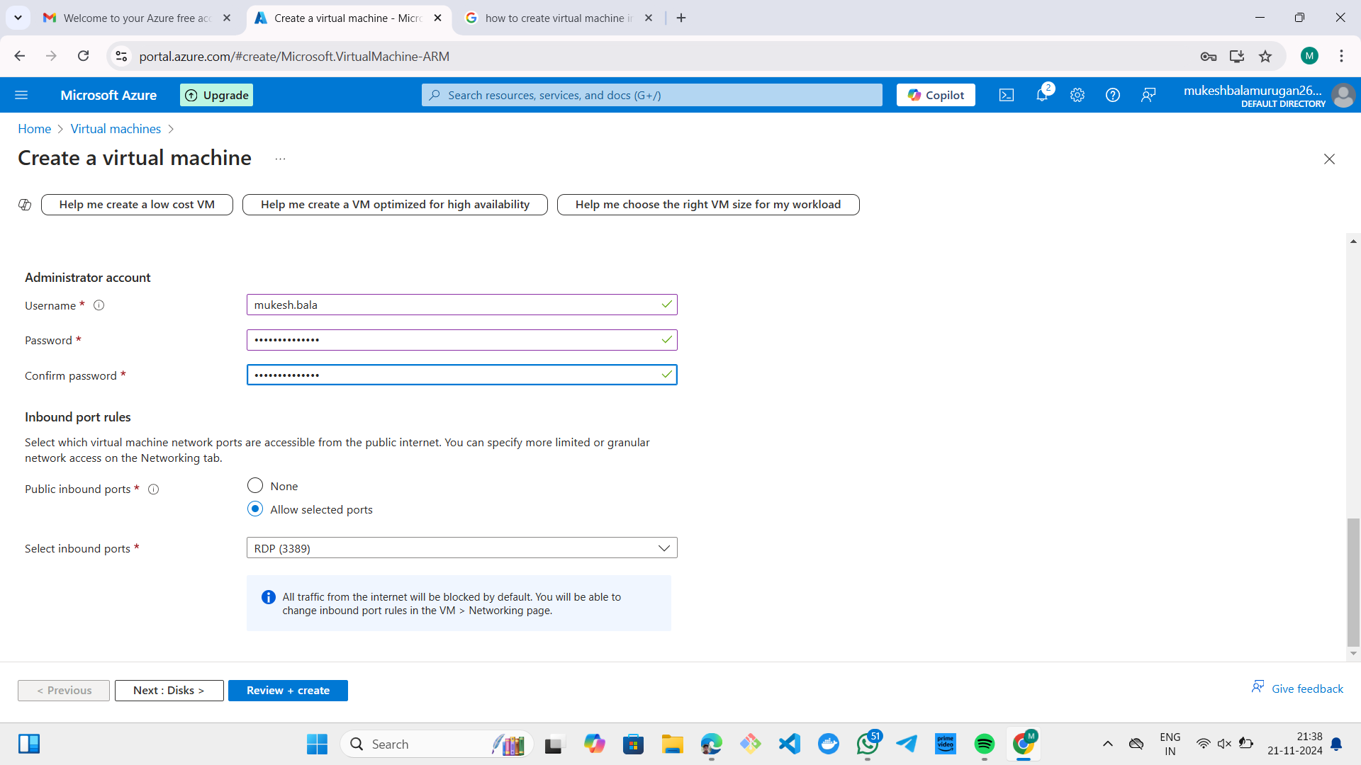

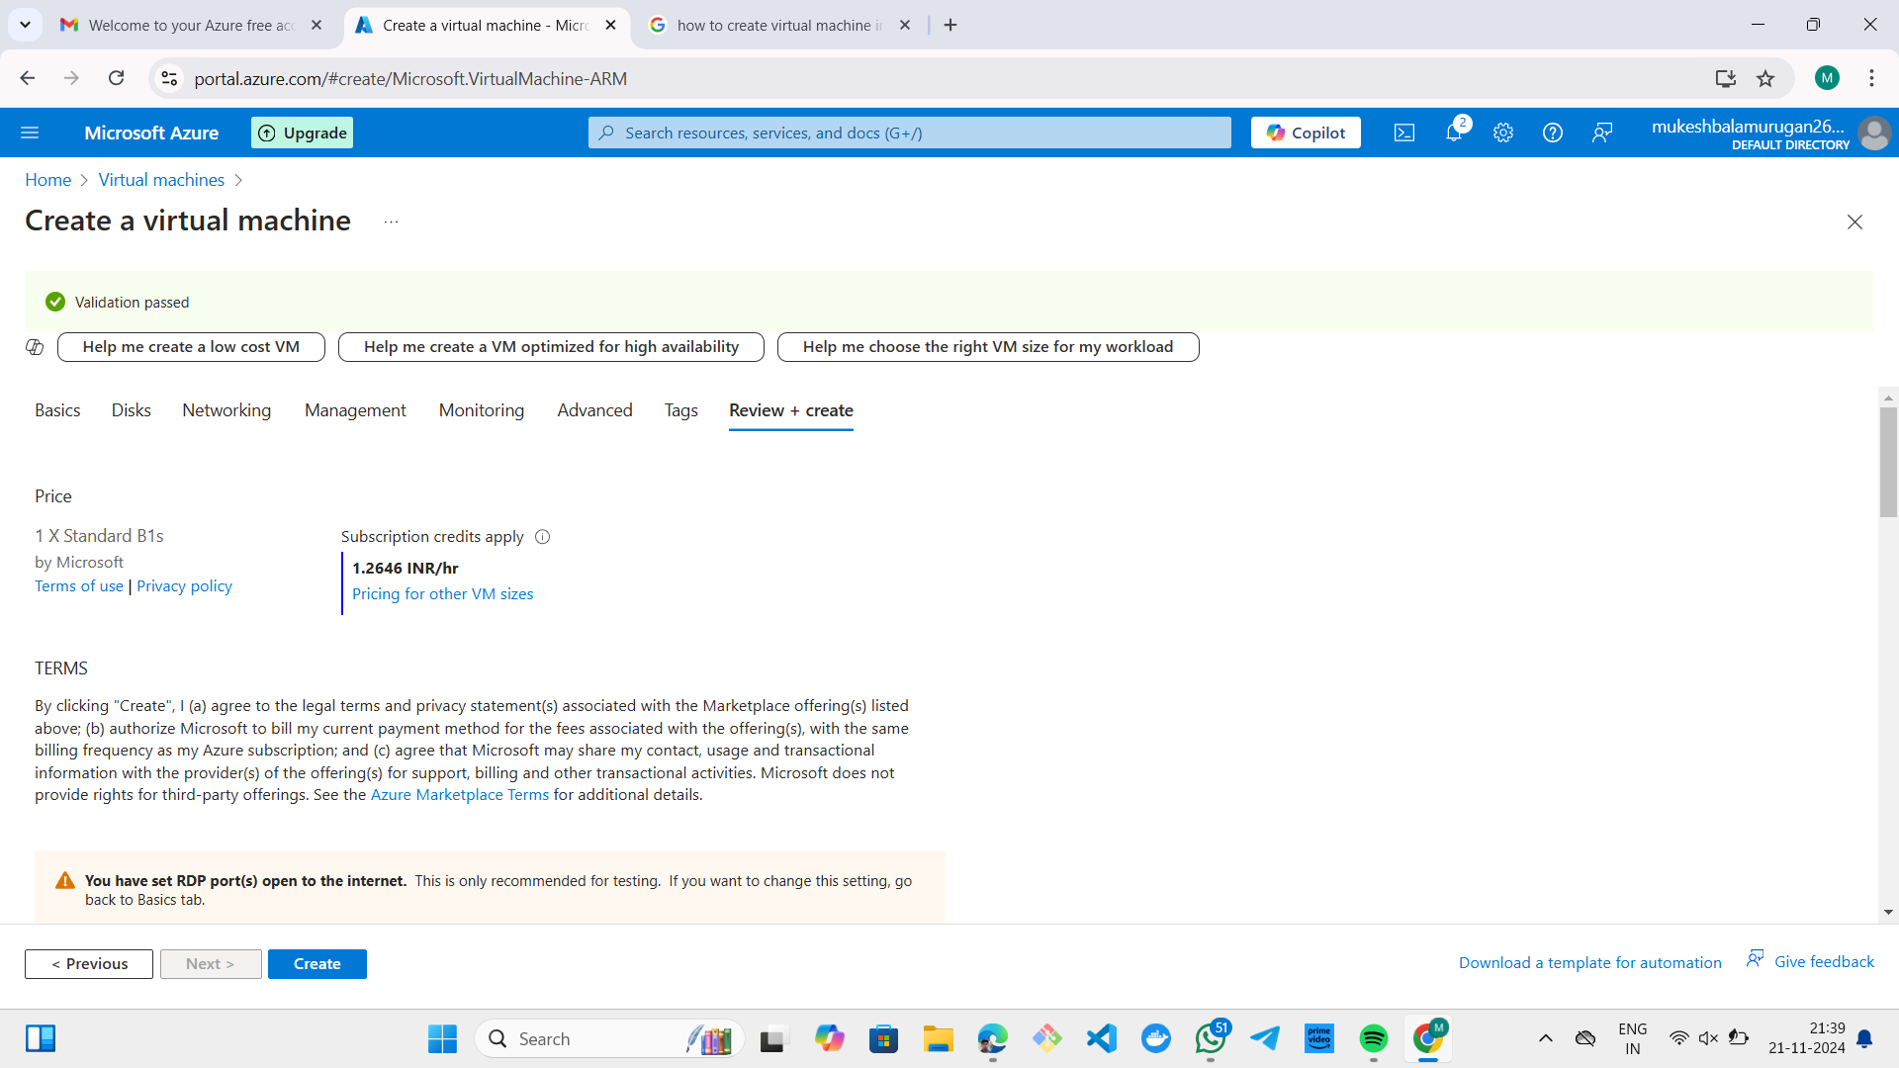

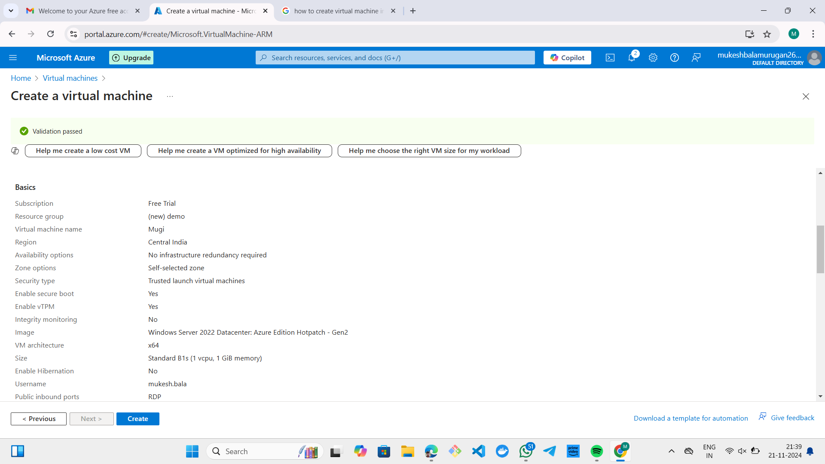

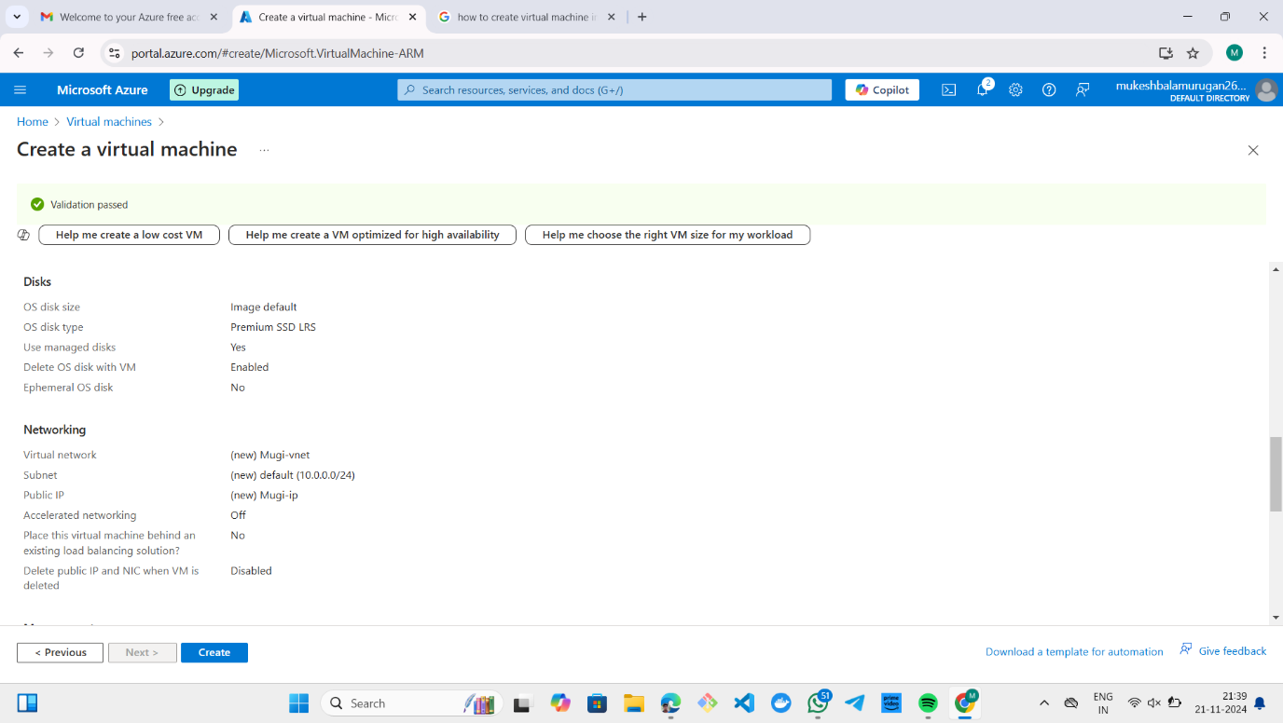

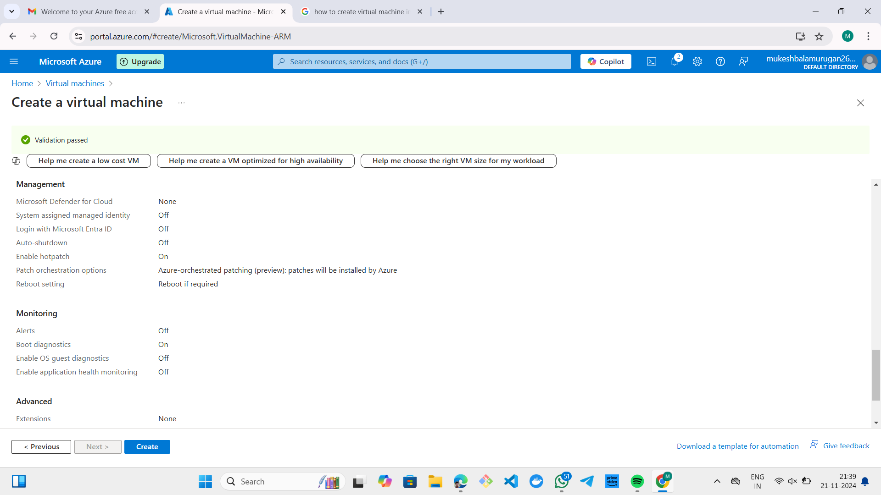

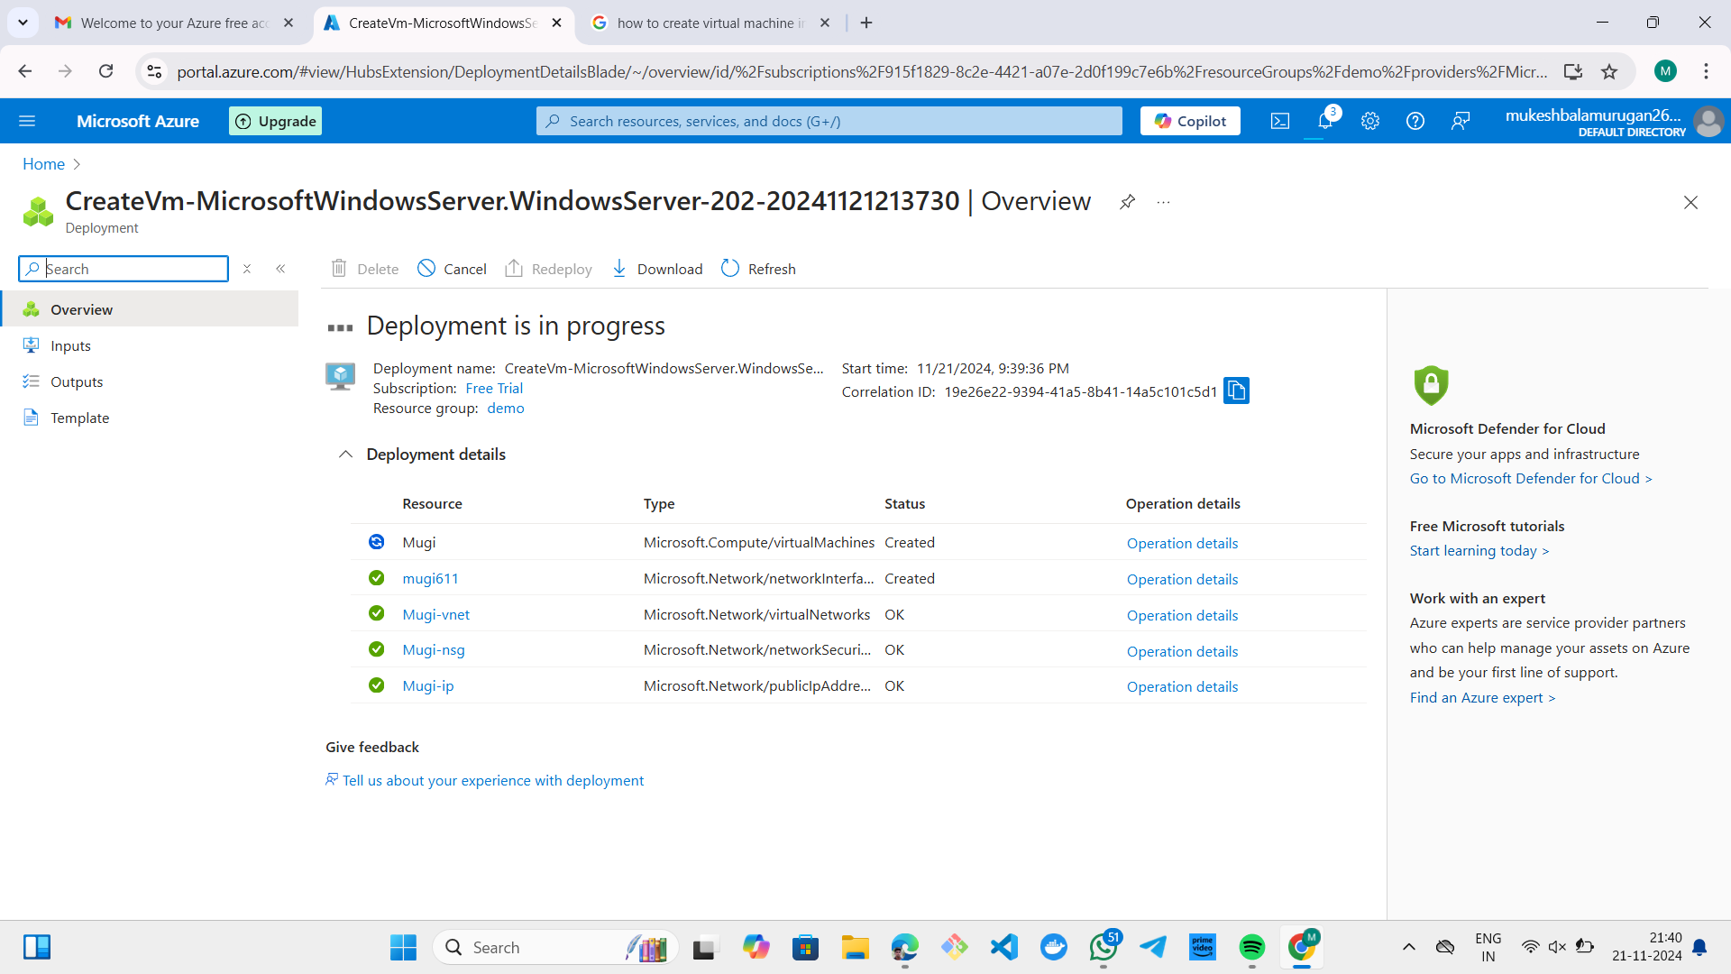

**Step 6: Deployment and Access**

1. Azure will begin the deployment, and you'll see the status.
2. Once the VM is created, go to the **"Virtual Machines"** section in the Azure Portal.
3. Click on your VM to view details. You can get the **Public IP Address** from the Overview page.
4. Use the **Public IP Address** to connect to the VM using Remote Desktop (RDP) for Windows or SSH for Linux, depending on your configuration.

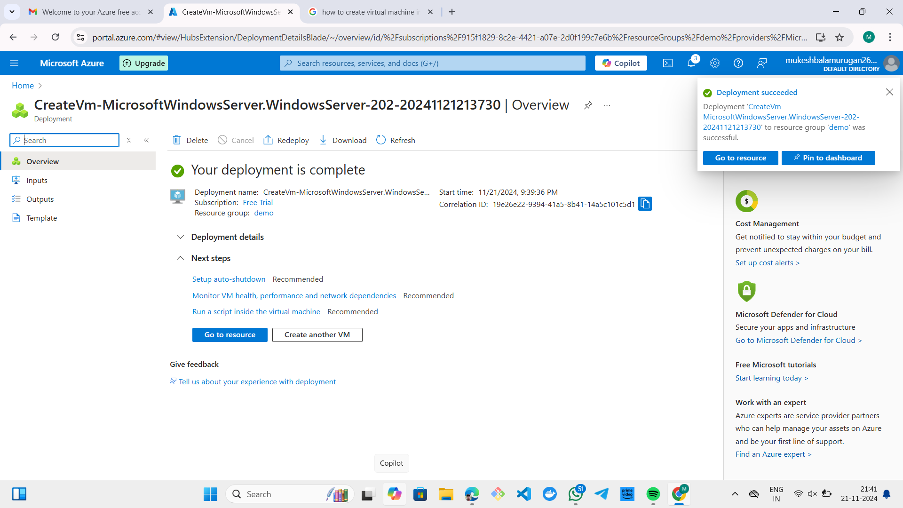

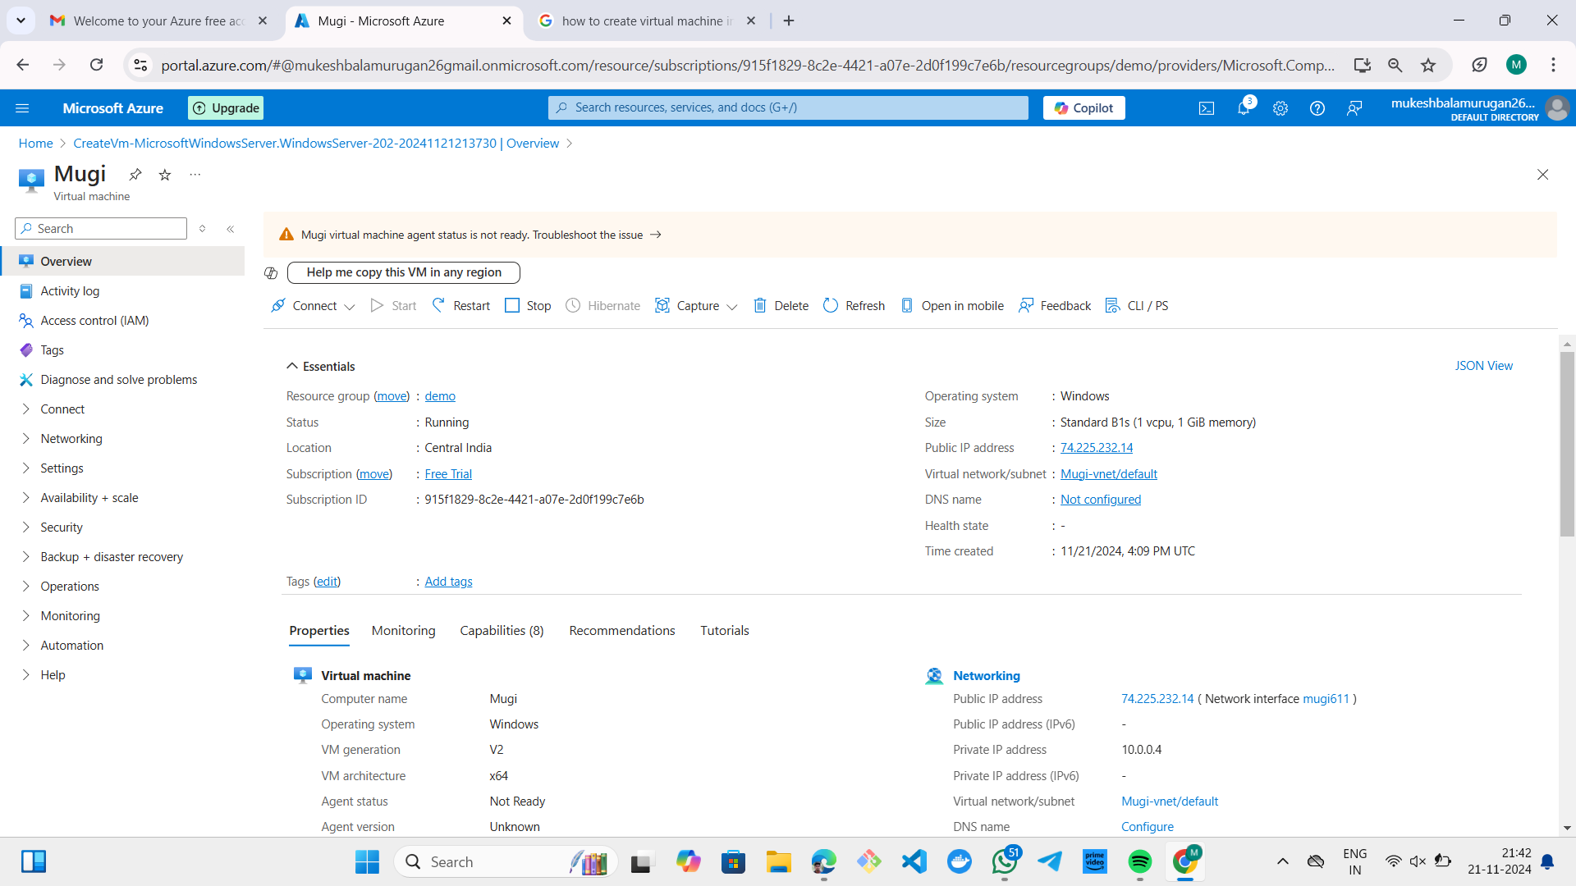

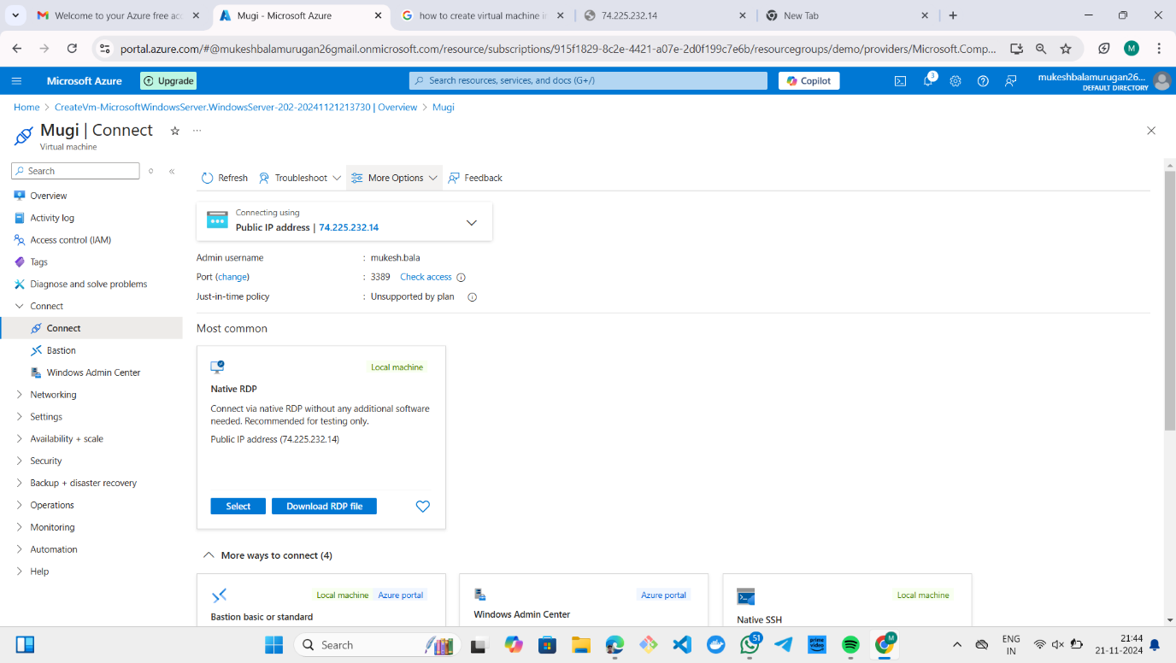

**Step 7: Virtual Machine Created**

**Step 8: Deleting virtual machine:**

