MANAV RACHNA INTERNATIONAL INSTITUTE OF RESEARCH AND STUDIES

**SCHOOL OF COMPUTER APPLICATIONS DEPARTMENT OF COMPUTER APPLICATIONS**

Text Box

|  |  |
| --- | --- |
| **STUDENT NAME** | Mukesh dagar |
| **ROLL NO** | **24/SCA/BCA(AI&ML)/042** |
| **PROGRAMME** | **BACHELOR OF COMPUTER APPLICATION** |
| **SEMESTER** | **1st SEMESTER** |
| **SECTION/GROUP** | **1B AI/ML/G1** |
| **DEPARTMENT** | **COMPUTER APPLICATION** |
| **BATCH** | **2024-27** |

Q1: **Create a table called employee with the following structure?**

**a. Add a column commission with domain to the Employee table.**

**b. Insert any five records into the table.**

**c. Update the column details of job**

**d. Rename the column of Employ table using alter command.**

**e. Delete the employee whose empno is 19.**

**Ans:**

**create table Employee (Emp_No number primary key, Ename varchar2(30), Job varchar2(30), Mgr number, Salary number);**

**insert into Employee values (01, 'Monika', 'software developer',100,100000);**

**insert into Employee values (02, 'sanaya', 'software Designer', 200, 200000);**

**insert into Employee values (03, 'priya', 'web developer', 300, 300000);**

**insert into Employee values (04, 'mia', 'Ai developer',400, 50000);**

**insert into Employee values (19, 'ria', 'Data Manager',500,40000);**

**select * from Employee;**

**Alter table Employee add (comission number);**

**update Employee set job='web designer' where Ename='Saksham';**

**alter table Employee Rename column Emp_No to E_no;**

**select from Employee;**

**Delete from Employee where E_no=19;**

**select from Employee;**

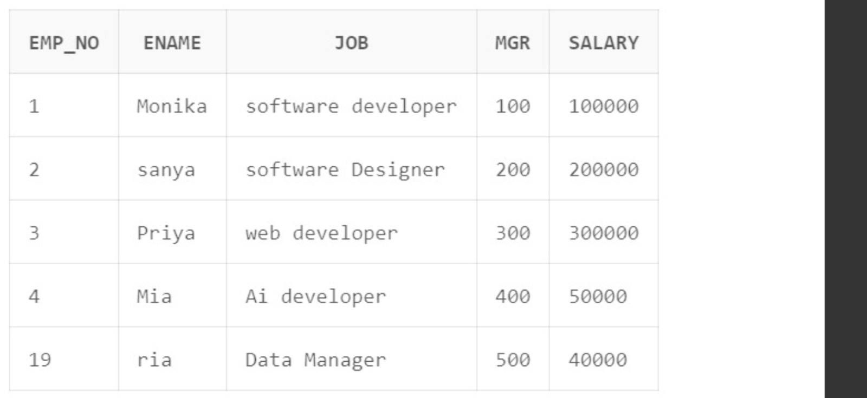

**Q2: Create department table with the following structure?**

**Ans:**

create table department (dept_no number primary key, dept_name varchar2(20), location varchar2(25));

alter table department add designation varchar2(30);

insert into department values (1, 'testing', 'delhi', 'labour');

insert into department values (2, 'coding', 'new york', 'skilled labour');

insert into department values (9, 'HR', 'england', 'managerial');

update department set location='remote' where dept_no='9';

alter table department drop column dept_name;

select * from department;

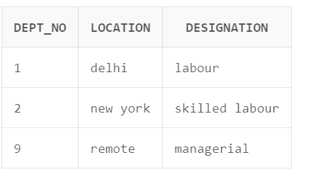

Q3: Create a table called customer table?

Ans: 

Output:

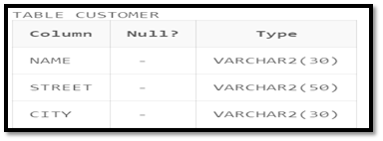

1. Insert records into the table.

insert into customer values('Monika', 'No-21', 'faridabad');

insert into customer values('Sanya', 'No-20', 'delhi');

insert into customer values('Mia', 'No-22', 'hrd');

insert into customer values ('Ria', 'No-23', 'Faridabad');

select * from customer;

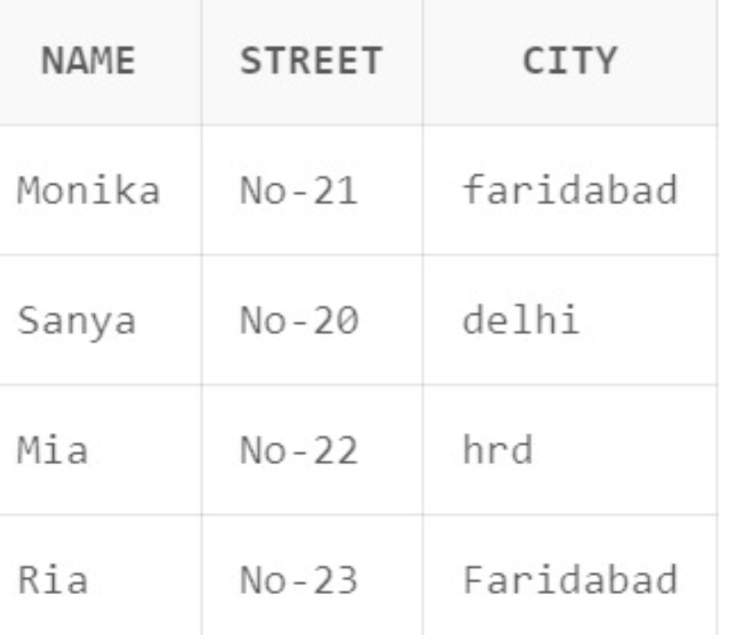

1. Add salary column to the table.



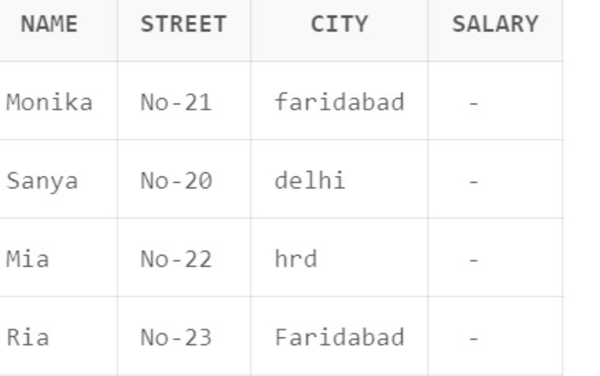

C. Alter the table column domain.



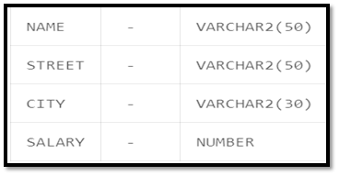

D . Drop salary column of the customer table.



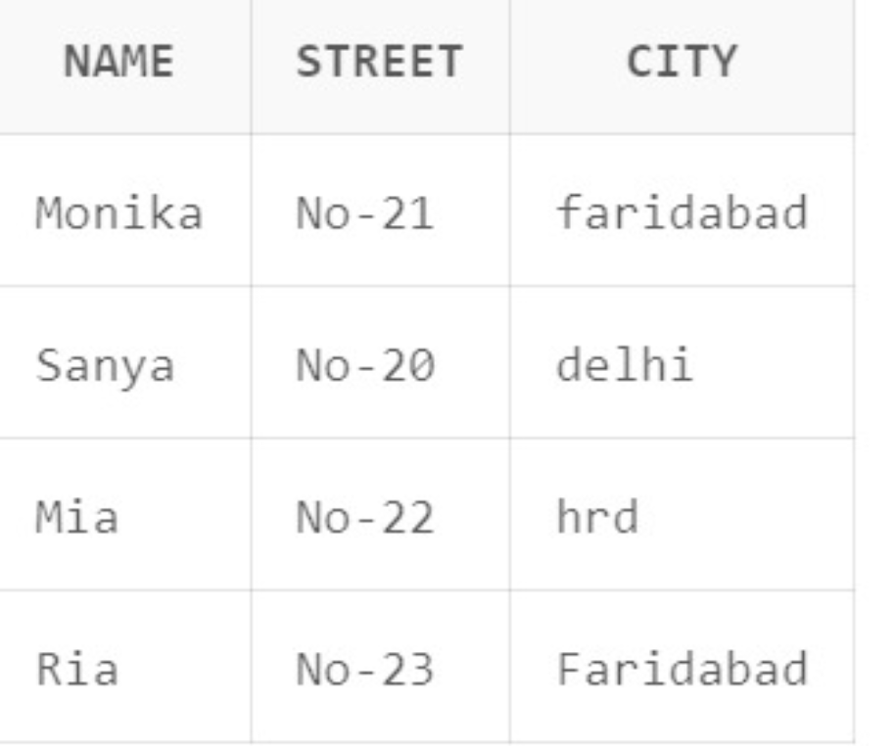

e. Delete the rows of customer table whose cust_city is 'hyd'.



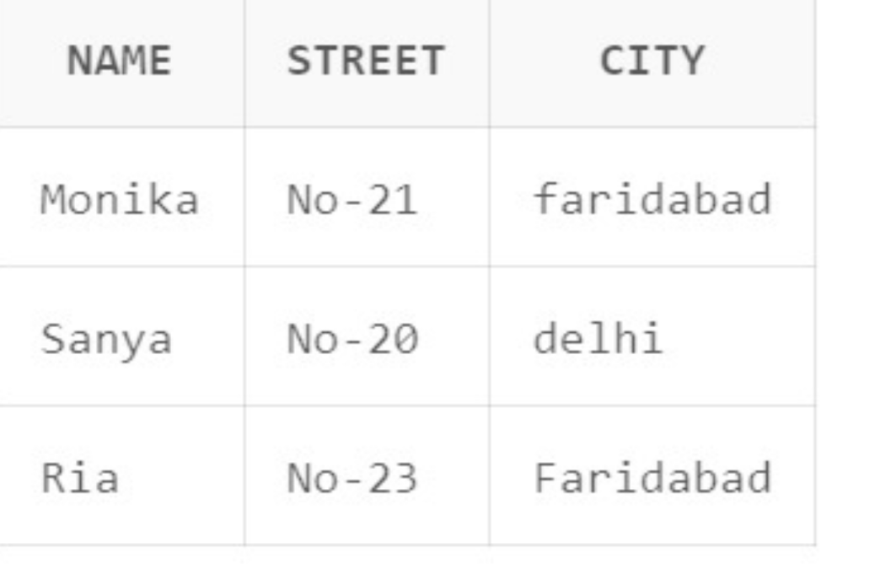

Q4: Create a table called branch table?

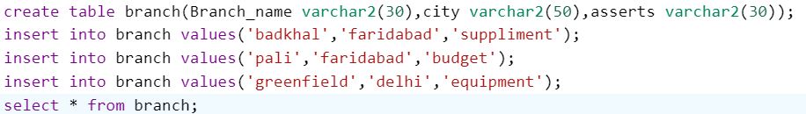

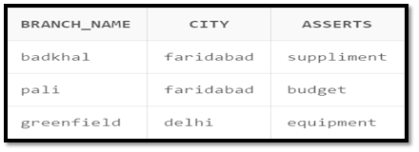

1. Increase the size of data type for asserts to the branch.



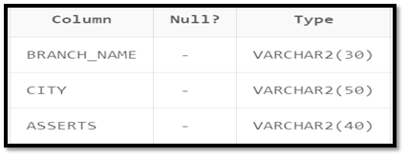

1. Add and drop a column to the branch table.

Add:



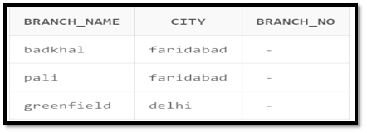

Drop:



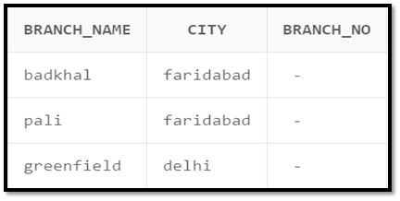

c. Insert values to the table.





d. Update the branch name column.



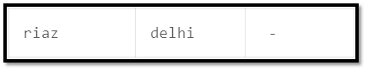

e. Delete any two columns from the table.



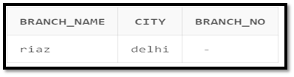

Q5. Create a table called sailor table?

1. Add column age to the sailor table.



1. Insert values into the sailor table.

create table sailor (sid number,S_name varchar2(30), rating number);

alter table sailor add (age number);

insert into sailor values (01, 'Monika',10,20);

insert into sailor values (02, 'Sanya',7,18);

insert into sailor values (03, 'Mia',8,19);

select * from sailor;

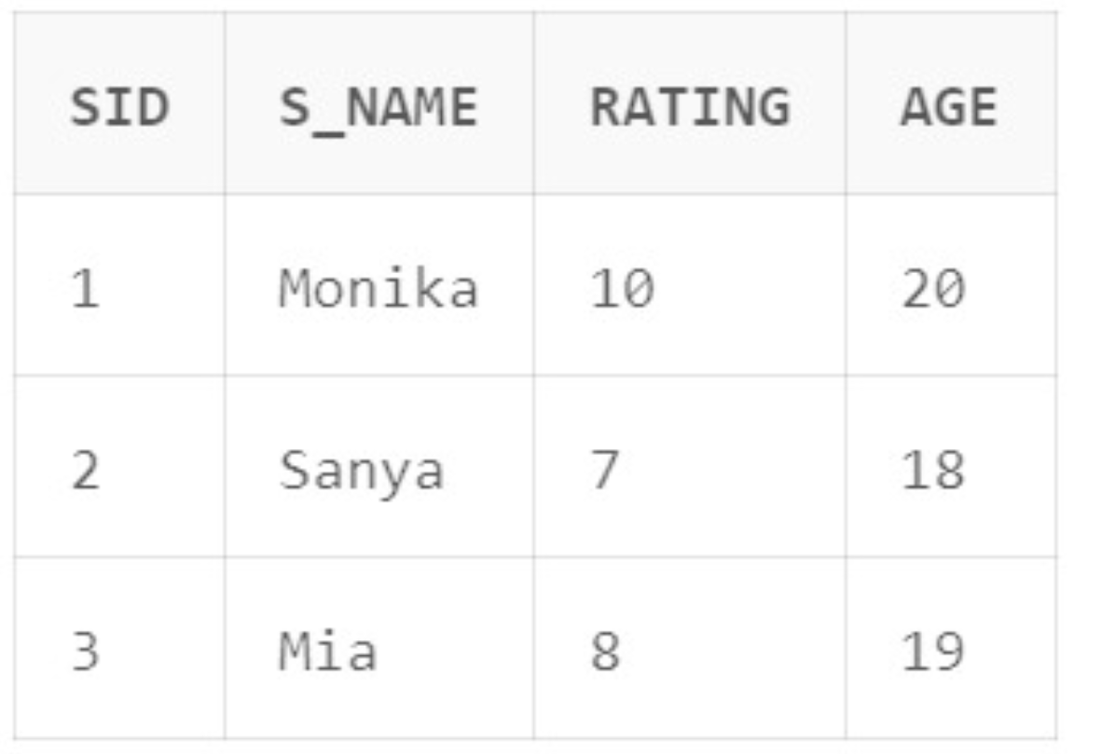

C. Delete the row with rating >8.



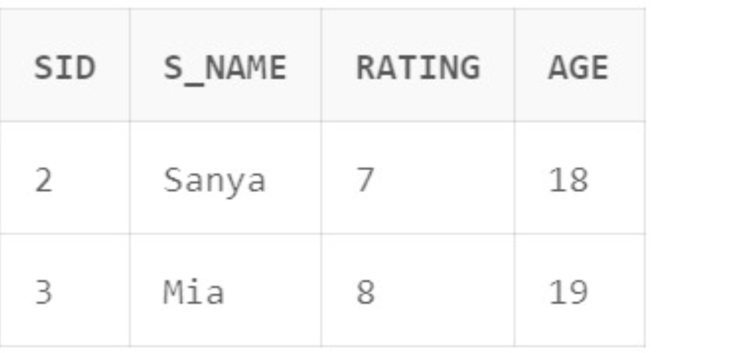

d. Update the column details of sailor.



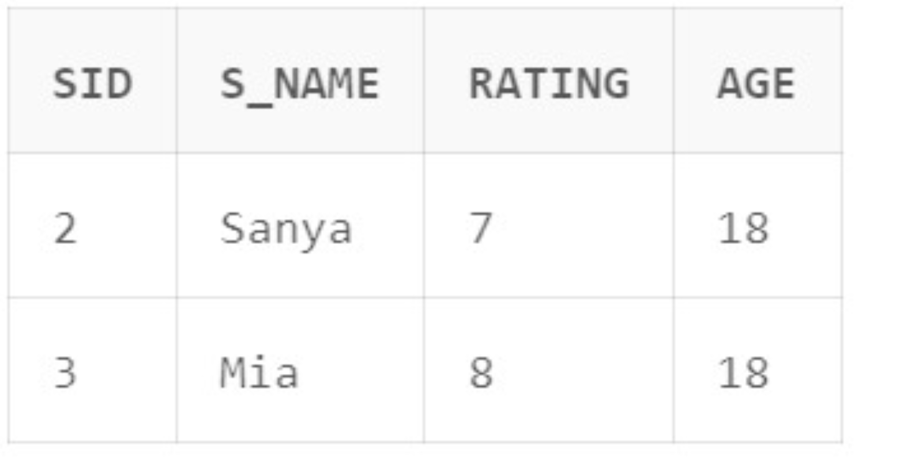

e. Insert null values into the table.

insert into sailor values (04,'Meow',8, null);

select * from sailor;

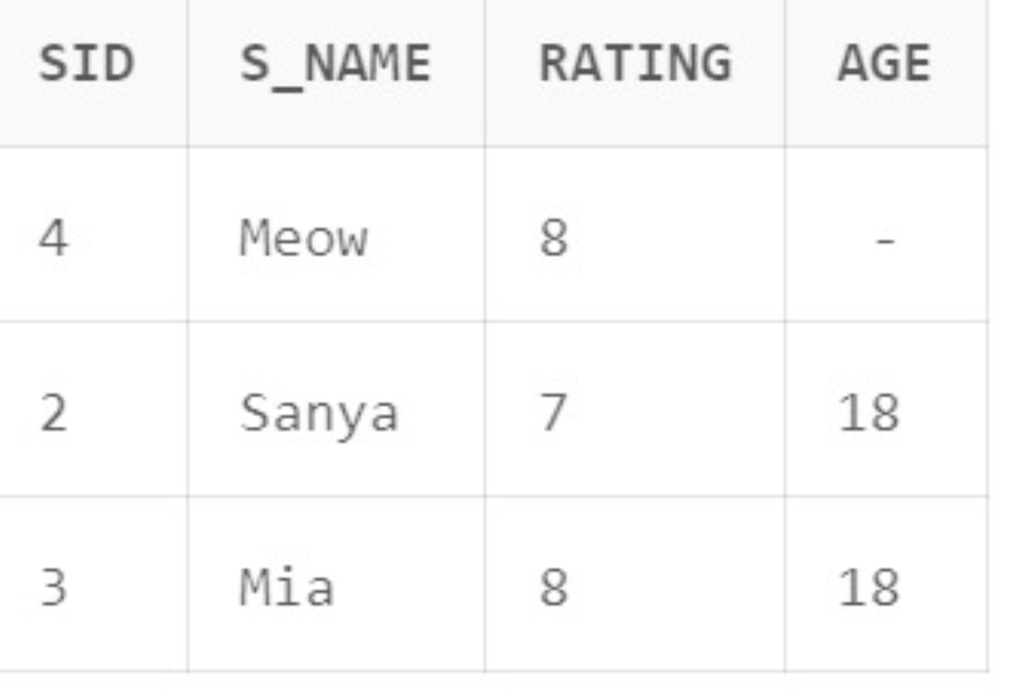

Q6:create a tabled reserves table

a. Insert values into the reserves table.

b. Add column time to the reserves table.

c. Alter the column day data type to DATE.

d. Drop the column time in the table

e. Delete the row of the table with some condition

