The Global Reference Architecture (GRA)

Person Query Request Service 1.0.0

Service Description Document

Version 1.0.0

March 2018
Table of Contents

1. Introduction 1
2. Service Overview 1
2.1 Purpose 1
2.2 Scope 2
2.3 Capabilities 2
2.4 Real-World Effects 2
2.5 Summary 2
2.6 Description 2
2.7 Security Classification 2
2.8 Service Specification Package Version 2
3. Service Interoperability Requirements 2
3.1 Service Interaction Requirements 2
3.1.1 Summary of Requirements 2
3.1.2 Service Consumer Authentication 3
3.1.3 Service Consumer Authorization 3
3.1.4 Identity and Attribute Assertion Transmission 3
3.1.5 Service Authentication 3
3.1.6 Message Non-Repudiation 3
3.1.7 Message Integrity 4
3.1.8 Message Confidentiality 4
3.1.9 Message Addressing 4
3.1.10 Reliability 4
3.1.11 Transaction Support 4
3.1.12 Service Metadata Availability 4
3.2 Service Assumptions 4
3.3 Service Dependencies 4
3.4 Execution Context 4
3.4.1 Reachability 4
3.4.2 Willingness 4
3.4.3 Awareness 5
3.4.4 Intermediaries, Connectors, and Adaptors 5
3.5 Policies and Contracts 5
None. 5
3.6 Security 5
3.7 Privacy 5
3.8 Other Requirements 5
4. Additional Information 5
5. Service Model 5
5.1 Information Model 5
5.1.1 IEPD Reference 5
5.1.2 Data Inputs 5
5.1.3 Data Outputs 6
5.1.4 Data Provenance 6
5.2 Behavior Model 6
5.2.1 Action Model 6
5.2.2 Process Model 6

Introduction

In the context of the GRA and Service-Oriented Architecture [soa] in general, a service is the means by which one partner gains access to one or more capabilities offered by another partner. Capabilities generate real-world effects that can be as simple as sharing information or can involve performing a function as part of a complex process or changing the state of other related processes. Government organizations have numerous capabilities and a multitude of partner organizations, both inside and outside of their traditional communities. There are significant benefits for these organizations to share information and have access to each other's capabilities. Achieving interoperability among these organizations requires alignment of business and technical requirements and capabilities. In addition, it is critical to have a consistent way of specifying these requirements and capabilities and sharing them across organizational boundaries. The GRA was developed to facilitate interoperability and to assist in meeting other key requirements common in a complex government information sharing environment. In order to achieve interoperability, a consistent approach must be defined to identify, describe, and package services and their interactions in many different technical environments, across multiple government lines of business, at all levels of government, and with partner organizations.

The GRA defines a service interface as “the means for interacting with a service.” It includes specific protocols, commands, and information exchange by which actions are initiated on the service. A service interface is what a system designer or implementer (programmer) uses to design or build executable software that interacts with the service. That is, the service interface represents the “how” of the interaction. Since the service interface is the physical manifestation of the service, best practices call for service interfaces that can be described in an open-standard, machine-referenceable format (that is, a format which could be automatically processed by a computer).

A Service Specification is a formal document describing the capabilities made available through the service; the service model that defines the semantics of the service by representing its behavioral model, information model, and interactions; the policies that constrain the use of the service; and the service interfaces which provide a means to interacting with the service. A Service Specification is analogous to the software documentation of an Application Programming Interface [api]. It provides stakeholders with an understanding of the structure of the service and the rules applicable to its implementation. It gives service consumers the information necessary for consuming a particular service and service providers the information necessary for implementing the service in a consistent and interoperable way.

The main components of a Service Specification are the Service Description, one or more Service Interface Descriptions, and the schemas and the samples used to implement and test the service.
A Service Description contains information about all aspects of the service that are not directly tied to the physical implementation of the service; in other words, the service interface. A Service Interface Description is a description of the physical implementation; specifically, the service interface used in a specific implementation of the service. Since a service can leverage multiple Service Interfaces, the Service Specification might contain more than one Service Interface Description.

This document is the Service Description for the Person Query Request Service.

Service Overview

Purpose

Information query requests are critical in keeping justice business partners and systems up-to-date with current details regarding situational awareness, defendants and cases. This service provides the ability to submit queries seeking Person detail information.

Scope

This Person Query Request Service is limited to requesting details of a Person.

Capabilities

This service implements the query request to query for Person information.

Real-World Effects

The consumer will invoke this service to submit a Person Query Request.

Summary

This Person Query Request Service is limited to requesting details of a Person.

Description

This service is intended to request Person information. A likely consumer of this service is any officer or agency able to query for Person information, most likely law enforcement, courts or users of a portal that supports a federated query.

Security Classification

The highest level of security classification for the information exchanged by this service is Sensitive but Unclassified (SBU). As a result the service can be assigned a security classification of SBU.

Service Specification Package Version

This service specification is built according to version 1.0 of the GRA Service Specification Package (SSP).

Service Interoperability Requirements

Service Interaction Requirements

Summary of Requirements

The following table lists the Service Interaction Requirements established by the GRA Framework, and indicates whether each is mandatory for this service.

GRA Service Interaction Requirements | Mandatory (Yes/No)
Service Consumer Authentication | Yes
Service Consumer Authorization | Yes
Identity and Attribute Assertion Transmission | Yes
Service Authentication | Yes
Message Non-Repudiation | Yes
Message Integrity | Yes
Message Confidentiality | Yes
Message Addressing | Yes
Reliability | No
Transaction Support | No
Service Metadata Availability | Yes

Service Consumer Authentication

The service consumer must provide information in the message sent to this service that the service can use to authenticate the consumer and confirm that the consumer is a member of the federation.

Service Consumer Authorization

The service must confirm that the service consumer is in fact authorized to send messages to the service.

Identity and Attribute Assertion Transmission

The service consumer must make information about itself available to the service. Likewise, the service must make information about itself available to service consumers.

Service Authentication

A service consumer must be able to verify the identity of the service in trusted manner.

Message Non-Repudiation

All messages sent to this service must contain information to prove that a particular authorized sender in fact sent the message.

Message Integrity

All messages sent to this service must contain information for the service to confirm that the message has not changed since it left control of the sender.

Message Confidentiality

All messages sent to this service must be protected in a manner that prevents anyone except the authorized recipient from reading the message.

Message Addressing

All messages sent to this service must contain a unique message identifier (this supports correlation of asynchronous request/response) along with information indicating where the message originated, the ultimate destination of the message, a specific recipient to whom the message should be delivered and a specific address or entity to which reply messages should be sent, if they exist.

Reliability

This service does not require Reliability.

Transaction Support

This service does not require Transaction Support.

Service Metadata Availability

Since this service is part of a federation, this metadata about this service must be made available to all federation members

Service Assumptions

None.

Service Dependencies

None.

Execution Context

This section is divided into sub-sections based on the implementation guidelines established in the GRA Execution Context guidelines 1.2

Reachability

The infrastructure must provide a communication path that allows service consumers to send messages to the service.

Willingness

The infrastructure must enable encryption of the communication path between service consumer and service provider.

The infrastructure must also provide a mechanism for the service to confirm that the message sent from the consumer has not changed since it left the control of the consumer.

Awareness

Providers of this service should make details about the service and service interface available to potential service consumers.

Intermediaries, Connectors, and Adaptors

The infrastructure that implements this service should do so in a manner according to section 3.4 of the GRA Execution Context Guidelines 1.2.

Policies and Contracts

None.

Security

Communication with this service must happen in a manner that information sent to the service is guaranteed confidential. Also, the service must be able to verify the identity of the consumer and the consumer must be able to verify the identity of the service provider.

Privacy

There are no specific privacy considerations for this service.

Other Requirements

None

Additional Information

None

Service Model

Information Model

IEPD Reference

The Person Query Request Service uses the Person Query Request IEPD in the artifacts/service_model/information_model directory of this Service Specification Package.

The IEPD provides examples of a typical query request for Person information.

Data Inputs

Person Query Request message

This message contains Person query request information.

Data Outputs

This is an asynchronous service so there are no data outputs on this service.

Data Provenance

The data used to consume this service originates with the reporting agency.

Behavior Model

Action Model

Action Name: | SubmitPersonQueryRequest
Action Purpose
A service consumer will invoke this action in order to query for detailed information regarding a Person.

Action Inputs | Action Outputs
Person Query Request | Not applicable
Action Provenance
The data provenance for this action is identical to that of the information model for this service.

Process Model

This service offers one action for Person Query Request

- SubmitPersonQueryRequest - A service consumer will invoke this action on the service to query for detailed Person information. The consumer will receive an acknowledgement notifying of a successful connection or failure to connect. Upon receiving this message, this service analyzes the details of the message to determine which capabilities to invoke.

Sample process for the use of this service in an Open Source Message Switch Project:

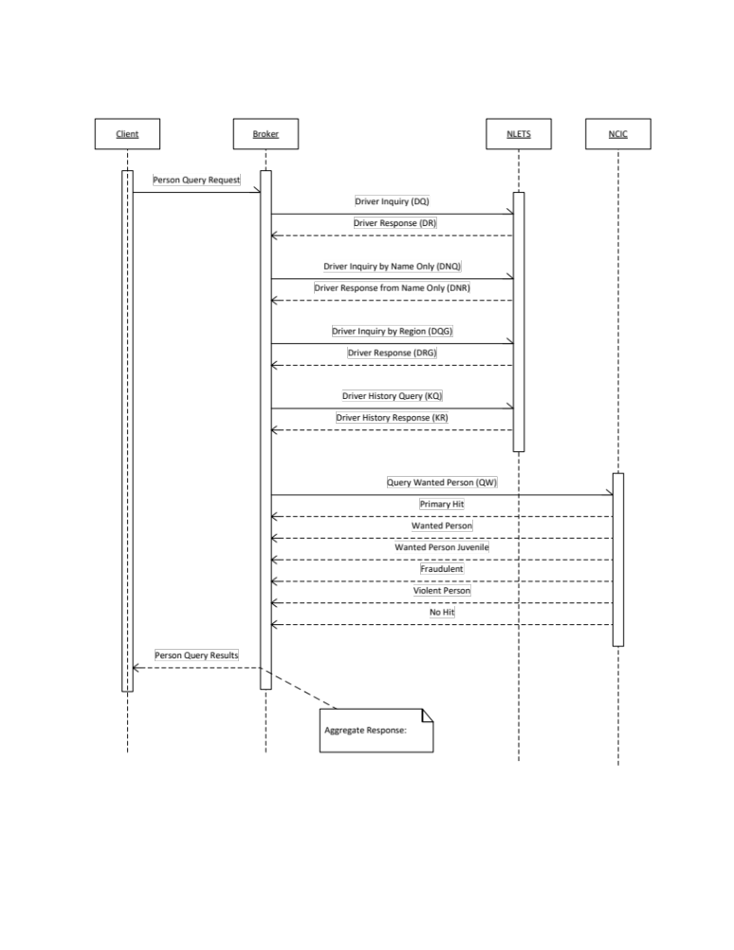

Figure 1 – Sample Person Query Request Process Model

Appendix A—Document History

[This section is used to document the history of the service description document]

Date | Version | Editor | Change
3/24/2018 | 1.0.0 | Jim Douglas

