**RANCHI WOMEN’S COLLEGE, RANCHI**



**A PROJECT REPORT**

**ON**

**“ONLINE SHOPPING (ELLECTROVILLA)”**

Submitted in Partial Fulfilment for the Degree of

B.Sc. Information Technology

Submitted by:-

Name- MADHURI MUNDA

Roll No- 12VCBSIT085

Name- SAHISTA PARVEEN

Roll No-12VCBSIT086

Name- BINITA SAPUWAR

Roll No-12VCBSIT088

**RANCHI WOMEN’S COLLEGE, RANCHI**

**A PROJECT REPORT**

**ON**

**“ONLINE SHOPPING (ELECTROVILLA)”**

Submitted in Partial Fulfilment for the Degree of

B.Sc. Information Technology

Submitted by:-

Name- MADHURI MUNDA

Roll No- 12VCBSIT085

Name- SAHISTA PARVEEN

Roll No-12VCBSIT086

Name- BINITA SAPUWAR

Roll No-12VCBSIT088

RANCHI WOMEN’S COLLEGE, RANCHI



CERTIFICATE

This is to certify that the project report entitled ONLINE SHOPPING (ELECTROVILLA)

Submitted to Ranchi Women’s College, Ranchi in partial fulfilment of the requirement for the award of degree of B.Sc. Information Technology, is an original work carried out by MADHURI MUNDA Roll No 12VCBSIT085

Signature

(Guide) (External Examiner)

**1. INTRODUCTION**

**“Online Shopping System**” is a web-based project which is made for remote-shopping or shoppingthrough Internet. As the technology is being advanced the way of life is changing accordance. Now a dayswe can order for anything from our home. There is no need to go the shop of the things we want. Thus the customer will get the service of online shopping and home delivery from his favorite shop. The order can be placed online through Internet. The payment, the confirmation of purchasing; we can do everything we want. Now we can think that how the days have been changed with time. People had to stand in rows to wait there terms to buy a particular thing from a popular shop. But what is happening now a days; we can extremely surprise that those things can be available on the door-step in few hours.

People had to suffer the rush of the market when they went for shopping. The problem was the rush; the quarrel at the time of buying the things. But the advancement of technology brought the new way for shopping. The way of shopping was completely changed with the coming of Internet Technology. People have to fill a simple form on the internet to place their order on any popular shop or shopping-mall for the thing they want to buy. Now people can order anything what they wants from the home.

**2. OBJECTIVE**

Today the internet and its boom have created a new economic scenario that not only stresses on the classical concept of the “product” but also on the modern concept of “service”. It is this level of service that dictates whether a commercial venture will succeed or not in the market. To provide a high accessibility of service we have proposed the design of online shopping website, so that potential customers need not go to a physical shop to buy products or services. There are several objective of this websites are following given below:

• This site is gives all the information about the e-shopping to provide better service for the customer.

• It provides the facility to the customers who want to shop on-line due to lack of time.

•It provides facility to the customer to payment by the cash .

• It’s providing the full details about the product and related information about the product like cost, size etc.

• With the help of it we can save the time and money also.

• It provides the remote shopping by the cash or Debit card.

**3.LIFE CYCLE MODEL**

Feasibility Study

Requirement Analysis And  
Specification

Design

Coding And Unit Testing

Integration And System Testing

Maintenance

**4. SYSTEM ANALYSIS**

System analysis is the process of gathering and interpreting facts, diagnosing problems and using the information to recommend improvements on the system. System analysis is a problem solving activity that requires intensive communication between the system users and system developers.

System analysis or study is an important phase of any system development process. The system is viewed as a whole, the inputs are identified and the system is subjected to close study to identify the problem areas. The solutions are given as a proposal. The proposal is reviewed on user request and suitable changes are made. This loop ends as soon as the user is satisfied with the proposal.

**EXISTING SYSTEM**

The current system for shopping is to visit the shop manually and from the available product choose the item customer want and buying the item by payment of the price of the item.

1. It is less user-friendly.

2. User must go to shop and select products.

3. It is difficult to identify the required product.

4. Description of the product limited.

5. It is a time consuming process

6. Not in reach of distant users.

**PROPOSED SYSTEM**

In the proposed system customer need not go to the shop for buying the products. He can order the product he wish to buy through theapplication in his Smartphone. The shop owner will be admin of the system. Shop owner can appoint moderators who will help owner in managing the customers and product orders. The system also recommends a home delivery system for the purchased products.

**SYSTEM REQUIREMENT SPECIFICATION**

**1. *GENERAL DESCRIPTION***

Product Description:

The system consists of two parts .A web application which can provide the online shopping service and an android application for the customer toaccess the web service from his Smartphone. Web application should be able to help the customer for selecting his item and to help the owner in managing the orders from the customers.

Problem Statement:

As online shopping became a trend nowadays the regular shops are losing their customers to online brands. Customers have effortless shopping experience and saving time through shopping online. For competing with those online brands, If shops are providing an online portal where their customers can shop through internet and get the products at their doors it will increase the number of customers.

**5. FEASIBILITY STUDY**

**WHAT IS FEASIBILITY STUDY?**

The feasibility study involves the analysis of the problem and collection of all relevant information relating to the product such as the different data items which would be input to the system, the processing required to be carried out on these data, the output data required to be produced by the system, as well as various constraints on the behavior of the system

**TYPE OF FEASIBILITY STUDY**

* Technical Feasibility
* Economic Feasibility
* Operational Feasibility

**TECHNICAL FEASIBILITY**

In the feasibility study first step is that the organization or company has to decide that what technologies are suitable to develop by considering existing system. Here in this application used the technologies like PHP, HTML, JAVA SCRIPT,CSSandMySQL

**ECONOMICAL FEASIBILITY**

#### It refers to the benefits or outcomes we are deriving from the product as compared to the total cost we are spending for developing the product. If the benefits are more or less the same asthe older system, then it is not feasible to develop the product. In the present system, the development of new product greatly enhances the accuracy of the system and cuts short the delay in the processing of Birth and Death application. The errors can be greatly reduced and at the same time provides a great level of security. Here we don’t need any additional equipment except memory of required capacity. No need for spending money on client for maintenance because the database used is web enabled database.

**OPERATIONAL FEASIBILITY**

Not only must an application make economic and technical sense, it must also make operational sense; Very often we need to improve the existing operations, maintenance, and support infrastructure to support the operation of the new application that you intend to develop.  To determine what is the impact we will need to understand both the current operations and support infrastructure of our organization and the operations and support characteristics of our new application

**4. REQUIREMENT ANALYSIS AND SPECIFICATION**

**SOFTWARE AND HARDWARE REQUIREMENT OF THE PROJECT**

#### Hardware Requirements:

System Type : INTEL

Processor : PENTIUM

Processor Speed : 2.8 GHZ

Hard Disk : 40 GB

RAM Size : 4 GB

#### Software Requirements:

Platform : Windows 8

Front-end : ASP, HTML, JAVA SCRIPT, CSS

Back-end : ORACLE 10G

**6. REQUIREMENT ANALYSIS AND SPECIFICATION**

Requirement analysis in systems engineering and software engineering, encompasses those tasks that go into determining the needs or conditions to meet for a new or altered product or project, taking account of the possibly conflicting requirements of the various stakeholders, analyzing, documenting, validating and managing software or system requirements.

Requirement analysis is critical to the failure of systems or software projects. The requirements should be documented, actionable, measurable, testable, traceable, related to identified business needs or opportunities and define to a level of detail sufficient for system design.

Requirements specification is the invention and definition of the behavior of a new system such that it will produce the required effects in the problem domain. It generally involves modeling. It results in the specification document.

**7.TESTING**

Testing is a process of executing a program with a intent of finding an error. A good test case is one that has a high probability of finding an error that is yet undiscovered. A successful test is one that uncovers a yet undiscovered error. Testing cannot show the absence of defects, it can only show software defects that are present.

**TEST CASE DESIGN**

White box Testing:

White box testing is a test case design method that uses the control structure of the procedural design to derive test cases. Using white box testing method, the software engineer can derive test cases that guarantee that all independent parts within a module have been exercised atleast once, exercise all logical decisions on their true and false sides, execute all loops at their boundaries and within their operational bounds and exercise internal data structures to ensure their validity.

Black box testing:

Black box testing method focus on functional requirements of the software. That is , black box testing enables the software engineer to derive sets of input condition that will fully exercise all functional requirements for a program.

Black box testing attempts to find errors in the following categories:

1.Incorrect or missing functions

2.Interface errors and performance errors

3.Errors in data structures or external database access.

4.Performance errors

5.Initialization and termination errors.

**TESING STRATEGIES**

A software strategy for software testing integrates software test case design techniques into a well-planned series of steps that result in successful construction of software.

There are four types of strategies:

Unit test**:**

Unit testing focuses on verification effort on the smallest unit of software design module.

The test is always white box oriented, and the step can be conducted in parallel for multiple modules.This testing is carried out during coding stage.

Integration test:

Integration testing is a systematic technique for construction of program structure while the time of conducting tests to uncover errors associated with interfacing. The objective is to take unit-tested modules and build a program structure that has been dictated by the design

Validation test**:**

Validation testing is a final series of software testing. Validation testing succeeds when the software function in a manner that can be reasonably expected by the customer. Software validation is achieved through aseries of black box tests that demonstrate conformity with requirements.

System test:

After integration of all modules of the system it will give appropriate information , expected to the user.

**8. MAINTENANCE**

Software maintenance in software engineering is the modification of a software product after delivery to correct faults, to improve performance or other attributes.

A common perception of maintenance is that it merely involves fixing defects. However, one study indicated that over 80% of maintenance effort is used for non-corrective actions.

This perception of maintenance is perpetuated by users submitting problem reports that in reality are functionality enhancements to the system. More recent studies put the bug-fixing proportion closer to 21%.

**9. SYSTEM DESIGNS**

System design is the solution for the creation of a new system. This phase focuses on the detailed implementation of the feasible system. It emphasis on translating design. Specifications to performance specification. System design has two phases of development

* Logical design
* Physical design

During logical design phase the analyst describes inputs (sources), output s(destinations), databases (data sores) and procedures (data flows) all in a format that meets the user requirements. The analyst also specifies the needs of the user at a level that virtually determines the information flow in and out of the system and the data resources. Here the logical design is done through data flow diagrams and database design. The physical design is followed by physical design or coding. Physical design produces the working system by defining the design specifications, which specify

exactly what the candidate system must do. The programmers write the necessary programs that accept input from the user, perform necessary processing on accepted data and produce the required report on a hard copy or display it on the screen.

**INPUT AND OUTPUT DESIGN**

INPUT DESIGN:

Input design is the link that ties the information system into the world of its users. The input design involves determining the inputs, validating thedata, minimizing the data entry and provides amulti-user facility.Inaccurate inputs are the most common cause of errors in dataprocessing. Errors entered by the data entry operators can be controlled by input design. The user-originated inputs are converted to a computer based format in the input design. Input data are collected and organized into groups of similar data. Once identified, the appropriate input media are selected for processing. All the input data are validated and if any data violates any conditions, the user is warned by a message. If the data satisfies all the conditions, it is transferred to the appropriate tables in the database. In this project the student details are to be entered at the time of registration. A page is designed for this purpose which is user friendly and easy to use. The design is done such that users get appropriate messages when exceptions occur.

OUTPUT DESIGN:

Computer output is the most important and direct source of information to the user. Output design is a very important phase since the output needs to be in an efficient manner. Efficient and intelligible output design improves the system relationship with the user and helps in decision making. Allowing the user to view the sample screen is important because the user is the ultimate judge of the quality of output. The output module of this system is the selected notifications.

**DATABASE**

DATABASE DESIGN:

Databases are the storehouses of data used in the software systems. The data is stored in tables inside the database. Several tables arecreated for the manipulation of the data for the system. Two essential settings for a database are

* Primary Key-the field that is unique for all the record occurrences.
* Foreign Key- the field used to set relation between tables.

Normalization is a technique to avoid redundancy in the tables.

**SYSTEM TOOLS**

The various system tools that have been used in developing both the front end and the back end of the project are being discussed in this chapter.

FRONT END:

HTML, CSS, JAVA SCRIPT, PHP

HTML (Hyper Text Markup Language):

HTML is a syntax used to format a text document on the web.

CSS (Cascading Style Sheets):

CSS is a style sheet language used for describing the look and formatting of a document written in a markup language.

Java Script:

JS is a dynamic computer programming language. It is most commonly used as part of web browsers, whose implementations allow client-sidescripts to interact with the user, control the browser, communicate asynchronously, and alter the document content that is displayed. Java Script is used to create pop-up windows displaying different alerts inthe system like “User registered successfully”,”Product added to cart” etc.

PHP(Hypertext Preprocessor):

PHP is a server-side scripting language designed for web development but also used as a general-purpose programming language. As of January 2013, PHP was installed on more than 240 million websites (39% of those sampled) and 2.1 million web servers. Originally created by Rasmus Lerdorf in 1994, the reference implementation of PHP (powered by the Zend Engine) is now produced by The PHP Group. While PHP originally stood for Personal Home Page, it now stands for PHP: Hypertext Preprocessor, which is a recursive backronym.PHP code can be simply mixed with HTML code, or it can be used in combination with various templating engines and web frameworks.

BACK END:

The back end is implemented using MySQL which is used to design the databases.

MySQL:

MySQL is the world's second most widely used open-source relational database management system (RDBMS). The SQL phrase stands for Structured Query Language.

An application software called Navicat was used to design the tables in MySQL.

**DATA FLOW DIAGRAM**

A Data Flow Diagram (DFD) is a structured analysis and design tool that can be used for flowcharting. A DFD is a network that describes the flow of data and the processes that change or transform the data throughout a system. This network is constructed by using a set of symbols that do not imply any physical implementation. It has the purpose of clarifying systemrequirements and identifying major transformations. So it is the starting point of the design phase that functionally decomposes the requirements specifications down to the lowest level of detail. DFD can be considered to an abstraction of the logic of an information-oriented or a process-oriented system flow-chart. For these reasons DFD’s are often referred to as logical data flow diagrams.

**WHAT IS A DATA DICTIONARY?**

A data dictionary, or metadata [repository](http://en.wikipedia.org/wiki/Software_repository), is a "centralized repository of information about data such as meaning, relationships to other data, origin, usage, and format." The term may have one of several closely related meanings pertaining to [databases](http://en.wikipedia.org/wiki/Database) and [database management systems](http://en.wikipedia.org/wiki/Database_management_system) (DBMS):

* a [document](http://en.wikipedia.org/wiki/Document) describing a database or collection of databases.
* an integral [component](http://en.wikipedia.org/wiki/Software_component) of a [DBMS](http://en.wikipedia.org/wiki/Database_management_system) that is required to determine its structure.
* a piece of [middleware](http://en.wikipedia.org/wiki/Middleware) that extends or supplants the native data dictionary of a DBMS.

EXTERNAL ENTITY:

An external entity is a source or destination of a data flow. Only those entities which originate or receive data are represented on a data flow diagram. The symbol used is a rectangular box.

PROCESS:

A process shows a transformation or manipulation of data flow within the system. The symbol used is an oval shape.

DATAFLOW:

The data flow shows the flow of information from a source to its destination. Data flow is represented by a line, with arrowheads showing the direction of flow. Information always flows to or from a process and may be written, verbal or electronic. Each data flow may be referenced by the processes or data stores at its head and tail, or by a description of its contents.

DATA STORE:

A data store is a holding place for information within the system: It is represented by an open ended narrow rectangle. Data stores may be long-term files such as sales ledgers, or may be short-term accumulations: for example batches of documents that are waiting to be processed. Each data store should be given a reference followed by an arbitrary number.

**CONTEXT DIAGRAM** DIAGRAM

System Context Diagrams are  diagrams used in  systems design  to represent the more important external factors that interact with the system at hand. This type of diagram usually pictures the system at the centre, with no details of its interior structure, surrounded by all its interacting systems, environment and activities. The objective of a system context diagram is to focus attention on external factors and events that should be considered in developing a complete set of system requirements and constraints”.

System context diagrams are related to  UML, and show the interactions between a system and other actors with which the system is designed tointerface.Context diagrams can be developed with the use of two types of building blocks:

**CONTEXT DIAGRAM**

View Products

Product

Admin

Enter User Name Password

Purchase

User

Purchase/View

**WHAT ARE E-R DIAGRAMS?**

In  software engineering an  entity-relationship model (ERM) is an abstract and conceptual representation of  data. Entity-relationship modeling is a  database modeling method, used to produce a typeof  conceptual schema or  semantic data model of a system, often a relational, and its requirements in a  top-down fashion. Diagrams created by this process are called  entity-relationship diagrams, ER diagrams, or  ERDs.

**SYMBOL USED FOR E-R DIAGRAM**

E

Entity Set

R

Relationship Entity

R

R

Attribute

Primary Key

Data Flow

R

**R**

One to One Relationship

**E-R DIAGRAM**

**INVOICE**

**ORDER**

**PLACE**

**PRODUCT**

**CHOIC**E

**ADMIN**

**ISSUES**

**USER**

**GENERATE**

**WHAT IS USE CASE DIAGRAM?**

The use-case model for any system consists of a set of “use-cases”. The purpose of a use-case diagram is to define a piece of coherent behavior without revealing the internal structure of the system .It represents a sequence of interaction between the user and the system.

**USE CASE DIAGRAM**

Admin

Admin

Admin

Client

Client

**10.TABLES**

* ADMIN LOGIN

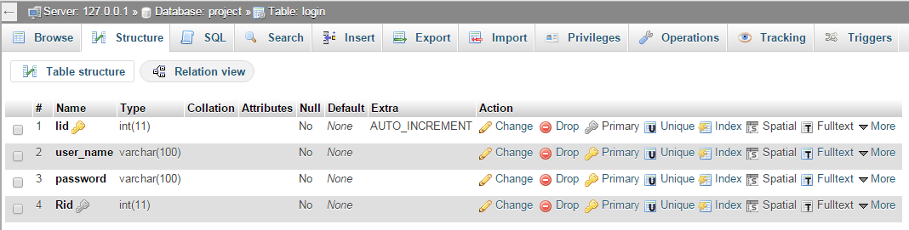

ADMIN LOGIN TABLE

* REGISTRATION TABLE

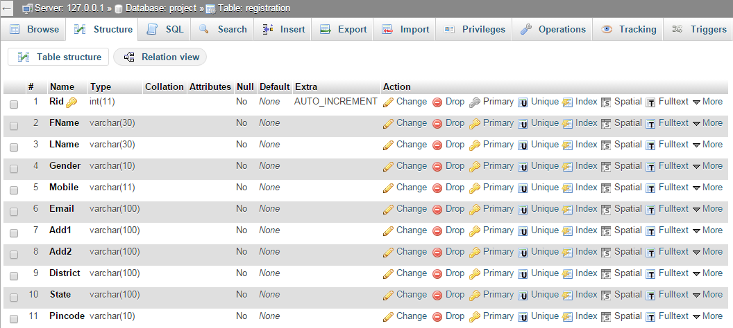

* PRODUCT DETAILS

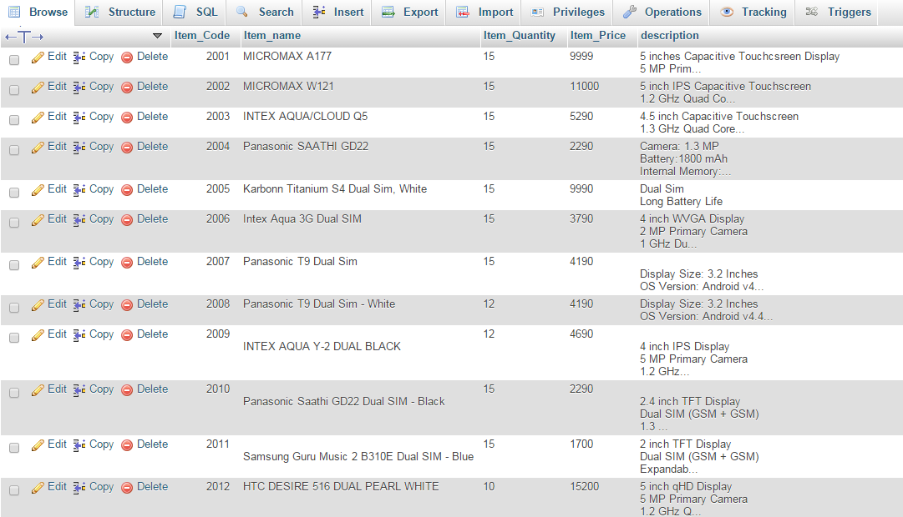

We have 24 tables for products as there are 24 varieties of the products

* PRODUCT TABLE

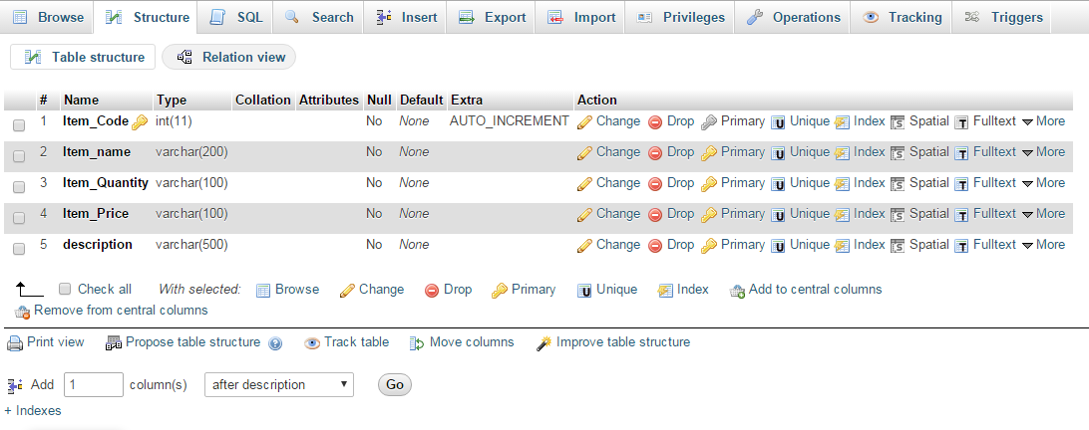

* ORDER DETAILS

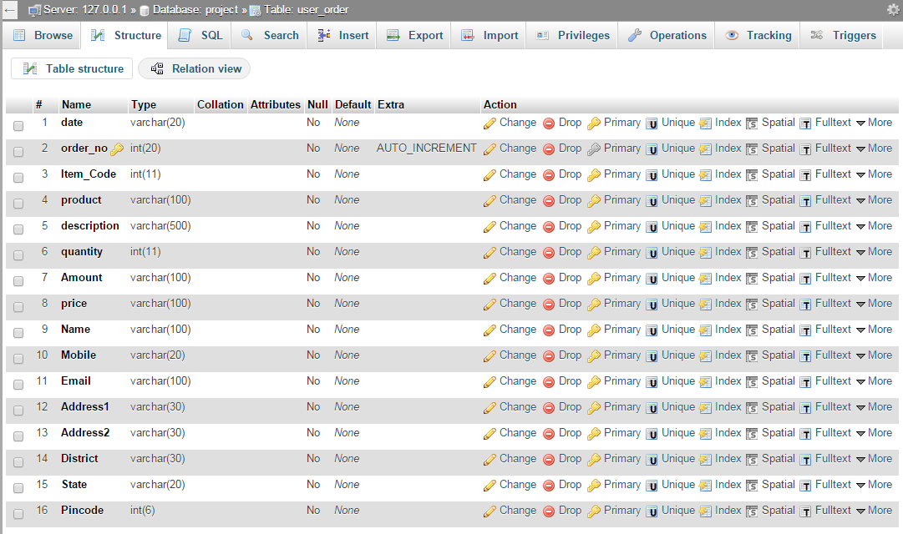

* ORDER TABLE

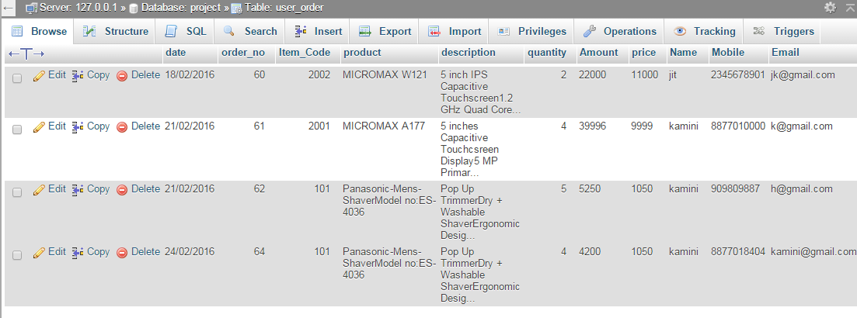

* TRACK ORDER

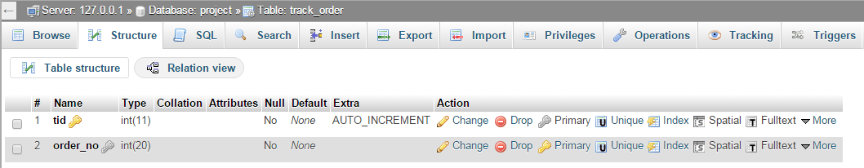

**11. SCREEN SHOTS**

* ADMIN LOGIN

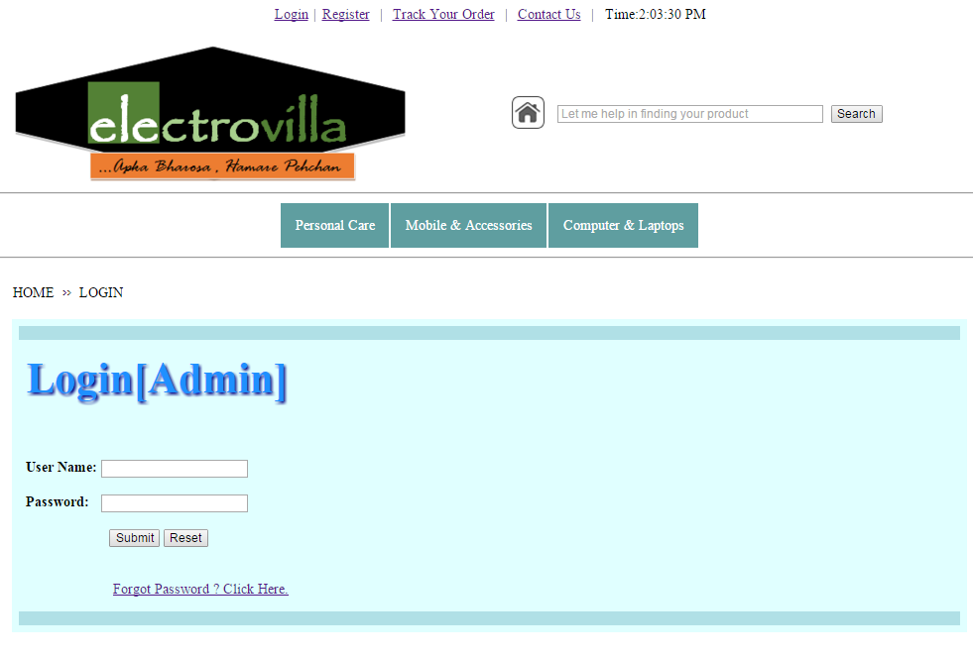

* REGISTRATION

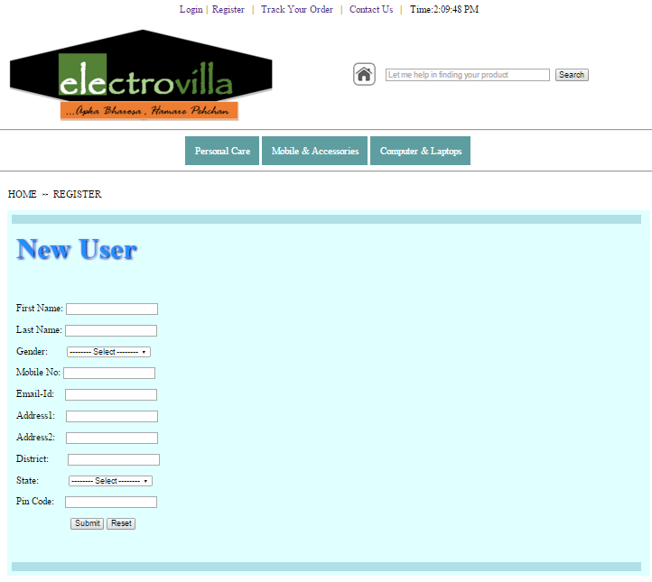

* TRACK YOUR ORDER

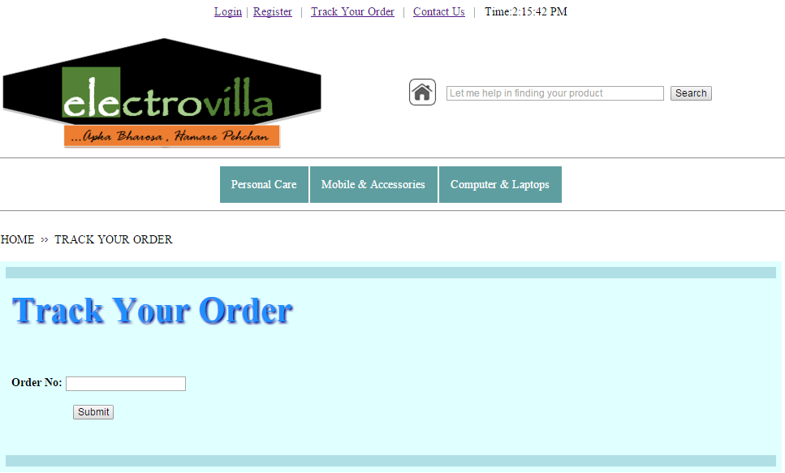

* HOME PAGE

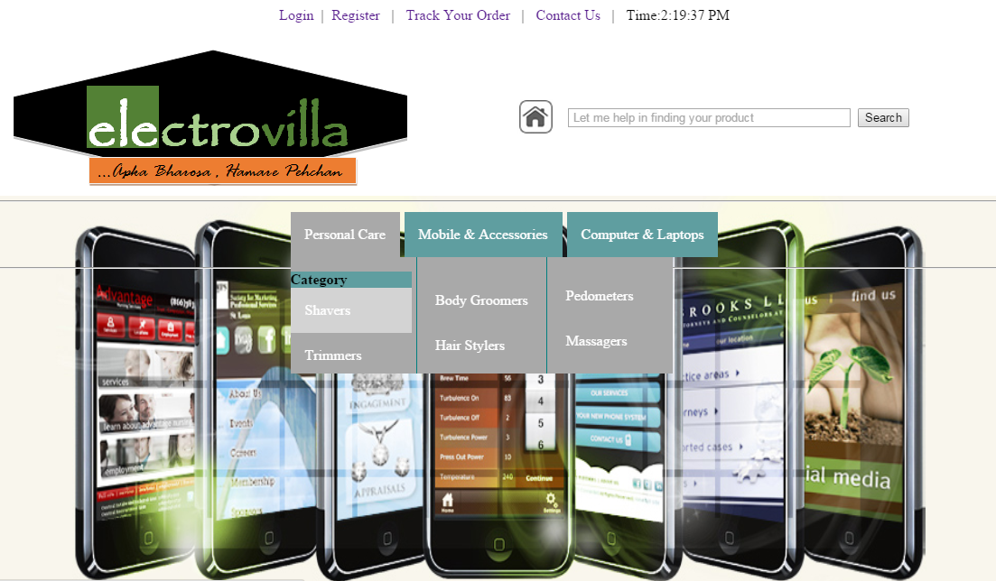

* DETAILS CHECK BY ADMIN

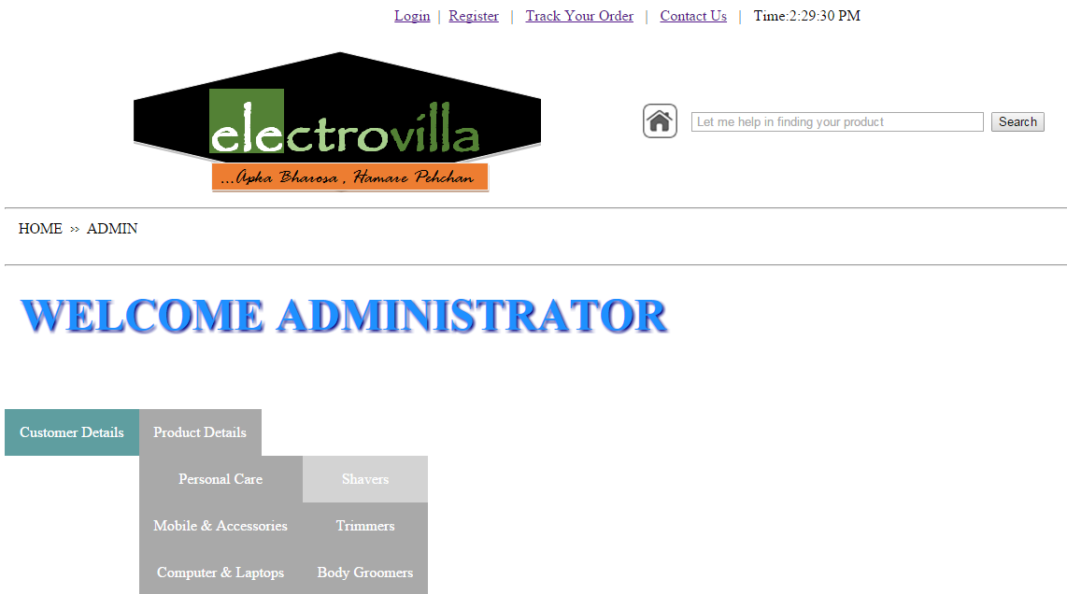

* CONTACT US

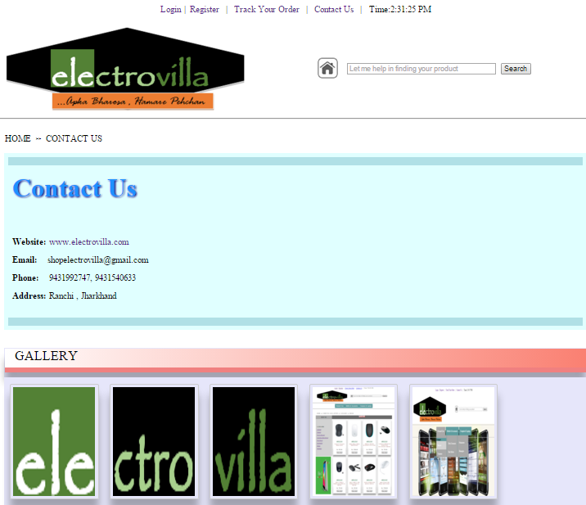

* PRODUCT LIST

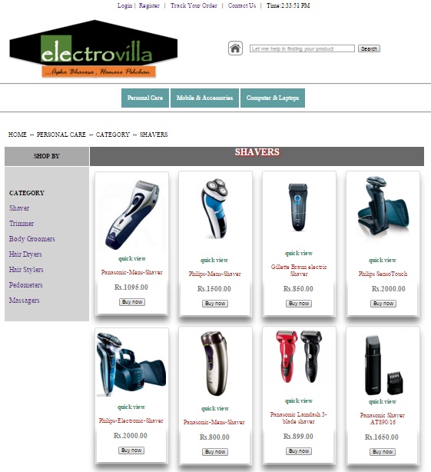

* SELECT A PRODUCT

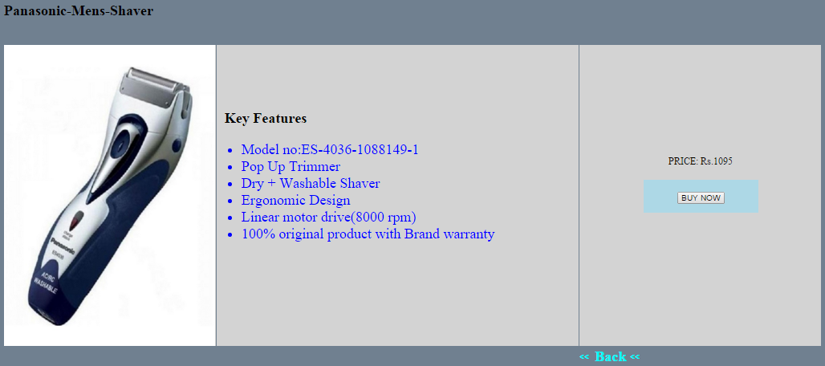

* PRODUCT DESCRIPTION/BUY

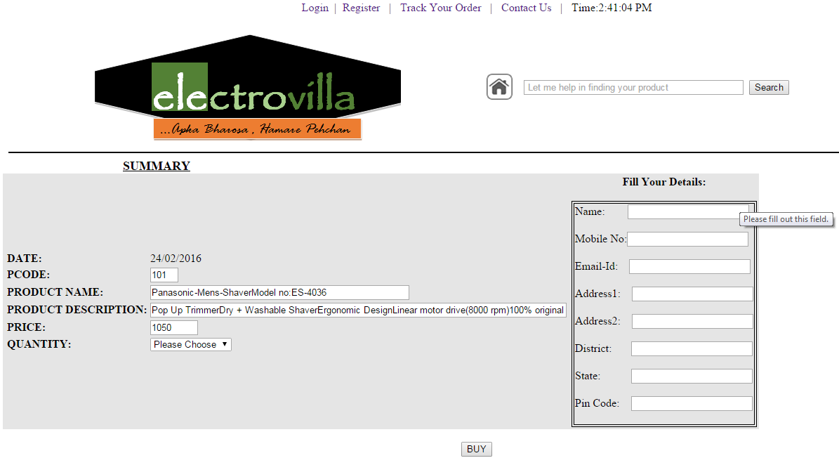

* ORDER RECEIPT

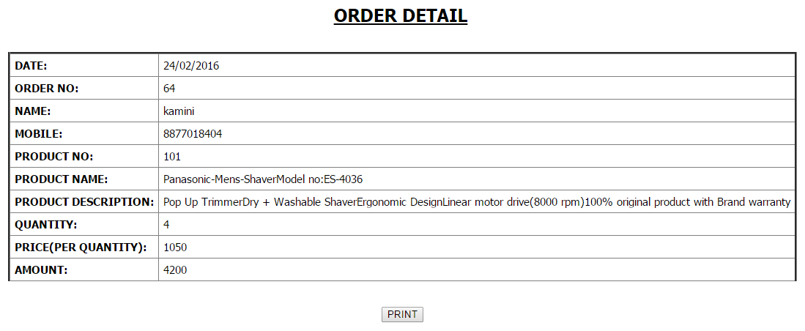

* PRINT OF ORDER DETAILS

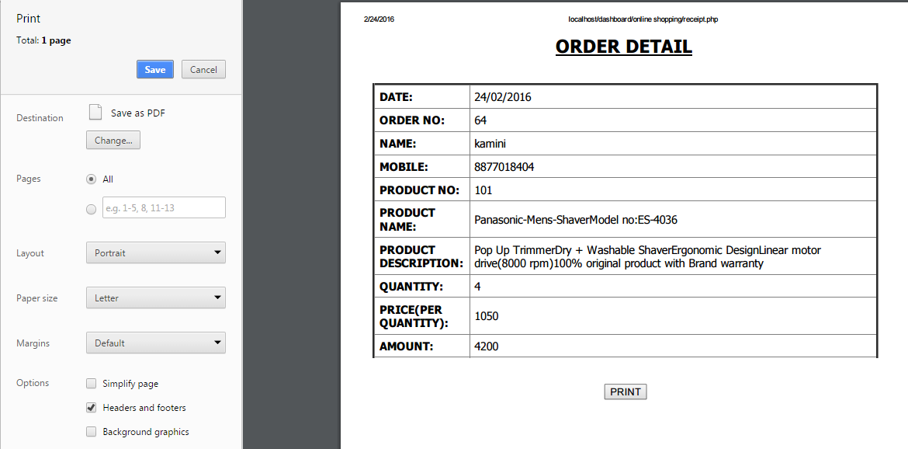

**7. CODING**

* Home Page

<html>

<title>Home Page</title>

<head>

<meta charset="utf-8">

<meta name="viewport" content="width=device-width, initial-scale=1">

<link href="stylemenu.css" rel="stylesheet">

<style>

/* animation part on background */

#crossfade > img {

width: 85%;

height: 69%;

position: absolute;

top: 220px;

left: 95px;

color: transparent;

opacity: 0;

z-index: -1;

-webkit-backface-visibility: hidden;

-webkit-animation: imageAnimation 30s linear infinite 0s;

-moz-animation: imageAnimation 30s linear infinite 0s;

-o-animation: imageAnimation 30s linear infinite 0s;

-ms-animation: imageAnimation 30s linear infinite 0s;

animation: imageAnimation 30s linear infinite 0s;

}

#crossfade > img:nth-child(2) {

-webkit-animation-delay: 6s;

-moz-animation-delay: 6s;

-o-animation-delay: 6s;

-ms-animation-delay: 6s;

animation-delay: 6s;

}

#crossfade > img:nth-child(3) {

-webkit-animation-delay: 12s;

-moz-animation-delay: 12s;

-o-animation-delay: 12s;

-ms-animation-delay: 12s;

animation-delay: 12s;

}

#crossfade > img:nth-child(4) {

-webkit-animation-delay: 18s;

-moz-animation-delay: 18s;

-o-animation-delay: 18s;

-ms-animation-delay: 18s;

animation-delay: 18s;

}

#crossfade > img:nth-child(5) {

-webkit-animation-delay: 24s;

-moz-animation-delay: 24s;

-o-animation-delay: 24s;

-ms-animation-delay: 24s;

animation-delay: 24s;

}

@-webkit-keyframes imageAnimation {

0% { opacity: 0;

-webkit-animation-timing-function: ease-in; }

8% { opacity: 1;

-webkit-animation-timing-function: ease-out; }

17% { opacity: 1 }

25% { opacity: 0 }

100% { opacity: 0 }

@-moz-keyframes imageAnimation {

0% { opacity: 0;

-moz-animation-timing-function: ease-in; }

8% { opacity: 1;

-moz-animation-timing-function: ease-out; }

17% { opacity: 1 }

25% { opacity: 0 }

100% { opacity: 0 }

}

@-o-keyframes imageAnimation {

0% { opacity: 0;

-o-animation-timing-function: ease-in; }

8% { opacity: 1;

-o-animation-timing-function: ease-out; }

17% { opacity: 1 }

25% { opacity: 0 }

100% { opacity: 0 }

}

@-ms-keyframes imageAnimation {

0% { opacity: 0;

-ms-animation-timing-function: ease-in; }

8% { opacity: 1;

-ms-animation-timing-function: ease-out; }

17% { opacity: 1 }

25% { opacity: 0 }

100% { opacity: 0 }

}

@keyframes imageAnimation {

0% { opacity: 0;

animation-timing-function: ease-in; }

8% { opacity: 1;

animation-timing-function: ease-out; }

17% { opacity: 1 }

25% { opacity: 0 }

100% { opacity: 0 }

}

/*end of animation part */

.newspaper {

-webkit-column-count: 3; /* Chrome, Safari, Opera */

-moz-column-count: 3; /* Firefox */

column-count: 3;

-webkit-column-gap: 10px; /* Chrome, Safari, Opera */

-moz-column-gap: 10px; /* Firefox */

column-gap: 10px;

-webkit-column-rule: 1px solid teal; /* Chrome, Safari, Opera */

-moz-column-rule: 1px solid teal; /* Firefox */

column-rule: 1px solid teal;

}

</style>

</head>

<body onload="dt()">

<div id='content'>

<center>

<table >

<tr>

<td align="right"><font size="3"><a href="login4.php" class="nav nav-pills" >Login</a></td><td>&nbsp;|&nbsp; </td>

<td><a href="Register4.php">Register</a></td><td>&nbsp; | &nbsp;</td>

<td><a href="TrackYourOrder.php">Track Your Order</a></td><td>&nbsp; | &nbsp;</td>

<td><a href="Contact_us.php">Contact Us</a></td><td>&nbsp; | &nbsp;</td>

<td ><p id="r1"></p><p id="r2"></p></font></td>

</tr></table></center>

<center>

<table border="0" width="1100">

<tr>

<td ><img src="electro_logo1.png" ></img></td><td ><a href="home.php"><img src="hom.png" height="40"></img></a></td><td><font face="baskerville old face"><i><input type="text" size="40" name="n1" placeholder= " let me help in finding your product"></i></font>&nbsp;&nbsp;

<input type="button" value="Search"></td>&nbsp;&nbsp;&nbsp;&nbsp;&nbsp;

</tr></table></center>

<hr width="1332">

<center>

<table><tr>

<td width="100"><ul class="main-navigation" >

<li><a href="#">Personal Care</a>

<ul>

<div class="newspaper"><p>

<li><b>Category</b></li>

<li><a href="shaver.php">Shavers</a></li>

<li><a href="trimmers.php">Trimmers</a></li><br>

<li><a href="body_Groomers.php">Body Groomers</a></li>

<li><a href="Hair_Stylers.php">Hair Stylers</a></li>

<br><li><a href="Pedometers.php">Pedometers</a></li>

<li><a href="Massagers.php">Massagers</a></li>

</p></div>

</ul></li>

</td>

<td width="100"><ul class="main-navigation" >

<li><a href="#">Mobile & Accessories</a>

<ul>

<div class="newspaper"><p>

<li><b>Category</b></li>

<li><a href="mobile_phones.php">Mobile phones</a></li>

<li><a href="tablets_ipads.php">Tablets and iPads</a></li>

<li><a href="bluetooth_devices.php">Bluetooth devices</a></li>

<li><a href="landline_phones.php">Landline phones</a></li>

<li><a href="headphones_earphones.php">Headphones and Earphones</a></li>

<li><a href="adaptors_connectors.php">Adaptors and Connectors</a></li>

<li><a href="docks_keypads.php">Docks and Keypads</a></li>

<li><a href="cases_sleeves.php">Cases and Sleeves</a></li>

<li><a href="screen_guards.php">Screen Guards</a></li>

</p></div>

</ul>

</li>

</td>

<td width="100"><ul class="main-navigation" >

<li><a href="#">Computer & Laptops</a>

<ul>

<div class="newspaper"><p>

<li><b>Category</b></li>

<li><a href="laptops.php">Laptops</a></li>

<li><a href="printers.php">Printers</a></li>

<li><a href="wi-fi_devices.php">Wi-Fi Devices</a></li><br><br>

<li><a href="external_hard_drives.php">External Hard Drives</a></li>

<li><a href="pen_drives.php">Pen Drives</a></li>

<li><a href="keyboards.php">Keyboards</a></li><br><br>

<li><a href="mouse.php">Mouse</a></li>

<li><a href="headsets.php">Headsets</a></li>

</p></div>

</ul>

</li>

</td>

</tr>

</table>

<hr width="1332">

<center>

<div id="crossfade">

<img src="banner_1.jpg" alt="Image 1" >

<img src="banner_11.jpg" alt="Image 2" >

<img src="banner_2.jpg" alt="Image 3" >

<img src="banner_3.jpg" alt="Image 1">

<img src="banner_4.jpg" alt="Image 1">

</div>

</center>

<br>

<br>

<script>

(function(i,s,o,g,r,a,m)

{i['GoogleAnalyticsObject']=r;i[r]=i[r]||function()

{

(i[r].q=i[r].q||[]).push(arguments)},i[r].l=1*new Date();a=s.createElement(o),

m=s.getElementsByTagName(o)[0];a.async=1;a.src=g;m.parentNode.insertBefore(a,m)

})(window,document,'script','//www.google-analytics.com/analytics.js','ga');

ga('create', 'UA-46156385-1', 'cssscript.com');

ga('send', 'pageview');

</script>

<script>

function dt()

{

var d;

d=new Date();

document.getElementById("r1").innerHTML="Time:"+d.toLocaleTimeString();

window.setTimeout("dt()",1000);

}

</script>

</body>

<html>

* Product – Shaver List

<html>

<title>Shaver</title>

<head>

<meta name="viewport" content="width=device-width, initial-scale=1.0">

<link href="stylemenu.css" rel="stylesheet">

<link href="styleright.css" rel="stylesheet">

<style>

.newspaper {

-webkit-column-count: 3; /* Chrome, Safari, Opera */

-moz-column-count: 3; /* Firefox */

column-count: 3;

-webkit-column-gap: 10px; /* Chrome, Safari, Opera */

-moz-column-gap: 10px; /* Firefox */

column-gap: 10px;

-webkit-column-rule: 1px solid teal; /* Chrome, Safari, Opera */

-moz-column-rule: 1px solid teal; /* Firefox */

column-rule: 1px solid teal;

}

div.img {

margin: 10px;

border: 1px solid gainsboro;

float: right;

width: 180px;

display: inline-block;

border-radius: 4px;

padding: 5px;

transition: 0.3s;

}

div.img:hover {

box-shadow: 0 0 5px 1px rgba(0, 140, 186, 0.5);

border: 1px solid #777;

}

div.img img {

width: 100%;

height: auto;

}

div.desc {

padding: 20px;

text-align: center;

}

h2 {

color: white;

text-shadow: 2px 2px 4px red;

}

div {

box-shadow: 0 15px 20px rgba(0, 0, 0, 0.3);

}

</style>

</head>

<body onload="dt()">

<center>

<table >

<tr>

<td align="right"><font size="3"><a href="login4.php" class="nav nav-pills" >Login</a></td><td>&nbsp;|&nbsp; </td>

<td><a href="Register4.php">Register</a></td><td>&nbsp; | &nbsp;</td>

<td><a href="TrackYourOrder.php">Track Your Order</a></td><td>&nbsp; | &nbsp;</td>

<td><a href="Contact_us.php">Contact Us</a></td><td>&nbsp; | &nbsp;</td>

<td ><p id="r1"></p><p id="r2"></p></font></td>

</tr>

</table>

</center>

<center>

<table border="0" width="1070">

<tr>

<td ><img src="electro_logo1.png"></img></td><td ><a href="home.php"><img src="hom.png" height="40"></img></a></td><td><font face="baskerville old face"><i><input type="text" size="40" name="n1" placeholder= " Let me help in finding your product"></i></font>&nbsp;&nbsp;<input type="button" value="Search"></td>&nbsp;&nbsp;&nbsp;&nbsp;&nbsp;

</tr>

</table>

</center>

<hr width="1332">

<center>

<table>

<tr>

<td width="100"><ul class="main-navigation" >

<li><a href="#">Personal Care</a>

<ul>

<div class="newspaper"><p>

<li><b>Category</b></li>

<li><a href="shaver.php">Shavers</a></li>

<li><a href="trimmers.php">Trimmers</a></li><br>

<li><a href="body_Groomers.php">Body Groomers</a></li>

<li><a href="Hair_Dryers.php">Hair Dryers</a></li>

<li><a href="Hair_Stylers.php">Hair Stylers</a></li>

<br><li><a href="Pedometers.php">Pedometers</a></li>

<li><a href="Massagers.php">Massagers</a></li>

</p></div>

</ul>

</li>

</td>

<td width="100"><ul class="main-navigation" >

<li><a href="#">Mobile & Accessories</a>

<ul>

<div class="newspaper"><p>

<li><b>Category</b></li>

<li><a href="mobile_phones.php">Mobile phones</a></li>

<li><a href="tablets_ipads.php">Tablets and iPads</a></li>

<li><a href="bluetooth_devices.php">Bluetooth devices</a></li>

<li><a href="mobile_phones_accessories.php">Mobile phones Accessories</a></li>

<li><a href="headphones_earphones.php">Headphones and Earphones</a></li>

<li><a href="adaptors_connectors.php">Adaptors and Connectors</a></li>

<li><a href="power_banks.php">Power Banks</a></li>

<li><a href="cases_sleeves.php">Cases and Sleeves</a></li>

<li><a href="screen_guards.php">Screen Guards</a></li>

</p></div>

</ul>

</li>

</li>

</td>

<td width="100"><ul class="main-navigation" >

<li><a href="#">Computer & Laptops</a>

<ul>

<div class="newspaper"><p>

<li><b>Category</b></li>

<li><a href="laptops.php">Laptops</a></li>

<li><a href="printers.php">Printers</a></li>

<li><a href="wi-fi_devices.php">Wi-Fi Devices</a></li><br><br>

<li><a href="external_hard_drives.php">External Hard Drives</a></li>

<li><a href="pen_drives.php">Pen Drives</a></li>

<li><a href="keyboards.php">Keyboards</a></li><br><br>

<li><a href="mouse.php">Mouse</a></li>

<li><a href="headsets.php">Headsets</a></li>

</p></div>

</ul></li></td></li>

</td></tr></table>

</center>

<script> (function(i,s,o,g,r,a,m){i['GoogleAnalyticsObject']=r;i[r]=i[r]||function(){

(i[r].q=i[r].q||[]).push(arguments)},i[r].l=1*new Date();a=s.createElement(o),

m=s.getElementsByTagName(o)[0];a.async=1;a.src=g;m.parentNode.insertBefore(a,m)

})(window,document,'script','//www.google-analytics.com/analytics.js','ga');

ga('create', 'UA-46156385-1', 'cssscript.com');

ga('send', 'pageview');

</script>

<script>

function dt()

{

var d;

d=new Date();

document.getElementById("r1").innerHTML="Time:"+d.toLocaleTimeString();

//document.getElementById("r2").innerHTML="("+d.toDateString()+")";

window.setTimeout("dt()",1000);

}

</script>

<script>

function redirect()

{

window.location="shaver1.php";

}

</script>

<hr width="1332">

<br>

<br>

<center>

<table border="0" width="1070">

<tr><td>HOME&nbsp;&nbsp;<font face="harrington">>></font>&nbsp;&nbsp;PERSONAL CARE&nbsp;&nbsp;<font face="harrington">>></font>&nbsp;&nbsp;CATEGORY&nbsp;&nbsp;<font face="harrington">>></font>&nbsp;&nbsp;SHAVERS </td></tr></table>

<br>

<table border="0" width="1100">

<tr ><td ></td><th bgcolor="#A9A9A9"><b>SHOP BY</b></td><th colspan="4" bgcolor="696969" ><h2><b>SHAVERS</b></h2></th>

<div><tr ><th rowspan="3" ></th><td width="800" bgcolor="#D3D3D3">

<br><b>&nbsp;&nbsp; CATEGORY</b><font size="4" ><br>

<br>&nbsp;&nbsp; <a href="shaver.php">Shaver</a>

<br><br>

&nbsp;&nbsp; <a href="trimmers.php">Trimmer</a>

<br><br>

&nbsp;&nbsp; <a href="body_Groomers.php">Body Groomers</a>

<br><br>

&nbsp;&nbsp; <a href="Hair_Dryers.php">Hair Dryers</a>

<br><br>

&nbsp;&nbsp; <a href="Hair_Stylers.php">Hair Stylers</a>

<br><br>

&nbsp;&nbsp; <a href="Pedometers.php">Pedometers</a>

<br><br>

&nbsp;&nbsp; <a href="Massagers.php">Massagers</a>

<br>

</td>

<td align="center" ><ul>

<div class="img">

<img src="Panasonic-Mens-Shaver-ES-4036-1088149-1-efaad.jpg" alt="Mountains" width="1300" height="1300" >

<a href="shaver1.php" ><center><font color="seagreen">

<b>quick view</b></font><br><br><font color="#B22222">

Panasonic-Mens-Shaver</font>

</center>

</a>

<div class="desc"><font size="4" color="grey"><b>Rs.1095.00 </b></font><br><br><a href="shaver1.php"><input type="submit" value="Buy now" id="1"></a></div>

</div>

</ul>

</td>

<td align="center">

<div class="img">

<img src="philips_shaver.jpg" alt="Mountains" width="1300" height="1300">

<a href="shaver2.php" ><center><br><br><font color="seagreen"><b>quick view</b></font>

<br><br><font color="#B22222">Philips-Mens-Shaver </font>

</center>

</a>

<div class="desc"><font size="4" color="grey"><b>Rs.1500.00 </b></font><br><br><a href="shaver2.php"><input type="submit" value="Buy now" id="2" ></a></div>

</div>

</td>

<td align="center">

<div class="img">

<img src="Gillette_BRAUN_New_Entry_140_Electric_Razor-Shaver.jpg" alt="Mountains" width="1300" height="1300">

<a href="shaver3.php" ><center><br><font color="seagreen"><b>quick view</b></font><br><br><font color="#B22222">Gillette Braun electric Shaver</font>

</center>

</a>

<div class="desc"><font size="4" color="grey"><b>Rs.850.00</b></font><br><br><a href="shaver3.php"><input type="submit" value="Buy now" id="3" ></a></div>

</div>

</td>

<td align="center">

<div class="img">

<img src="RQ1250_16-IMS-en_IN shaver.jpg" alt="Mountains" width="1300" height="1300">

<a href="shaver4.php" ><center><br><br><font color="seagreen"><b>quick view</b></font><br><br><font color="#B22222">Philips SensoTouch</font><br>

</center>

</a>

<center><div class="desc">&nbsp;&nbsp;&nbsp;&nbsp;&nbsp;&nbsp;&nbsp;&nbsp;<font size="4" color="grey"><b>Rs.2000.00</b></font><br><br>

<a href="shaver4.php">&nbsp;<input type="submit" value="Buy now" ></a></center></div>

</div>

</td>

<tr ><td >

</td>

<td align="center">

<div class="img">

<img src="article-1317538-0B77BDB4000005DC-881_468x446.jpg" alt="Mountains" width="1300" height="1300">

</a>

<a href="shaver5.php" ><br>

<br><center><font color="seagreen"><b>quick view</b></font><br><br><font color="#B22222">Philips-Electronic-Shaver</font><br>

</a>

<div class="desc">

<font size="4" color="grey"><b>Rs.2000.00</b></font><br><br><a href="shaver5.php"><input type="submit" value="Buy now" ></a></div>

</div>

</td>

<td align="center">

<div class="img">

<img src="shaver p.jpg" alt="Mountains" width="1300" height="1300">

</a>

<a href="shaver6.php" ><br><br><font color="seagreen"><b>quick view</b></font><br><br><font color="#B22222">Panasonic-Mens-Shaver </font><br>

</a>

<div class="desc"><font size="4" color="grey"><b>Rs.800.00</b></font><br><br><a href="shaver6.php"><input type="submit" value="Buy now" ></a></div>

</div></td>

<td align="center" >

<div class="img"><img src="panasonic-shaver-2012-02-es-st23-450x355.jpg" alt="Mountains" width="1300" height="1300">

<br><br>

<a href="shaver7.php" ><br><font color="seagreen"><b>quick view</b></font><br><br><font color="#B22222">Panasonic Lamdash 3-blade shaver</font><br>

</a>

<div class="desc"><font size="4" color="grey"><b>Rs.899.00</b></font><br><br><a href="shaver7.php"><input type="submit" value="Buy now" ></a></div>

</div>

</td>

<td align="center">

<div class="img">

<img src="panasonic-gents-electric-shaver--er-240-1415012145.jpg" alt="Mountains" width="1300" height="1300">

</a>

<a href="shaver9.php" ><br><font color="seagreen"><b>quick view</b></font><br><br><font color="#B22222">Panasonic Shaver AT890/16</font><br>

</a>

<div class="desc"><font size="4" color="grey"><b>Rs.1650.00</b></font><br><br><a href="shaver9.php"><input type="submit" value="Buy now" ></a></div>

</div>

</td>

<tr ><td>

</td>

<td align="center">

<div class="img">

<a target="_blank" >

<img src="Panasonic-Shaver-ES534-SDL077442588-1-c37ae.jpg" alt="Mountains" width="1300" height="1300">

<br><br><br><br>

<a href="shaver10.php"><br><font color="seagreen"><b>quick view</b></font><br><br><font color="#B22222">Panasonic ES534</font>

</a>

<div class="desc"><font size="4" color="grey"><b>Rs.799.00</b></font><br><br><a href="shaver10.php"><input type="submit" value="Buy now" ></a></div>

</div></td>

<td align="center">

<div class="img">

<a target="_blank">

<img src="$_32.jpg" alt="Mountains" width="1300" height="1300">

<br><br><br><br><br><br><br><br><br>

<a href="shaver11.php" ><br><font color="seagreen"><b>quick view</b></font><br><br><font color="#B22222">Gillete shaver</font>

</a>

<div class="desc"><font size="4" color="grey"><b>Rs.399.00</b></font><br><br><a href="shaver11.php"><input type="submit" value="Buy now" ></a></div>

</div>

</td>

<td align="center">

<div class="img

<img src="ES3833_A_zpse5ebd140.jpg" alt="Mountains" width="600" height="400">

<br>

<a href="shaver12.php"><br><font color="seagreen"><b>quick view</b></font><br><br><font color="#B22222">Panasonic ES3833</font>

</a>

<div class="desc"><font size="4" color="grey"><b>Rs.1999.00</b></font><br><br><a href="shaver12.php"><input type="submit" value="Buy now" ></a></div>

</div>

</td>

<td align="center">

</td>

</div>

</a>

</a>

</table>

</center>

<br>

<br>

<table border=0 cellpadding="20" bgcolor="#C0C0C0" width="1325">

<tr>

<td>

</td>

</tr>

</table>

</body>

</html>

* Single Shaver Description

<html>

<link href="stylebutton.css" rel="stylesheet">

<link href="styleright.css" rel="stylesheet">

<body bgcolor="#708090">

<table>

<tr><td >

<font size="5" ><b>Panasonic-Mens-Shaver</b></font></td></tr></table>

<br>

<br>

<table ><tr bgcolor="#D3D3D3">

<td height="500" width="350" >

<img src="Panasonic-Mens-Shaver-ES-4036-1088149-1-efaad.jpg" height="500" width="350"></img></td>

<td height="500" width="600"><font size="5" color="black" >&nbsp;&nbsp;<b>Key Features</b></font>

<font color="blue" size="5">

<ul>

<li> Model no:ES-4036-1088149-1</li>

<li> Pop Up Trimmer

<li>Dry + Washable Shaver</li>

<li>Ergonomic Design</li>

<li>Linear motor drive(8000 rpm)</li>

<li>100% original product with Brand warranty</li>

</ul></font>

<br>

<br>

</td>

<td height="500" width="400">

<center>

<form action="OrderShaver.php" method="POST">

PRICE: Rs.1095<br><br>

<div class="esc"><input type="hidden" value=101 name="code">

<input type="submit" value="BUY NOW"></div>

<br></form>

</center>

</td>

</table>

<table >

<td width="400"></td><td width="400"></td>

<th width="400">

<a href="shaver.php"><font face="harrington" color="#00FFFF" size="5"><<</font>&nbsp;<font size="5" color="#00FFFF" ><b> Back </b></font><font face="harrington" color="#00FFFF" size="5"><<</font></a>

</th>

</table>

</body>

</html>

* Order Shaver Details

<html>

<link href="stylemenu.css" rel="stylesheet">

<link href="stylebutton.css" rel="stylesheet">

<link href="styleright.css" rel="stylesheet">

<body onload="dt()">

<center>

<table >

<tr>

<td align="right"><font size="3"><a href="login4.php" class="nav nav-pills" >Login</a></td><td>&nbsp;|&nbsp; </td>

<td><a href="Register4.php">Register</a></td><td>&nbsp; | &nbsp;</td>

<td><a href="TrackYourOrder.php">Track Your Order</a></td><td>&nbsp; | &nbsp;</td>

<td><a href="Contact_us.php">Contact Us</a></td><td>&nbsp; | &nbsp;</td>

<td ><p id="r1"></p><p id="r2"></p></font></td>

</tr>

</table>

</center>

<center>

<table border="0" width="1100">

<tr>

<td ><img src="electro_logo1.png" ></img></td><td ><a href="home.php"><img src="hom.png" height="40"></img></a></td><td><font face="baskerville old face"><i>

<input type="text" size="40" name="n1" placeholder= " Let me help in finding your product"></i></font>&nbsp;&nbsp;<input type="button" value="Search"></td>&nbsp;&nbsp;&nbsp;&nbsp;&nbsp;<td >

</td>

</tr>

</table>

</center>

<hr color="black" width="1332">

</body>

<script>

function dt()

{

var d;

d=new Date();

document.getElementById("r1").innerHTML="Time:"+d.toLocaleTimeString();

window.setTimeout("dt()",1000);

}

</script>

<?php

$s_id=$_POST["code"];

$d1=date("d/m/Y");

$servername = "localhost";

$user="project";

$pass2="project";

$dbname = "project";

// Create connection

$conn = new mysqli($servername,$user,$pass2, $dbname);

// Check connection

if ($conn->connect_error) {

die("Connection failed: " . $conn->connect_error);

}

$sql = "SELECT * FROM item where Item_Code='$s_id'";

$result = $conn->query($sql);

if ($result->num_rows > 0)

{

// output data of each row

while($row = $result->fetch_assoc())

{

echo "<tr><td>"."<FONT SIZE='4'>"."&nbsp;&nbsp;&nbsp;&nbsp;&nbsp;&nbsp;&nbsp;&nbsp;&nbsp;&nbsp;

&nbsp;&nbsp;&nbsp;&nbsp;&nbsp;&nbsp;&nbsp;&nbsp;&nbsp;&nbsp;&nbsp;&nbsp;&nbsp;&nbsp;&nbsp;&nbsp;&nbsp

&nbsp;&nbsp;&nbsp;&nbsp;&nbsp;&nbsp;&nbsp;&nbsp;&nbsp".

"<b><u>SUMMARY</u></b>"."</FONT>"."</td>";

echo"<br>";

echo "<table border='0' bgcolor='#E5E5E5' bordercolor='black'>";

echo "<td>";

echo "<table border='0' bgcolor='#E5E5E5' bordercolor='black'>";

echo "<form action='receipt.php' method='post'><tr>";

echo "<tr><td>"."<b>DATE:</b>"."</td>";

echo "<td>".$d1."</td></tr>";

echo "<tr><td>"."<b>PCODE:</b>"."</td>";

echo "<td>"."<input type='text' size='1' value='$row[Item_Code]' name='a1' readonly='readonly'>"."</td></tr>";

echo "<tr><td>"."<b>PRODUCT NAME:</b>"."</td>";

echo "<td>"."<input type='text' size='48' value='$row[Item_name]' name='a2' readonly='readonly'>"."</td></tr>";

echo "<tr><td>"."<b>PRODUCT DESCRIPTION:</b>"."</td>";

echo "<td>"."<input type='text' size='80' value='$row[description]' name='a3' readonly='readonly'>"."</td></tr>";

echo "<tr><td>"."<b>PRICE:</b>"."</td>";

echo "<td>"."<input type='text' size='5' value='$row[Item_Price]' name='a4' readonly='readonly'>"."</td></tr>";

echo "<tr><td>"."<b>ENTER QUANTITY:</b>"."</td>";

echo "<td>"."<input type =' text’ name='a5' required='required'>

value='5'>5</option></select>"."</td></tr></table>";

echo "</td>";

echo "<td>";

echo "<b>" ;

echo "<center>Fill Your Details:</center>"; echo "<br>";

echo "<table border='1' bgcolor='#E5E5E5' bordercolor='black'>";

echo "<td>";

echo "Name: &nbsp;&nbsp;&nbsp;&nbsp;&nbsp;&nbsp;&nbsp;"."<input type='text' name='n1' required='required' >"."<br>";

echo "<br>";

echo "Mobile No:"."<input type='text' name='n2' required='required'>"."<br>";

echo "<br>";

echo "Email-Id: &nbsp;&nbsp;&nbsp;"."<input type='text' name='n3' required='required'>"."<br>";

echo "<br>";

echo "Address1:&nbsp;&nbsp;&nbsp;&nbsp;"."<input type='text' name='n4' required='required'>"."<br>";

echo "<br>";

echo "Address2: &nbsp;&nbsp;&nbsp;"."<input type='text' name='n5' required='required'>"."<br>";

echo "<br>";

echo "District: &nbsp;&nbsp;&nbsp;&nbsp;&nbsp;&nbsp;"."<input type='text' name='n6' required='required'>"."<br>";

echo "<br>";

echo "State:&nbsp;&nbsp;&nbsp;&nbsp;&nbsp;&nbsp;&nbsp; &nbsp;&nbsp;&nbsp;"."<input type='text' name='n7' required='required'>"."<br>";

echo"<br>";

echo "Pin Code: &nbsp;&nbsp;&nbsp;"."<input type='text' name='n8' required='required'>"."<br>";

echo "<br></td></tr></table>";

echo "</td></table>";

echo "<br>";

echo "<center>";

echo "<input type='submit' value='BUY'>";

}

}

?>

</body>

</html>

* Receipt

<html>

<body>

<center>

<?php

$p_id=$_POST["a1"];

$p_name=$_POST["a2"];

$p_desc=$_POST["a3"];

$price=$_POST["a4"];

$quan=$_POST["a5"];

$name=$_POST["n1"];

$mobile=$_POST["n2"];

$email=$_POST["n3"];

$add1=$_POST["n4"];

$add2=$_POST["n5"];

$dist=$_POST["n6"];

$state=$_POST["n7"];

$pin=$_POST["n8"];

$amount=$quan*$price;

$d1=date("d/m/Y");

$servername = "localhost";

$user="project";

$pass2="project";

$dbname = "project";

// Create connection

$conn = new mysqli($servername,$user,$pass2, $dbname);

// Check connection

if ($conn->connect_error) {

die("Connection failed: " . $conn->connect_error);

}

$sql = "insert into user_order(Item_Code,product,description,quantity,price,Name,Mobile,Email,Address1,Address2,District,State,Pincode,Amount,date)values('$p_id','$p_name','$p_desc','$quan','$price','$name','$mobile','$email','$add1','$add2','$dist','$state','$pin','$amount','$d1')";

$result = $conn->query($sql);

$str1="select * from user_order order by order_no desc limit 1";

$result1=$conn->query($str1);

if($result1->num_rows>0)

{

while($r1=$result1->fetch_assoc())

{

$a=$r1['order_no'];

$str2="select * from user_order where order_no=$a";

$result2=$conn->query($str2);

if($result2->num_rows>0)

{

while($r2=$result2->fetch_assoc())

{

?>

<center>

<FONT SIZE="5" COLOR="Black" font face="Tahoma"><b><u>ORDER DETAIL</u></b></FONT>

<br><br><br>

<table style="border-collapse: collapse; font:15px Tahoma;" border="3" cellspacing="8" cellpadding="6">

<tbody>

<tr><td><b>DATE:</b></td><td><?php echo $r2["date"] ?></td><tr>

<tr><td><b>ORDER NO:</b></td><td><?php echo $r2["order_no"] ?></td><tr>

<tr><td><b>NAME:</b></td><td><?php echo $r2["Name"] ?></td><tr>

<tr><td><b>MOBILE:</b></td><td><?php echo $r2["Mobile"] ?></td><tr>

<tr><td><b>PRODUCT NO:</b></td><td><?php echo $r2["Item_Code"] ?></td><tr>

<tr><td><b>PRODUCT NAME:</b></td><td><?php echo $r2["product"] ?></td><tr>

<tr><td><b>PRODUCT DESCRIPTION:</b></td><td><?php echo $r2["description"] ?></td><tr>

<tr><td><b>QUANTITY:</b></td><td><?php echo $r2["quantity"] ?></td><tr>

<tr><td><b>PRICE(PER QUANTITY):</b></td><td><?php echo $r2["price"] ?></td><tr>

<tr><td><b>AMOUNT:</b></td><td><?php echo $r2["Amount"] ?></td><tr>

</table>

<br>

<br>

<center>

<form>

<input type="button" value="PRINT" onclick="window.print()">

</form>

</center>

<?php

}

}

}

}

?>

</body>

</html>

* Admin Login

<html>

<title>login</title>

<head>

<style>

ul {

list-style: none;

padding: 0;

margin: 0;

background: #A9A9A9;

}

ul li {

display: block;

position: relative;

float: left;

background: #5F9EA0;

}

li ul { display: none; }

ul li a {

display: block;

padding: 1em;

text-decoration: none;

white-space: nowrap;

color: #fff;

}

ul li a:hover { background: #808080;}

li:hover > ul {

display: block;

position: absolute;

}

li:hover li { float: none; }

li:hover a { background: #A9A9A9;}

li:hover a { background: #A9A9A9; }

li:hover li a:hover { background: #D3D3D3; }

.main-navigation li ul li { border-top: 0; }

/* Displays second level dropdowns to the right of the first level dropdown */

ul ul ul {

left: 100%;

top: 0;

}

ul:after { clear: both; }

.newspaper {

-webkit-column-count: 3; /* Chrome, Safari, Opera */

-moz-column-count: 3; /* Firefox */

column-count: 3;

-webkit-column-gap: 10px; /* Chrome, Safari, Opera */

-moz-column-gap: 10px; /* Firefox */

column-gap: 10px;

-webkit-column-rule: 1px solid teal; /* Chrome, Safari, Opera */

-moz-column-rule: 1px solid teal; /* Firefox */

column-rule: 1px solid teal;

}

h2 {

color: #1E90FF;

text-shadow: 2px 2px 4px #000080 ;

}

</style>

</head>

<body onload="dt()">

<center>

<table >

<tr>

<td align="right"><font size="3"><a href="login4.php" class="nav nav-pills" >Login</a></td><td>&nbsp;|&nbsp; </td>

<td><a href="Register4.php">Register</a></td><td>&nbsp; | &nbsp;</td>

<td><a href="TrackYourOrder.php">Track Your Order</a></td><td>&nbsp; | &nbsp;</td>

<td><a href="Contact_us.php">Contact Us</a></td><td>&nbsp; | &nbsp;</td>

<td align="center"><p id="r1"></p><p id="r2"></p></font></td>

</tr>

</table>

</center>

<center>

<table border="0" width="1070">

<tr>

<td ><img src="electro_logo1.png" ></img></td><td >

<a href="home.php"><img src="hom.png" height="40"></img></a></td><td><font face="baskerville old face"><i>

<input type="text" size="40" name="n1" placeholder= " Let me help in finding your product"></i></font>&nbsp;&nbsp;<input type="button" value="Search"></td>&nbsp;&nbsp;&nbsp;&nbsp;&nbsp;

</tr>

</table>

</center>

<hr width="1332">

<center>

<table>

<tr>

<td width="100"><ul class="main-navigation" >

<li><a href="#">Personal Care</a>

<ul>

<div class="newspaper"><p>

<li><b>Category</b></li>

<li><a href="shaver.php">Shavers</a></li>

<li><a href="trimmers.php">Trimmers</a></li><br>

<li><a href="body_Groomers.php">Body Groomers</a></li>

<li><a href="Hair_Dryers.php">Hair Dryers</a></li>

<li><a href="Hair_Stylers.php">Hair Stylers</a></li>

<br><li><a href="Pedometers.php">Pedometers</a></li>

<li><a href="Massagers.php">Massagers</a></li>

</p></div>

</ul>

</li>

</td>

<td width="100"><ul class="main-navigation" >

<li><a href="#">Mobile & Accessories</a>

<ul>

<div class="newspaper"><p>

<li><b>Category</b></li>

<li><a href="mobile_phones.php">Mobile phones</a></li>

<li><a href="tablets_ipads.php">Tablets and iPads</a></li>

<li><a href="bluetooth_devices.php">Bluetooth devices</a></li>

<li><a href="mobile_phones_accessories.php">Mobile phones Accessories</a></li>

<li><a href="headphones_earphones.php">Headphones and Earphones</a></li>

<li><a href="adaptors_connectors.php">Adaptors and Connectors</a></li>

<li><a href="power_banks.php">Power Banks</a></li>

<li><a href="cases_sleeves.php">Cases and Sleeves</a></li>

<li><a href="screen_guards.php">Screen Guards</a></li>

</p></div>

</ul>

</li>

</li>

</td>

<td width="100"><ul class="main-navigation" >

<li><a href="#">Computer & Laptops</a>

<ul>

<div class="newspaper"><p>

<li><b>Category</b></li>

<li><a href="laptops.php">Laptops</a></li>

<li><a href="printers.php">Printers</a></li>

<li><a href="wi-fi_devices.php">Wi-Fi Devices</a></li><br><br>

<li><a href="external_hard_drives.php">External Hard Drives</a></li>

<li><a href="pen_drives.php">Pen Drives</a></li>

<li><a href="keyboards.php">Keyboards</a></li><br><br>

<li><a href="mouse.php">Mouse</a></li>

<li><a href="headsets.php">Headsets</a></li>

</p></div>

</ul>

</li>

</td>

</li>

</td>

</tr>

</table>

</center>

<hr width="1332">

<script>

(function(i,s,o,g,r,a,m){i['GoogleAnalyticsObject']=r;i[r]=i[r]||function(){

(i[r].q=i[r].q||[]).push(arguments)},i[r].l=1*new Date();a=s.createElement(o),

m=s.getElementsByTagName(o)[0];a.async=1;a.src=g;m.parentNode.insertBefore(a,m)

})(window,document,'script','//www.google-analytics.com/analytics.js','ga');

ga('create', 'UA-46156385-1', 'cssscript.com');

ga('send', 'pageview');

</script>

<script>

function dt()

{

var d;

d=new Date();

document.getElementById("r1").innerHTML="Time:"+d.toLocaleTimeString();

//document.getElementById("r2").innerHTML="("+d.toDateString()+")";

window.setTimeout("dt()",1000);

}

</script>

<br>

<center>

<table border="0" width="1070">

<tr><td>HOME&nbsp;&nbsp;<font face="harrington">>></font>&nbsp;&nbsp;LOGIN </td></tr></table>

<table border="0" cellspacing="8" cellpadding="8" bgcolor="#E0FFFF" width="1070" >

<th bgcolor="#B0E0E6"></th>

<tr>

<td><b><font size="6" color="#1E90FF" ><h2>Login[Admin]</h2></font></b></td></tr>

<br>

<tr><td><form name="login" id="login" method="POST" action="check_login.php">

<b>User Name: </b><input type="text" name="n1">

<br>

<br><b>Password:</b>&nbsp;&nbsp;&nbsp;<input type="Password" name="n2">

<br>

<br>

&nbsp;&nbsp;&nbsp;&nbsp;&nbsp;&nbsp;&nbsp;&nbsp;&nbsp;&nbsp;&nbsp;&nbsp;&nbsp;&nbsp;&nbsp;&nbsp;&nbsp;&nbsp;&nbsp;&nbsp;&nbsp;<input type="submit" value="Submit" >

<input type="reset" value="Reset" onclick=reset()>

</form></td></tr>

<tr><td>&nbsp;&nbsp;&nbsp;&nbsp;&nbsp;&nbsp;&nbsp;&nbsp;&nbsp;&nbsp;&nbsp;&nbsp;&nbsp;&nbsp;&nbsp;&nbsp;&nbsp;&nbsp;&nbsp;&nbsp;&nbsp;&nbsp;<a href="ForgotPassword.php">Forgot Password ? Click Here.</a></td></tr>

<tfoot bgcolor="#B0E0E6" width="2">

<tr><td></td></tr>

</tfoot>

</table>

</center>

<br>

<br>

<table border=0 cellpadding="20" bgcolor="#C0C0C0" width="1325">

<tr>

<td>

</td>

</tr>

</table>

<center>

</script>

</body>

</html>

* Admin Login- Customer Report

<html>

<body bgcolor="#B0E0E6">

<center>

<?php

$servername = "localhost";

$user="project";

$pass2="project";

$dbname = "project";

// Create connection

$conn = new mysqli($servername,$user,$pass2, $dbname);

// Check connection

if ($conn->connect_error) {

die("Connection failed: " . $conn->connect_error);

}

$str1="select date,Name,order_no from user_order";

$result1=$conn->query($str1);

if($result1->num_rows>0)

{

?>

<center>

<FONT SIZE="5" COLOR="Black" font face="Tahoma"><b><u>CUSTOMER REPORT</u></b></FONT>

<br><br><br>

<table style="border-collapse: collapse; font:15px Tahoma;" border="3" cellspacing="8" cellpadding="6">

<tbody>

<tr><td width='100'><b>DATE:</b></td>

<td width='100'><b>NAME:</b></td>

<td width='100'><b>ORDER NO:</b></td></tr>

<?php

while($r2=$result1->fetch_assoc())

{

?>

<tr><td width='100'><?php echo $r2["date"] ?></td>

<td width='100'><?php echo $r2["Name"] ?></td>

<td width='100'><?php echo $r2["order_no"] ?></td>

<tr>

<?php

}

?>

</table>

<center>

<br>

<form>

<b></b><br>

<?php

$rr="select * from user_order";

$rr1=$conn->query($rr);

if($rr1->num_rows>0)

{ $a1=0;

while($r3=$rr1->fetch_assoc())

{

$a1=$a1+1;

}

echo "<b>"."<font size='4'>"."Total number of customers:"."</b>"."&nbsp;".$a1."</font>";

echo "<br>";

echo "<br>";echo "<br>" ;

}

?>

<input type="button" value="PRINT" onclick="window.print()">

<input type="button" value="BACK" onclick="redirect()">

</form>

</center>

<?php

}

?>

<script>

function redirect(){

window.location="admin.php";

}

</script>

</body>

</html>

* Admin login –Product Details ( Shaver )

<html>

<body bgcolor="#B0E0E6">

<center>

<?php

$servername = "localhost";

$user="project";

$pass2="project";

$dbname = "project";

// Create connection

$conn = new mysqli($servername,$user,$pass2, $dbname);

// Check connection

if ($conn->connect_error) {

die("Connection failed: " . $conn->connect_error);

}

$str1="select Item_Code,Item_name,Item_price,Item_Quantity from item";

$result1=$conn->query($str1);

if($result1->num_rows>0)

{

?>

<center>

<FONT SIZE="5" COLOR="Black" font face="Tahoma"><b><u>PRODUCT REPORT(SHAVER)</u></b></FONT>

<br><br><br>

<table style="border-collapse: collapse; font:15px Tahoma;" border="3" cellspacing="8" cellpadding="6">

<tbody>

<tr><td width='100'><b>PRODUCT NO:</b></td>

<td width='100'><b>PRODUCT NAME:</b></td><td width='100'><b>PRICE:</b></td>

<td width='100'><b>QUANTITY:</b></td></tr>

<?php

while($r2=$result1->fetch_assoc())

{

?>

<tr><td width='100'><?php echo $r2["Item_Code"] ?></td>

<td width='100'><?php echo $r2["Item_name"] ?></td>

<td width='100'><?php echo $r2["Item_price"] ?></td>

<td width='100'><?php echo $r2["Item_Quantity"] ?></td><tr>

<?php

}

?>

</table>

<center>

<br>

<br>

<form>

<input type="button" value="PRINT" onclick="window.print()">

<input type="button" value="BACK" onclick="redirect()">

</form>

</center>

<?php

}

?>

<script>

function redirect(){

window.location="admin.php";

}

</script>

</body>

</html>

* Registration

<html>

<title>REGISTRATION</title>

<head>

<link href="stylemenu.css" rel="stylesheet">

<style>

.newspaper {

-webkit-column-count: 3; /* Chrome, Safari, Opera */

-moz-column-count: 3; /* Firefox */

column-count: 3;

-webkit-column-gap: 10px; /* Chrome, Safari, Opera */

-moz-column-gap: 10px; /* Firefox */

column-gap: 10px;

-webkit-column-rule: 1px solid teal; /* Chrome, Safari, Opera */

-moz-column-rule: 1px solid teal; /* Firefox */

column-rule: 1px solid teal;

}

h2 {

color: #1E90FF;

text-shadow: 2px 2px 4px #000080 ;

}

</style>

</head>

<body onload="dt()">

<center>

<table >

<tr>

<td align="right"><font size="3"><a href="login4.php" class="nav nav-pills" >Login</a></td><td>&nbsp;|&nbsp; </td>

<td><a href="Register4.php">Register</a></td><td>&nbsp; | &nbsp;</td>

<td><a href="TrackYourOrder.php">Track Your Order</a></td><td>&nbsp; | &nbsp;</td>

<td><a href="Contact_us.php">Contact Us</a></td><td>&nbsp; | &nbsp;</td>

<td align="center"><p id="r1"></p><p id="r2"></p></font></td>

</tr>

</table>

</center>

<center>

<table border="0" width="1070">

<tr>

<td ><img src="electro_logo1.png"></img></td><td ><a href="home.php"><img src="hom.png" height="40"></img></a></td><td><font face="baskerville old face"><i><input type="text" size="40" name="n1" placeholder= " Let me help in finding your product"></i></font>&nbsp;&nbsp;<input type="button" value="Search"></td>&nbsp;&nbsp;&nbsp;&nbsp;&nbsp;

</tr>

</table>

</center>

<hr width="1332">

<center>

<table>

<tr>

<td width="100"><ul class="main-navigation" >

<li><a href="#">Personal Care</a>

<ul>

<div class="newspaper"><p>

<li><b>Category</b></li>

<li><a href="shaver.php">Shavers</a></li>

<li><a href="trimmers.php">Trimmers</a></li><br>

<li><a href="body_Groomers.php">Body Groomers</a></li>

<li><a href="Hair_Dryers.php">Hair Dryers</a></li>

<li><a href="Hair_Stylers.php">Hair Stylers</a></li>

<br><li><a href="Pedometers.php">Pedometers</a></li>

<li><a href="Massagers.php">Massagers</a></li>

</p></div>

</ul>

</li>

</td>

<td width="100"><ul class="main-navigation" >

<li><a href="#">Mobile & Accessories</a>

<ul>

<div class="newspaper"><p>

<li><b>Category</b></li>

<li><a href="mobile_phones.php">Mobile phones</a></li>

<li><a href="tablets_ipads.php">Tablets and iPads</a></li>

<li><a href="bluetooth_devices.php">Bluetooth devices</a></li>

<li><a href="mobile_phones_accessories.php">Mobile phones Accessories</a></li>

<li><a href="headphones_earphones.php">Headphones and Earphones</a></li>

<li><a href="adaptors_connectors.php">Adaptors and Connectors</a></li>

<li><a href="power_banks.php">Power Banks</a></li>

<li><a href="cases_sleeves.php">Cases and Sleeves</a></li>

<li><a href="screen_guards.php">Screen Guards</a></li>

</p></div>

</ul>

</li>

</li>

</td>

<td width="100"><ul class="main-navigation" >

<li><a href="#">Computer & Laptops</a>

<ul>

<div class="newspaper"><p>

<li><b>Category</b></li>

<li><a href="laptops.php">Laptops</a></li>

<li><a href="printers.php">Printers</a></li>

<li><a href="wi-fi_devices.php">Wi-Fi Devices</a></li><br><br>

<li><a href="external_hard_drives.php">External Hard Drives</a></li>

<li><a href="pen_drives.php">Pen Drives</a></li>

<li><a href="keyboards.php">Keyboards</a></li><br><br>

<li><a href="mouse.php">Mouse</a></li>

<li><a href="headsets.php">Headsets</a></li>

</p></div>

</ul>

</li>

</td>

</li>

</td>

</tr>

</table>

</center>

<script>

(function(i,s,o,g,r,a,m){i['GoogleAnalyticsObject']=r;i[r]=i[r]||function(){

(i[r].q=i[r].q||[]).push(arguments)},i[r].l=1*new Date();a=s.createElement(o),

m=s.getElementsByTagName(o)[0];a.async=1;a.src=g;m.parentNode.insertBefore(a,m)

})(window,document,'script','//www.google-analytics.com/analytics.js','ga');

ga('create', 'UA-46156385-1', 'cssscript.com');

ga('send', 'pageview');

</script>

<script>

function dt()

{

var d;

d=new Date();

document.getElementById("r1").innerHTML="Time:"+d.toLocaleTimeString();

//document.getElementById("r2").innerHTML="("+d.toDateString()+")";

window.setTimeout("dt()",1000);

}

</script>

<hr width="1332">

<br>

<center>

<table border="0" width="1070">

<tr><td>HOME&nbsp;&nbsp;<font face="harrington">>></font>&nbsp;&nbsp;REGISTER </td></tr></table>

<table border="0" cellspacing="8" cellpadding="8" bgcolor="#E0FFFF" width="1070">

<th bgcolor="#B0E0E6"></th>

<tr>

<td><b><font size="6" color="#1E90FF"><h2>New User </h2></font></b></td></tr>

<br>

<tr><td colspan="11"><form action="Insertion.php" method="POST" onsubmit="return validate()" name="formValidation" >

First Name: <input type="text" name="t1"><br>

<br>

Last Name: <input type="text" name="t2"><br>

<br>

Gender: &nbsp;&nbsp;&nbsp;&nbsp;&nbsp;&nbsp;<select name="t3"><option value="s">-------- Select --------</option><option

value="male">Male</option><option value="female">Female</option></select><br>

<br>

Mobile No: <input type="text" name="t4" ><br>

<br>

Email-Id: &nbsp;&nbsp;&nbsp;<input type="text" name="t5"><br>

<br>

Address1:&nbsp;&nbsp;&nbsp;&nbsp;<input type="text" name="t6"><br>

<br>

Address2: &nbsp;&nbsp;&nbsp;<input type="text" name="t7"><br>

<br>

District: &nbsp;&nbsp;&nbsp;&nbsp;&nbsp;&nbsp;<input type="text" name="t8"><br>

<br>

State: &nbsp;&nbsp;&nbsp;&nbsp;&nbsp;&nbsp;&nbsp;&nbsp;&nbsp;&nbsp;<select name="t9">

<option value="s">-------- Select --------</option>

<option value="jk">Jammu & Kashmir</option>

<option value="jharkhand">Jharkhand</option>

<option value="kr">Karnataka</option>

<option value="hr">Haryana</option>

<option value="pu">Punjab</option>

<option value="tr">Tripura</option>

<option value="up">Uttar Pradesh</option>

<option value="bh">Bihar</option>

<option value="wb">West Bengal</option>

<option value="ap">Arunachal Pradesh</option>

<option value="sk">Sikkim</option>

<option value="as">Assam</option>

<option value="ma">Manipur</option>

<option value="ng">Nagaland</option>

<option value="mp">Madhya Pradesh</option>

<option value="mh">Maharashtra</option>

<option value="rj">Rajasthan</option>

<option value="gu">Gujarat</option>

<option value="chh">Chhattisgarh</option>

<option value="od">Orissa</option>

<option value="bng">Bangalore</option>

<option value="hp">Himachal Pradesh</option>

<option value="goa">Goa</option>

<option value="anp">Andhra Pradesh</option>

<option value="kr">Kerela</option>

<option value="tn">Tamil Nadu</option>

</select><br>

<br>

Pin Code: &nbsp;&nbsp;&nbsp;<input type="text" name="t10"><br>

<br>

&nbsp;&nbsp;&nbsp;&nbsp;&nbsp;&nbsp;&nbsp;&nbsp;&nbsp;&nbsp;&nbsp;&nbsp;&nbsp;&nbsp;&nbsp;&nbsp;&nbsp;&nbsp;&nbsp;&nbsp;<input type="submit" value="Submit">

<input type="Reset" value="Reset" onclick=reset()></form></td></tr>

<tr><td></td></tr>

<tfoot bgcolor="#B0E0E6" width="2">

<tr><td></td></tr>

</tfoot>

</table>

</center>

<script>

</script>

<br>

<br>

<table border=0 cellpadding="20" bgcolor="#C0C0C0" width="1325">

<tr>

<td>

</td>

</tr>

</table>

<center>

</body>

</html>

* Track Your Order

<html>

<title>Track Order</title>

<head>

<meta name="viewport" content="width=device-width, initial-scale=1.0">

<style>

.menu ul {

list-style-type: none;

margin: 2;

padding: 0;

}

.menu li {

padding: 8px;

margin-bottom: 7px;

background-color :#33b5e5;

color: #ffffff;

box-shadow: 0 1px 3px rgba(0,0,0,0.50), 0 1px 2px rgba(0,0,0,0.24);

}

.menu li:hover {

background-color: purple;

}

ul {

list-style: none;

padding: 0;

margin: 0;

background: #A9A9A9;

}

ul li {

display: block;

position: relative;

float: left;

background: #5F9EA0;

}

li ul { display: none; }

ul li a {

display: block;

padding: 1em;

text-decoration: none;

white-space: nowrap;

color: #fff;

}

ul li a:hover { background: #808080;}

li:hover > ul {

display: block;

position: absolute;

}

li:hover li { float: none; }

li:hover a { background: #A9A9A9;}

li:hover a { background: #A9A9A9; }

li:hover li a:hover { background: #D3D3D3; }

.main-navigation li ul li { border-top: 0; }

/* Displays second level dropdowns to the right of the first level dropdown */

ul ul ul {

left: 100%;

top: 0;

}

ul:after { clear: both; }

.newspaper {

-webkit-column-count: 3; /* Chrome, Safari, Opera */

-moz-column-count: 3; /* Firefox */

column-count: 3;

-webkit-column-gap: 10px; /* Chrome, Safari, Opera */

-moz-column-gap: 10px; /* Firefox */

column-gap: 10px;

-webkit-column-rule: 1px solid teal; /* Chrome, Safari, Opera */

-moz-column-rule: 1px solid teal; /* Firefox */

column-rule: 1px solid teal;

}

</style>

<style>

div.img {

margin: 10px;

border: 1px solid gainsboro;

float: right;

width: 180px;

display: inline-block;

border-radius: 4px;

padding: 5px;

transition: 0.3s;

}

div.img:hover {

box-shadow: 0 0 5px 1px rgba(0, 140, 186, 0.5);

border: 1px solid #777;

}

div.img img {

width: 100%;

height: auto;

}

div.desc {

padding: 20px;

text-align: center;

}

h2 {

color: #1E90FF;

text-shadow: 2px 2px 4px #000080 ;

}

</style>

</head>

<body onload="dt()">

<center>

<table >

<tr>

<td align="right"><font size="3"><a href="login4.php" class="nav nav-pills" >Login</a></td><td>&nbsp;|&nbsp; </td>

<td><a href="Register4.php">Register</a></td><td>&nbsp; | &nbsp;</td>

<td><a href="TrackYourOrder.php">Track Your Order</a></td><td>&nbsp; | &nbsp;</td>

<td><a href="Contact_us.php">Contact Us</a></td><td>&nbsp; | &nbsp;</td>

<td ><p id="r1"></p><p id="r2"></p></font></td>

/tr>

</table>

</center>

<center>

<table border="0" width="1070">

<tr>

<td ><img src="electro_logo1.png"></img></td><td ><a href="home.php"><img src="hom.png" height="40"></img></a></td><td><font face="baskerville old face"><i><input type="text" size="40" name="n1" placeholder= " Let me help in finding your product"></i></font>&nbsp;&nbsp;<input type="button" value="Search"></td>&nbsp;&nbsp;&nbsp;&nbsp;&nbsp;

</tr>

</table>

</center>

<hr width="1332">

<center>

<table>

<tr>

<td width="100"><ul class="main-navigation" >

<li><a href="#">Personal Care</a>

<ul>

<div class="newspaper"><p>

<li><b>Category</b></li>

<li><a href="shaver.php">Shavers</a></li>

<li><a href="trimmers.php">Trimmers</a></li><br>

<li><a href="body_Groomers.php">Body Groomers</a></li>

<li><a href="Hair_Dryers.php">Hair Dryers</a></li>

<li><a href="Hair_Stylers.php">Hair Stylers</a></li>

<br><li><a href="Pedometers.php">Pedometers</a></li>

<li><a href="Massagers.php">Massagers</a></li>

</p></div>

</ul>

</li>

</td>

<td width="100"><ul class="main-navigation" >

<li><a href="#">Mobile & Accessories</a>

<ul>

<div class="newspaper"><p>

<li><b>Category</b></li>

<li><a href="mobile_phones.php">Mobile phones</a></li>

<li><a href="tablets_ipads.php">Tablets and iPads</a></li>

<li><a href="bluetooth_devices.php">Bluetooth devices</a></li>

<li><a href="mobile_phones_accessories.php">Mobile phones Accessories</a></li>

<li><a href="headphones_earphones.php">Headphones and Earphones</a></li>

<li><a href="adaptors_connectors.php">Adaptors and Connectors</a></li>

<li><a href="power_banks.php">Power Banks</a></li>

<li><a href="cases_sleeves.php">Cases and Sleeves</a></li>

<li><a href="screen_guards.php">Screen Guards</a></li>

</p></div>

</ul>

</li>

</li>

</td>

<td width="100"><ul class="main-navigation" >

<li><a href="#">Computer & Laptops</a>

<ul>

<div class="newspaper"><p>

<li><b>Category</b></li>

<li><a href="laptops.php">Laptops</a></li>

<li><a href="printers.php">Printers</a></li>

<li><a href="wi-fi_devices.php">Wi-Fi Devices</a></li><br><br>

<li><a href="external_hard_drives.php">External Hard Drives</a></li>

<li><a href="pen_drives.php">Pen Drives</a></li>

<li><a href="keyboards.php">Keyboards</a></li><br><br>

<li><a href="mouse.php">Mouse</a></li>

<li><a href="headsets.php">Headsets</a></li>

</p></div>

</ul>

</li>

</td>

</li>

</td>

</tr>

</table>

</center>

<hr>

<script>

(function(i,s,o,g,r,a,m){i['GoogleAnalyticsObject']=r;i[r]=i[r]||function(){

(i[r].q=i[r].q||[]).push(arguments)},i[r].l=1*new Date();a=s.createElement(o),

m=s.getElementsByTagName(o)[0];a.async=1;a.src=g;m.parentNode.insertBefore(a,m)

})(window,document,'script','//www.google-analytics.com/analytics.js','ga');

ga('create', 'UA-46156385-1', 'cssscript.com');

ga('send', 'pageview');

</script>

<script>

function dt()

{

var d;

d=new Date();

document.getElementById("r1").innerHTML="Time:"+d.toLocaleTimeString();

//document.getElementById("r2").innerHTML="("+d.toDateString()+")";

window.setTimeout("dt()",1000);

}

</script>

<br>

<center>

<table border="0" width="1070">

<tr><td>HOME&nbsp;&nbsp;<font face="harrington">>></font>&nbsp;&nbsp;TRACK YOUR ORDER </td></tr></table>

<table border="0" cellspacing="8" cellpadding="8" bgcolor="#E0FFFF" width="1070" >

<th bgcolor="#B0E0E6"></th>

<tr>

<td><b><font size="6" color="#1E90FF" ><h2>Track Your Order</h2></font></b></td></tr>

<br>

<tr><td><form action ="OrderStatus.php" name="track" id="track" method="POST">

<b>Order No: </b><input type="text" name="a1">

<br>

<br>

&nbsp;&nbsp;&nbsp;&nbsp;&nbsp;&nbsp;&nbsp;&nbsp;&nbsp;&nbsp;&nbsp;&nbsp;&nbsp;&nbsp;&nbsp;&nbsp;&nbsp;&nbsp;&nbsp;<input type="submit" value="Submit" onclick=sub1()>

<br>

<br>

</form></td></tr>

<tfoot bgcolor="#B0E0E6" width="2">

<tr><td></td></tr>

</tfoot>

</table>

<script>

</script>

<br>

<br>

<table border=0 cellpadding="20" bgcolor="#C0C0C0" width="1325">

<tr>

<td>

</td>

</tr>

</table>

<center>

</body>

</html>

* Contact Us

<html>

<title>Contact Us</title>

<head>

<meta name="viewport" content="width=device-width, initial-scale=1.0">

<link href="stylemenu.css" rel="stylesheet">

<link href="styleright.css" rel="stylesheet">

<style>

.menu ul {

list-style-type: none;

margin: 2;

padding: 0;

}

.menu li {

padding: 8px;

margin-bottom: 7px;

background-color :#33b5e5;

color: #ffffff;

box-shadow: 0 1px 3px rgba(0,0,0,0.50), 0 1px 2px rgba(0,0,0,0.24);

}

.menu li:hover {

background-color: purple;

}

ul {

list-style: none;

padding: 0;

margin: 0;

background: #A9A9A9;

}

ul li {

display: block;

position: relative;

float: left;

background: #5F9EA0;

}

li ul { display: none; }

ul li a {

display: block;

padding: 1em;

text-decoration: none;

white-space: nowrap;

color: #fff;

}

ul li a:hover { background: #808080;}

li:hover > ul {

display: block;

position: absolute;

}

li:hover li { float: none; }

li:hover a { background: #A9A9A9;}

li:hover a { background: #A9A9A9; }

li:hover li a:hover { background: #D3D3D3; }

.main-navigation li ul li { border-top: 0; }

/* Displays second level dropdowns to the right of the first level dropdown */

ul ul ul {

left: 100%;

top: 0;

}

ul:after { clear: both; }

.newspaper {

-webkit-column-count: 3; /* Chrome, Safari, Opera */

-moz-column-count: 3; /* Firefox */

column-count: 3;

-webkit-column-gap: 10px; /* Chrome, Safari, Opera */

-moz-column-gap: 10px; /* Firefox */

column-gap: 10px;

-webkit-column-rule: 1px solid teal; /* Chrome, Safari, Opera */

-moz-column-rule: 1px solid teal; /* Firefox */

column-rule: 1px solid teal;

}

h2 {

color: #1E90FF;

text-shadow: 2px 2px 4px #000080 ;

}

</style>

<style>

div.img {

margin: 20x;

border: 1px solid #ccc;

float: left;

width: 150px;

align: center;

}

div.img:hover {

border: 1px solid grey;

}

div.img img {

width: 150px;

height: 200px;

}

div.desc {

padding: 100px;

text-align: center;

}

div {

box-shadow: 0 20px 20px rgba(0, 0, 0, 0.3);

}

#grad {

background: red; /* For browsers that do not support gradients */

background: -webkit-linear-gradient(-90deg, salmon, white); /* For Safari 5.1 to 6.0 */

background: -o-linear-gradient(-90deg, salmon, white); /* For Opera 11.1 to 12.0 */

background: -moz-linear-gradient(-90deg, salmon, white); /* For Firefox 3.6 to 15 */

background: linear-gradient(-90deg, salmon,white); /* Standard syntax */

}

</style>

</head>

<body onload="dt()">

<center>

<table >

<tr>

<td align="right"><font size="3"><a href="login4.php" class="nav nav-pills" >Login</a></td><td>&nbsp;|&nbsp; </td>

<td><a href="Register4.php">Register</a></td><td>&nbsp; | &nbsp;</td>

<td><a href="TrackYourOrder.php">Track Your Order</a></td><td>&nbsp; | &nbsp;</td>

<td><a href="Contact_us.php">Contact Us</a></td><td>&nbsp; | &nbsp;</td>

<td ><p id="r1"></p><p id="r2"></p></font></td>

</tr>

</table>

</center>

<center>

<table border="0" width="1070">

<tr>

<td ><img src="electro_logo1.png"></img></td><td ><a href="home.php"><img src="hom.png" height="40"></img></a></td><td><font face="baskerville old face"><i><input type="text" size="40" name="n1" placeholder= " Let me help in finding your product"></i></font>&nbsp;&nbsp;<input type="button" value="Search"></td>&nbsp;&nbsp;&nbsp;&nbsp;&nbsp;

</tr>

</table>

</center>

<hr width="1332" >

<script>

function dt()

{

var d;

d=new Date();

document.getElementById("r1").innerHTML="Time:"+d.toLocaleTimeString();

//document.getElementById("r2").innerHTML="("+d.toDateString()+")";

window.setTimeout("dt()",1000);

}

</script>

<br>

<center>

<table border="0" width="1070">

<tr><td>HOME&nbsp;&nbsp;<font face="harrington">>></font>&nbsp;&nbsp;CONTACT US </td></tr></table>

<table border="0" cellspacing="8" cellpadding="8" bgcolor="#E0FFFF" width="1070" >

<th bgcolor="#B0E0E6"></th>

<tr>

<td><b><font size="6" color="#1E90FF" ><h2>Contact Us</h2></font></b></td></tr>

<br>

<tr><td><form name="Contact" id="login" method="POST">

<b>Website: </b><a href="#"> www.electrovilla.com</a>

<br>

<br><b>Email: </b>&nbsp;&nbsp;&nbsp;shopelectrovilla@gmail.com

<br>

<br><b>Phone: </b>&nbsp;&nbsp;&nbsp;9431992747, 9431540633&nbsp;&nbsp;&nbsp;

<br>

<br>

<b>Address: </b>Ranchi , Jharkhand

<br>

</form></td></tr>

<tfoot bgcolor="#B0E0E6" width="2">

<tr><td></td></tr>

</tfoot>

</table>

<br>

<br>

<table width="1070" bgcolor="#E6E6FA">

<tr >

<td >

<div id="grad">

<font size="5" >&nbsp;&nbsp;&nbsp;GALLERY</font>

<hr size="7" color="#F08080">

</div>

</td>

</tr>

</table>

<table width="1070" bgcolor="#E6E6FA">

<td align="center" >

<div class="img" >

<img src="ad0.png" alt="Forest" width="500" height="200">

</div>

<div class="img">

<img src="p18.png" alt="Northern Lights" width="500" height="200">

</div>

<div class="img">

<img src="p19.png" alt="Mountains" width="500" height="200">

</div>

<div class="img">

<img src="g1.png" width="500" height="200">

</div>

<div class="img">

<img src="screenshot4.png" alt="Mountains" width="500" height="200">

</div>

</td>

</tr>

</table>

<br>

<br>

<table border=0 cellpadding="20" bgcolor="#C0C0C0" width="1325">

<tr>

<td>

</td>

</tr>

</table>

<center>

</body>

</html>

**13. CONCLUSION**

The entire module is designed in such a way that future modifications can be done easily. The following conclusions can be deduced from the development of the project.

* Maintaining the database of the entire system improves the efficiency.
* It provides a friendly graphical user interface which proves to be better when compared to the existing system.
* It gives appropriate access to the authorized users depending on their permissions.
* It effectively overcomes the delay in communications.
* Updating of information also becomes easier.
* System security,data security and reliability are the striking features.
* The system has adequate scope or modification in the future, if necessary.

**14. FUTURE ENHANCEMENT**

This application avoids the manual work and problems concern with it. It is an easy way to obtain the information regarding the various products as everything is entirely stored or maintained by the database.

We have worked hard in order to present an improved website better than existing one’s regarding the information about the various activities. Still, we found that our project can be done in a better way.

Primarily, when we request information about a particular product it shows the minimal details about a particular product. It would be better if a complete detail of the product can be obtained so that the user can have a better idea about the product. We can also upgrade the system by adding one more functionality of giving the user an option to buy various products from different sections at a go. Moreover, it would be better if stocks of the products being sold and booked are being maintained.

The next enhancement that we can add is the search option. We can directly search to the particularproduct from this site. We conclude by saying that these enhancements could be thought of at present.

**15. BIBLIOGRAPHY**

* PHP: The Complete Reference By Steven Holzener
* HTML: The HTML Tutorial
* Software engineering By Rajiv Mall.
* Database management system By Navathe.
* [www.w3schools.com](http://www.w3schools.com)
* [www.ezoneonline.in](http://www.ezoneonline.in)
* www.google.com