**Name of the dataset: Mental health in tech survey 2016**

This dataset is about the mental health problem facing by the employees in the tech companies. This dataset is from a 2016 survey that measures attitudes towards mental health and frequency of mental health disorders in the tech workplace. This survey was conducted by OSMI (open source mental illness) with more than 1400 IT employees around the world asking questions related to mental health and their working environment.

Source for the dataset: <https://osmihelp.org/research> , www.kaggle.com

Variables:

**Age: age of the employee who participated in the survey.**

**Gender: Gender of the employees who participated in the survey.**

**Country: This variable has a country name where the employees work.**

**self-employed**: this variable has the details of the employees who are self-employed.

**Do you have a family history of mental illness:** This is the question asked to employees, it consists of yes/no answers?

**Have you sought treatment for a mental health condition**?: This variable is the question asked to the employees, this variable stores whether the employees have taken treatment for their mental health problem or not.

**How many employees does your company or organization have?:**  This variable has the number of employees working in their company

**Do you work remotely (outside of an office) at least 50% of the time?:** Does the employee works outside the office or not.

**Is your employer primarily a tech company/organization?:** The company which employee working is a tech company or some other.

**Does your employer provide mental health benefits?:** Does the company provide some benefits for mental health disorder problems?

**Do you know the options for mental health care your employer provides?:** Does the employee know about the benefits or options provided for mental health care from the employer?

**Has your employer ever discussed mental health as part of an employee wellness program?:**  Does the employer provide any information regarding mental health as apart of an employee wellness program?

**Does your employer provide resources to learn more about mental health issues and how to seek help?:** Does the employer helps the employee to learn about mental health issues are they helping to solve their problems.

**How easy is it for you to take medical leave for a mental health condition?:** Is it easy or difficult to take leave when you are prompted with a mental health condition?

**Do you think that discussing a mental health issue with your employer would have negative consequences?:** If an employee discusses their problem of mental health disorder with the employer does it create a negative opinion on the employee?

**Do you think that your employer takes care of your mental health the same as physical health?:** How much importance does the employer give for mental health problems?

**Would you be willing to discuss a mental health issue with your coworkers?:** How does the employee feel to share their problem with co-workers or teammates?

**Would you be willing to discuss a mental health issue with your direct supervisor(s)?:** How does the employee feel to share their problem with the supervisor?

**Would you be willing to discuss a mental health issue with family members or friends?:**How does the employee feel to share their problem with the family members or friends?

Questions:

1)What are the problems does the employee faces if they are suffering from mental health disorder?

2) How much the employer supports the employee with a mental health issue?

Dashboards:

Dash board1:

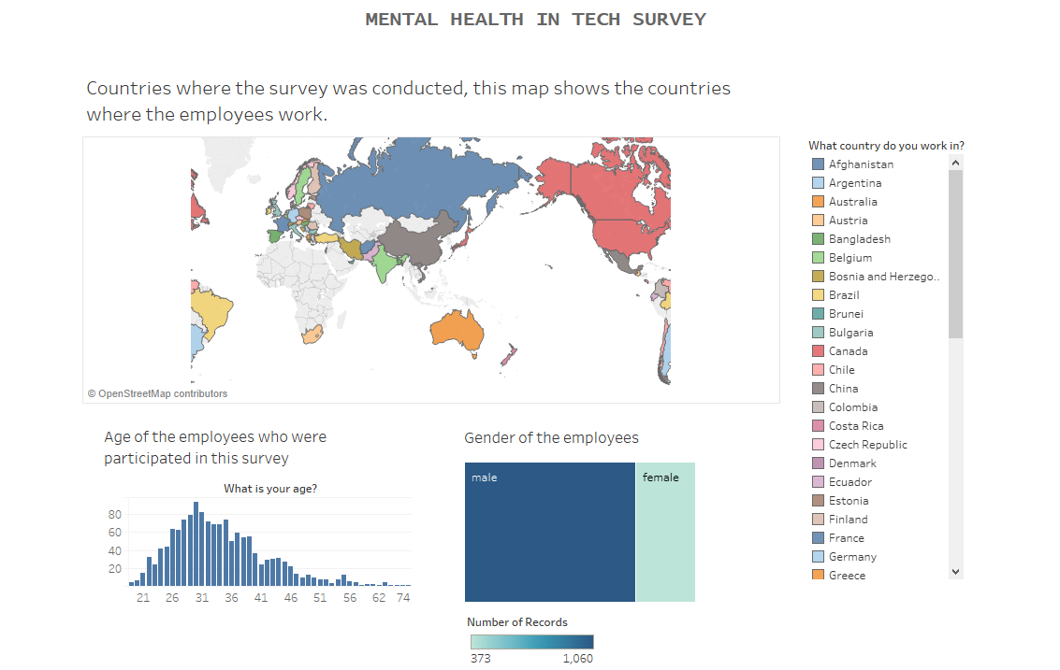

Here we can see the countries where the survey was conducted and the employees who participated in this survey are working. Which age group employees have participated and the gender of the participants. We can observe that most of the employee belong to the 26 to 35 age group. And most of the participants are male.

Dashboard 2:

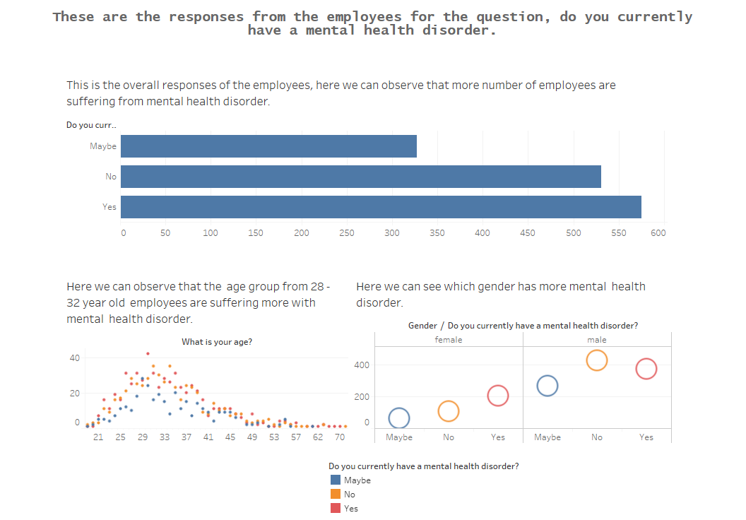

In this dashboard, we can see how many employees are currently having mental health disorder. The first chart shows the overall responses of the employees. Next chart shows which age group employees are having mental health disorder and the last chart shows how many male and female are suffering from mental health issues. We can observe that more than 50% of employees are having mental health disorder and most of them belong to 35 – 36-year-old age group and if we see gender wise it shows more male employees have this problem.

Dashboard 3:

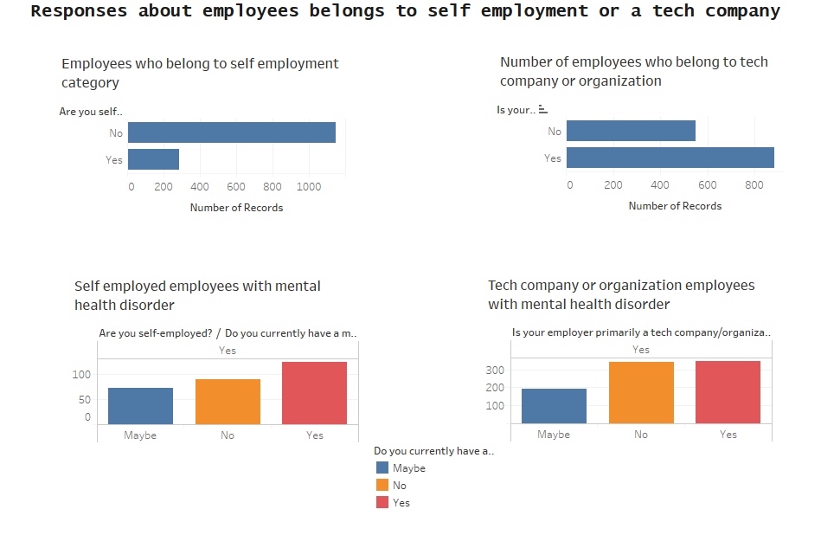

In this dashboard, we can observe that most of the employees who participated in this survey belong to tech company /organization only 20% belong to self-employed. Next two charts show how many employees are having mental illness in each category. We can see that in a tech company 30% plus employees have a mental health problem and almost the same number people say that they don’t have that problem. And rest tells they may have or they may not have. But in self-employed we can see more employees are suffering from these problems.

Dashboard 4:

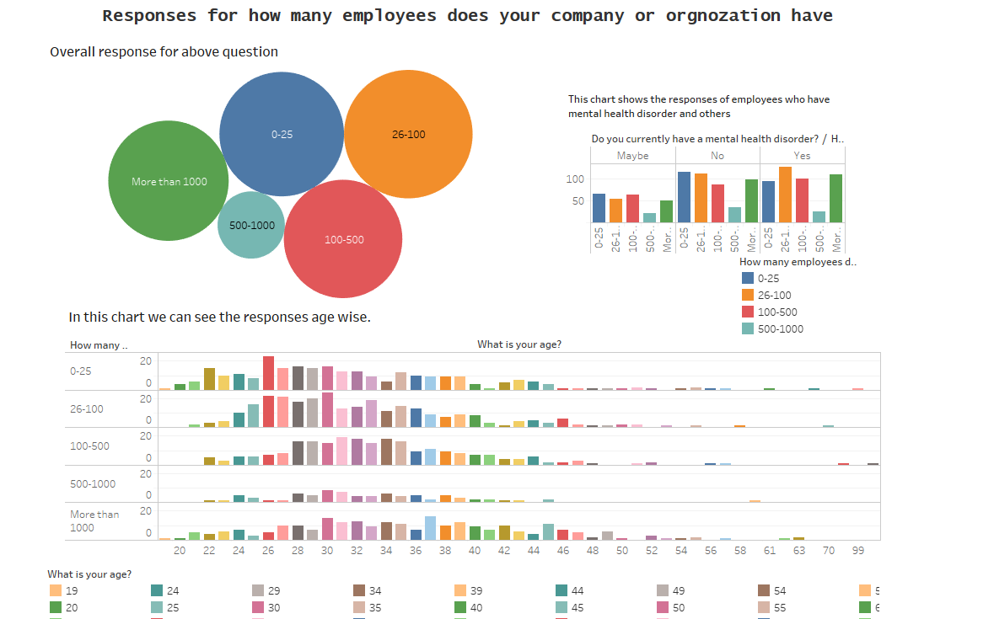

In this dashboard, the number of employees in each company is divided into many groups. We can observe that there are groups like 0-25, 26-100, 100-500, 500-1000 and more than 1000, so the employees were asked to choose to which their company belongs to. We can see except 500 – 1000 all are same. And the next chart shows the mental employees suffering from a mental health disorder we can see in 26- 100 groups we can find more employees who are suffering from mental health problems. And the last chart shows the age group with a mental health disorder belongs to which size group. Here also we can see that age group between 26 and 36 are more suffering from mental health disorder.

Dashboard 5:

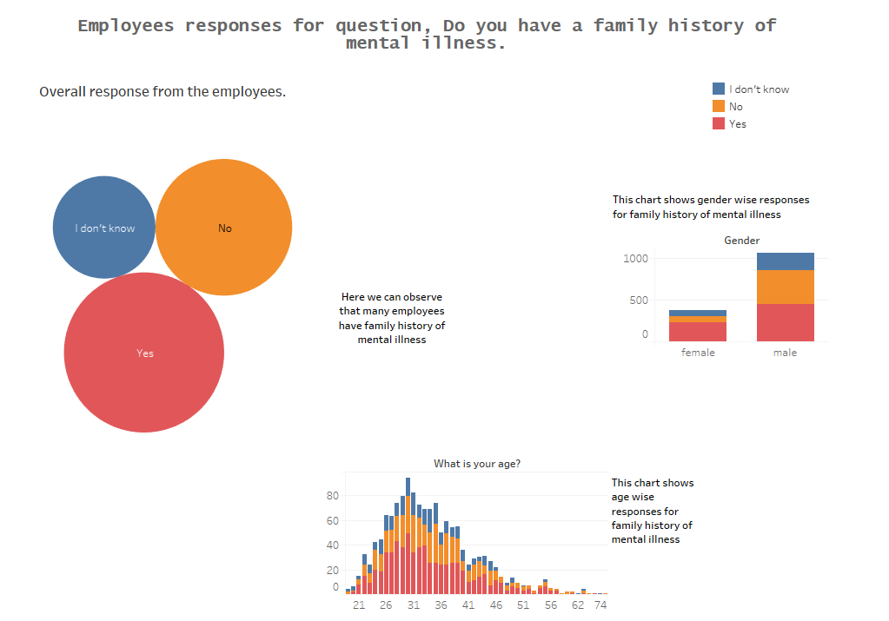

In this dashboard, we can observe employee with family history of mental illness. The first chart shows the overall response to this question, the second chart shows gender-wise. And the last chart shows age wise. In the age, we can observe here also 26-36 age group has this problem.

Dashboard 6:

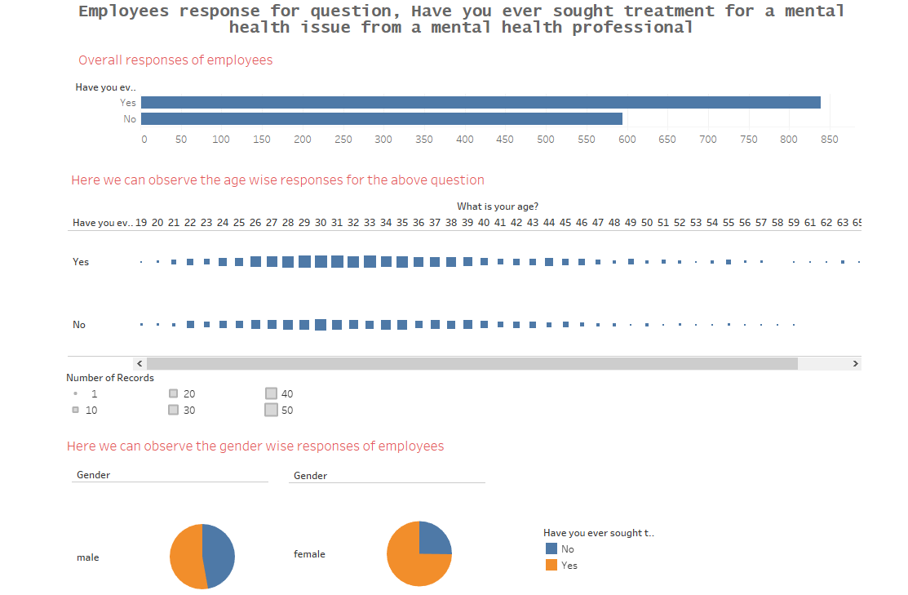

This dashboard shows employees who are taken treatment for mental health illness from a mental health professional. The first chart shows the number of employees taken treatment and not taken. We can see that most of the employees have taken treatment. And the next two charts show according to age and gender in both we can observe that most of the employees take care of their mental health by taking treatment from mental health professional.

Dashboard 7:

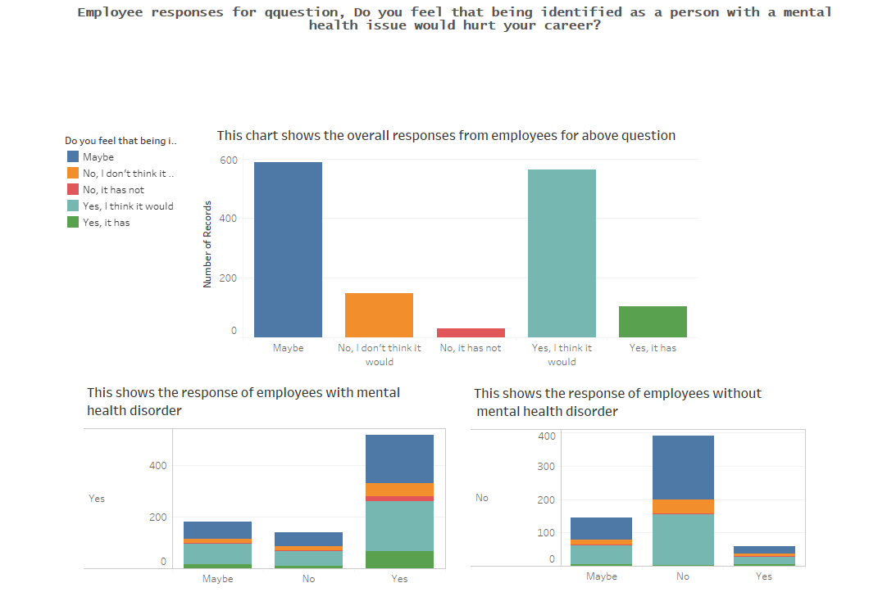

In this dashboard, we can see responses for mental health disorder problem hurts the career of the employee. When we see the overall response 50% says maybe and 40% says yes. And in the next two charts, we will see in the employee with mental health disorder say yes it hurts career. And the employee without mental health disorder says it won't affect the career.

Dashboard 8:

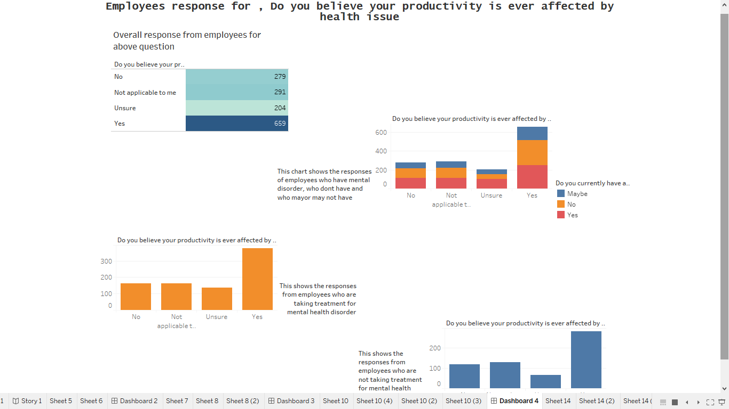

In this dashboard, we will see the response for does the mental health issue affects their productivity or not. In the first chart shows a clear number of how many employees thinks that it will affect their productivity. So we see that the number of employees feels that it will affect their productivity is high. the second chart shows what does the employee with and without mental health disorder thinks. And the last two charts show that the employee who sought treatment and who don’t what do they think. When we see both charts employee thinks that mental health issue will affect their productivity.

Dashboard 9:

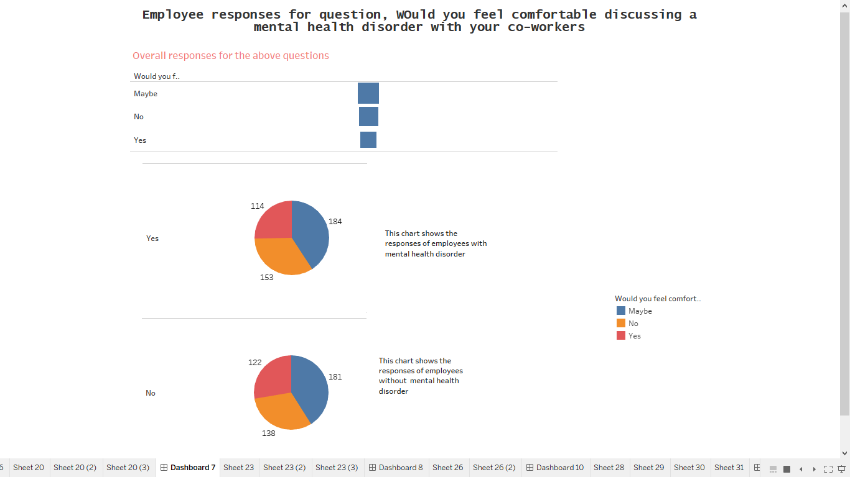

In this dashboard, we can see employee response for how they feel if they discuss about mental health disorder with a coworker. In the first chart, we can see that most of the employee says may be that they are not telling either yes or no. and the next two charts show the responses from the employee having a mental disorder and without. When we observe both the charts both the response are almost the same.

Dashboard 10:

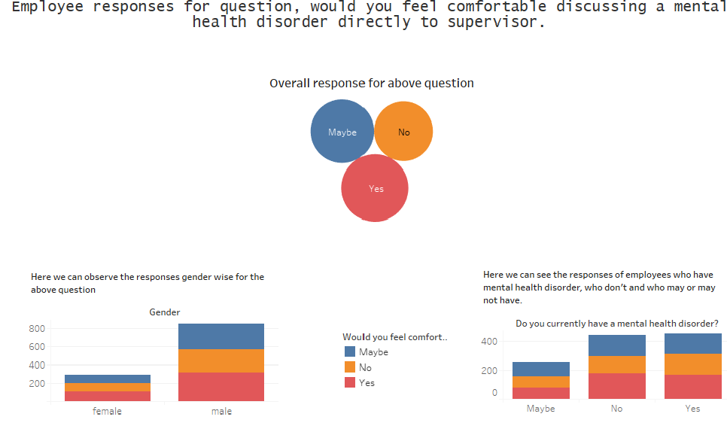

In this dashboard, we can see the responses for do they feel comfortable to discuss about mental health disorder directly with the supervisor, the first chart shows the overall response in that we can see the equal opinion from employees. The second chart shows gender wise responses in that we can observe that male employees feel more comfortable than female employees. And the last chart shows how the employee with mental health disorder and the employee without mental health disorder thinks. Here we can see the equal opinion from both with and without mental health disorder.

Dashboard 11:

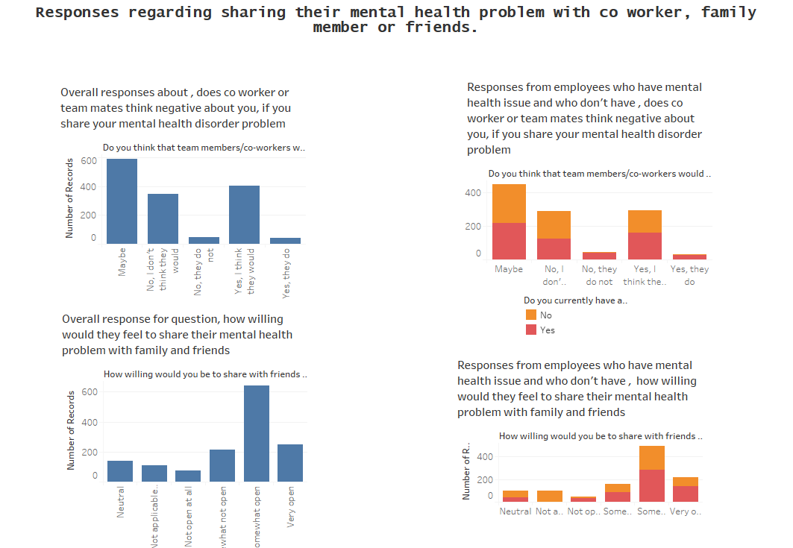

In this dashboard, we can see how the employee feel sharing their mental health problem with family coworker, family member or friends. First two charts show how they feel to share with coworkers or team mates one chart shows the overall response and other shows response of employees with disorder and without disorder. By analyzing it shows some think that they may feel negative and some tells may be.

Next two charts show how willing would employees fell to share their mental problems with family and friends, the first chart shows the overall response we can see that most of the employees like to open up sometimes and share their problem. And in the second it shows the responses of employees having mental health disorder and who don’t, many of them like to open up sometimes. By analyzing we can say responses from both charts are almost same.

Dashboard 12:

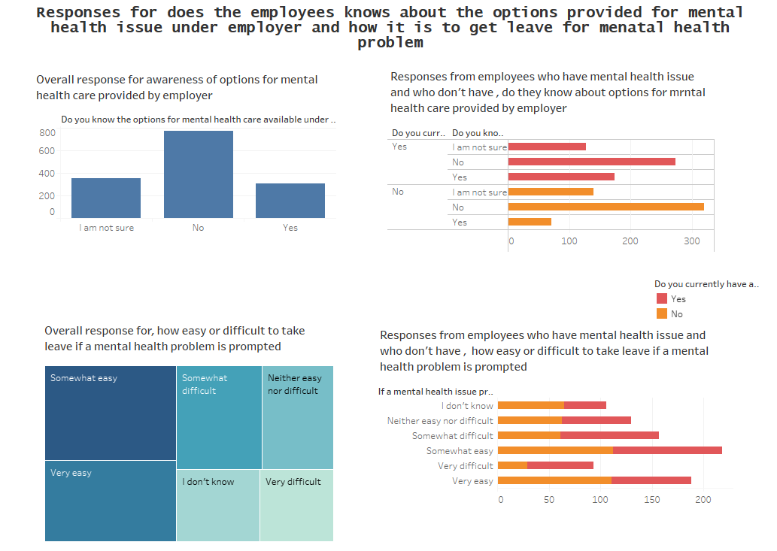

In this dashboard, we can see responses from the employee for asking do they know about the options provided by the employers for mental health issues and how much difficult or easy get a leave when are prompt with mental health problems.

First two chart shows the responses for the awareness of option of mental health care provided by employer. By analyzing the first chart which shows the overall responses, many employees don’t know about the options provided by the employer. The second chart shows the opinion of employee with mental health disorder and without mental health disorder in both the cases we can see many of them don’t know about the options provided by the employer.

The last two chart shows the responses for how difficult or easy to get leave when they are prompted with mental health disorder. First we will see the overall response here we can see many employees say its easy not difficult, we will see what employees with mental disorder tells in the second chart even they tell its not much difficult to get a leave.

Dashboard 13:

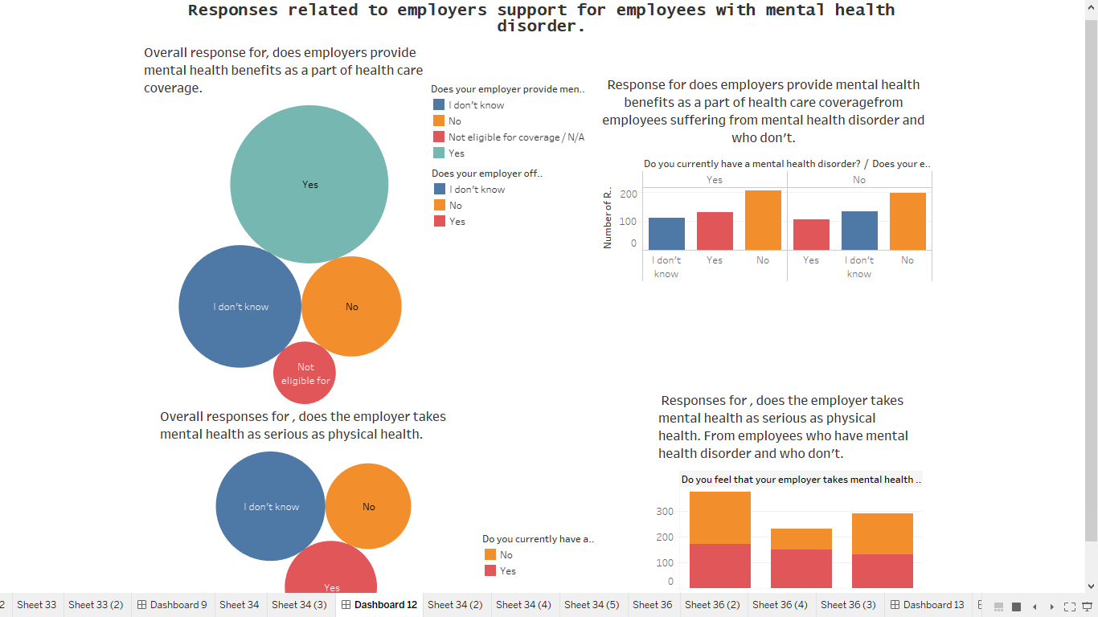

In this dashboard we can see what the employees tell about the support of employers for employees with mental health disorder.

The first two charts are about does the employers provide mental health benefits as a part of health care coverage. In first chart we can see overall response by analyzing this chart we can say that employers provide the mental health benefits as apart of health care, and many of them are not aware of that. The second chart shows the responses of employees with mental health disorder here we can observe that many employees say that employer doesn’t provide any mental health benefits as a part of health care coverage.

The last two chart shows the responses for does the employer takes mental health as serious as physical health, when we see overall response some tell yes and some no. The second shows the response of employees with disorder and without disorder. Many employee with disorder say no.

Dashboard 14:

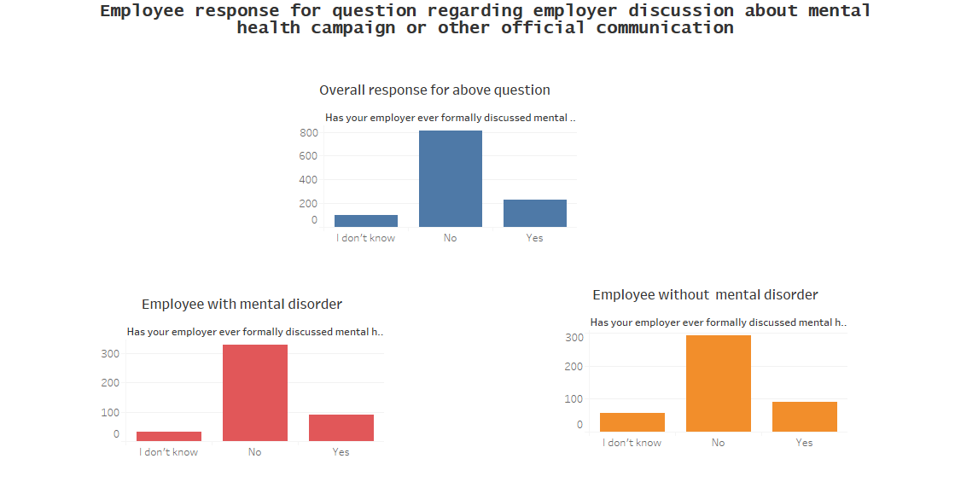

This dashboard shows the response regarding employer discussion about mental health campaign or other official communication, the first chart shows the overall response we can see that many employees have said no for employer discussion about mental health campaign. And the second chart shows the employees with a mental disorder response there also we can see the majority is response is no. And the last chart shows the response of employees without a mental disorder and their response is also no. so the company has to start some mental health campaign.

Dashboard 15:

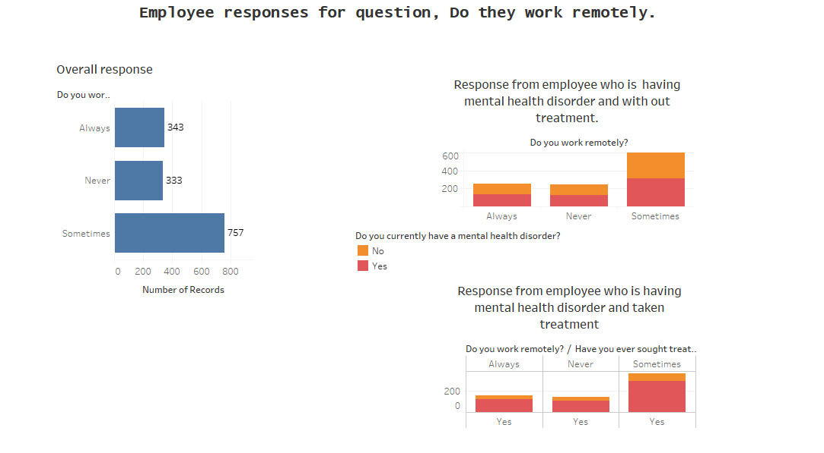

This dashboard about does employee work remotely. Here we can see 3 charts one chart shows the overall response many employees work remotely sometimes. And the second chart shows the responses of employees with mental disorder and without the disorder, there also we can see many of them work some times. And the last chart shows the response of employees who are taking treatment for mental illness, here also we can see many of them work some times. Very less number of employees work always.

Insights:

Almost 60% of the responders already sought treatment for mental illness. It seems to be more concentrated 25 and 36 years old.

Most people who have mental health problem consider that their productivity is affected by the illness and their career would be hurt. Who doesn't seek for treatment too, but in a minor rate, and they think it maybe would hurt their career.

Most people have a family history of mental illness, between who have a mental health problem, the rate is even higher.

Who seek treatment seems to know more about the local and online resources for mental health issues.

Most responders who don't seek treatment think is "somewhat easy" or "very easy" to leave from work for a medical issue. But who seek for treatment told it could not be so easy.

And most people would talk with supervisors rather than with coworkers.

Employers should create an environment for sharing their mental health by creating awareness conducting some mental illness campaigns.

Action Insight:

If the employer doesn't have the money to offer mental health coverage to all his employees, he can concentrate the efforts offering mental health help just to the people with more risk of having a mental disease making his mental health program more efficient.

**Part 2:**

Dashboard 1:

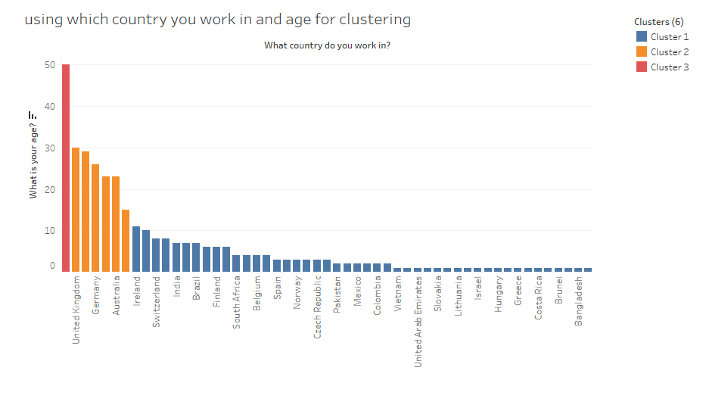

In this dashboard, I have used two variable one is what is your age and what country do you work. In this chart shows the countries and age of employee who work in that country

In this, there are 3 clusters. Lower ones are cluster1, medium ones are cluster 2 and the third cluster in one with the highest value. Cluster 3 has its own range so it is single.

Dashboard 2:

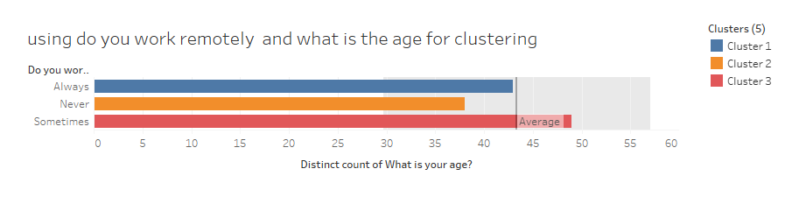

In this dashboard, we can see which age group work more remotely. In this, there are 3 clusters medium one is cluster 1, the lowest one is cluster 2, the largest one is cluster3.

Dashboard 3:

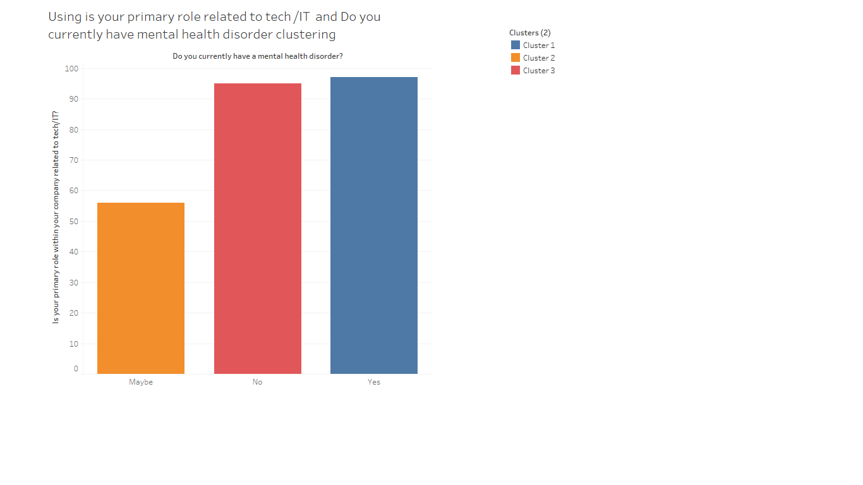

In this dashboard, we can see two variables employee primary role related to tech/IT and do you currently have a mental health disorder. In this chart, we can see 3 clusters lowest one is cluster1, the medium one is the cluster 2, largest one is cluster 1.

Dashboard 4:

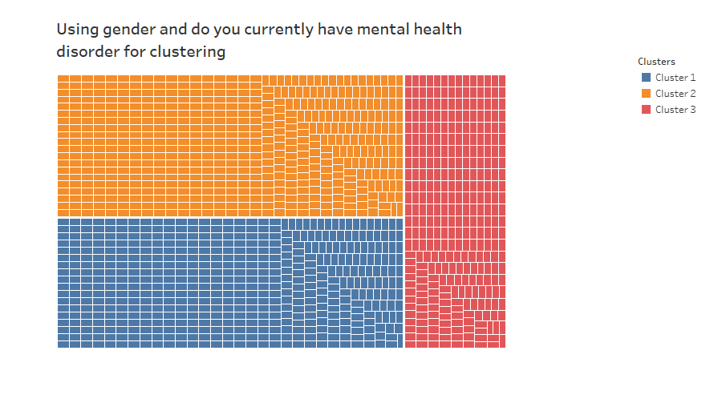

In this dashboard, we can see two variables what is your age and do you currently have a mental health disorder. In this chart, we can see cluster based upon similar property.

**TECHINIQUE USED FOR DATA ANALYSIS IS CLUSTERING**

This dataset doesn’t have date variables and numerical values so it was not possible to apply other techiques.

Insights:

Almost 60% of responders are suffering from mental health. It seems to be more concentrated 25 and 36 years old.

Action Insight

The employer has to take care of employees with mental health as well, they should create awareness of options available under health coverage plans.