**Enable below parameter on CD- pipeline to automate triggered from pipeline-CI**

1.

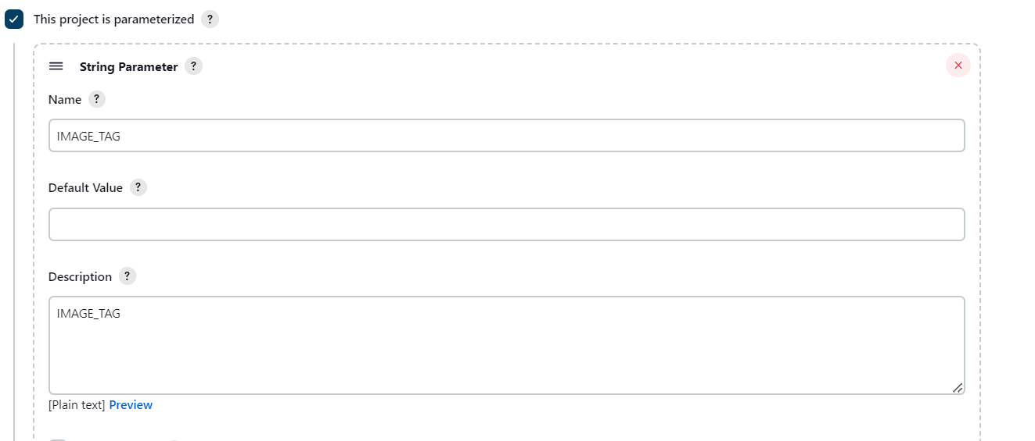

2.

