Contents
Project Overview 1
CMS Risk Adjustment 1
GAP Suspecting 2
1.0 Technical Layout 2
Data Loader Main 6
1. Purpose & Scope 6
2. Parameters (Widgets) 7
3. Configuration Files 8
4. Architecture & Data Flow 9
5. Processing Logic 11
5.1 Cell-by-Cell Execution Flow 11
5.2 Supported File Types (18 Total) 12
5.3 Supplemental Processing (Delta Share Path) 14
5.4 Non-Supplemental Processing (Volume Path) 15
6. Error Handling & Failure Reporting 16
7. Dependencies 17
8. Operational Runbook 18
9. Data Lineage 20
Ingestion to Transformation 21
1. Purpose & Scope 21
2. Parameters (Widgets) 22
3. Configuration Files Used 23
4. Execution Flow 23
5. SQL Transformation Scripts 24
SQL Template Placeholders 26
6. Historical vs. Incremental Logic 27
7. Cell 3 — One-Time Member Deletion Utility 28
8. Error Handling 28
9. Dependencies 29
10. Operational Runbook 30
Qualifying Claims 33
1. What This Notebook Does 33
2. Parameters 33
3. Data Flow (Step by Step) 33
4. Qualification Rules (Business Logic) 35
5. Cell-by-Cell Breakdown 36
6. Enrichment (Cell 6) 37
7. Deduplication & Upsert 37
8. Output 38
9. Dependencies 39
10. Error Handling 40
11. Operational Runbook 40
Pseudo Ingest to Transform 41
1. What This Notebook Does 41
2. Parameters 42
3. Execution Flow 42
4. Part A: Child Notebook Invocation (Cell 6) 43
5. Part B: Supplemental Pseudo-Claims Processing (Cells 7–8) 44
6. Cell-by-Cell Summary 46
7. Why This Notebook Exists 46
8. Output 47
9. Dependencies 47
10. Error Handling 48
11. Operational Runbook 48
12. Data Lineage 50
MA Model Input Data 51
1. What This Notebook Does 51
2. Parameters 51
3. Execution Flow 52
4. Input Tables 53
5. Output Tables (Gold/Curation) 55
6. Key Business Logic 57
7. Cell-by-Cell Summary 59
8. Schema Resolution 60
9. Deduplication Logic 61
10. Error Handling 61
11. Dependencies 62
12. Operational Runbook 63
13. Data Lineage 65
CMS HCC Risk Score Calculation 66
1. What This Notebook Does 66
2. Parameters 66
3. Execution Flow 68
3. Execution Flow 68
4. The 13 Scoring Steps (Part A) Explained 70
5. SEDITS Rules (Step 5) 72
6. Community Model Segments (Step 4) 72
7. Part B: Risk Member HCC Processing 73
8. Part C: Risk Member HCC Summary 73
9. Output Tables 74
10. Reference Tables (from Config Schema) 76
11. Intermediate Data 77
12. Error Handling 77
13. Dependencies 77
14. Operational Runbook 79
15. Data Lineage 82
16. Related Notebooks 83

Project Overview

CMS Risk Adjustment
CMS Risk Adjustment is a methodology used by the Centers for Medicare & Medicaid Services (CMS) to ensure that health plans are fairly compensated for the risk profile of their enrolled members. It adjusts payments based on the health status and demographic characteristics of beneficiaries.
Why It Matters:
- Fair Reimbursement:
Plans serving sicker or more complex patients receive higher payments to reflect the expected cost of care.
- Encourages Accurate Documentation:
Providers and plans are incentivized to document all relevant diagnoses to ensure proper risk scoring.
- Supports Value-Based Care:
Accurate risk scores help align incentives with patient outcomes and care quality.
How It Works:
- Use claims and encounter data to identify diagnoses. Use member demographic data to classify the member in right category & model.
- Diagnoses are then mapped to Hierarchical Condition Categories (HCCs), which are weighed to calculate a Risk Adjustment score (aka RAF).
- The RAF score influences the capitation payment CMS makes to Medicare Advantage and ACA plans.

GAP Suspecting
Diagnosis GAP Suspecting is a process used to identify missing or undocumented chronic conditions in a member’s medical record that could impact their risk score and care management. These gaps often occur when a condition was previously documented but not captured in the current reporting period.

1.0 Technical Layout
Solution Design:(link to lucid chart)
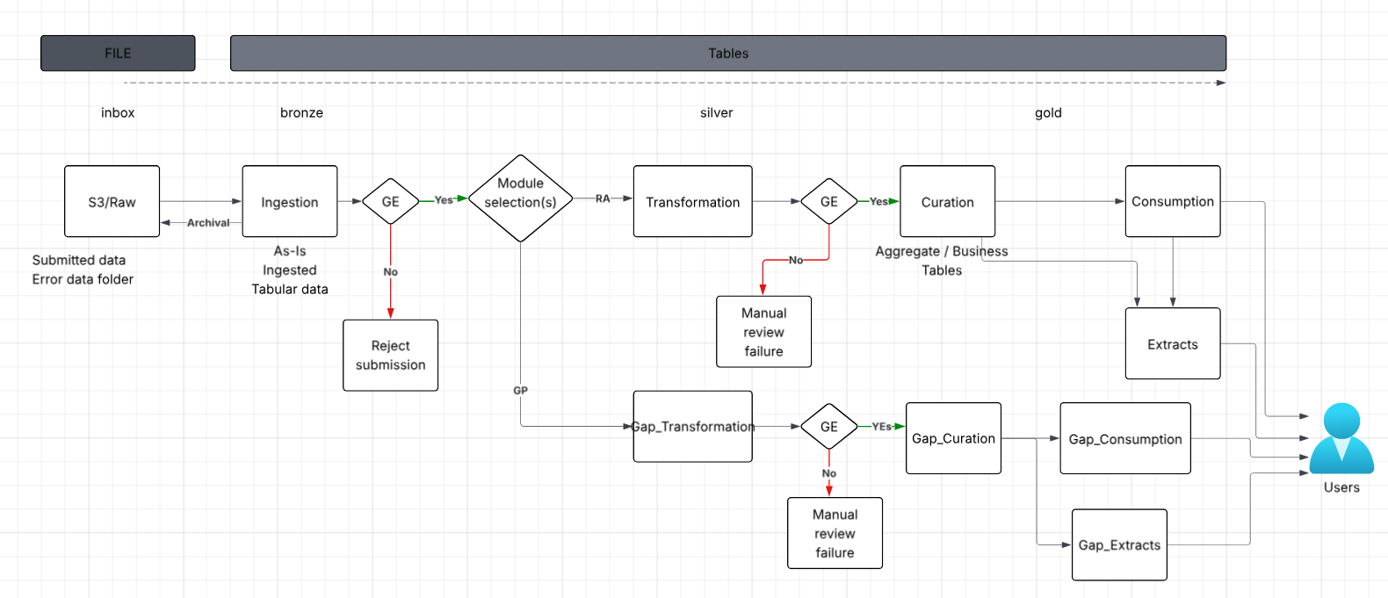
Schema Design:
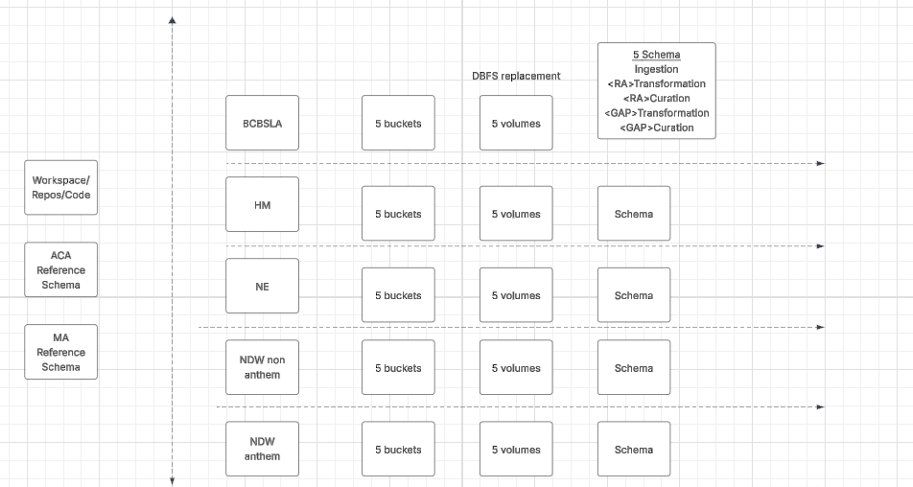

Catalog snapshot in Databricks: lINK TO DATABRICKS CATALOG @Yuva Kosuru
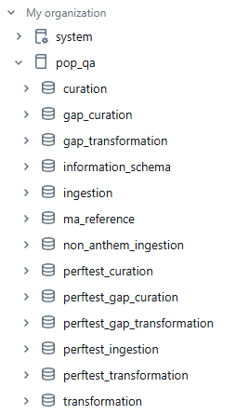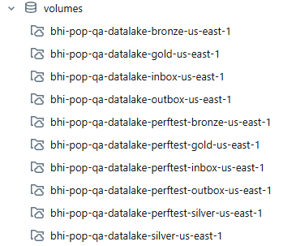

Folder Structure in Codebase: LINK to github
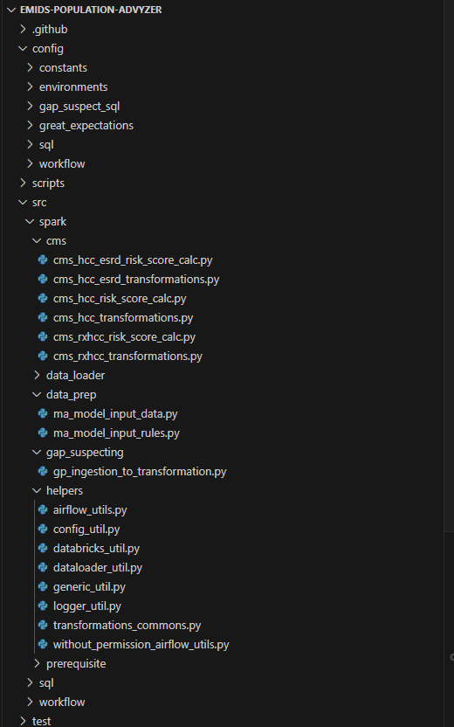

Data Loader Main

1. Purpose & Scope
data_loader_main is the primary data ingestion pipeline for the EMIDS Population Advyzer platform. It orchestrates loading raw healthcare data (Medicare Advantage / CMS Risk Adjustment) into Unity Catalog Delta tables, following a Bronze-layer ingestion pattern.
Key responsibilities:
- Ingest pipe-delimited (.txt) and fixed-width source files from S3-backed Databricks Volumes
- Load supplemental tables (MMR, MAO-004, MOR) from Delta Share sources
- Apply schema validation, date conversions, and audit trail enrichment
- Archive processed files into date-partitioned directories
- Report success/failure summary with detailed error logging
Location: src/spark/data_loader/data_loader_main

2. Parameters (Widgets)
Parameter | Type | Default | Description
env | Dropdown | DEV | Target environment: DEV, QA, STG, PROD
plan_name | Text | (empty) | Health plan identifier (e.g., perftest, planA). Drives schema/path resolution
ingestion_tables | Text | (empty) | Comma-separated list of tables to process. Empty = process all 18 file types
batch_id | Text | (empty) | Comma-separated SUBM_BID values for filtering supplemental Delta Share tables (e.g., 89,90)
supp_source_load_month | Dropdown | 01 | Month component (01–12) for MAO SOURCE_LOAD_MONTH stamp
supp_source_load_year | Text | Current year | Year component for MAO SOURCE_LOAD_MONTH stamp (combined as YYYY_MM)
Parameter Usage Examples
# Process all files for plan "perftest" in QA
env=QA, plan_name=perftest, ingestion_tables=(empty)

# Process only member and pharmacy for plan "planA" in DEV
env=DEV, plan_name=planA, ingestion_tables=member,pharmacy

# Process supplemental MAO with batch filtering
env=QA, plan_name=perftest, ingestion_tables=mao_004, batch_id=89,90, supp_source_load_month=12, supp_source_load_year=2025

3. Configuration Files
File | Path | Purpose
data_loader_config.yaml | config/constants/data_loader_config.yaml | Master config: catalog/schema templates, file names, merge keys, file type mappings, Delta Share config, special file patterns
expected_schema.yaml | config/constants/expected_schema.yaml | PySpark StructType definitions for each table (used for schema validation)
ma_supplemental_file_layout.yaml | config/constants/ma_supplemental_file_layout.yaml | Fixed-width column positions for MAO-004, MMR, and MOR file parsing
file_read_meta.yaml | config/sql/file_read_meta.yaml | Column lists for downstream transformations
values.yaml | config/environments/{env}/values.yaml | Environment-specific settings (e.g., delta_share_catalog)
Key Config Variables (from data_loader_config.yaml)
catalog: pop_{env}
source_schema: "{plan_name}ingestion"
target_schema: "{plan_name}transformation"
src_file_dir: /Volumes/pop_{env}/volumes/bhi-pop-{env}-datalake-{plan_name}inbox-us-east-1
ingestion_file_dir: /Volumes/pop_{env}/{plan_name}ingestion/ingestion/src_files
archive_dir: /Volumes/pop_{env}/{plan_name}ingestion/ingestion/archive

4. Architecture & Data Flow
DFD Symbol Legend: External Entity = [Entity] | Process = (Process) | Data Store = || Data Store || | Data Flow = →
[Databricks Widgets / Runtime Parameters]
│ env, plan_name, ingestion_tables, batch_id, supplemental month/year
▼
(1.0 Load YAML Configuration)
│ reads config/constants and environment values
▼
|| Configuration Files || data_loader_config.yaml | expected_schema.yaml | supplemental layouts | values.yaml
│ catalog/schema/path templates
▼
(2.0 Resolve Catalog, Schema, and Paths)
│ target: pop_{env}.{plan}ingestion
├──────────────────────────────────────────┐
▼ ▼
[Delta Share Catalog] [S3 Inbox Volume]
│ supplemental tables │ .txt volume files
▼ ▼
(3.1 Process Supplemental Data) (3.2 Move Raw Files to Staging)
│ SUBM_BID filter, mapping, dedupe │ per-table staging folders
│ ▼
│ || Staging Directories ||
│ │ staged .txt files
│ ▼
│ (4.0 Parse Source Files)
│ │ pipe-delimited or fixed-width rows
└──────────────────────┬───────────────────┘
▼
(5.0 Common Processing)
│ SOURCE_LOAD_MONTH, audit columns, trim strings, date conversions, schema alignment
▼
|| Delta Stage Tables || stage_{table_name}
▲ append mode
│
(6.0 Archive Source Files)
│ processed files
▼
|| Archive Volume || /{YYYY}/{MM}/{DD}/

5. Processing Logic

5.1 Cell-by-Cell Execution Flow
Cell | Title | Purpose
1 | Markdown Header | Documents widget parameters
2 | Widget Definitions | Creates dbutils.widgets for runtime parameters
3 | Imports & Variables | Imports helpers, reads widget values, builds source_load_month
4 | Config Loading | Loads YAML configs, resolves catalog/schema/paths, switches catalog
5 | Table Selection | Parses ingestion_tables widget or defaults to all 18 file types
6 | Supplemental Processing | Processes MMR/MAO-004/MOR from Delta Share (removes from selected_tables on success)
7 | File Movement | Moves raw files from inbox volume to per-table staging folders
8 | File Processing | Main loop: discovers, parses, loads, and archives each table's files
9 | Summary & Logging | Reports success/failure counts; raises exception if any failures

5.2 Supported File Types (18 Total)
Non-Supplemental (15 files) — Pipe-delimited .txt with schema validation:
File Name | Target Table | Merge Keys
member | stage_member | HOME_PLAN_ID_CD, MEMB_ID_CD
member_enrollment | stage_member_enrollment | PLAN_ID, MEMB_ID_CD, HOME_PLAN_ID_CD, COVRG_BEGIN_DT
member_enrollee_history | stage_member_enrollee_history | HOME_PLAN_ID_CD, MEMB_ID_CD, BHI_MEMB_ID
facility_header | stage_facility_header | CLM_ID_CD, HOME_PLAN_ID_CD
facility_detail | stage_facility_detail | CLM_ID_CD, CLM_LN_NUM, HOME_PLAN_ID_CD
facility_diag | stage_facility_diag | CLM_ID_CD, HOME_PLAN_ID_CD, DIAG_TYPE_CD, DIAG_NUM
professional | stage_professional | CLM_ID_CD, CLM_LN_NUM, HOME_PLAN_ID_CD
professional_diag | stage_professional_diag | CLM_ID_CD, HOME_PLAN_ID_CD, DIAG_TYPE_CD, DIAG_NUM
pharmacy | stage_pharmacy | CLM_ID_CD, CLM_LN_NUM, HOME_PLAN_ID_CD
quality_events | stage_quality_events | —
lab | stage_lab | —
designated_provider | stage_designated_provider | —
provider | stage_provider | —
location | stage_location | —
health_events | stage_health_events | —
Supplemental (3 files) — Fixed-width or Delta Share with special parsing:
File Name | Target Tables | Source Format
mmr | stage_mmr | Fixed-width text OR Delta Share (atm_stg_mmr_clear)
mao_004 | stage_medicare_mao, stage_medicare_mao_header, stage_medicare_mao_trailer | Fixed-width text (record-type split) OR Delta Share (atm_stg_mao)
mor | stage_mor_* (Part C & Part D tables) | Fixed-width text (multi-record-type)

5.3 Supplemental Processing (Delta Share Path)
When supplemental tables are in selected_tables, they are processed first via Delta Share:
- Load environment config to get delta_share_catalog
- Parse batch_id into a list of SUBM_BID values
- For each supplemental table:
  - Read from the shared Delta catalog (e.g., bhi_medadvsupp_data_deploy_01.atomic.*)
  - Apply SUBM_BID filter (if provided)
  - Apply table-specific logic:
    - MAO-004: Filter VOID_FLAG=0, DATA_ANOMALY_FLAG=0, DELETE_FLAG='0', SRVC_TYP IN ('I','O','P')
    - MMR: Filter DELETE_FLAG='0', deduplicate by MEDCR_BNFCRY_ID + PAYMENT_YEAR (latest CRT_TS)
  - Apply column mapping (rename source columns to target schema)
  - Stamp SOURCE_LOAD_MONTH (from parameter for MAO, derived from DATA_CYCLE_ID for MMR)
  - Add PROCESS_IND_YN = 'N' tracking flag
- On success: remove from selected_tables (won't process from volumes)
- On failure: log warning, leave in selected_tables for volume fallback
Note: If we want to execute without golden records for mmr and medicare_mao, then needs to do the changes for _load_single_delta_table function in dataloader_util.py helpers folder.
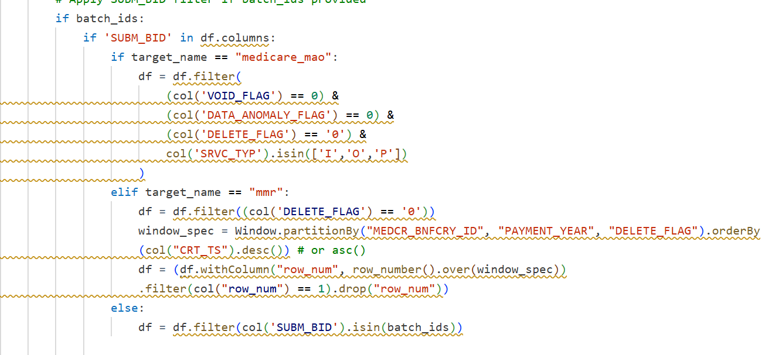
From above code, we need to do change in if condition medicare_mao to medicare_mao_test and mmr to mmr_test.
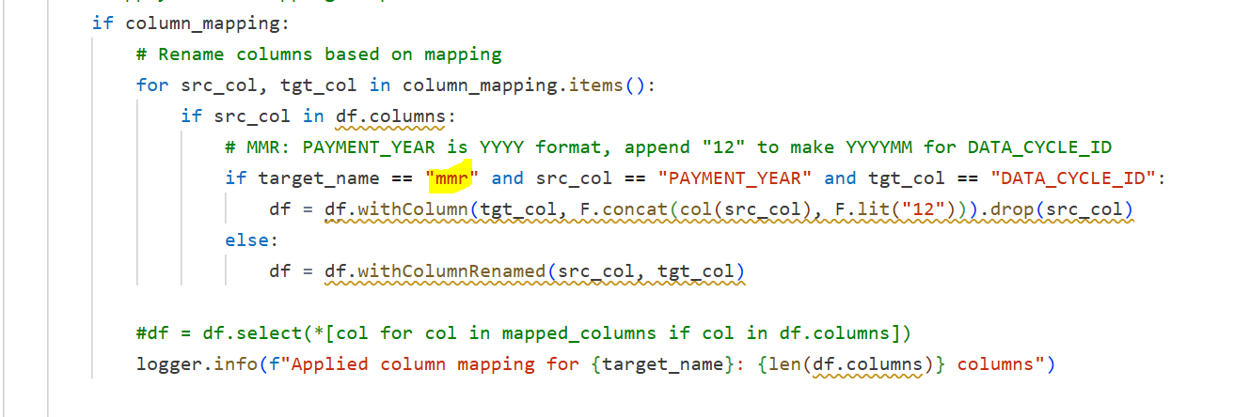

In above code also change mmr to mmr_test.
In below yaml, we need to remove marked line.
emids-population-advyzer/config/constants/data_loader_config.yaml

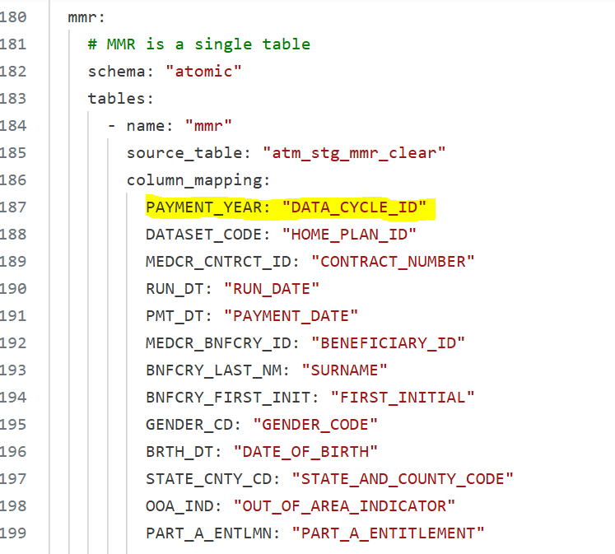

In mmr.sql of below path :
src/spark/data_standardization/ingestion_transformation_sql/mmr.sql
Add filter condition as below:
TRIM(stage.ADJUSTMENT_REASON_CODE) = ''

5.4 Non-Supplemental Processing (Volume Path)
- File Movement: Raw files moved from inbox volume to per-table staging folders
  - Pattern matching: {TABLE_NAME}_{MMDDYYYY}.txt for standard files
  - Special pattern matching for supplemental files (e.g., MAO004PV, HCCMODD, PTDMODD, MONMEMD)
- File Discovery: discover_text_files() checks for .txt files in staging folder
- Parsing:
  - Non-supplemental: load_txt() with pipe delimiter (|) and predefined StructType schema
  - Supplemental fallback: Dynamic dispatch to parse_mao_004_files(), parse_mmr_files(), or parse_mor_files()
- Enrichment (via load_dataframe_into_table()):
  - Extract SOURCE_LOAD_MONTH from filename date pattern
  - Add audit columns (CREATED_DATE, CREATED_BY, UPDATED_DATE, UPDATED_BY, VALIDATED_TIMESTAMP)
  - Trim all string columns (removes stray whitespace from join keys)
  - Apply multi-format date conversions on *_DT columns
  - Align DataFrame to target Delta table schema (cast types, add missing columns as NULL)
- Write: Append to {target_schema}.stage_{table_name} using insertInto()
- Archive: Move processed files to {archive_dir}/{table}/{YYYY}/{MM}/{DD}/{filename}_{timestamp}.txt

6. Error Handling & Failure Reporting
Error Categories
Stage | Error Type | Behavior
Config loading | FileNotFoundError, YAMLError | Raises immediately — pipeline cannot proceed
File movement | Any exception | Raises immediately
File discovery | No files found | Logs warning, adds to file_failures, continues to next table
File parsing | Parse/read error | Logs error, adds to file_failures, continues to next table
Table processing | Schema/write error | Logs error, adds to file_failures, continues to next sub-table
Archiving | Move error | Logs error, adds to file_failures, does not halt
Delta Share | Any exception | Logs warning, falls back to volume processing
Failure Tracking
file_failures = [] # List of (path_or_name, stage, reason) tuples
processed_tables = set() # Successfully loaded table names
The final cell raises an Exception if len(file_failures) > 0, ensuring the Databricks Job reports a failure status.

7. Dependencies
Helper Modules
Module | Key Functions Used
src.spark.helpers.logger_util | get_logger()
src.spark.helpers.config_util | get_config_yaml()
src.spark.helpers.databricks_util | load_txt(), get_plan_name(), get_path_plan_name()
src.spark.helpers.dataloader_util | archive_all_files(), parse_mao_004_files(), parse_mmr_files(), parse_mor_files(), discover_text_files(), parse_schema(), move_raw_file_dbutils(), load_dataframe_into_table(), process_supplemental_tables_from_delta_share()
External Dependencies
Package | Purpose
pyspark | Spark DataFrames, SQL, schema types
yaml | YAML config parsing
re | Regex for filename pattern matching
uuid | Unique file IDs for MAO/MOR processing
delta | DeltaTable for merge operations (downstream)

8. Operational Runbook
Prerequisites
- Cluster: Requires a cluster with USER_ISOLATION security mode
- Unity Catalog access: User must have permissions on pop_{env} catalog
- Volume access: Read/write on inbox and ingestion volumes
- Delta Share: Access to supplemental data catalog (configured per environment)
- Source files: Raw .txt files must be present in the inbox volume
How to Run
Interactive (Notebook UI):
- Attach to a cluster (e.g., Cluster_MK_QA)
- Set widget values at the top of the notebook
- Run All cells
Scheduled (Databricks Job):
- Configured via Declarative Automation Bundles in config/pop-advyzer-main-bundle/
- Parameters passed via job widget overrides
Common Scenarios
Scenario | Parameters
Full load (all files) | env=QA, plan_name=perftest, ingestion_tables= (empty)
Single table reload | env=QA, plan_name=perftest, ingestion_tables=member
Supplemental only | env=QA, plan_name=perftest, ingestion_tables=mmr,mao_004, batch_id=89
MAO with specific cycle | env=QA, plan_name=perftest, ingestion_tables=mao_004, batch_id=89, supp_source_load_month=12, supp_source_load_year=2025
Troubleshooting
Symptom | Likely Cause | Resolution
"No text files found" for all tables | Files not yet landed in inbox volume | Verify S3 delivery; check volume path
Schema mismatch errors | Source file has new/renamed columns | Update expected_schema.yaml
Delta Share timeout/auth error | Catalog access revoked or network issue | Check delta_share_catalog in env config; verify UC permissions
"source_load_month parameter is mandatory" | MAO processing without supp_source_load_month | Provide month/year widgets before running
MERGE key failures downstream | Stray whitespace in source files | Verify trim_string_columns() is applied (should be automatic)
"File processing failed for N files" | One or more tables had errors | Check file_failures list in logs for per-table details
Post-Run Validation
-- Check loaded row counts
SELECT 'stage_member' AS table_name, COUNT(*) AS row_count
FROM pop_{env}.{plan}ingestion.stage_member
UNION ALL
SELECT 'stage_facility_header', COUNT(*)
FROM pop_{env}.{plan}ingestion.stage_facility_header;

-- Verify latest SOURCE_LOAD_MONTH
SELECT DISTINCT SOURCE_LOAD_MONTH
FROM pop_{env}.{plan}ingestion.stage_member
ORDER BY SOURCE_LOAD_MONTH DESC
LIMIT 5;

-- Check supplemental PROCESS_IND_YN
SELECT PROCESS_IND_YN, COUNT(*)
FROM pop_{env}.{plan}ingestion.stage_mmr
GROUP BY PROCESS_IND_YN;

9. Data Lineage
Source (S3 / Delta Share)
│
▼
pop_{env}.{plan}ingestion.stage_* ← THIS PIPELINE
│
▼
pop_{env}.{plan}transformation.* ← Data Standardization pipeline
│
▼
pop_{env}.{plan}curation.* ← Risk Scoring / Dashboard pipelines

Ingestion to Transformation

1. Purpose & Scope
ingestion_to_transformation is the data standardization pipeline (Silver layer) for the EMIDS Population Advyzer platform. It reads raw data from stage_* tables in the ingestion schema and transforms it into clean, business-ready tables in the transformation schema.
What it does:
- Reads from pop_{env}.{plan}ingestion.stage_* tables (Bronze)
- Applies SQL-based MERGE/INSERT logic to standardize data
- Writes to pop_{env}.{plan}transformation.* tables (Silver)
- Supports full historical loads and incremental loads
- Executes 19 SQL transformation scripts in sequence
Location: src/spark/data_standardization/ingestion_to_transformation

2. Parameters (Widgets)
Parameter | Type | Default | Description
env | Dropdown | DEV | Target environment: DEV, QA, STG, PROD
plan_name | Text | (empty) | Health plan identifier (e.g., non_anthem, perftest)
transformation_tables | Text | (empty) | Comma-separated list of tables to process. Empty = process all tables
historical_flag | Dropdown | Y | Y = full historical load, N = incremental (new records only)
source_load_month | Dropdown | 01 | Month (01–12) for SOURCE_LOAD_MONTH filter
source_load_year | Dropdown | Current year | Year for SOURCE_LOAD_MONTH filter (current year to 3 years back)
How historical_flag Works
Flag | Behavior
Y (Historical) | Reads ALL records from stage_* tables (full reload into transformation)
N (Incremental) | Reads only new/unprocessed records using SOURCE_LOAD_MONTH filter or LEFT ANTI JOIN

3. Configuration Files Used
File | Path | What It Provides
values.yaml | config/environments/{env}/values.yaml | catalog, config_schema
file_read_meta.yaml | config/sql/file_read_meta.yaml | STAGE_LOAD_TABLES, PREREQUISITE_TABLES (table execution order)
data_loader_config.yaml | config/constants/data_loader_config.yaml | MAO_FILE_TYPE value

4. Execution Flow
Ingestion to Transformation — Execution Flow
1. Set Widgets | ↓ | Capture runtime parameters: env, plan_name, transformation_tables, historical_flag, source_load_month, and source_load_year.
2. Load Configs | ↓ | Read YAML files and resolve catalog, ingestion schema, transformation schema, config schema, and SQL script paths.
3. Build Table List | ↓ | Combine PREREQUISITE_TABLES and STAGE_LOAD_TABLES, or use the user-selected list. Prerequisites run first: member_id, risk_prov, and risk_location.
4. Prepare SQL Replacements | ↓ | Build the replacement dictionary for SQL placeholders such as ${catalog}, ${ingestion}, ${transformation}, ${SOURCE_LOAD_MONTH}, ${CURRENT_USER}, and related runtime values.
5. Execute Transformation Loop | ↓ | For each table: set ${Source} based on historical_flag when needed, read the SQL file from ingestion_transformation_sql/, replace placeholders, split statements by semicolon, and execute each statement with spark.sql().
6. Log Summary | ✓ | Report total duration, log successful and failed scripts, and raise errors when execution fails.

5. SQL Transformation Scripts
All scripts live in src/spark/data_standardization/ingestion_transformation_sql/.
Execution Order
Prerequisites (always run first):
# | Script | What It Does
1 | member_id.sql | Assigns/resolves MEMBER_BID surrogate keys for members
2 | risk_prov.sql | Assigns PROVIDER_BID surrogate keys
3 | risk_location.sql | Assigns LOCATION_BID surrogate keys
Main tables (run after prerequisites):
# | Script | Target Table | Operation
4 | member.sql | member | MERGE (upsert by HOME_PLAN_ID_CD, MEMB_ID_CD)
5 | member_enrollment.sql | member_enrollment | MERGE
6 | facility.sql | facility_header, facility_detail, facility_diag | MERGE (multi-step: ID generation → header → detail → diag)
7 | professional.sql | professional, professional_diag | MERGE
8 | pharmacy.sql | pharmacy | MERGE
9 | health_events.sql | health_events | MERGE
10 | lab.sql | lab | MERGE
11 | quality_events.sql | quality_events | MERGE
12 | provider.sql | provider | MERGE
13 | location.sql | location | MERGE
14 | designated_primary_provider.sql | designated_primary_provider | MERGE
15 | mmr.sql | mmr | INSERT/MERGE (flag-dependent)
16 | mor.sql | mor | MERGE
17 | medicare_mao.sql | medicare_mao | INSERT (flag-dependent source)
18 | process_medicare_mao.sql | Updates MAO processing flags | UPDATE
19 | load_medicare_mao.sql | Final MAO load | INSERT

SQL Template Placeholders
Each .sql file uses these placeholders, replaced at runtime:
Placeholder | Replaced With | Example Value
${catalog} | Unity Catalog name | pop_qa
${ingestion} / ${schema_ingestion} | Ingestion schema | non_anthemingestion
${transformation} / ${gap_schema_transformation} | Transformation schema | non_anthemtransformation
${plan_name} | Plan name | non_anthem
${schema_reference} | Reference/config schema | reference
${CURRENT_USER} | Audit user | 'user@company.com'
${SOURCE_LOAD_MONTH} | Year_Month filter | '2025_11'
${FileType} | MAO file type | 'mao_supplemental_dx'
${CURRENT_YEAR} | Year | 2025
${CURRENT_MONTH} | Month | 11
${CURRENT_YEAR_MONTH} | Combined | '2025_11'
${Source} | Source query/table for MMR/MAO | (dynamic based on historical_flag)

6. Historical vs. Incremental Logic
MMR Table
Flag | ${Source} Value
Y (Historical) | Full table: {catalog}.{schema_ingestion}.stage_mmr
N (Incremental) | Only new records via LEFT ANTI JOIN on CONTRACT_NUMBER, RUN_DATE, PAYMENT_DATE, SOURCE_LOAD_MONTH
Medicare MAO Table
Flag | ${Source} Value
Y (Historical) | Full table: {catalog}.{schema_ingestion}.stage_medicare_mao
N (Incremental) | Filtered: WHERE SOURCE_LOAD_MONTH = '{year_month}'
All Other Tables
For non-supplemental tables (member, facility, professional, etc.), the SQL scripts themselves filter by SOURCE_LOAD_MONTH = ${SOURCE_LOAD_MONTH} regardless of the flag. The MERGE logic handles deduplication.

7. Cell 3 — One-Time Member Deletion Utility
Cell 3 is a standalone utility (not part of the normal pipeline flow) that deletes all records for a specific PERSON_ID across transformation tables.
Deletion order (respects foreign keys):
- facility_detail (child of facility_header via FACILITY_BID)
- facility_diag (child of facility_header via FACILITY_BID)
- professional_diag (child of professional via PROFESSIONAL_BID)
- facility_header, professional, member, member_enrollment, medical_claims (by MEMBER_BID)
Note: The PERSON_ID is hardcoded. Update the value before running.

8. Error Handling
Scenario | Behavior
SQL file not found | Logs error, returns False, continues to next script
SQL execution error | Logs error with traceback, raises exception (halts pipeline)
Config/widget error | Raises exception immediately
Any unhandled error | Caught in top-level try/except, logged, re-raised
The finally block always logs total execution duration.

9. Dependencies
Helper Modules
Module | Functions Used
data_ingestion_loader.py | get_table_list() — parses table list from widget or defaults from config
data_standardization_helper.py | execute_transformation_script() — sets ${Source} and calls SQL executor
data_ingestion_loader.py | execute_sql_script() — reads .sql file, applies replacements, executes
src.spark.helpers.databricks_util | get_plan_name() — resolves plan name for schema building
src.spark.helpers.config_util | get_config_yaml() — loads YAML config files
src.spark.helpers.logger_util | get_logger() — standard logging
How SQL Execution Works (under the hood)
SQL Execution Helper Flow
1. get_table_list() | → | Returns the ordered list of transformation script names from user input or config-defined defaults.
2. execute_transformation_script() | → | Receives each script name, prepares runtime replacements, and sets ${Source} dynamically for MMR and MAO based on historical_flag.
3. execute_sql_script() | → | Reads the corresponding .sql file from the SQL script directory.
4. Replace Placeholders | → | Substitutes all runtime placeholders such as ${catalog}, ${ingestion}, ${transformation}, ${SOURCE_LOAD_MONTH}, and ${Source}.
5. Split SQL Statements | → | Splits the SQL file into executable statements using semicolons.
6. Execute with Spark SQL | ✓ | Runs each prepared SQL statement through spark.sql() and logs success or failure.

10. Operational Runbook
Prerequisites
- Cluster with Unity Catalog access to pop_{env}
- The data_loader_main pipeline must have already loaded data into stage_* tables
- Prerequisite ID tables (member_id, risk_prov, risk_location) will be created/updated first
Common Scenarios
Scenario | Parameters
Full historical reload (all tables) | env=QA, plan_name=non_anthem, transformation_tables=, historical_flag=Y, month=11, year=2025
Incremental load (all tables) | env=QA, plan_name=non_anthem, transformation_tables=, historical_flag=N, month=11, year=2025
Single table re-run | env=QA, plan_name=non_anthem, transformation_tables=member, historical_flag=Y
MMR + MAO only (incremental) | env=QA, plan_name=non_anthem, transformation_tables=mmr,medicare_mao, historical_flag=N, month=12, year=2025
Default Table Execution Order
When transformation_tables is empty, the full list is:
Prerequisites: member_id → risk_prov → risk_location
Main tables: member → facility → health_events → lab → location →
pharmacy → professional → provider → quality_events →
designated_primary_provider → mmr → mor
Troubleshooting
Symptom | Likely Cause | Fix
"SQL file not found" | Script name doesn't match a .sql file | Check transformation_tables spelling; verify file exists in ingestion_transformation_sql/
"Failed to parse table list" | Bad format in transformation_tables widget | Use comma-separated lowercase names, no spaces
MERGE fails with schema mismatch | Source stage_* table has different columns | Re-run data_loader_main with updated schema config
"No BID found for PERSON_ID" (Cell 3) | Member doesn't exist in member_id table | Verify the PERSON_ID value is correct
Slow execution on large tables | Historical flag=Y on production data | Use N for incremental; run during off-hours
Post-Run Validation
-- Check row counts in transformation tables
SELECT 'member' AS tbl, COUNT(*) AS cnt FROM pop_{env}.{plan}transformation.member
UNION ALL
SELECT 'facility_header', COUNT(*) FROM pop_{env}.{plan}transformation.facility_header
UNION ALL
SELECT 'professional', COUNT(*) FROM pop_{env}.{plan}transformation.professional;

-- Verify SOURCE_LOAD_MONTH was processed
SELECT DISTINCT SOURCE_LOAD_MONTH
FROM pop_{env}.{plan}transformation.member
ORDER BY 1 DESC LIMIT 5;

Qualifying Claims

1. What This Notebook Does
qualifying_claims determines which medical claims are eligible for CMS Risk Adjustment scoring. Not every claim qualifies — only claims that meet specific business rules (paid status, valid dates, correct bill types, recognized procedures) are used for risk scoring.
In plain English: It filters and flags facility + professional claims, then loads the qualified ones into a unified medical_claims table.
Location: src/spark/data_standardization/qualifying_claims

2. Parameters
Parameter | Type | Default | What It Controls
env | Dropdown | DEV | Environment: DEV, QA, STG, PROD
plan_name | Text | (empty) | Health plan (e.g., non_anthem)
source_load_month | Dropdown | 01 | Month to process (01–12)
source_load_year | Dropdown | Current year | Year to process
The month + year combine into SOURCE_LOAD_MONTH filter (e.g., 2025_11) to process only the target batch.

3. Data Flow (Step by Step)
Qualifying Claims Pipeline — Data Flow
Input Data Stores  facility_header  facility_detail  facility_diag  professional  member_enrollment | → | 1. Read Source Tables  Read transformation-schema tables filtered by SOURCE_LOAD_MONTH.
Member Enrollment  member_enrollment | → | 2. Join Facility Claims to Enrollment  Join facility claim records with member enrollment using MEMBER_BID and coverage dates.
Facility Claim Stream | → | 3. Split Facility Claims  Separate inpatient claims where CLM_TP_CD = 1 and outpatient claims where CLM_TP_CD = 2.
Inpatient / Outpatient Streams | → | 4. Apply Qualification Rules  Evaluate paid status, population ID, allowed amount, coverage dates, and valid bill-type logic.
Reference Data Store  ref_risk_proc_qualifying | → | 5. Validate CPT / HCPCS  Check procedure codes against qualifying reference codes and effective-date ranges.
Professional Claims  professional | → | 6. Process Professional Claims  Apply the same eligibility, coverage, and procedure-validation logic to professional claims.
Qualified Facility Claims  Qualified Professional Claims | → | 7. Union Claim Streams  Combine facility and professional claim outputs into one common medical-claims structure.
Reference Data Stores  ref_visit_type_rbcs  ref_place_of_service_tob | → | 8. Enrich Claims  Add visit type from RBCS reference and place-of-service values from type-of-bill reference.
Unified Enriched Claims | → | 9. Deduplicate  Keep the latest row per CLAIM_BID, CLM_LN_NUM, and CLM_TP_CD using UPDATED_DATE ordering.
Deduplicated Qualified Claims | → | 10. Upsert Target Table  Merge final records into pop_{env}.{plan}transformation.medical_claims.

4. Qualification Rules (Business Logic)
A claim is flagged QUALIFY_CLAIMS = 'Y' only if ALL conditions are met:
Outpatient Claims (CLM_TP_CD = 2)
Rule | Condition
Paid | CLM_PMT_STS_CD = 'P'
Has cost | ALLWD_AMT > 0
Medicare | POP_ID = '05'
Within coverage | FIRST_SERV_DT >= COVRG_BEGIN_DT AND LAST_SERV_DT <= COVRG_END_DT
Valid bill type | TP_OF_BILL_CD starts with: 12, 13, 43, 71, 73, 76, 77, or 85
Inpatient Claims (CLM_TP_CD = 1)
Rule | Condition
Paid | CLM_PMT_STS_CD = 'P'
Medicare | POP_ID = '05'
Within coverage | FIRST_SERV_DT >= COVRG_BEGIN_DT AND LAST_SERV_DT <= COVRG_END_DT
Valid bill type | TP_OF_BILL_CD starts with: 11 or 41
Professional Claims (CLM_TP_CD = 3)
Rule | Condition
Paid | CLM_PMT_STS_CD = 'P'
Medicare | POP_ID = '05'
Within coverage | FIRST_SERV_DT >= COVRG_BEGIN_DT AND LAST_SERV_DT <= COVRG_END_DT
CPT/HCPCS Procedure Validation (All Claim Types)
After the basic rules, qualified claims are further checked against ref_risk_proc_qualifying:
- If the claim's CPT_AND_HCPCS_CD matches a valid procedure within its effective date range → stays qualified
- If no match found → INVALID_CPT_HCPCS = 'Y'
- If ANY line in a claim group qualifies → the entire claim is marked QUALIFY_CLAIMS = 'Y'

5. Cell-by-Cell Breakdown
Cell | What It Does
1 | Creates widget parameters (env, plan, month, year)
2 | Reads widget values, builds schema names
3 | Loads YAML configs, sets catalog, gets current user
4 | Facility claims processing — reads tables, joins, splits inpatient/outpatient, applies rules, validates CPT/HCPCS
5 | Professional claims processing — same logic but for professional claims
6 | Union + Enrich + Upsert — combines both, adds visit type & place of service, deduplicates, writes to medical_claims

6. Enrichment (Cell 6)
After qualifying, claims are enriched with two reference lookups:
Visit Type ID:
- Joins medical_claims with ref_visit_type_rbcs on CPT_AND_HCPCS_CD = HCPCS_CD
- Date validation: service date must fall within HCPCS_CD_ADD_DT and HCPCS_CD_END_DT
- Assigns a VISIT_TYPE_ID to categorize the visit
Place of Service:
- Joins with ref_place_of_service_tob on TP_OF_BILL_CD
- Only applies to facility claims (CLM_TP_CD = 1 or 2)
- Maps the type-of-bill code to a standardized place of service code

7. Deduplication & Upsert
Deduplication logic:
- Window: partition by CLAIM_BID, CLM_LN_NUM, CLM_TP_CD
- Order by: UPDATED_DATE DESC (most recent wins)
- Keep only row_number = 1
Upsert condition (MERGE into medical_claims):
target.CLAIM_BID = source.CLAIM_BID
AND target.CLM_TP_CD = source.CLM_TP_CD
AND target.CLM_LN_NUM = source.CLM_LN_NUM
- Matching rows → UPDATE (refreshes all columns + UPDATED_DATE/UPDATED_BY)
- New rows → INSERT

8. Output
Target table: pop_{env}.{plan}transformation.medical_claims
Key output columns:
Column | Description
CLAIM_BID | Surrogate key (renamed from FACILITY_BID or PROFESSIONAL_BID)
CLM_TP_CD | Claim type: 1 = inpatient, 2 = outpatient, 3 = professional
QUALIFY_CLAIMS | Y = qualifies for risk scoring, N = does not qualify
INVALID_CPT_HCPCS | Y = procedure code not in reference table
VISIT_TYPE_ID | Visit category from RBCS reference
PLACE_OF_SERV_CD | Place of service (mapped from type of bill)
PROGRAM | CMS (POP_ID=05), HHS (POP_ID 01–04), or UNK
RISK_YEAR | Year from STMT_THRU_DT (facility) or LAST_SERV_DT (professional)
PLAN_NAME | Plan name from widget

9. Dependencies
Helper Modules
Module | Functions Used
qualifying_transformation.py | join_facility_and_enrollment(), filter_outpatient_claims(), filter_inpatient_claims(), process_facility_claims(), process_profother_claims()
databricks_util.py | read_table(), upsert_delta_update_columns(), get_plan_name()
config_util.py | get_config_yaml()
logger_util.py | get_logger()
Reference Tables
Table | Purpose
ref_risk_proc_qualifying | Valid CPT/HCPCS procedure codes with effective/expiration dates
ref_visit_type_rbcs | Maps HCPCS codes to visit type IDs
ref_place_of_service_tob | Maps type-of-bill codes to place-of-service codes

10. Error Handling
Cell | On Failure
Cell 3 (Config) | Raises exception immediately — can't proceed without config
Cell 4 (Facility) | Logs error + raises — stops pipeline
Cell 5 (Professional) | Logs error + raises — stops pipeline
Cell 6 (Upsert) | Logs error + raises — stops pipeline
All cells use is_table_mandatory=False when reading tables, so missing tables return empty DataFrames instead of failing.

11. Operational Runbook
Prerequisites
- ingestion_to_transformation must have run first (populates the source tables)
- Reference tables must be loaded in the ma_reference schema
- Cluster with Unity Catalog access to pop_{env}
Common Scenarios
Scenario | Parameters
Process November 2025 claims | env=QA, plan_name=non_anthem, source_load_month=11, source_load_year=2025
Reprocess a specific month | Same as above — upsert handles re-runs safely
Troubleshooting
Symptom | Likely Cause | Fix
Zero rows in output | No claims match the SOURCE_LOAD_MONTH filter | Verify data exists in facility_header / professional for that month
All claims marked QUALIFY_CLAIMS = 'N' | Business rules not met (wrong POP_ID, unpaid claims) | Check CLM_PMT_STS_CD, POP_ID, coverage date alignment
All marked INVALID_CPT_HCPCS = 'Y' | Reference table outdated or empty | Verify ref_risk_proc_qualifying has current-year data
Upsert fails | Schema mismatch between DataFrame and target table | Compare column lists; check for new columns added upstream

.

Pseudo Ingest to Transform

1. What This Notebook Does
pseudo_ingest_to_transform is a parent orchestrator that combines two tasks:
- Runs the standard transformation — calls ingestion_to_transformation as a child notebook to process all regular tables (member, facility, professional, etc.)
- Processes supplemental pseudo-claims — takes MAO supplemental diagnosis records and loads them into medical_claims with QUALIFY_CLAIMS = 'Y' (they auto-qualify since they come directly from CMS)
Why pseudo-claims skip qualifying logic: These are MAO encounter-level diagnosis records from CMS. Unlike regular facility/professional claims, they don't need to be evaluated for payment status or bill type — CMS has already validated them.
Location: src/spark/data_standardization/pseudo_ingest_to_transform

2. Parameters
Parameter | Type | Default | What It Controls
env | Dropdown | DEV | Environment: DEV, QA, STG, PROD
plan_name | Text | (empty) | Health plan (e.g., non_anthem)
pseudo_claim_tables | Text | (empty) | Tables to pass to child notebook (e.g., medicare_mao)
historical_flag | Dropdown | Y | Y = full load, N = incremental
source_load_month | Dropdown | 01 | Month to process (01–12)
source_load_year | Dropdown | Current year | Year to process

3. Execution Flow
Pseudo Ingest to Transform Pipeline — Flow
Runtime Setup  Cells 2–5 | → | Set Widgets & Load Configs  Read env, plan_name, pseudo_claim_tables, historical_flag, source_load_month, and source_load_year. Load YAML configuration and resolve schemas.
Part A  Standard Transformation | → | Cell 6: Run Child Notebook  Call ingestion_to_transformation using dbutils.notebook.run(), pass all runtime parameters, and allow a 24-hour timeout.
Child Notebook Output  Transformation Tables | → | Standard Tables Processed  Process regular tables such as member, facility, professional, MMR, MAO, and other configured transformation scripts.
Part B Source  SUPPLEMENTAL_CLAIMS | → | Cell 7: Read & Transform Supplemental Claims  Filter by SOURCE_LOAD_MONTH, add default columns, mark pseudo-claims as auto-qualified, and rename columns to match the medical_claims schema.
Transformed Pseudo-Claims | → | Cell 8: Deduplicate  Deduplicate by CLAIM_BID, CLM_LN_NUM, and CLM_TP_CD, keeping the latest record by UPDATED_DATE.
Deduplicated Records | → | Final Upsert  Merge supplemental pseudo-claims into pop_{env}.{plan}transformation.medical_claims alongside regular qualified claims.

4. Part A: Child Notebook Invocation (Cell 6)
This cell calls ingestion_to_transformation with dbutils.notebook.run().
Setting | Value
Child notebook path | ./ingestion_to_transformation (same directory)
Timeout | 86400 seconds (24 hours)
Parameters passed | env, plan_name, transformation_tables, historical_flag, source_load_month, source_load_year
What the child notebook does:
- Runs SQL transformation scripts for all tables in pseudo_claim_tables
- Processes standard tables (member, facility, professional, mmr, mao, etc.)
- See docs/ingestion_to_transformation.md for full details
On success: Logs duration and continues to Part B On failure: Logs error and re-raises (stops pipeline)

5. Part B: Supplemental Pseudo-Claims Processing (Cells 7–8)
After the child notebook completes, this notebook processes MAO supplemental claims — these are CMS encounter-level diagnosis records that bypass normal qualifying logic.
Cell 7: Read & Transform
Source table: {plan}transformation.SUPPLEMENTAL_CLAIMS Filter: SOURCE_LOAD_MONTH = '{year}_{month}'
Column Mappings (rename):
Source Column | Target Column
SUPPLEMENTAL_BID | CLAIM_BID
MBI | MEMB_ID_CD
ICN | CLM_ID_CD
Auto-set columns (defaults for pseudo-claims):
Column | Value | Reason
QUALIFY_CLAIMS | 'Y' | Always qualifies (CMS-validated)
PROGRAM | Based on POP_ID: CMS (05), HHS (01-04), UNK (other) | Program assignment
RISK_YEAR | year(LAST_SERV_DT) | Service year
PLAN_NAME | From widget | Plan identifier
CLM_TP_CD | Kept from source | Pseudo-claim type
BUNDLED | '' (empty) | Not applicable for supplemental
INVALID_CPT_HCPCS | '' (empty) | No CPT validation needed
All cost columns | NULL | No financial data in supplemental
All procedure columns | '' (empty) | No procedure codes
Final select: Only columns listed in QUALIFIED_SUPPLEMETAL_MAO_COLUMNS config
Cell 8: Deduplicate & Upsert
Deduplication:
- Partition by: CLAIM_BID, CLM_LN_NUM, CLM_TP_CD
- Order by: UPDATED_DATE DESC (most recent wins)
- Keep: row_number = 1
Upsert into medical_claims:
target.CLAIM_BID = source.CLAIM_BID
AND target.CLM_TP_CD = source.CLM_TP_CD
AND target.CLM_LN_NUM = source.CLM_LN_NUM

6. Cell-by-Cell Summary
Cell | What It Does
1 | Markdown header (documentation)
2 | Creates widget parameters
3 | Reads widget values, builds schema names
4 | Prints parameter summary (verification)
5 | Loads YAML configs, sets catalog, gets current user
6 | Runs child notebook ingestion_to_transformation (standard tables)
7 | Reads & transforms supplemental claims (adds defaults, renames columns)
8 | Deduplicates & upserts into medical_claims table

7. Why This Notebook Exists
The standard qualifying_claims pipeline evaluates claims against business rules (payment status, bill type, CPT codes, coverage dates). But MAO supplemental claims are different:
- They come from CMS directly (already validated)
- They don't have CPT/HCPCS procedure codes
- They don't have payment amounts
- They always qualify for risk scoring
So instead of running them through the qualifying logic (where they'd all fail due to missing fields), this notebook:
- First runs the standard transformation (child notebook)
- Then directly loads supplemental claims into medical_claims with QUALIFY_CLAIMS = 'Y'

8. Output
Target table: pop_{env}.{plan}transformation.medical_claims
Supplemental records land in the same medical_claims table as regular qualified claims, distinguished by:
- PSEUDO_CLAIM_TYPE column (identifies the supplemental claim type)
- CLM_TP_CD value from source
- Empty cost/procedure columns
- QUALIFY_CLAIMS = 'Y' (always)

9. Dependencies
Notebooks
Notebook | Relationship
ingestion_to_transformation | Called as child notebook (Part A)
Helper Modules
Module | Functions Used
databricks_util.py | get_plan_name(), read_table(), upsert_delta_update_columns()
config_util.py | get_config_yaml()
logger_util.py | get_logger()
Config Files
File | What It Provides
config/environments/{env}/values.yaml | catalog, config_schema
config/sql/file_read_meta.yaml | QUALIFIED_SUPPLEMETAL_MAO_COLUMNS (output column list)

10. Error Handling
Cell | On Failure
Cell 5 (Config) | Raises immediately — can't proceed
Cell 6 (Child notebook) | Logs error + duration, re-raises (stops pipeline)
Cell 7 (Supplemental transform) | Logs error, raises exception
Cell 8 (Upsert) | Logs error, raises exception
The finally block in Cell 6 always prints an execution summary regardless of success/failure.

11. Operational Runbook
Prerequisites
- data_loader_main must have loaded data into stage_* tables
- SUPPLEMENTAL_CLAIMS table must have data for the target SOURCE_LOAD_MONTH
- Cluster with Unity Catalog access
Common Scenarios
Scenario | Parameters
Full run (standard + supplemental) | env=QA, plan_name=non_anthem, pseudo_claim_tables=medicare_mao, historical_flag=Y, month=11, year=2025
Incremental run | Same but historical_flag=N
Only supplemental (skip child) | Comment out Cell 6, run Cells 7–8 only
Troubleshooting
Symptom | Likely Cause | Fix
Child notebook times out | Large data volume or cluster issues | Check child notebook logs; increase cluster size
"Table SUPPLEMENTAL_CLAIMS not found" | Table doesn't exist or wrong schema | Verify {plan}transformation.SUPPLEMENTAL_CLAIMS exists
Zero rows in supplemental output | No data for that SOURCE_LOAD_MONTH | Verify data exists: SELECT COUNT(*) FROM ... WHERE SOURCE_LOAD_MONTH = '2025_11'
Upsert fails | Schema mismatch with medical_claims | Compare QUALIFIED_SUPPLEMETAL_MAO_COLUMNS config with target table schema

12. Data Lineage
Pseudo Ingest to Transform — Data Lineage Flow
THIS NOTEBOOK
Parent Orchestrator
↓
Part A: Child Notebook  ingestion_to_transformation  Input: stage_* tables  Output: {plan}transformation.*  Examples: member, facility, professional, MMR, MAO | + | Part B: Supplemental Claims  {plan}transformation.SUPPLEMENTAL_CLAIMS  Add default columns  Rename to medical_claims schema  Set QUALIFY_CLAIMS = 'Y'
↓ combined regular + supplemental claim output ↓
{plan}transformation.medical_claims
Stores both regular qualified claims and supplemental pseudo-claims
↓
Downstream Consumers
Risk Scoring / HCC Gap Suspecting

│ │
└───────────────┬───────────────┘
▼
┌───────────────────────────────┐
│ {plan}transformation │
│ .medical_claims │
│ (both regular + supplemental) │
└───────────────────────────────┘
│
▼
Risk Scoring / HCC Gap Suspecting

MA Model Input Data

1. What This Notebook Does
ma_model_input_data prepares the input data for CMS Risk Adjustment scoring. It builds two Gold-layer tables that the risk scoring engine consumes:
- risk_member — Who to score (member demographics + enrollment + MMR attributes)
- risk_member_diag — What to score them on (qualified diagnosis codes from claims)
In simple terms: It takes member info, their enrollment, supplemental CMS data (MMR), and qualified medical claims, then combines everything into the format the risk model expects.
Location: src/spark/data_prep/ma_model_input_data

2. Parameters
Parameter | Type | Default | What It Controls
env | Dropdown | DEV | Environment: DEV, QA, STG, PROD
plan_name | Text | (empty) | Health plan (e.g., non_anthem)
source_load_month | Dropdown | 01 | Month to process (01–12)
source_load_year | Dropdown | Current year | Year to process (current year to 3 years back)
The year range supports scoring for current and past 3 years (CMS requirement).

3. Execution Flow
┌───────────────────────────────────────────────────────┐
│ MA MODEL INPUT DATA PIPELINE │
├───────────────────────────────────────────────────────┤
│ │
│ Cells 2-6: Setup (widgets, configs, catalog) │
│ │ │
│ ▼ │
│ Cell 7: Load source tables │
│ • member (filtered by SOURCE_LOAD_MONTH) │
│ • member_enrollment │
│ • mmr (deduplicated: latest per member+year) │
│ • time_periods (lookup TIME_PERIOD value) │
│ │ │
│ ▼ │
│ Cell 8: Build risk_member │
│ • Join member + enrollment + MMR │
│ • Transform MMR flags (ESRD, Medicaid, etc.) │
│ • Deduplicate │
│ • Upsert into risk_member table │
│ │ │
│ ▼ │
│ Cell 9: Load claims + diagnosis tables │
│ • medical_claims (QUALIFY_CLAIMS = 'Y' only) │
│ • professional_diag │
│ • facility_diag │
│ • supplemental_claim_diag (MAO supplemental) │
│ │ │
│ ▼ │
│ Cell 10: Join claims with diagnoses │
│ • Regular claims (type 1,2,3) + facility/prof diag│
│ • Pseudo claims (type 9) + supplemental diag │
│ │ │
│ ▼ │
│ Cell 11: Build risk_member_diag │
│ • Union regular + supplemental diagnosis │
│ • Deduplicate │
│ • Upsert into risk_member_diag table │
│ │
└───────────────────────────────────────────────────────┘

4. Input Tables
From Transformation Schema (Silver)
Table | Filter | What It Provides
member | SOURCE_LOAD_MONTH = '{year}_{month}' | Member demographics (DOB, gender, death date, state)
member_enrollment | SOURCE_LOAD_MONTH = '{year}_{month}' | Coverage dates, product type, benefit indicators
mmr | Latest per MEMBER_BID + YEAR | CMS supplemental attributes (ESRD, Medicaid, OREC, etc.)
medical_claims | SOURCE_LOAD_MONTH + QUALIFY_CLAIMS = 'Y' | Qualified claims only
professional_diag | SOURCE_LOAD_MONTH | Diagnosis codes from professional claims
facility_diag | SOURCE_LOAD_MONTH | Diagnosis codes from facility claims
supplemental_claim_diag | SOURCE_LOAD_MONTH | Diagnosis codes from MAO supplemental claims
From Config Schema (Reference)
Table | What It Provides
time_periods | Maps year to TIME_PERIOD value (filter: TIME_PERIOD_TYPE_CD = 'c')

5. Output Tables (Gold/Curation)
risk_member
Target: pop_{env}.{plan}_curation.risk_member
One row per member-enrollment combination with all attributes needed for risk scoring.
Key Columns | Description
RISK_MEMBER_ID | Surrogate key (from MEMBER_BID)
HOME_PLAN_ID_CD | Plan identifier
MEMB_ID_CD | Member ID
MEMB_BRTH_DT | Date of birth
MEMB_GENDER_CD | Gender
COVRG_BEGIN_DT / COVRG_END_DT | Coverage period
POP_ID | Population (05 = Medicare)
PROD_TYPE_CD | Product type
OREC | Original reason for entitlement
ESRD_STATUS | End-stage renal disease flag
MEDICAID_STATUS | Medicaid dual eligibility (0/1/2/NULL)
INSTITUTIONAL_STATUS_PART_C | Long-term institutional flag
MODEL_SEGMENT_PART_C / _PART_D | Risk model segment
TIME_PERIOD | Scoring time period
PLAN_NAME | Plan name
Upsert key: RISK_MEMBER_ID + HOME_PLAN_ID_CD + DEID_MEM_ID + PERSON_ID_CD + MEMB_BRTH_DT + MEMB_GENDER_CD + MEMB_DEATH_DT + POP_ID + COVRG_BEGIN_DT + COVRG_END_DT + PROD_ID_CD + PROD_TYPE_CD + MED_BNFT_IND + PHRMCY_BNFT_IND
risk_member_diag
Target: pop_{env}.{plan}_curation.risk_member_diag
One row per member-claim-diagnosis combination.
Key Columns | Description
RISK_MEMBER_ID | Links to risk_member
HOME_PLAN_ID_CD | Plan identifier
MEMB_ID_CD | Member ID
CLM_ID_CD | Claim ID
CLAIM_BID | Claim surrogate key
CLM_TP_CD | Claim type (1=inpatient, 2=outpatient, 3=professional, 9=pseudo)
DIAG_CD | ICD diagnosis code
ICD_VER | ICD version (9/10)
DX_SOURCE | Source: empty for regular, 'SUPPLEMENTAL' for MAO
SUPPLEMENTAL_DIAG_FLAG | Supplemental diagnosis flag
PLAN_NAME | Plan name
TIME_PERIOD | Scoring time period
Upsert key: MEMB_ID_CD + HOME_PLAN_ID_CD + PLAN_NAME + CLM_ID_CD + DIAG_CD + CLM_TP_CD

6. Key Business Logic
MMR Deduplication (Cell 7)
The MMR table may have multiple records per member per year. Only the latest record is kept:
ROW_NUMBER() OVER (
PARTITION BY MEMBER_BID, SUBSTRING(source_load_month, 1, 4)
ORDER BY source_load_month DESC
) = 1
MMR Flag Transformations (in create_risk_member_df)
Raw MMR values are converted to standardized flags for risk scoring:
Field | Raw Value | Transformed Value
ESRD_STATUS | 'Y' (lowercase) | 'Y'
ESRD_STATUS | Anything else | 'N'
INSTITUTIONAL_STATUS_PART_C | 'Y' | 'Y'
INSTITUTIONAL_STATUS_PART_C | Anything else | 'N'
INSTITUTIONAL_STATUS_PART_D | 'A' or 'D' | 'Y'
INSTITUTIONAL_STATUS_PART_D | Anything else | 'N'
CSNP_STATUS | MODEL_SEGMENT_PART_C = 'SE' | 'Y'
CSNP_STATUS | Anything else | 'N'
MEDICARE_NEWENROLLEE_STATUS | 'Y' or 'N' | 'Y'
MEDICARE_NEWENROLLEE_STATUS | Anything else | 'N'
MEDICAID_STATUS | '09','10','00' | 0 (No dual)
MEDICAID_STATUS | '01','03','05','06' | 1 (Full dual)
MEDICAID_STATUS | '02','04','08' | 2 (Partial dual)
MEDICAID_STATUS | '99' or empty | NULL
Join Logic (Cell 8 / create_risk_member_df)
member
INNER JOIN member_enrollment ON (MEMB_ID_CD, HOME_PLAN_ID_CD)
LEFT JOIN mmr ON (member.DEID_MEM_ID = mmr.BENEFICIARY_ID)
AND (enrollment.SEG3_ID = mmr.PAYMENT_YEAR)
- Inner join ensures only enrolled members are scored
- Left join on MMR means members without supplemental data still get scored (with NULL MMR fields)
- SEG3_ID contains the benefit year, matched to MMR's PAYMENT_YEAR
Diagnosis Join Logic (Cell 10)
Claim Type | Diagnosis Source
1 (Inpatient), 2 (Outpatient), 3 (Professional) | professional_diag UNION facility_diag
9 (Pseudo/Supplemental) | supplemental_claim_diag (MAO)
Join key: CLAIM_BID

7. Cell-by-Cell Summary
Cell | What It Does
1 | Markdown — documents widgets
2 | Calculates year range (current year to 3 years back)
3 | Creates widget parameters
4 | Reads widget values into variables
5 | Imports helper functions
6 | Loads YAML configs, resolves catalog/schema, gets account name
7 | Loads source tables (member, enrollment, MMR, time_periods)
8 | Builds & upserts risk_member (join + transform + deduplicate)
9 | Loads claims & diagnosis tables (medical_claims, prof_diag, facility_diag, supplemental_diag)
10 | Joins claims with diagnoses (regular claims + supplemental separately)
11 | Builds & upserts risk_member_diag (union + deduplicate + upsert)

8. Schema Resolution
Plan Name | Silver Schema | Gold Schema
non_anthem | transformation | curation
Any other plan | {plan_name}_transformation | {plan_name}_curation

9. Deduplication Logic
risk_member
Partition by: RISK_MEMBER_ID, HOME_PLAN_ID_CD, DEID_MEM_ID, PERSON_ID_CD,
MEMB_BRTH_DT, MEMB_GENDER_CD, MEMB_DEATH_DT, POP_ID,
COVRG_BEGIN_DT, COVRG_END_DT, PROD_ID_CD, PROD_TYPE_CD,
MED_BNFT_IND, PHRMCY_BNFT_IND
Order by: UPDATED_DATE DESC (most recent wins)
Keep: row_number = 1
risk_member_diag
Partition by: MEMB_ID_CD, HOME_PLAN_ID_CD, PLAN_NAME, CLM_ID_CD, DIAG_CD, CLM_TP_CD
Order by: UPDATED_DATE DESC (most recent wins)
Keep: row_number = 1

10. Error Handling
Cell | On Failure
Cell 6 (Config) | Raises immediately — can't proceed
Cell 7 (Load tables) | Raises immediately — no data to process
Cell 8 (risk_member) | Logs error, raises "Failed to write risk_member transformations"
Cell 9 (Load claims) | Raises immediately
Cell 10 (Join diag) | Raises immediately
Cell 11 (risk_member_diag) | Logs error, raises "Failed to write risk_member_diag transformations"
The finally block in Cell 11 always logs total execution time.
Tables marked is_table_mandatory=False return empty DataFrames if missing (won't crash).

11. Dependencies
Helper Modules
Module | Functions Used
ma_model_input_rules.py | create_risk_member_df() — joins member+enrollment+MMR, transforms flags
databricks_util.py | read_table(), clean_up(), upsert_delta_update_columns()
config_util.py | get_config_yaml()
logger_util.py | get_logger()
Config Files
File | What It Provides
config/environments/{env}/values.yaml | catalog, config_schema, target_score_table_mode
config/sql/file_read_meta.yaml | Column lists: MEMBERS_COLUMNS, MEMBER_ENROLLMENT_COLUMNS, RISK_MEMBER_COLUMNS, RISK_MEMBER_DIAG_COLUMNS, PROFESSIONAL_DIAG_COLUMNS, FACILITY_DIAG_COLUMNS, MEDICARE_MAO_DIAG_SUPPLEMENTAL_COLUMNS, SUPPLEMENTAL_MMR_RENAME_MAP

12. Operational Runbook
Prerequisites
- ingestion_to_transformation must have run (populates Silver tables)
- qualifying_claims must have run (populates medical_claims with QUALIFY_CLAIMS = 'Y')
- pseudo_ingest_to_transform must have run (populates supplemental claims)
- Reference table time_periods must exist in config schema
- Cluster with Unity Catalog access to pop_{env}
Common Scenarios
Scenario | Parameters
Process November 2025 | env=QA, plan_name=non_anthem, source_load_month=11, source_load_year=2025
Reprocess a prior year | env=QA, plan_name=non_anthem, source_load_month=12, source_load_year=2023
Different plan | env=QA, plan_name=planA, source_load_month=11, source_load_year=2025
Troubleshooting
Symptom | Likely Cause | Fix
"No time_period found" | time_periods table missing data for selected year | Insert time period for the year in config schema
Zero rows in risk_member | No members for that SOURCE_LOAD_MONTH | Verify upstream pipeline ran for that month
Zero rows in risk_member_diag | No qualified claims exist | Check medical_claims has rows with QUALIFY_CLAIMS = 'Y'
MMR join produces all NULLs | DEID_MEM_ID doesn't match BENEFICIARY_ID | Verify MMR data loaded; check ID mapping
Upsert fails | Schema mismatch | Compare column list in config with target table
"Failed to create risk_member DataFrame" | Join/transform error | Check source table schemas; verify MMR rename map
Post-Run Validation
-- Check risk_member counts
SELECT COUNT(*) AS member_count,
COUNT(DISTINCT RISK_MEMBER_ID) AS unique_members
FROM pop_{env}.{plan}_curation.risk_member
WHERE TIME_PERIOD = '<expected_time_period>';

-- Check risk_member_diag counts by claim type
SELECT CLM_TP_CD, COUNT(*) AS diag_count
FROM pop_{env}.{plan}_curation.risk_member_diag
WHERE TIME_PERIOD = '<expected_time_period>'
GROUP BY CLM_TP_CD;

-- Verify supplemental diagnoses loaded
SELECT COUNT(*) AS supplemental_diags
FROM pop_{env}.{plan}_curation.risk_member_diag
WHERE DX_SOURCE = 'SUPPLEMENTAL';

13. Data Lineage
pop_{env}.{plan}transformation.member ┐
pop_{env}.{plan}transformation.member_enrollment │
pop_{env}.{plan}transformation.mmr ├──▶ risk_member
pop_{env}.config.time_periods ┘

pop_{env}.{plan}transformation.medical_claims ┐
pop_{env}.{plan}transformation.professional_diag │
pop_{env}.{plan}transformation.facility_diag ├──▶ risk_member_diag
pop_{env}.{plan}transformation.supplemental_claim_diag ┘

│ │
▼ ▼
pop_{env}.{plan}_curation pop_{env}.{plan}_curation
.risk_member .risk_member_diag
│ │
└─────────┬───────────┘
▼
CMS HCC Risk Scoring Engine
(src/spark/cms/)

CMS HCC Risk Score Calculation

1. What This Notebook Does
cms_hcc_risk_score_calc is the CMS HCC Risk Score Calculation Engine — the core Gold-layer pipeline that computes risk scores for Medicare Advantage members.
What it calculates: For each member, it determines how much CMS expects to pay based on their demographics (age, sex, disability status) and their diagnosed medical conditions (mapped to HCC categories).
What it produces (3 output tables):
- risk_member_output — Final risk scores per member (raw, normalized, weighted)
- risk_member_hcc — Detailed HCC-level breakdown per member (which HCCs, scores, chronic flags)
- risk_member_hcc_summary — Deduplicated summary of HCC assignments
Supports:
- Multiple model versions in one run (e.g., v24,v28)
- Multiple time periods in one run (e.g., 1,2,3)
- Supplemental MMR inclusion toggle
- Pseudo-claim inclusion toggle
Location: src/spark/cms/cms_hcc_risk_score_calc

2. Parameters
Parameter | Type | Default | What It Controls
model | Text | (empty) | Model name (e.g., cms_hcc)
env | Dropdown | DEV | Environment: DEV, QA, UAT, PROD
versions | Text | (empty) | Comma-separated model versions (e.g., v24,v28)
time_periods | Text | (empty) | Comma-separated periods (e.g., 1,2,3)
home_plan_id | Text | (empty) | Plan ID filter (e.g., 10)
contract | Text | (empty) | Contract number (e.g., 77514)
plan_name | Text | (empty) | Plan name (e.g., non_anthem)
incl_supplemental_mmr | Dropdown | Y | Include supplemental MMR data: Y / N
incl_pseudo_claim | Dropdown | N | Include pseudo/supplemental claims: Y / N
source_load_month | Dropdown | 01 | Month (01–12)
source_load_year | Dropdown | Current year | Year (current to 3 years back)
Key Parameter Combinations
incl_supplemental_mmr | incl_pseudo_claim | Output Schema
Y | N | {plan_name}_curation_supp
N | N | {plan_name}_curation
N | Y | {plan_name}_curation (with pseudo claims)

3. Execution Flow

3. Execution Flow
┌───────────────────────────────────────────────────────────────┐
│ CMS HCC RISK SCORE CALCULATION ENGINE │
├───────────────────────────────────────────────────────────────┤
│ │
│ Cells 1-4: Setup (widgets, configs, schema resolution) │
│ │ │
│ ▼ │
│ ┌─────────────────────────────────────────────────────────┐ │
│ │ NESTED LOOP: for time_period in time_periods_list: │ │
│ │ for version in versions_list: │ │
│ │ │ │
│ │ Part A: RISK SCORE CALCULATION (13 Steps) │ │
│ │ ───────────────────────────────────────────────── │ │
│ │ Step 1: Load input data + reference tables │ │
│ │ Step 2: Enrich claims with member data │ │
│ │ Step 3: Calculate original disability flag │ │
│ │ Step 4: Assign community model segment │ │
│ │ Step 5: Apply age/sex SEDITS edits │ │
│ │ Step 6: Map ICD codes to HCC categories │ │
│ │ Step 7: Apply HCC hierarchy rules │ │
│ │ Step 8: Assign demographic + HCC scores │ │
│ │ Step 9: Calculate interaction scores │ │
│ │ Step 10: Calculate final raw risk score │ │
│ │ Step 11: Normalize scores │ │
│ │ Step 12: Calculate weighted risk score │ │
│ │ Step 13: Add metadata + write to risk_member_output │ │
│ │ │ │
│ │ Part B: RISK MEMBER HCC │ │
│ │ ────────────────────────── │ │
│ │ • Load scored output + medical claims + chronic ref │ │
│ │ • Process risk HCC data │ │
│ │ • Write to risk_member_hcc table │ │
│ │ │ │
│ │ Part C: RISK MEMBER HCC SUMMARY │ │
│ │ ─────────────────────────────── │ │
│ │ • Drop claim-level columns │ │
│ │ • Deduplicate at member-HCC level │ │
│ │ • Write to risk_member_hcc_summary table │ │
│ │ │ │
│ └─────────────────────────────────────────────────────────┘ │
│ │
└───────────────────────────────────────────────────────────────┘

4. The 13 Scoring Steps (Part A) Explained
Step | Function | What It Does
1 | load_and_prepare_data() | Loads risk_member, risk_member_diag, plus 8 reference tables (coefficients, hierarchy, interactions, normalization, weightage, ICD-to-HCC map, community model rules, time periods)
2 | enrich_claims_with_member_data() | Joins member demographics with their diagnosis records; filters by time period
3 | get_original_disability() | Determines if a member was originally entitled due to disability (ORIGDS flag)
4 | assign_community_model() | Assigns the correct community model segment (e.g., CNA_F65_69, NE_MCAID_ORIGDIS_NE) based on member attributes
5 | age_sex_sedits() | Applies CMS Sex/Age SEDITS edits — reassigns certain HCC codes based on age and gender (e.g., breast cancer codes only for females)
6 | map_icd_to_hcc() | Maps each ICD-10 diagnosis code to its CMS HCC category using the version-specific crosswalk
7 | apply_hcc_hierarchy_rules() | Removes lower-ranked HCCs when a higher-ranked HCC is present (e.g., if HCC8 exists, drop HCC9/10)
8 | assign_scores() | Looks up coefficient values for demographics, each HCC, original disability, and HCC count payment
9 | add_interaction_rules_and_calculate_score() | Applies CMS interaction terms (e.g., HCC47 + HCC85 = interaction bonus)
10 | calculate_final_scores() | Sums: demographic + HCC + interaction + original disability = raw risk score
11 | normalization_scores() | Divides raw score by CMS normalization factor for the model year
12 | weighted_risk_score() | Applies version-specific weightage (when blending v24 and v28 during transition years)
13 | Write output | Adds metadata columns (model, version, time period, audit) and appends to risk_member_output
Score Formula
Raw Risk Score = DEMOG_SCORE + HCC_SCORE + INTERACTION_SCORE + ORIGDS_SCORE + HCC_COUNT_PAYMENT_SCORE

Normalized Risk Score = Raw Risk Score / Normalization Factor

Weighted Risk Score = Normalized Risk Score × Version Weightage

5. SEDITS Rules (Step 5)
SEDITS (Software Edits) are CMS rules that reassign or remove diagnosis codes based on age and sex:
Version v28 Rules
Condition | Action
Female + Hemophilia codes (D66, D67) | Assign HCC 112
Age < 18 + Chronic lung disease codes | Assign -1 (remove)
Age < 50 + Breast cancer codes | Assign HCC 22
Age >= 2 + Certain pediatric codes | Assign -1 (remove)
Version v24 Rules
Condition | Action
Female + Hemophilia codes (D66, D67) | Assign HCC 48
Age < 18 + Chronic lung disease codes | Assign HCC 112
Age < 6 or > 18 + Certain codes | Assign -1 (remove)

6. Community Model Segments (Step 4)
Each member is assigned to one of these model segments based on their attributes:
Segment Pattern | Meaning
CNA_* / CFA_* | Community Non-Dual Aged / Full-Dual Aged
CND_* / CFD_* | Community Non-Dual Disabled / Full-Dual Disabled
INS_* | Institutional
NE_* | New Enrollee
SNPNE_* | Special Needs Plan New Enrollee
The segment determines which coefficients are used for scoring.

7. Part B: Risk Member HCC Processing
After scoring, this section creates the detailed HCC breakdown:
- Reads back the scored risk_member_output for the current year_month + time_period
- Loads medical_claims and chronic_condition reference table
- Calls process_risk_member_hcc() which:
  - Maps each member's HCCs to chronic conditions
  - Links HCCs back to the originating claims and diagnosis codes
  - Adds claim dates and types
- Writes to risk_member_hcc table

8. Part C: Risk Member HCC Summary
A deduplicated summary of Part B:
- Drops claim-level columns (CLAIM_TYPE, CLAIM_BID, CLAIM_DATE, DIAG_CD)
- Deduplicates using RISK_MEMBER_HCC_SUMMARY_COLUMNS config
- Calls create_risk_member_hcc_summary() for any additional enrichment
- Writes to risk_member_hcc_summary table

9. Output Tables
risk_member_output
Target: pop_{env}.{target_schema}.risk_member_output
Column | Description
RISK_MEMBER_ID | Member surrogate key
HOME_PLAN_ID_CD | Plan identifier
MEMBER_AGE | Calculated age
MEMBER_GENDER | Gender (M/F)
ISSUER_ID / CONTRACT_ID | Contract identifiers
RISK_MODEL_TYPE | Model name (e.g., cms_hcc)
RISK_MODEL_VERSION | Version (e.g., v24, v28)
RISK_MODEL_YEAR | SAS model year (currently 2025)
RISK_MODEL_SEGMENT | Community model segment
YEAR_MONTH | Processing period
DEMOG_SCORE | Demographic score
HCC_SCORE | Total HCC score
HCC_COUNT_PAYMENT_SCORE | HCC count-based payment score
INTERACTION_SCORE | Interaction term score
ORIGDS_SCORE | Original disability score
RISK_SCORE_RAW | Sum of all score components
RISK_SCORE_NORMALIZED | Raw / normalization factor
RISK_SCORE_PAYMENT_HCC | Payment-level risk score
WEIGHTAGE | Version blend weight
WEIGHTED_RISK_SCORE | Normalized × weightage
DIAG_CD_TO_HCC_JSON_LIST | JSON: diagnosis → HCC mappings
HCC_TO_SCORE_JSON_LIST | JSON: HCC → score mappings
INCL_SUPP_MMR | Whether supplemental MMR included
INCL_PSEUDO_CLAIM | Whether pseudo claims included
TIME_PERIOD | Time period identifier
SAS_MODEL_VERSION | SAS model version reference
CYCLE_RUN_DATE | Execution timestamp
risk_member_hcc
Target: pop_{env}.{target_schema}.risk_member_hcc
Detailed HCC-level breakdown per member with claim linkage and chronic condition flags.
risk_member_hcc_summary
Target: pop_{env}.{target_schema}.risk_member_hcc_summary
Deduplicated member-HCC level summary (without individual claim details).

10. Reference Tables (from Config Schema)
Table | What It Provides
model_coefficients | Score values for demographic groups, HCCs, interactions
hierarchy_configuration | HCC hierarchy rules (which HCC supersedes which)
interaction_coefficients | Interaction terms (HCC combinations that add bonus)
normalization_factors | CMS normalization divisors per model/version/year
version_weightage_risk_year | Blending weights when transitioning between versions
icd_to_hcc_mapping | ICD-10 to HCC crosswalk
community_model_rules | Rules for assigning community model segment
time_periods | Time period definitions
sas_model_version | SAS model version lookup
chronic_condition | Chronic condition reference (for HCC summary)

11. Intermediate Data
The pipeline writes a temporary table during processing:
{catalog}.{target_schema}.temp_hcc_hierarchy_df{version}
This is created after Step 7 (hierarchy rules) to checkpoint data and is dropped in the finally block after processing completes.

12. Error Handling
Phase | On Failure
Config/validation | Raises ValueError immediately if time_periods or versions are empty
Data loading | Raises "Failed to load data from tables"
Scoring (Steps 1-13) | Raises "Failed to complete transformations"
risk_member_hcc | Raises with error type and message
risk_member_hcc_summary | Raises with error details
The finally block always:
- Drops the temp table
- Logs execution time

13. Dependencies
Helper Modules
Module | Key Functions
cms_hcc_transformations.py | age_sex_sedits(), assign_scores()
transformations_commons.py | load_and_prepare_data(), enrich_claims_with_member_data(), get_original_disability(), map_icd_to_hcc(), apply_hcc_hierarchy_rules(), add_interaction_rules_and_calculate_score(), calculate_final_scores(), normalization_scores(), weighted_risk_score(), assign_community_model(), load_risk_member_and_reference_data(), process_risk_member_hcc(), get_sas_model_version(), create_risk_member_hcc_summary()
databricks_util.py | clean_up(), upsert_delta_table(), get_curation_schema(), get_plan_name()
config_util.py | get_config_yaml()
logger_util.py | get_logger()
Config Files
File | What It Provides
config/environments/{env}/values.yaml | catalog, schema, target table, timeout
config/sql/file_read_meta.yaml | Output column lists (RISK_MEMBER_OUTPUT_COLUMNS, RISK_MEMBER_HCC_COLUMNS, RISK_MEMBER_HCC_SUMMARY_COLUMNS)
config/constants/ma_ra_model_constants.yaml | SEDITS diagnosis codes, MA reference schema name

14. Operational Runbook
Prerequisites
- ma_model_input_data must have run (populates risk_member and risk_member_diag)
- qualifying_claims or pseudo_ingest_to_transform must have run (populates medical_claims)
- All reference tables must be loaded in the config schema
- Cluster with Unity Catalog access
Common Scenarios
Scenario | Parameters
Standard run (single version) | model=cms_hcc, versions=v28, time_periods=1, env=QA, plan_name=non_anthem, home_plan_id=10, contract=77514, month=11, year=2025, incl_supplemental_mmr=Y
Dual version blend | versions=v24,v28, time_periods=1
Multi-period run | time_periods=1,2,3
Without supplemental MMR | incl_supplemental_mmr=N
With pseudo claims | incl_pseudo_claim=Y
Troubleshooting
Symptom | Likely Cause | Fix
"Time periods is required" | Widget left empty | Provide at least one time period
"Versions is required" | Widget left empty | Provide at least one version (e.g., v28)
Zero risk scores | No qualified diagnoses or no matching HCCs | Verify risk_member_diag has data; check ICD-to-HCC mapping
All DEMOG_SCORE = 0 | Community model segment not matching coefficients | Verify community_model_rules and model_coefficients tables
Normalization produces nulls | Missing normalization factor for version/year | Add entry to normalization_factors reference table
Weighted score = 0 | Missing weightage entry | Add entry to version_weightage_risk_year
Temp table not dropped | Pipeline crashed before finally | Manually run: DROP TABLE IF EXISTS {catalog}.{schema}.temp_hcc_hierarchy_df{version}
Post-Run Validation
-- Check score distribution
SELECT RISK_MODEL_VERSION, TIME_PERIOD,
COUNT(*) AS members,
ROUND(AVG(RISK_SCORE_RAW), 4) AS avg_raw,
ROUND(AVG(RISK_SCORE_NORMALIZED), 4) AS avg_normalized,
ROUND(AVG(WEIGHTED_RISK_SCORE), 4) AS avg_weighted
FROM pop_{env}.{schema}.risk_member_output
WHERE YEAR_MONTH = '2025_11'
GROUP BY RISK_MODEL_VERSION, TIME_PERIOD;

-- Check HCC distribution
SELECT HCC_CODE, COUNT(*) AS member_count
FROM pop_{env}.{schema}.risk_member_hcc
WHERE CYCLE_RUN = '2025_11'
GROUP BY HCC_CODE
ORDER BY member_count DESC
LIMIT 20;

-- Verify no zero-score members with diagnoses
SELECT COUNT(*) AS zero_score_with_diag
FROM pop_{env}.{schema}.risk_member_output o
JOIN pop_{env}.{source_schema}.risk_member_diag d ON o.RISK_MEMBER_ID = d.RISK_MEMBER_ID
WHERE o.RISK_SCORE_RAW = 0 AND o.YEAR_MONTH = '2025_11';

15. Data Lineage
pop_{env}.{plan}_curation.risk_member ┐
pop_{env}.{plan}_curation.risk_member_diag ├──▶ THIS PIPELINE
pop_{env}.config.model_coefficients │
pop_{env}.config.hierarchy_configuration │
pop_{env}.config.interaction_coefficients │
pop_{env}.config.normalization_factors │
pop_{env}.config.icd_to_hcc_mapping │
pop_{env}.config.community_model_rules ┘
│
▼
pop_{env}.{target_schema}.risk_member_output
pop_{env}.{target_schema}.risk_member_hcc
pop_{env}.{target_schema}.risk_member_hcc_summary
│
▼
MA Dashboard / Gap Suspecting / Reporting

16. Related Notebooks
Notebook | Model
cms_hcc_risk_score_calc | CMS-HCC (this notebook)
cms_rxhcc_risk_score_calc | CMS-RxHCC (pharmacy risk)
cms_hcc_esrd_risk_score_calc | CMS-HCC ESRD (end-stage renal)
cms_persistence_hcc | Persistent HCC tracking

