Publish a Project:

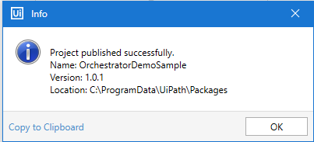

Add a Service:

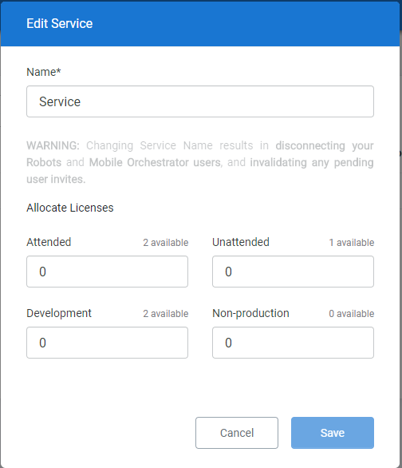

Create Environment and assign Robots to environment.

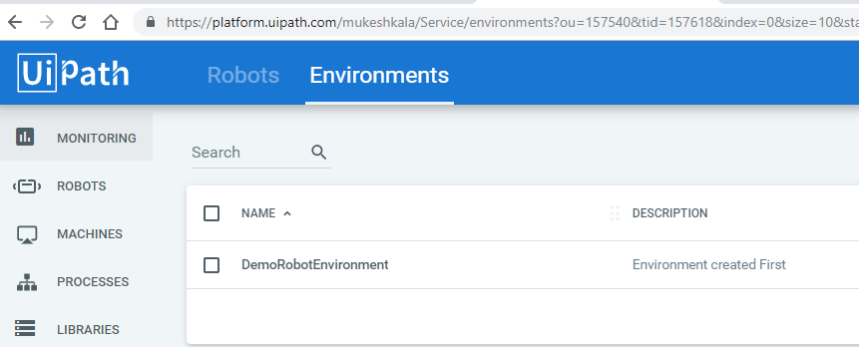

To Establish a connection between a robot and a orchestrator, we need to perform 3 steps:

1. Provisioning the machine
2. Provisioning robot
3. Setting up the local robot.

Provisioning the Robot in Orchestrator

1. Go to machine

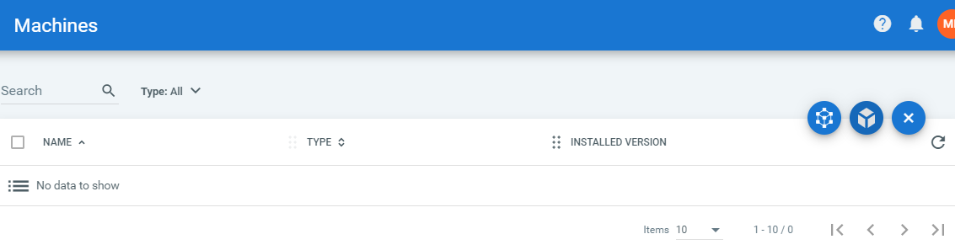

1. We have machine template and standard machine.
2. Select the machine template – Only attended floating robots are available, they are tied to machine templates which enables user to login from any machine in the machine template pool.
3. Floating robot is suitable when working in a non vdi environment or in a hot seat scenario, where a different computer can be used everyday

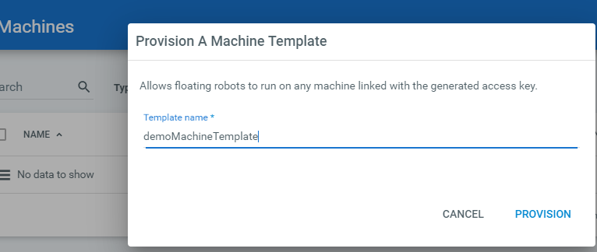

1. Add a New Floating robot

Get Domain name from cmd

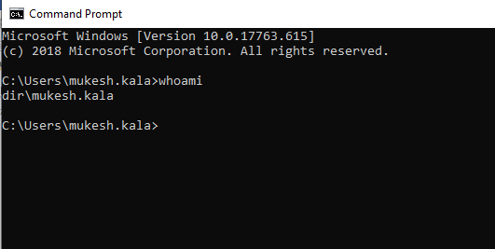

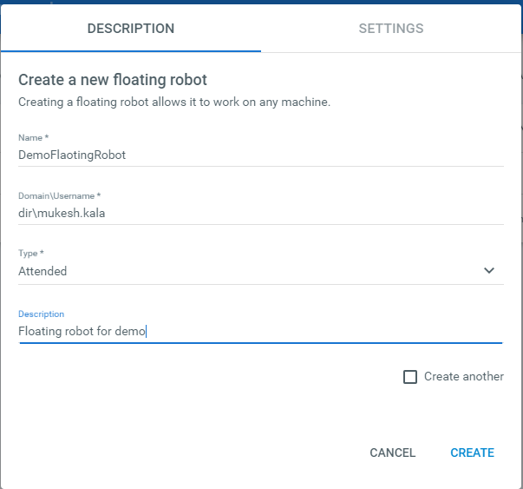

1. Open the Robot Setting –
   1. Go to system tray and look for uipath robot.
   2. If no icon : Search for uiRobot in start menu or go to uipath folder in C drive and start uirobot.exe
   3. Open the setting in the uiRobot

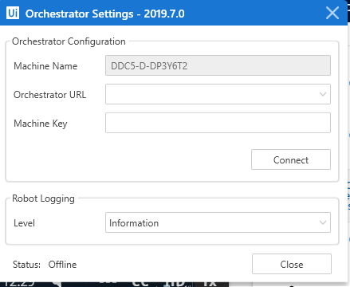

* 1. Go to Machine in Orchestrator and get the machine key

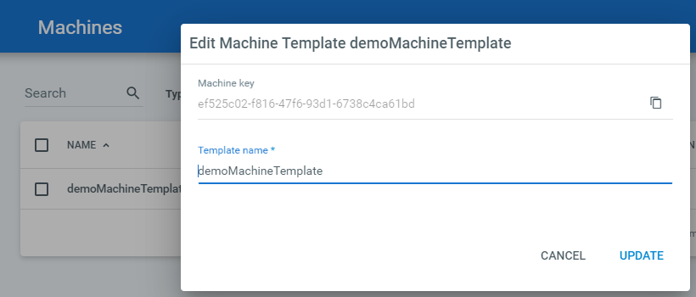

* 1. Provide the Orchestrator Url and machine name

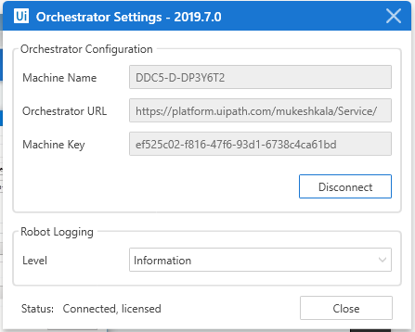

Orchestrator URL: get it from URL

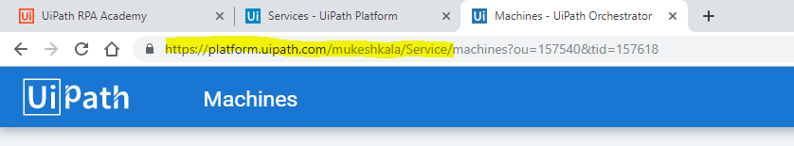

Status is Now : Connected, licensed as shown above.

1. Check the robot status: Available.

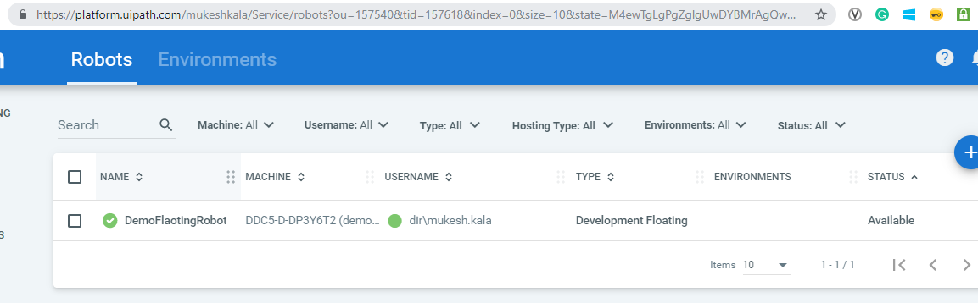

The Above process was for a floating robot. Lets create a Standard machine now.

1. Copy the machine name from uirobot

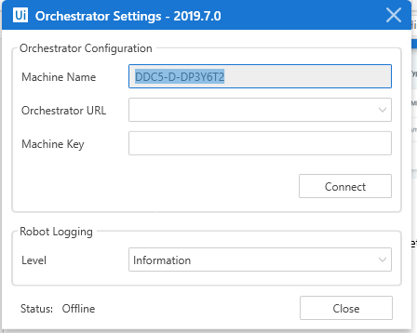

1. New standard machine and Provision

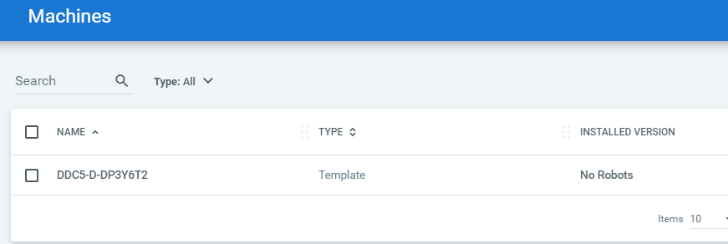

Process to create a standard robot

1. Go to Robot
2. Create a new standard robot.

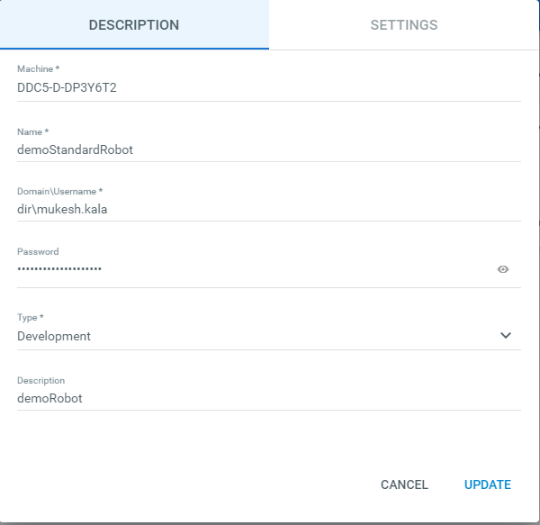

1. get the new machine key

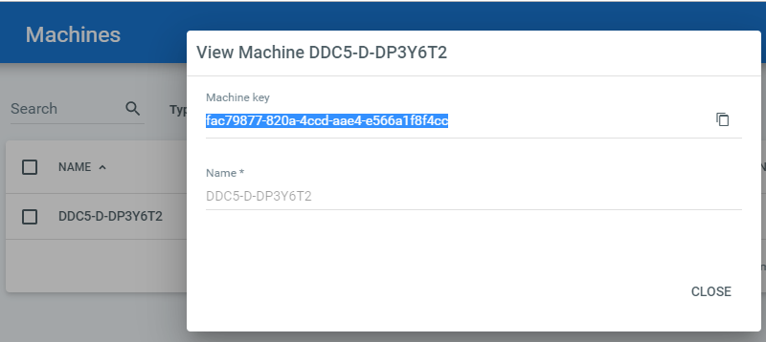

1. Input the same in Ui Robot and Connect

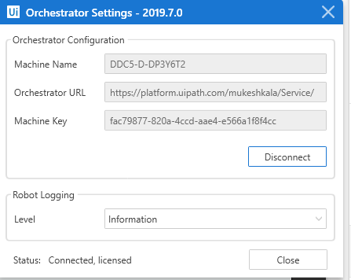

Standard robots are tied to standard machines an represent a unique user machine combination . standard robots are available for all the robot type (Attended, un attended, Development, Non Production ).

To manage and start Processes with orchestrator. We require 5 steps:

1. Register Robot with Orchestrator.
2. Publish a project from studio to turn into an orchestrator package.
3. Create an environment containing the robot we want to use.
4. Create a process to link the package with the environment created.
5. Start a Job to generate the execution of the package.

Update New version in Orchestrator:

1. Make some changes in the robot and publish it to orchestrator and get the new published version.
2. Go to processes and click on packages:

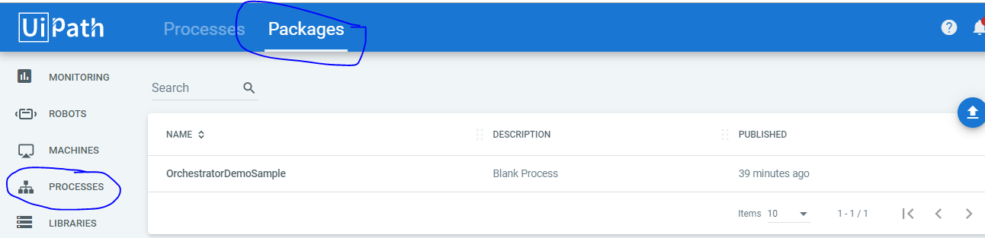

1. View Version window

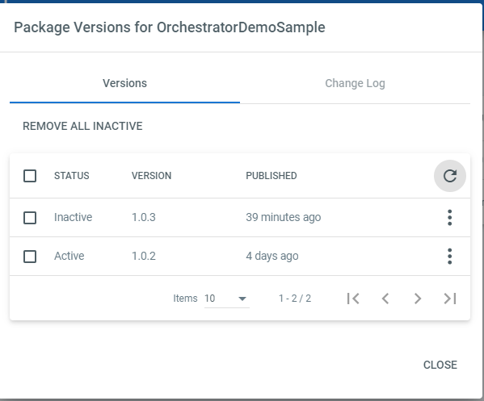

1. Download Type Blue icon indicates new version is available. Update it to new Version and save

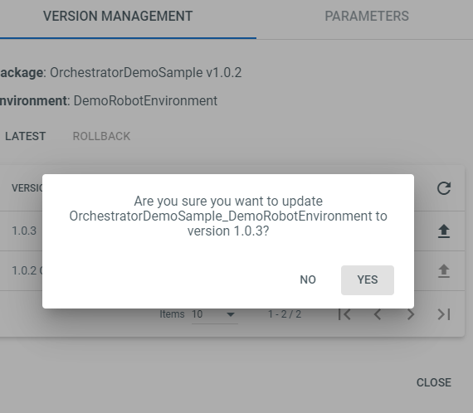

To Pass arguments from orchestrator

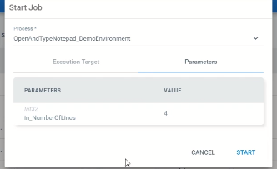

**Dynamic Allocation Robots when Job is created:**

If we want to run a process certain number of times, every robot in that environment runs the process as soon as it becomes available, until that specific number is reached.

In the Execute target Tab of a Job, we can select the allocate dynamically Tab

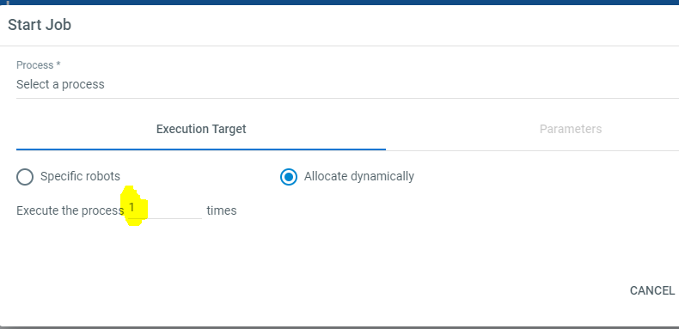

This way we create a Jo Queue for individual environment and tasks will be assigned to the robots which are not busy and executed right away.

If the Number of Job exceeds than the robot available, the remaining one are moved to **pending allocation** and are executed once the robot is available.

Total robot 3 and 6 Jobs.

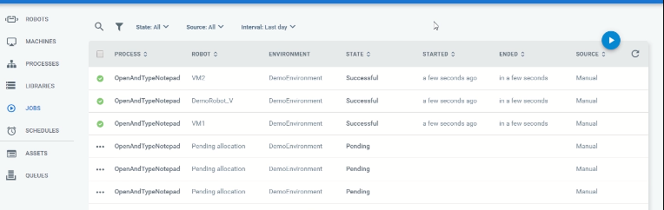

**Scheduling Job**

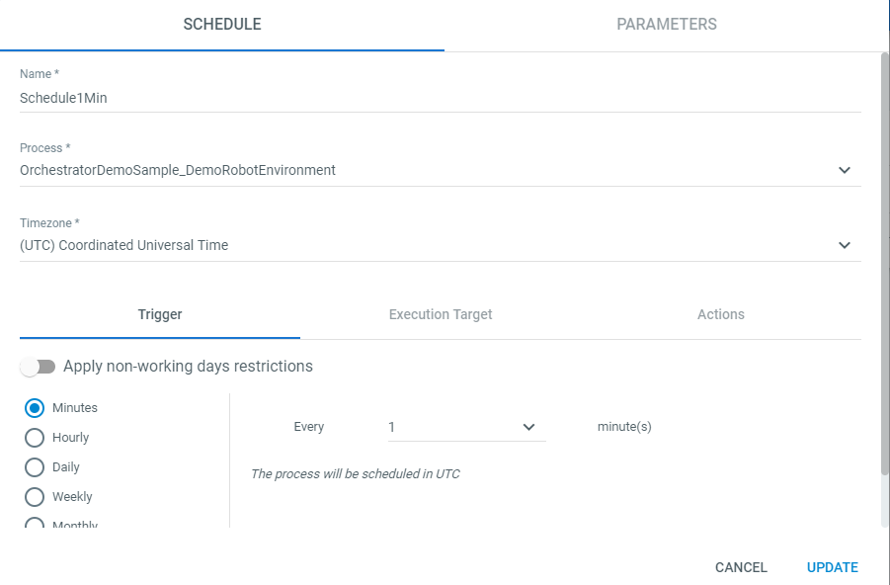

Schedule jobs can be identified as shown below

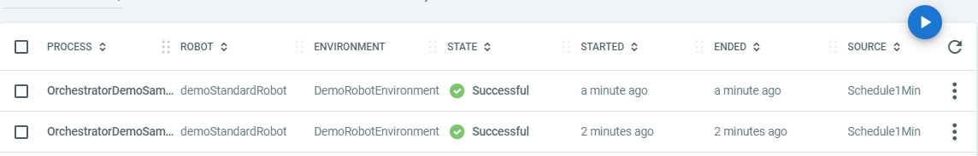

Three types of Source are available:

Manual: Start Job

Schedule: Schedule Jobs

Agent: robot Tray

Schedules can be enabled and Disabled manually.

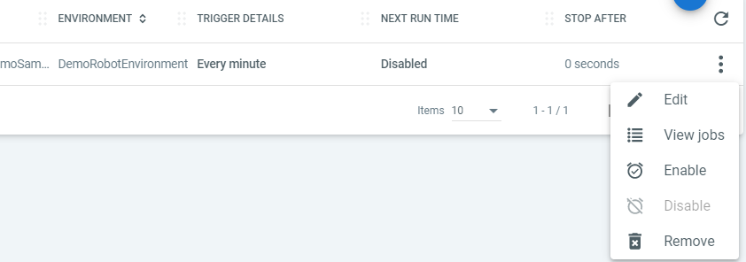

In Orchestrator Setting Tab, we have Non- Working days Tab, helpful for not running the schedules.

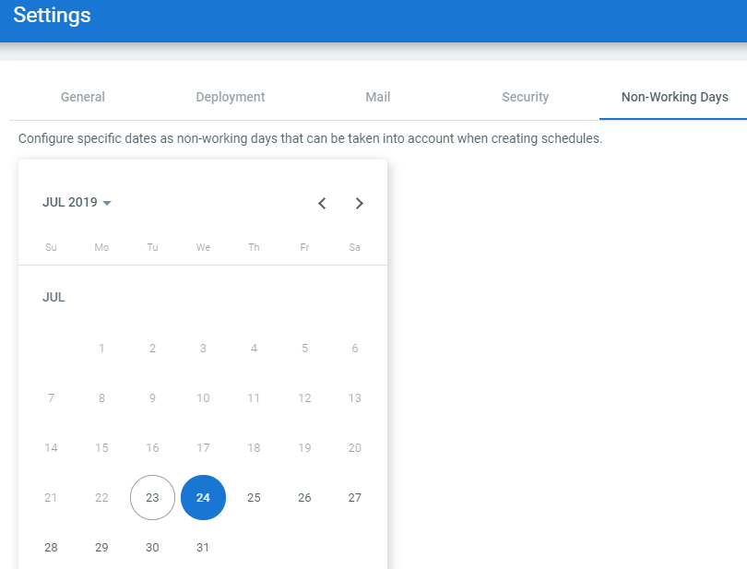

In the schedules Page, Set the Time Zone and the Switch for Nonworking days.

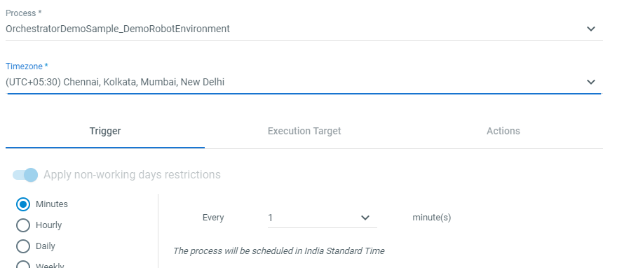

Additional tabs have setting for configuring jobs.

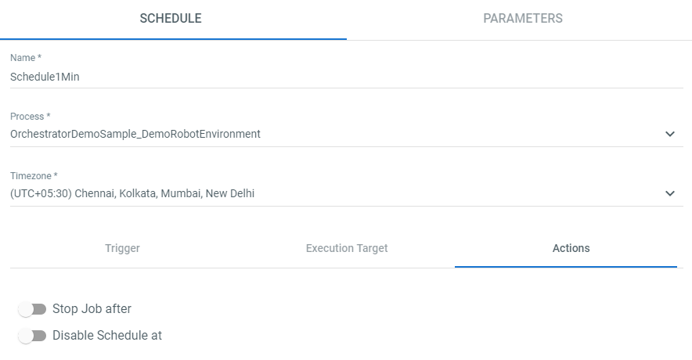

If 2 jobs are assigned the same Robot, second one is in pending state by the time robot becomes available.

Kill : Stops the automation right away.

Stop : Enables to safely stop a automation. This works with should stop Activity uipath. Robot looks for should stop activity and keep executing till it find should stop.

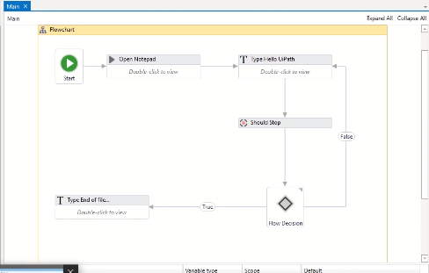

Logs and Alerts

Robots >> View Logs >>

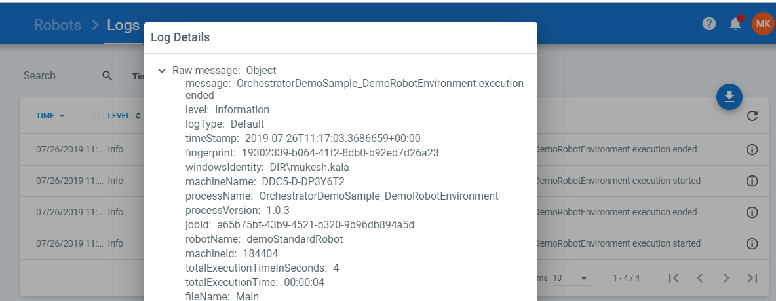

Jobs >> View Logs

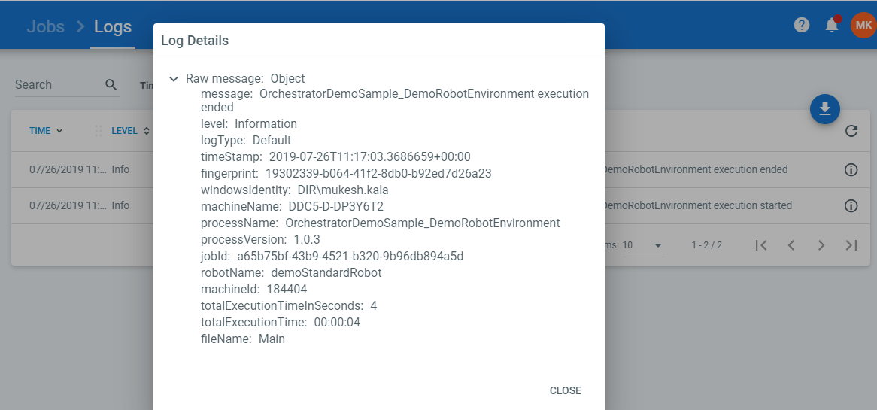

Default Logging level of a Robot is Information

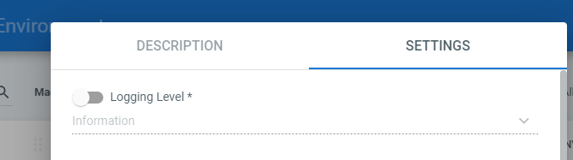

Logs can be customized by using Add Log fields

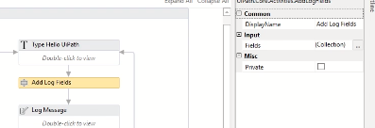

Notifications are displayed in real times and have the separate following severity levels :

Info

Success

Warn

Error

Fatal

Notification icon is triggered only in case of Fatal and Error alerts.

All users whose email addresses have been configured and the users page and who are assigned a role that grants them view permissions on the alert page receive both email alerts every time a fatal or error alerts are encountered and detailed reports of all the alerts.

Alerts Messages can be configured by below menu

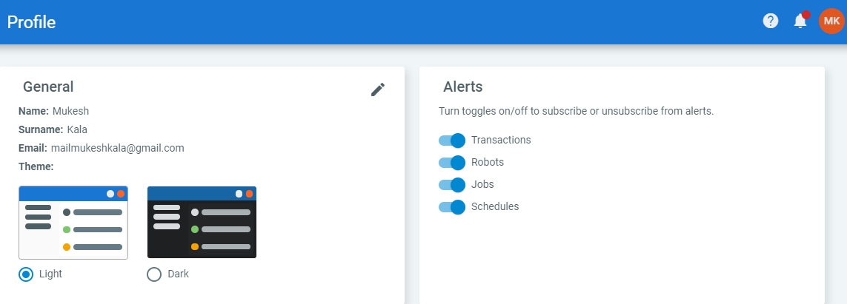

Assets:

Variable in a project can be shared across multiple projects using assets.

4 Types of Assets;

Text

Boolean

Integer

Credential

Create asset in orchestrator.

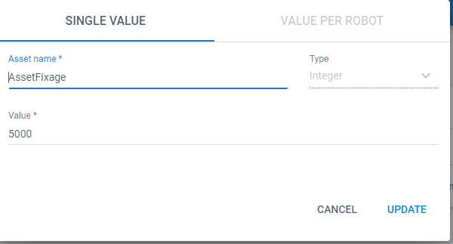

Use getAsset Activity in Studio

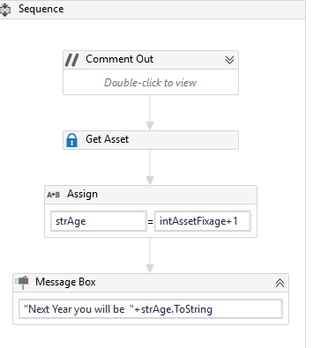

If we have more than one robot: we have option of per robot option

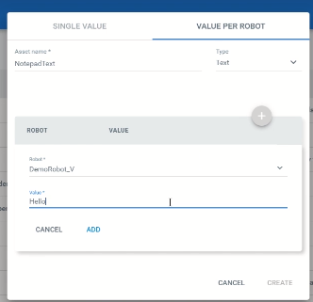

For credential, we have:

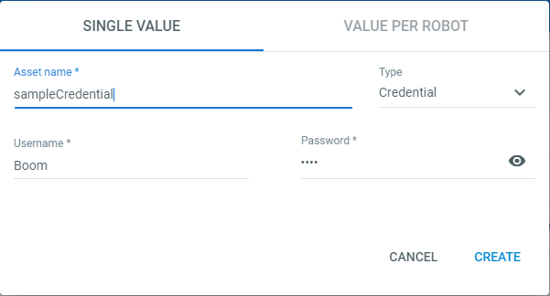

In studio



QUEUE:

Store lists of items that must be processed by multiple robots.

Start by creating Queue in Orchestrator:

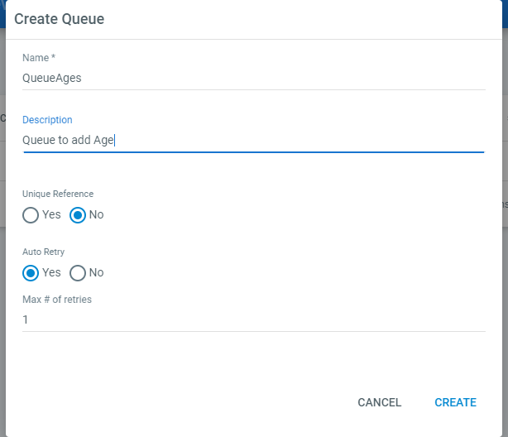

If auto retry is enabled, and the transaction fails with an application exception, Orchestrator re sends the items t the robots as many as times specified in the Maximum number of retries.

**To add items to the Queue:**



Add Queue item with new status.

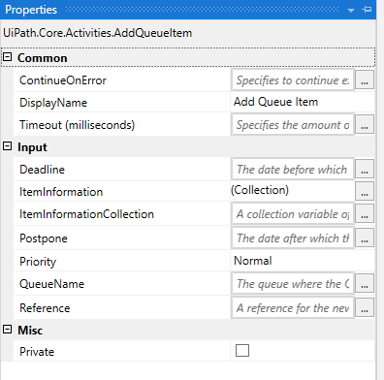

**The Queue Name and the priority property are mandatory.**

Queue sends the items to the Robot based on the Priority

2 other Properties: Enables us to add timeframe for queue item.

1. Postpone:
2. Deadline:

Reference:



Get all the items in the specified queue.



Use to set the Status per Transaction – Failed / Successful.

If status is not updated by the robot, it will be marked as Abandoned in 24 Hours.

… Process ………………

1. Read an Excel File and place each item in queue:

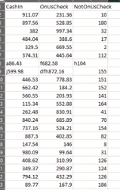

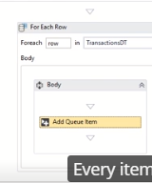

1. Every item has 3 arguments:

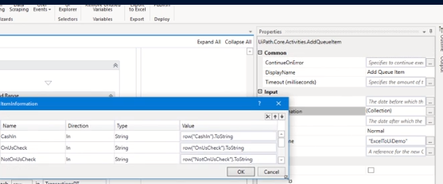

1. 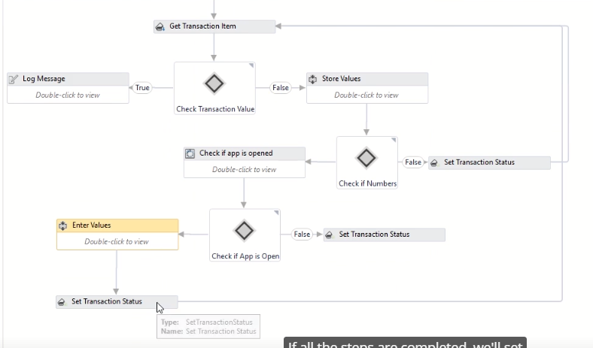



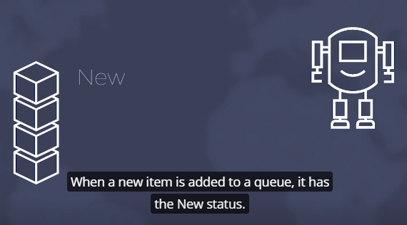

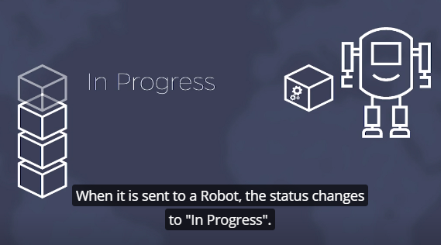

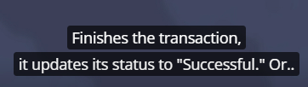

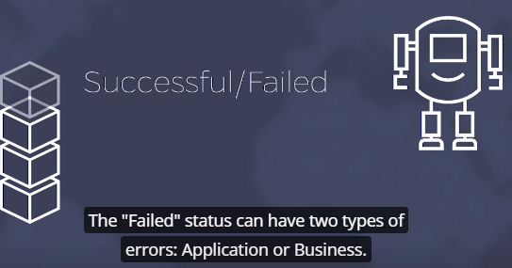

If Auto Retry Property is enabled, Orchestrator resends any failed items to robot to reprocessed.

Status is Retried.

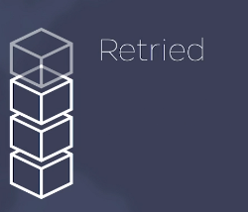

If an Item is Picked from Queue and is Un Processed for 24 hours, Status is Abandoned.



4 Revision statuses are available but only for the queue items that have been abandoned or have failed with an application or business exception.

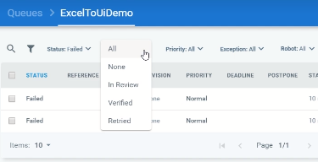

Statuses of Items:

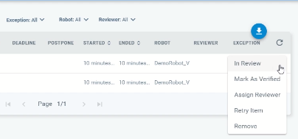

We can send for review

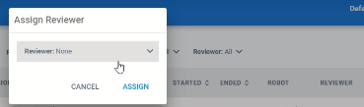

Review Requests Tab:

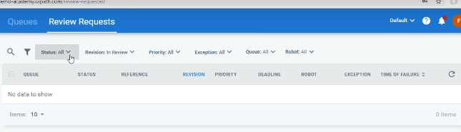



Let us change postpone and deadline properties - useful when environment is not ready.

Queue > More Actions > View Charts >

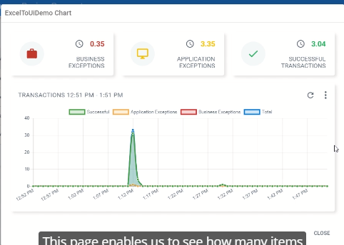



To Track in Progress items.

