1.Simulation of FDMA in MATLAB

Objective 1 : To simulate an FDMA system by allocating individual frequency channels to multiple users and determine the channel bandwidth assigned to each user.

Aim : To simulate a Frequency Division Multiple Access (FDMA) system using MATLAB
and analyze its communication performance in terms of channel bandwidth, data rate, and
signal-to-noise ratio (SNR).

Program :
clc; clear; close all;
fs=1000; t=0:1/fs:1;
TBW=600; Users=3;CBW=TBW/Users;
fc=[100 300 500];
m=sin(2*pi*10*t);
s1=m.*cos(2*pi*fc(1)*t);
s2=m.*cos(2*pi*fc(2)*t);
s3=m.*cos(2*pi*fc(3)*t);
subplot(2,1,1)
plot(t,s1,'r',t,s2,'g',t,s3,'b'),grid on
title('FDMA Channel Allocation'),xlabel('Time (s)'),ylabel('Amplitude')
subplot(2,1,2)
bar(1:Users,CBW*ones(1,Users)),grid on
xlabel('Users'),ylabel('Channel Bandwidth (kHz)'),title('Channel Bandwidth per User')

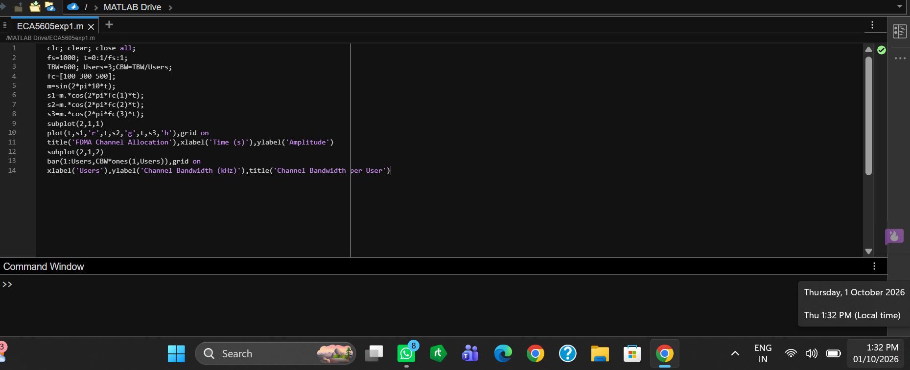

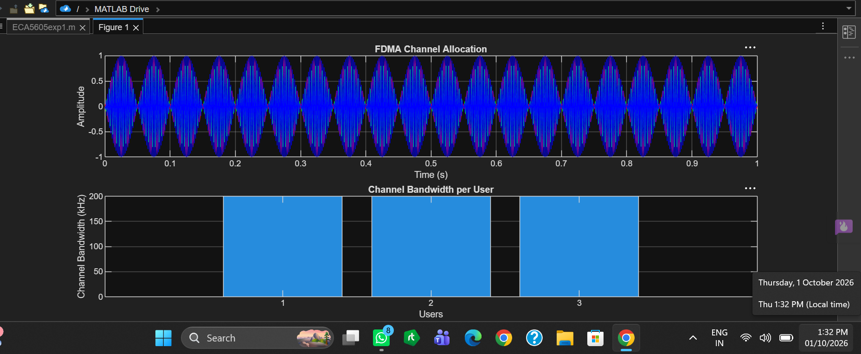
Output

Objective 2 : To calculate the data rate achieved by each user in the FDMA system based on the allocated
channel bandwidth.

Program :

clc; clear; close all;
BW = 200; % Channel Bandwidth (kHz)
Users = 3;
M = 2; % BPSK Modulation
DataRate = BW*log2(M); % Data Rate (kbps)
Rate = DataRate*ones(1,Users);
disp(' User Data Rate (kbps)')
disp([(1:Users)' Rate'])
figure
bar(1:Users,Rate)
xlabel('Users')
ylabel('Data Rate (kbps)')
title('FDMA Data Rate for Each User')
grid on
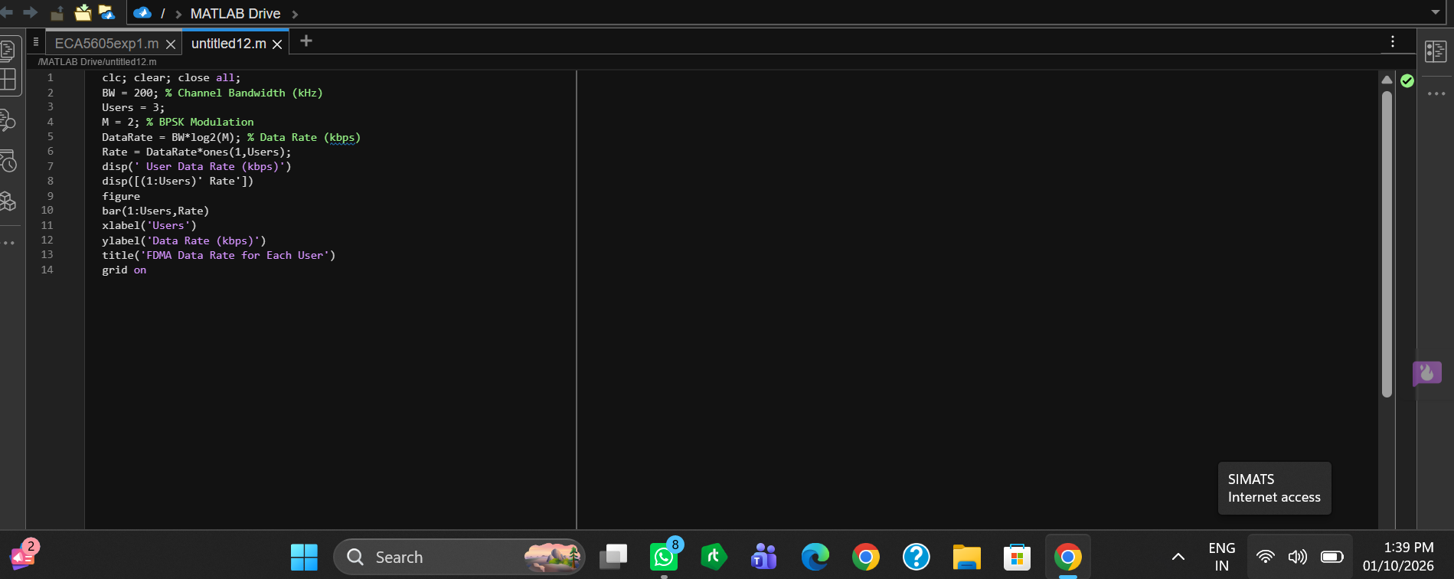

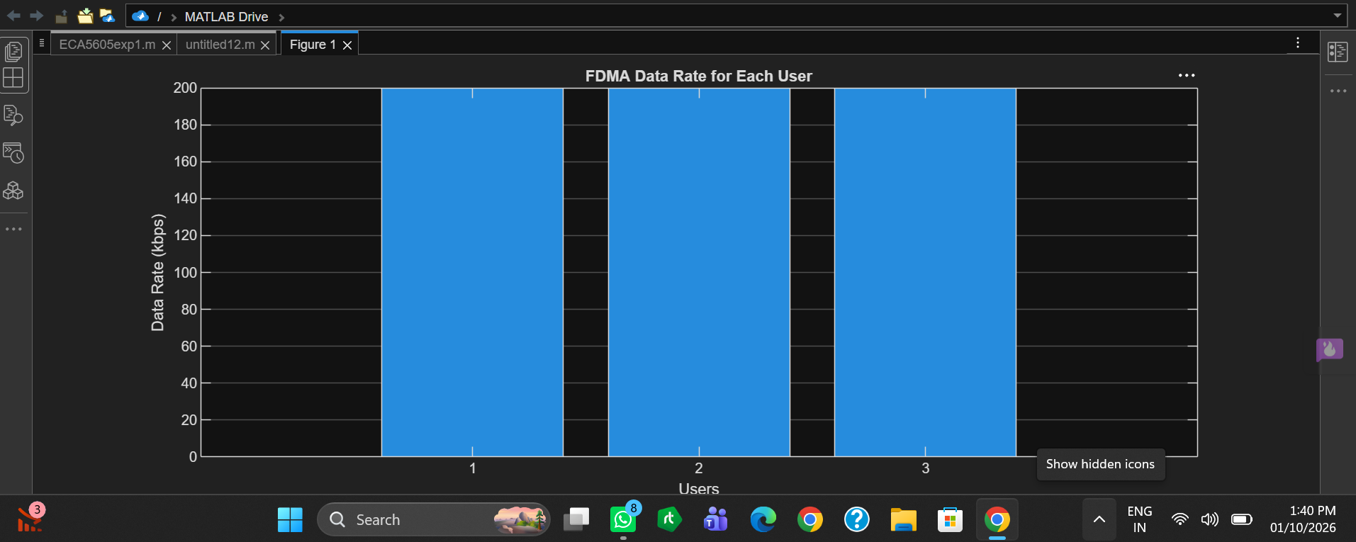

Output

Objective 3 : To evaluate the communication quality of the FDMA system by calculating the Signal-to-Noise Ratio (SNR) for different users.

Program :

clc; clear; close all;
Ps = 1; % Signal Power (W)
Pn = [0.1 0.05 0.01]; % Noise Power (W)
Users = 1:3;
SNR = 10*log10(Ps./Pn); % SNR in dB
disp('User Noise Power(W) SNR(dB)')
disp([Users' Pn' SNR'])
figure
bar(Users,SNR)
xlabel('Users')
ylabel('SNR (dB)')
title('Signal-to-Noise Ratio of FDMA Users')
grid on
OUTPUT:
