2.Implementing TDMA Slot Allocation in GSM.

Objective 1 : To calculate the Time Slot Duration in a GSM TDMA frame by dividing the total frame time into equal time slots. This helps in understanding the time structure of GSM
communication.
Aim : To implement TDMA (Time Division Multiple Access) slot allocation in GSM using
MATLAB and analyze system performance in terms of time slot duration, frame utilization,
and number of allocated slots.

Program :
clc; clear; close all;
FrameTime = 4.615; Slots = 8;
SlotDuration = FrameTime/Slots;
t = 0:SlotDuration:FrameTime;
figure
subplot(2,1,1)
stem(t,ones(size(t)),'filled')
title('TDMA Time Slot Structure')
xlabel('Time (ms)')
ylabel('Slot Level')
grid on
subplot(2,1,2)
plot(t,ones(size(t)),'-o','LineWidth',1.5)
title('Continuous View of Slot Allocation')
xlabel('Time (ms)')
ylabel('Slot Presence')
grid on
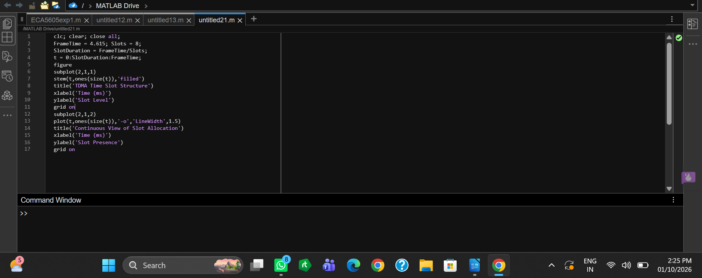

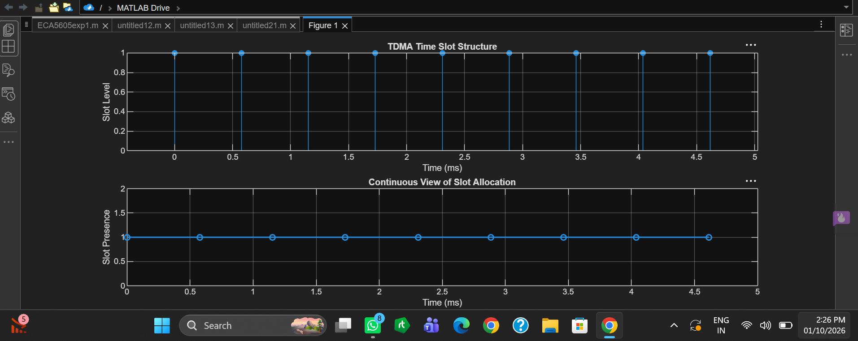

Output

Objective 2 : 2. To determine the Frame Utilization (%) based on the number of allocated time slots compared to total available slots. This evaluates the efficiency of TDMA resource usage.

Program :
clc; clear; close all;
TotalSlots = 8;
AllocatedSlots = 6;
FreeSlots = TotalSlots - AllocatedSlots;
Utilization = (AllocatedSlots/TotalSlots)*100;
disp('Frame Utilization (%)')
disp(Utilization)
figure
% Graph 1: Simple Line Plot (SAFE - no bar function)
subplot(2,1,1)
plot([1 2],[AllocatedSlots FreeSlots],'-o','LineWidth',2)
title('GSM Frame Utilization (Allocated vs Free)')
xlabel('Slot Type Index (1=Allocated, 2=Free)')
ylabel('Number of Slots')
grid on
% Graph 2: Pie Chart (SAFE)
subplot(2,1,2)
pie([AllocatedSlots FreeSlots])
title('Slot Distribution in GSM Frame')
legend('Allocated','Free')
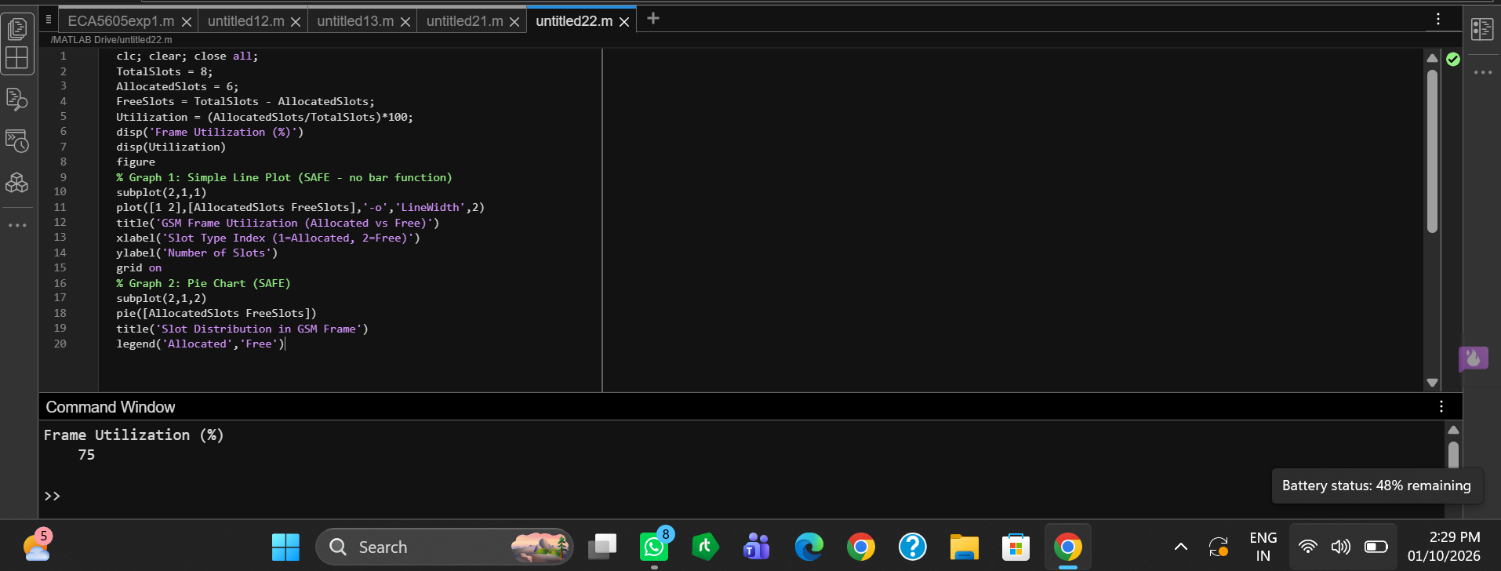
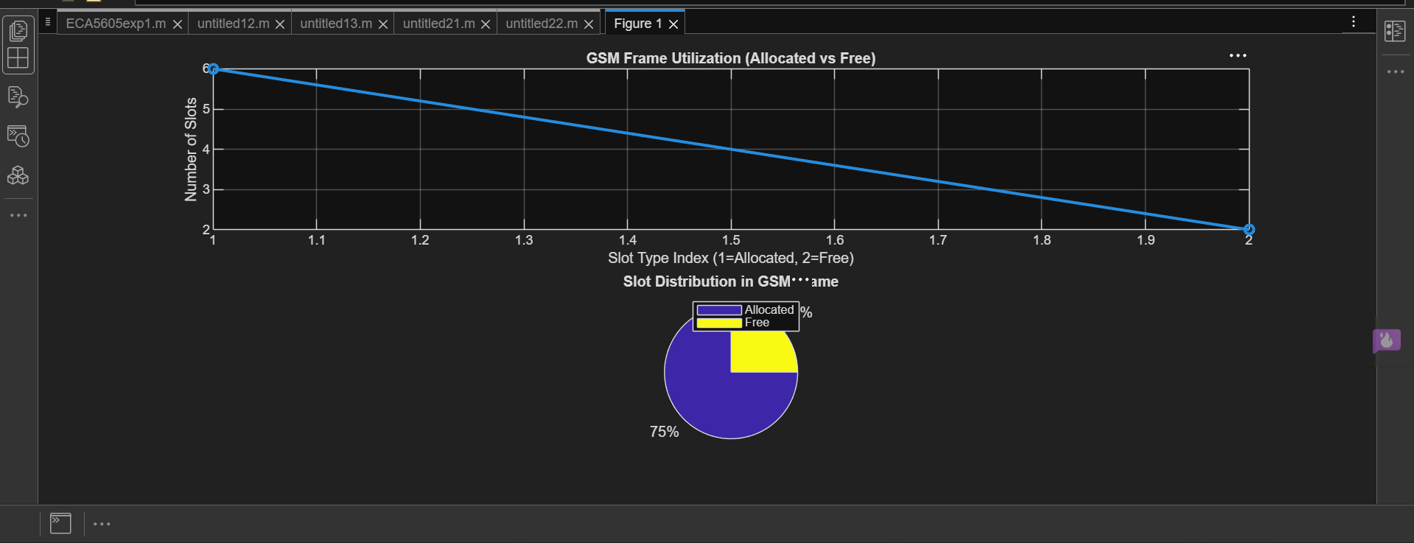
Output

Objective 3 : 3. To compute the Number of Allocated Time Slots for multiple users in the GSM system. This ensures proper scheduling and interference-free communication.

Program :
clc; clear; close all;
Users = 1:8; % Total users
TotalSlots = 5; % Available slots
Alloc = zeros(1,8); % Initialize allocation
Alloc(1:TotalSlots) = 1; % Assign slots to first users
Blocked = 1 - Alloc; % Remaining users blocked
disp('User Wise Slot Allocation')
disp(table(Users',Alloc','VariableNames',{'User','Status(1=Allocated,0=Blocked)'}))
figure
% Graph 1: Allocation per user
subplot(2,1,1)
stem(Users,Alloc,'filled','LineWidth',2)
title('TDMA Slot Allocation per User')
xlabel('User Index')
ylabel('Slot Status (1=Allocated, 0=Blocked)')
ylim([-0.2 1.2])
grid on
% Graph 2: System view (safe alternative to bar)
subplot(2,1,2)
plot(Users,Alloc,'-o','LineWidth',2)
hold on
plot(Users,Blocked,'-s','LineWidth',2)
title('TDMA Slot Utilization Analysis')
xlabel('User Index')
ylabel('Status')
legend('Allocated','Blocked')
grid on
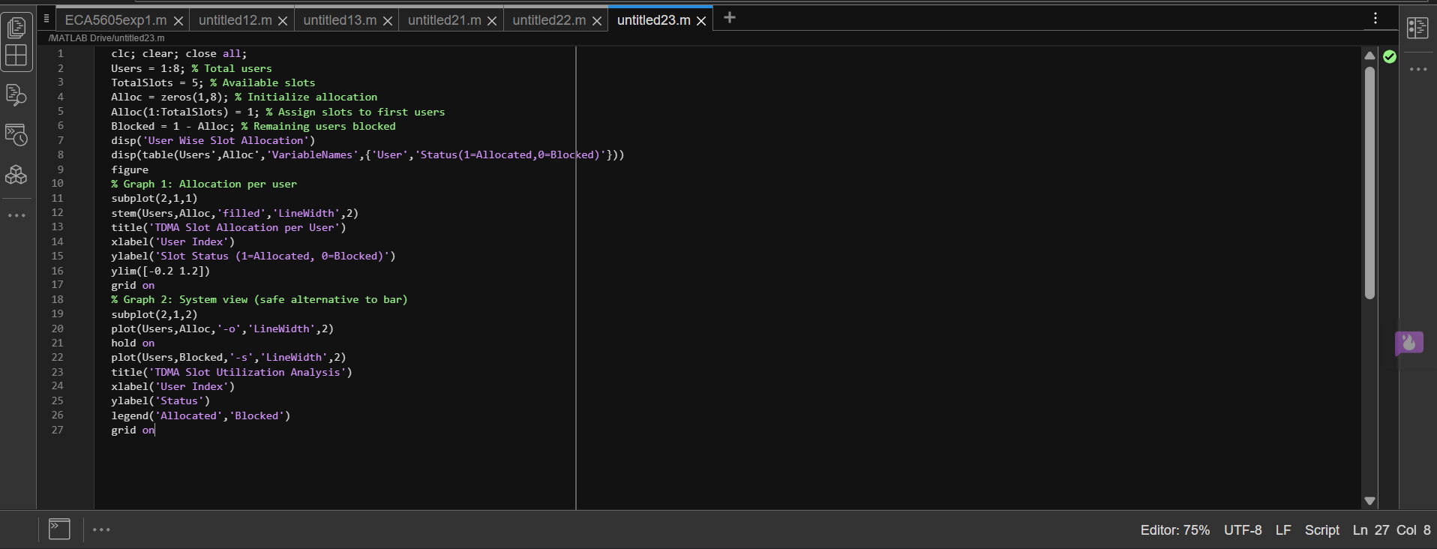

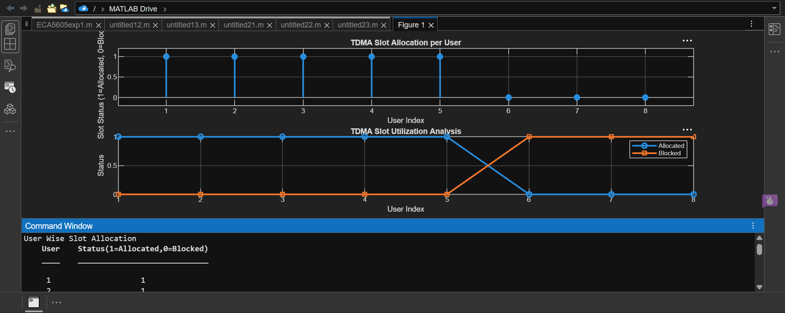
OUTPUT:

