 | 

VIVEKANANDHA COLLEGE OF ENGINEERING FOR WOMEN
[Autonomous]
An ISO 9001:2015 Certified Institution
(Approved by AICTE, New Delhi and Affiliated to Anna University, Chennai,
Accredited by NAAC and NBA Tier - I UG: CSE, EEE, ECE, IT and Bio-Tech.)
Tiruchengode - 637205, Namakkal Dt., Tamil Nadu

AI-ENABLED PREDICTIVE MONITORING AND ENERGY OPTIMIZATION OF RENEWABLE MICROGRIDS USING IoT
A MINI PROJECT REPORT
Submitted by
[TO BE PROVIDED]
[TO BE PROVIDED]

In partial fulfillment for the award of the degree of
[TO BE PROVIDED]
IN
[TO BE PROVIDED]

VIVEKANANDHA COLLEGE OF ENGINEERING FOR WOMEN
[Autonomous]
An ISO 9001:2015 Certified Institution
(Approved by AICTE, New Delhi and Affiliated to Anna University, Chennai,
Accredited by NAAC and NBA Tier - I UG: CSE, EEE, ECE, IT and Bio-Tech.)
Tiruchengode - 637205, Namakkal Dt., Tamil Nadu
[TO BE PROVIDED]

VIVEKANANDHA COLLEGE OF
ENGINEERING FOR WOMEN

BONAFIDE CERTIFICATE

Certified that this project report “AI-ENABLED PREDICTIVE MONITORING AND ENERGY OPTIMIZATION OF RENEWABLE MICROGRIDS USING IoT” is the bonafide work of “[TO BE PROVIDED]” who carried out the mini project work under my supervision.

Submitted to the Viva voce Examination held on _____________________.

____________________________  Signature of the Head of the Department  Name: [TO BE PROVIDED]  Department: [TO BE PROVIDED]  Address: [TO BE PROVIDED] | ____________________________  Signature of the Supervisor  Name: [TO BE PROVIDED]  Designation: [TO BE PROVIDED]  Department: [TO BE PROVIDED]

INTERNAL EXAMINER | EXTERNAL EXAMINER

ACKNOWLEDGEMENT
We express our sincere gratitude to our project supervisor, [TO BE PROVIDED], [TO BE PROVIDED], Department of [TO BE PROVIDED], for the valuable guidance, constant encouragement and constructive suggestions provided throughout the course of this mini project.
We thank the Head of the Department, [TO BE PROVIDED], and the entire faculty and non-teaching staff of the Department of [TO BE PROVIDED] for their support and for providing the laboratory facilities that made this work possible.
We are grateful to the Principal and the Management of Vivekanandha College of Engineering for Women for the infrastructure and encouragement extended to us.
Finally, we thank our family and friends for their patience and moral support during the preparation of this report.

THE CANDIDATES

INSTITUTE AND DEPARTMENT VISION AND MISSION

Institute Vision
[TO BE PROVIDED]

Institute Mission
[TO BE PROVIDED]

Department Vision
[TO BE PROVIDED]

Department Mission
[TO BE PROVIDED]

PROGRAMME EDUCATIONAL OBJECTIVES, PROGRAMME OUTCOMES AND PROGRAMME SPECIFIC OUTCOMES

Programme Educational Objectives
PEO 1: [TO BE PROVIDED]
PEO 2: [TO BE PROVIDED]
PEO 3: [TO BE PROVIDED]
PEO 4: [TO BE PROVIDED]
PEO 5: [TO BE PROVIDED]

Programme Outcomes
PO1: Engineering knowledge - Apply the knowledge of mathematics, science, engineering fundamentals and an engineering specialization to the solution of complex engineering problems.
PO2: Problem analysis - Identify, formulate, review research literature and analyze complex engineering problems reaching substantiated conclusions using first principles of mathematics, natural sciences and engineering sciences.
PO3: Design/development of solutions - Design solutions for complex engineering problems and design system components or processes that meet the specified needs with appropriate consideration for public health and safety and the cultural, societal and environmental considerations.
PO4: Conduct investigations of complex problems - Use research-based knowledge and research methods including design of experiments, analysis and interpretation of data, and synthesis of the information to provide valid conclusions.
PO5: Modern tool usage - Create, select and apply appropriate techniques, resources and modern engineering and IT tools including prediction and modelling to complex engineering activities with an understanding of the limitations.
PO6: The engineer and society - Apply reasoning informed by the contextual knowledge to assess societal, health, safety, legal and cultural issues and the consequent responsibilities relevant to the professional engineering practice.
PO7: Environment and sustainability - Understand the impact of the professional engineering solutions in societal and environmental contexts, and demonstrate the knowledge of, and the need for, sustainable development.
PO8: Ethics - Apply ethical principles and commit to professional ethics and responsibilities and norms of the engineering practice.
PO9: Individual and team work - Function effectively as an individual, and as a member or leader in diverse teams, and in multidisciplinary settings.
PO10: Communication - Communicate effectively on complex engineering activities with the engineering community and with society at large.
PO11: Project management and finance - Demonstrate knowledge and understanding of the engineering and management principles and apply these to one's own work, as a member and leader in a team, to manage projects and in multidisciplinary environments.

Programme Specific Outcomes
PSO1: [TO BE PROVIDED]
PSO2: [TO BE PROVIDED]
PSO3: [TO BE PROVIDED]

COURSE OUTCOME MAPPING WITH PROGRAMME OUTCOMES AND PROGRAMME SPECIFIC OUTCOMES
Upon completion of the course, students will be able to:
Course outcomes and their Bloom's taxonomy level
CO# | Course Outcomes | Bloom's Taxonomy Level
CO1 | Identify the area of the project | Remembering
CO2 | Illustrate the literature of the project | Understanding
CO3 | Determine the problem identified and plan the solution | Applying
CO4 | Experimentation / design analysis / prototype development | Creating
CO5 | Result and analysis | Analyzing
CO6 | Conclusion, scope for future work and documentation | Evaluating

CO - PO / PSO Mapping
The following mapping is proposed for this mini project. The values 3, 2 and 1 indicate a high, medium and low correlation respectively and 0 indicates no correlation. The mapping should be confirmed with the project supervisor.
CO - PO / PSO mapping matrix (3/2/1 = strong/medium/low correlation)
COs | PO1 | PO2 | PO3 | PO4 | PO5 | PO6 | PO7 | PO8 | PO9 | PO10 | PO11 | PSO1 | PSO2 | PSO3
CO1 | 3 | 2 | 1 | 0 | 0 | 0 | 0 | 0 | 0 | 0 | 0 | 2 | 0 | 0
CO2 | 2 | 3 | 1 | 1 | 0 | 0 | 0 | 0 | 0 | 0 | 0 | 1 | 1 | 0
CO3 | 2 | 2 | 3 | 2 | 1 | 0 | 0 | 0 | 0 | 0 | 0 | 2 | 1 | 0
CO4 | 2 | 1 | 3 | 3 | 2 | 1 | 0 | 0 | 2 | 1 | 0 | 2 | 2 | 1
CO5 | 2 | 1 | 2 | 2 | 2 | 1 | 1 | 1 | 2 | 1 | 1 | 2 | 1 | 2
CO6 | 2 | 1 | 1 | 1 | 0 | 2 | 2 | 1 | 0 | 0 | 2 | 1 | 1 | 2

RELEVANCE TO PROGRAMME OUTCOMES AND PROGRAMME SPECIFIC OUTCOMES
This mini project applies engineering knowledge to a real sustainability problem and therefore maps strongly to PO1 and PO2. The behaviour of a hybrid solar and wind microgrid was studied, the monitoring and prediction problem was formulated, and the measured and simulated sensor data were analysed using first principles.
The design and development of the embedded node, the data pipeline and the machine learning models address PO3 and PO4. The work included the design of the sensor interface, the construction of a reproducible dataset and the quantitative evaluation of the models on a held-out test set.
The use of the ESP8266 platform, the Flask framework, SQLite and the scikit-learn library satisfies PO5, since modern engineering and IT tools were selected and applied with an understanding of their limitations.
The project contributes to affordable and clean energy and to climate action, which aligns with PO6 and PO7. The report also documents the ethical treatment of data by never presenting simulated or estimated values as measured values, which supports PO8.
The work was carried out as a team, with clearly divided responsibilities for the firmware, the backend, the machine learning pipeline and the dashboard, which corresponds to PO9 and PO10. The planning of the schedule and the documentation of the deliverables relate to PO11.
The project also supports the Sustainable Development Goals, particularly SDG 7 (Affordable and Clean Energy), SDG 9 (Industry, Innovation and Infrastructure) and SDG 13 (Climate Action).

ABSTRACT
Renewable microgrids that combine solar photovoltaic and small wind generation are widely used, but their output is intermittent and developing faults often go unnoticed. This mini project designs and evaluates a low-cost Internet of Things (IoT) platform that monitors a hybrid solar and wind microgrid node, predicts its generation, classifies its operating condition, detects anomalies, and recommends how the available energy should be allocated between essential load, deferrable load and storage. An ESP8266 node measures solar and wind voltage, turbine speed, temperature, humidity and light level and publishes each reading over Wi-Fi to a Flask REST backend, which validates, deduplicates and stores the data and runs three Random Forest models. On a reproducible simulated dataset of 12,000 samples with a chronological split, the generation regressor reached a mean absolute error of 0.0147 W and an R-squared of 0.9968, the condition classifier an accuracy of 0.8528, and the anomaly detector an accuracy of 0.9861. These results characterise the software pipeline on simulated data and are not a claim of field accuracy.
Keywords: IoT, renewable microgrid, solar and wind energy, Random Forest, generation forecasting, anomaly detection, energy management, ESP8266, Flask, scikit-learn.
TABLE OF CONTENTS

ACKNOWLEDGEMENT ii
INSTITUTE AND DEPARTMENT VISION AND MISSION iii
Institute Vision iii
Institute Mission iii
Department Vision iii
Department Mission iii
PROGRAMME EDUCATIONAL OBJECTIVES, PROGRAMME OUTCOMES AND PROGRAMME SPECIFIC OUTCOMES iv
Programme Educational Objectives iv
Programme Outcomes iv
Programme Specific Outcomes v
COURSE OUTCOME MAPPING WITH PROGRAMME OUTCOMES AND PROGRAMME SPECIFIC OUTCOMES vii
CO - PO / PSO Mapping vii
RELEVANCE TO PROGRAMME OUTCOMES AND PROGRAMME SPECIFIC OUTCOMES viii
ABSTRACT x
LIST OF TABLES xiv
LIST OF FIGURES xv
LIST OF SYMBOLS AND ABBREVIATIONS xvi
INTRODUCTION 1
1.1 OVERVIEW OF RENEWABLE MICROGRIDS 1
1.2 NEED FOR PREDICTIVE MONITORING IN MICROGRIDS 1
1.3 ROLE OF THE INTERNET OF THINGS 2
1.4 MACHINE LEARNING FOR ENERGY ANALYTICS 2
1.5 PROBLEM STATEMENT 2
1.6 OBJECTIVES 3
1.7 SCOPE OF THE PROJECT 4
1.8 ORGANISATION OF THE REPORT 4
LITERATURE REVIEW 5
2.1 INTRODUCTION 5
2.2 IOT ARCHITECTURES FOR ENERGY MONITORING 5
2.3 SOLAR AND WIND GENERATION MODELLING 6
2.4 MACHINE LEARNING FOR GENERATION PREDICTION 6
2.5 ANOMALY AND FAULT DETECTION 7
2.6 ENERGY MANAGEMENT AND LOAD ALLOCATION 7
2.7 RESEARCH GAP 7
2.8 SUMMARY 8
SYSTEM DESIGN AND METHODOLOGY 9
3.1 INTRODUCTION 9
3.2 SYSTEM ARCHITECTURE 9
3.3 HARDWARE DESIGN 10
3.4 SENSOR NODE FIRMWARE 11
3.5 DATA CONTRACT AND REST API 11
3.6 DATABASE DESIGN 12
3.7 DATA PIPELINE AND FEATURE ENGINEERING 13
3.8 DATASET GENERATION 15
3.9 MACHINE LEARNING MODELS 15
3.10 ENERGY ALLOCATION POLICY 16
3.11 DASHBOARD 16
3.12 SOFTWARE AND TOOLCHAIN 17
3.13 TESTING APPROACH 17
3.14 SUMMARY 17
RESULTS AND DISCUSSION 19
4.1 INTRODUCTION 19
4.2 DATASET CHARACTERISTICS 19
4.3 SENSOR AND GENERATION ANALYSIS 20
4.4 GENERATION PREDICTION RESULTS 22
4.5 OPERATING-CONDITION CLASSIFICATION RESULTS 24
4.6 ANOMALY DETECTION RESULTS 25
4.7 FEATURE IMPORTANCE 26
4.8 ENERGY OPTIMIZATION RESULTS 27
4.9 API AND DASHBOARD VALIDATION 28
4.10 LIMITATIONS OF THE EVALUATION 28
4.11 SUMMARY 29
CONCLUSION AND FUTURE SCOPE 30
5.1 CONCLUSION 30
5.2 FUTURE SCOPE 31
5.3 SUSTAINABLE DEVELOPMENT GOALS 32
APPENDIX 1 - PIN CONFIGURATION AND WIRING 33
APPENDIX 2 - SAMPLE API EXCHANGE 34
APPENDIX 3 - INSTALLATION AND OPERATING GUIDE 35
REFERENCES 36

LIST OF TABLES
Table No. | Title | Page No.
2.1 | Summary of related work and the research gap | 8
3.1 | Hardware components and their roles | 10
3.2 | ESP8266 pin map | 11
3.3 | Ingest payload fields | 12
3.4 | REST API endpoints | 12
3.5 | Database tables and their purpose | 13
3.6 | Features used by the machine learning models | 14
3.7 | Model hyperparameters | 15
3.8 | Energy-allocation tiers and default values | 16
3.9 | Software, libraries and their roles | 17
4.1 | Dataset composition | 19
4.2 | Anomaly-type distribution | 20
4.3 | Generation regressor performance | 23
4.4 | Operating-condition classification report (held-out test set) | 24
4.5 | Anomaly detector performance on the held-out test set | 25
4.6 | Feature importance of the generation regressor | 27
4.7 | Energy-allocation scenarios | 27

LIST OF FIGURES
Figure No. | Title | Page No.
3.1 | System architecture of the IoT microgrid monitoring platform | 10
3.2 | Entity-relationship diagram of the SQLite database | 13
3.3 | Online and offline data pipelines sharing one feature-engineering implementation | 14
4.1 | Distribution of operating conditions in the dataset | 20
4.2 | Solar voltage and solar power over time | 21
4.3 | Wind voltage and turbine RPM over time | 21
4.4 | Light level versus solar generation | 21
4.5 | Turbine RPM versus wind generation | 22
4.6 | Relative contribution of solar and wind generation | 22
4.7 | Actual versus predicted power on the held-out test set | 23
4.8 | Regression evaluation and residuals | 23
4.9 | Generation trend and forecast | 23
4.10 | Comparison of model scores | 24
4.11 | Confusion matrix for the operating-condition classifier | 25
4.12 | Confusion matrix for the anomaly detector | 26
4.13 | Normal versus anomalous sensor patterns | 26
4.14 | Feature importance of the generation regressor | 27

LIST OF SYMBOLS AND ABBREVIATIONS
AC | Alternating Current
ADC | Analogue-to-Digital Converter
AI | Artificial Intelligence
API | Application Programming Interface
CSV | Comma-Separated Values
DC | Direct Current
DOI | Digital Object Identifier
ER | Entity-Relationship
GPIO | General-Purpose Input/Output
HTML | HyperText Markup Language
HTTP | HyperText Transfer Protocol
I2C | Inter-Integrated Circuit
IoT | Internet of Things
INA219 | Current, Voltage and Power Monitor
JSON | JavaScript Object Notation
LDR | Light-Dependent Resistor
MAE | Mean Absolute Error
ML | Machine Learning
MPP | Maximum Power Point
NTP | Network Time Protocol
PEO | Programme Educational Objective
PO | Programme Outcome
PSO | Programme Specific Outcome
RF | Random Forest
RMSE | Root Mean Square Error
RPM | Revolutions Per Minute
REST | Representational State Transfer
SDG | Sustainable Development Goal
SQL | Structured Query Language
SSR | Solid-State Relay
TOC | Table of Contents
VOC | Open-Circuit Voltage
WSN | Wireless Sensor Network

CHAPTER 1

INTRODUCTION

1.1 OVERVIEW OF RENEWABLE MICROGRIDS
A microgrid is a small, self-contained electrical system that combines distributed generation sources with local loads and, optionally, energy storage. When the generators are renewable, the microgrid can supply electricity with very low carbon emissions and at a low marginal cost. Hybrid systems that combine solar photovoltaic generation with small wind generation are attractive because the two sources are complementary: solar output peaks during the day while wind output can continue into the night. Such systems are widely used for rural electrification, agricultural pumping, telecom towers and campus demonstration facilities.

1.2 NEED FOR PREDICTIVE MONITORING IN MICROGRIDS
Renewable generation is intermittent and depends on weather that cannot be controlled. Because the available power changes from minute to minute, operators need continuous information about how much energy is being produced, whether the equipment is healthy and how the available energy should be used. Faults such as a shaded or soiled panel, a fouled turbine, a failed rectifier or a drifting sensor may not stop the system immediately, but they silently reduce the energy delivered and can shorten equipment life. If such conditions are detected early, maintenance can be scheduled before a minor degradation becomes a failure.

1.3 ROLE OF THE INTERNET OF THINGS
The Internet of Things provides the sensing, communication and actuation layer that makes continuous monitoring practical. Low-cost microcontrollers such as the ESP8266 integrate Wi-Fi connectivity and analogue and digital inputs in a single module, so a complete telemetry node can be built at very low cost. The node samples the sensors, constructs a compact message and publishes it to a server over the local wireless network, where it can be stored, analysed and displayed.

1.4 MACHINE LEARNING FOR ENERGY ANALYTICS
Once a reliable stream of sensor data is available, machine learning can add value in three ways. First, a regression model can estimate the generation that the system should be producing and provide a short-horizon forecast. Second, a classification model can label the current operating condition, for example normal, reduced generation, night idle or fault. Third, an anomaly-detection model can flag readings that do not fit the expected pattern, which usually indicates a sensor fault or an equipment problem. Random Forest models are well suited to this task because they handle mixed-scale sensor features, are robust to noise and provide feature importances that can be explained to an operator.

1.5 PROBLEM STATEMENT
Small renewable microgrids are often installed without any monitoring, so their actual performance is unknown and developing faults go unnoticed until the output collapses. Commercial monitoring systems are expensive and are usually closed, which makes them unsuitable for low-cost installations and for student projects. There is a need for an open, low-cost platform that continuously monitors a hybrid solar and wind microgrid, estimates its generation, identifies its operating condition and anomalies, and recommends how the available energy should be allocated, while being honest about the difference between measured values, simulated values and model predictions.

1.6 OBJECTIVES
• To design and build a low-cost ESP8266 sensor node that measures solar voltage and current, wind voltage and current, turbine speed, temperature, humidity and light level from a hybrid solar and wind microgrid.
• To develop a Flask REST backend that validates, deduplicates and stores the incoming telemetry in a SQLite database and exposes the data through a documented JSON API.
• To engineer physically meaningful diagnostic features from the raw sensor vector and to train Random Forest models for generation prediction, operating-condition classification and anomaly detection.
• To build an interactive web dashboard that shows live telemetry, historical trends, model outputs and an energy-allocation recommendation.
• To establish a reproducible evaluation using a fixed-seed dataset and a chronological train, validation and test split, and to report the honest performance of each model.
• To document the working principle, wiring, API contract and operating procedure so that the platform can be reproduced and extended.

1.7 SCOPE OF THE PROJECT
The project covers the sensor node, the backend, the machine learning pipeline, the dashboard and the evaluation. It is a laboratory prototype and uses low-voltage devices only. The relay output is held off by default and automatic load switching is deliberately not enabled, because safe switching requires a correctly rated relay or solid-state relay and a verified low-voltage bench test. At the time of writing the firmware has been compiled and verified, but the physical node has not been operated, so the machine learning models are trained and evaluated on simulated data.

1.8 ORGANISATION OF THE REPORT
Chapter 2 reviews the relevant literature and identifies the research gap. Chapter 3 describes the system architecture, the hardware, the firmware, the data contract, the database, the feature engineering and the machine learning models. Chapter 4 presents the dataset characteristics, the model results and the dashboard validation. Chapter 5 concludes the work and lists the future scope. The appendices contain the pin configuration, a sample API exchange and the installation and operating guide.

CHAPTER 2

LITERATURE REVIEW

2.1 INTRODUCTION
This chapter reviews published work on IoT architectures for energy monitoring, solar and wind generation modelling, machine learning for generation prediction, anomaly detection and energy management. The review is used to position the present project and to identify the gap that it addresses.

2.2 IOT ARCHITECTURES FOR ENERGY MONITORING
Al-Fuqaha et al. [1] survey the enabling technologies, protocols and applications of the Internet of Things and describe the layered architecture that most monitoring systems follow: a sensing layer, a network layer and an application layer. Lazarescu [9] demonstrates that a low-power wireless sensor platform can collect environmental data over long periods with minimal maintenance. Gungor et al. [5] review communication technologies and standards for the smart grid and note that the choice of communication layer is driven by cost, range and data rate. These works establish that a microcontroller with integrated Wi-Fi and a lightweight HTTP protocol is sufficient for low-rate energy telemetry.

2.3 SOLAR AND WIND GENERATION MODELLING
Antonanzas et al. [2] review photovoltaic power forecasting and classify the methods into physical, statistical and machine learning families. They observe that the terminal voltage of a panel follows a saturating curve against irradiance and that cell temperature modifies this curve, which is the basis of the voltage-deficit diagnostic feature used in this project. For wind, the standard model relates the turbine speed to wind speed through a cut-in speed, a near-linear rise and a rated region, and the rectified voltage of a small generator is approximately proportional to the rotational speed above the rectifier drop. Voyant et al. [14] review machine learning methods for solar radiation forecasting and confirm that ensemble methods such as Random Forests are competitive and require little tuning.

2.4 MACHINE LEARNING FOR GENERATION PREDICTION
Breiman [3] introduced Random Forests, an ensemble of decision trees trained on bootstrap samples with random feature subsets, and showed that the method is accurate, robust to outliers and provides a natural measure of feature importance. Raza and Khosravi [12] review artificial-intelligence-based load and generation forecasting for smart grids and buildings and report that ensemble tree methods perform well on tabular sensor data. Kanchev et al. [8] present energy management and operational planning for a microgrid with a photovoltaic generator and show how a forecast of the available power improves the dispatch decision.

2.5 ANOMALY AND FAULT DETECTION
Chandola et al. [4] survey anomaly detection and distinguish point, contextual and collective anomalies. Sensor faults, stuck sensors, generation drops, generator mismatch and over-voltage spikes are point anomalies that appear as unusual combinations of features rather than as unusual single values. A supervised classifier can be trained to recognise these combinations when a labelled fault history is available, which is the approach taken here. Han et al. [6] describe the preprocessing, feature construction and evaluation methodology used for such classification tasks.

2.6 ENERGY MANAGEMENT AND LOAD ALLOCATION
Hatziargyriou et al. [7] introduce microgrids and describe their control and management requirements. Siano [13] reviews demand response and smart grids and highlights the role of real-time information in shifting flexible load to periods of surplus generation. Lund [10] argues that renewable energy strategies for sustainable development depend on the integration of variable sources with flexible demand and storage. These works motivate the allocation policy implemented in this project, in which available generation is assigned first to essential load, then to a reserve, then to deferrable load and finally to storage.

2.7 RESEARCH GAP
The reviewed literature provides strong evidence for each individual building block, but it rarely combines them into a single, open, low-cost platform for a hybrid solar and wind microgrid. Table 2.1 summarises the relevant studies and shows that most concentrate on a single source, on a single task or on expensive instrumentation. The present project addresses this gap by integrating a low-cost sensor node, a documented REST backend, a transparent feature-engineering step, three Random Forest models and an advisory energy-allocation policy in one reproducible system, with an explicit separation of measured, simulated and predicted values.
Table 2.1 Summary of related work and the research gap
Study | Focus | Technique | Limitation
Al-Fuqaha et al. [1] | IoT architecture and protocols | Survey | No energy application
Lazarescu [9] | Low-power WSN monitoring | Embedded platform | Environmental data only
Antonanzas et al. [2] | PV power forecasting | Review of methods | Solar only, no node design
Voyant et al. [14] | Solar radiation forecasting | Machine learning review | No wind channel, no dashboard
Breiman [3] | Ensemble learning | Random Forest | Algorithm only
Raza and Khosravi [12] | Load and generation forecasting | AI review | No hardware integration
Chandola et al. [4] | Anomaly detection | Survey | Generic, not microgrid-specific
Kanchev et al. [8] | Microgrid energy management | Optimisation and control | Requires accurate forecasts
Siano [13] | Demand response | Review | No prediction models
This work | Hybrid solar and wind microgrid | IoT node + Random Forest + dashboard | Simulated evaluation, no field trial

2.8 SUMMARY
The literature confirms the value of IoT sensing, of Random Forest models for prediction and of transparent energy management, but no reviewed work brings these together for a low-cost hybrid solar and wind microgrid with the same attention to honesty about measured, simulated and predicted data. The next chapter describes the system that was built to fill this gap.

CHAPTER 3

SYSTEM DESIGN AND METHODOLOGY

3.1 INTRODUCTION
This chapter describes how the platform was designed and built. It covers the overall architecture, the hardware, the sensor node firmware, the data contract, the database, the feature engineering, the synthetic dataset, the machine learning models, the energy-allocation policy, the dashboard and the testing approach.

3.2 SYSTEM ARCHITECTURE
The system is organised as a sensing layer, a network and storage layer and an application layer, as shown in Figure 3.1. The sensor node reads the electrical, mechanical and environmental sensors, builds one JSON reading and posts it to the backend over the local Wi-Fi network. The backend validates the reading, stores it in a SQLite database, runs the three machine learning models and serves the dashboard. The dashboard runs entirely on the laptop that hosts the backend; the ESP8266 only publishes readings and never receives control commands.
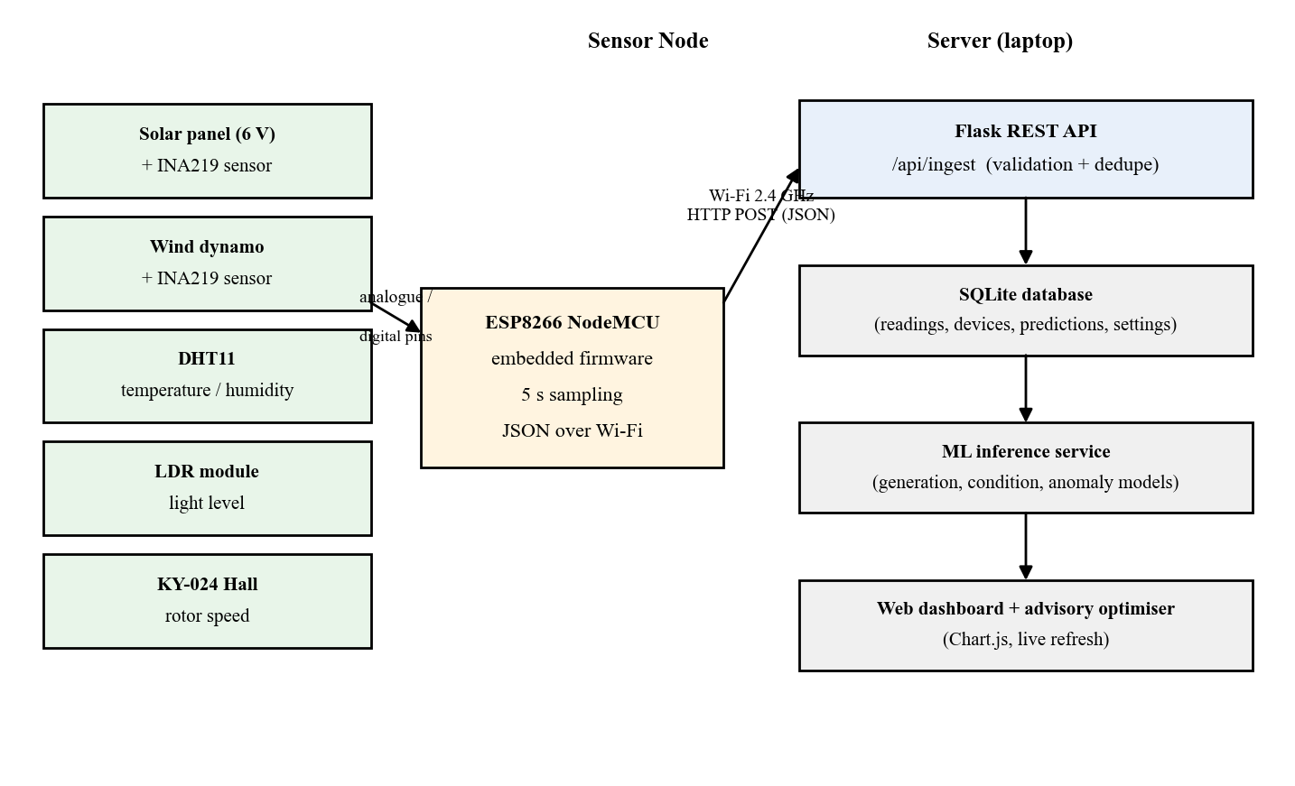
Figure 3.1 System architecture of the IoT microgrid monitoring platform

3.3 HARDWARE DESIGN
The node is built around the ESP8266 NodeMCU, which provides Wi-Fi connectivity, one analogue input and sufficient digital pins for the sensors. The generators are a small 6 V solar panel and a small DC wind dynamo. Because the microgrid is a low-voltage laboratory prototype, the measured voltages are small and the currents are in the milliampere range. Table 3.1 lists the components and their roles.
Table 3.1 Hardware components and their roles
Component | Specification | Role
ESP8266 NodeMCU | ESP-12E, 80 MHz, 3.3 V logic | Microcontroller and Wi-Fi node
Solar panel | 6 V, 1.5 W | Solar generation source
DC wind dynamo | Small DC generator with propeller | Wind generation source
INA219 (x2) | I2C, addresses 0x40 and 0x41 | Bus voltage and current measurement
DHT11 | 3.3 V, digital | Temperature and humidity
KY-024 Hall module | Digital output | Turbine revolution counting
LDR module | Comparator, digital output | Bright and dark light detection
Relay module | Active-low, default OFF | Advisory load switching (disabled)
Resistors | 10 kohm pull-up, load resistors | DHT11 pull-up and test load

3.4 SENSOR NODE FIRMWARE
The firmware is written for the NodeMCU 1.0 (ESP-12E) board and is designed to stay responsive: the main loop never blocks for more than a few milliseconds and uses non-blocking retries for the Wi-Fi link and for any sensor that failed at boot. Two INA219 modules share the I2C bus and are distinguished by their addresses. The Hall-effect module generates an interrupt on each magnet pass and the revolutions per minute are computed from the pulse count and the elapsed interval. The pin map is given in Table 3.2.
Table 3.2 ESP8266 pin map
Signal | Pin | GPIO | Notes
I2C SDA | D2 | GPIO4 | Shared by both INA219 modules
I2C SCL | D1 | GPIO5 | Shared by both INA219 modules
DHT11 data | D5 | GPIO14 | 10 kohm pull-up to 3V3
Hall digital out | D6 | GPIO12 | Interrupt, pulse counting
LDR digital out | D7 | GPIO13 | Bright and dark detection
Relay input | D0 | GPIO16 | Active-low, held OFF
On-board LED | D4 | GPIO2 | Heartbeat blink
The firmware sends a field as null rather than guessing it. In particular, generated current cannot be measured when no load is connected, because the INA219 measures current through its shunt and an open circuit carries no current; in that case the current and power fields are sent as null and the dashboard shows that the current was not measured. The relay is driven to its off state during start-up and is never switched automatically.

3.5 DATA CONTRACT AND REST API
The node posts a JSON object to the ingest endpoint. The backend converts the firmware field names to internal column names, parses the timestamp, checks every numeric field against a plausible range and rejects a reading with a precise reason when it is not usable. Table 3.3 lists the payload fields and Table 3.4 lists the endpoints exposed by the backend.
Table 3.3 Ingest payload fields
Field | Type | Required | Description
device_id | string | No | Node identifier
timestamp | ISO-8601 | No | UTC sample time
solar_voltage | number | Yes | Panel bus voltage (V)
solar_current | number or null | No | Panel current (A); null when not measurable
solar_power | number or null | No | Panel power (W)
wind_voltage | number | Yes | Dynamo bus voltage (V)
wind_current | number or null | No | Dynamo current (A)
wind_power | number or null | No | Dynamo power (W)
turbine_rpm | number | Yes | Turbine speed (RPM)
temperature | number | No | Ambient temperature (degC)
humidity | number | No | Relative humidity (%)
light_status | string | No | bright, dim, dark or unknown
sensor_status | string | Yes | OK or a list of failures
device_ip | string | No | Node IP address
Table 3.4 REST API endpoints
Method | Endpoint | Purpose
POST | /api/ingest | Validate, store and predict one reading
GET | /api/health | Service and model readiness
GET | /api/overview | Dashboard aggregate payload
GET | /api/readings/latest | Most recent reading and prediction
GET | /api/readings/history | Historical readings for charts
GET | /api/predictions/series | Predictions joined to readings
POST | /api/predict | Predict for a supplied or latest reading
GET | /api/model/status | Model metadata and test metrics
GET | /api/model/importance | Feature importances
GET/PUT | /api/settings | Runtime configuration
POST | /api/demo/seed | Insert simulated readings for demonstration
GET | /api/export/readings.csv | Download readings as CSV
POST | /api/maintenance/purge | Delete stored readings

3.6 DATABASE DESIGN
The backend stores data in a SQLite database with four tables. Readings are deduplicated on the pair of device identifier and reading timestamp, so a node that reconnects and re-sends the same sample cannot pollute the history. The entity-relationship diagram is shown in Figure 3.2 and the tables are described in Table 3.5.
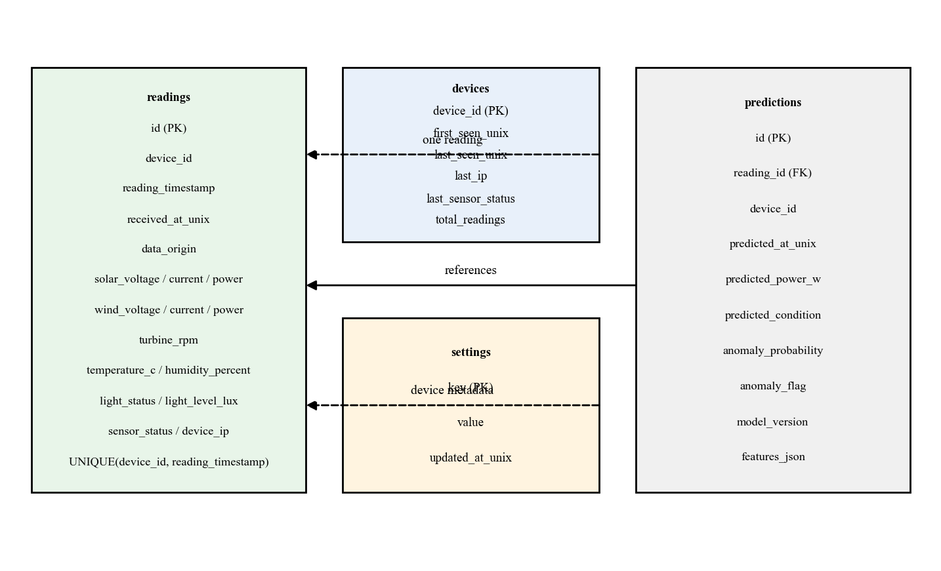
Figure 3.2 Entity-relationship diagram of the SQLite database
Table 3.5 Database tables and their purpose
Table | Purpose | Key columns
readings | One row per accepted sample | id, device_id, reading_timestamp, sensor values
devices | Latest state of each node | device_id, last_seen_unix, total_readings
predictions | Model output per reading | reading_id, predicted_power_w, predicted_condition
settings | Runtime configuration | key, value, updated_at_unix

3.7 DATA PIPELINE AND FEATURE ENGINEERING
The platform has two pipelines that share the same feature engineering code so that training and live inference remain consistent. The online pipeline processes live readings and the offline pipeline generates the dataset, trains the models and produces the evaluation figures. Both pipelines are shown in Figure 3.3.
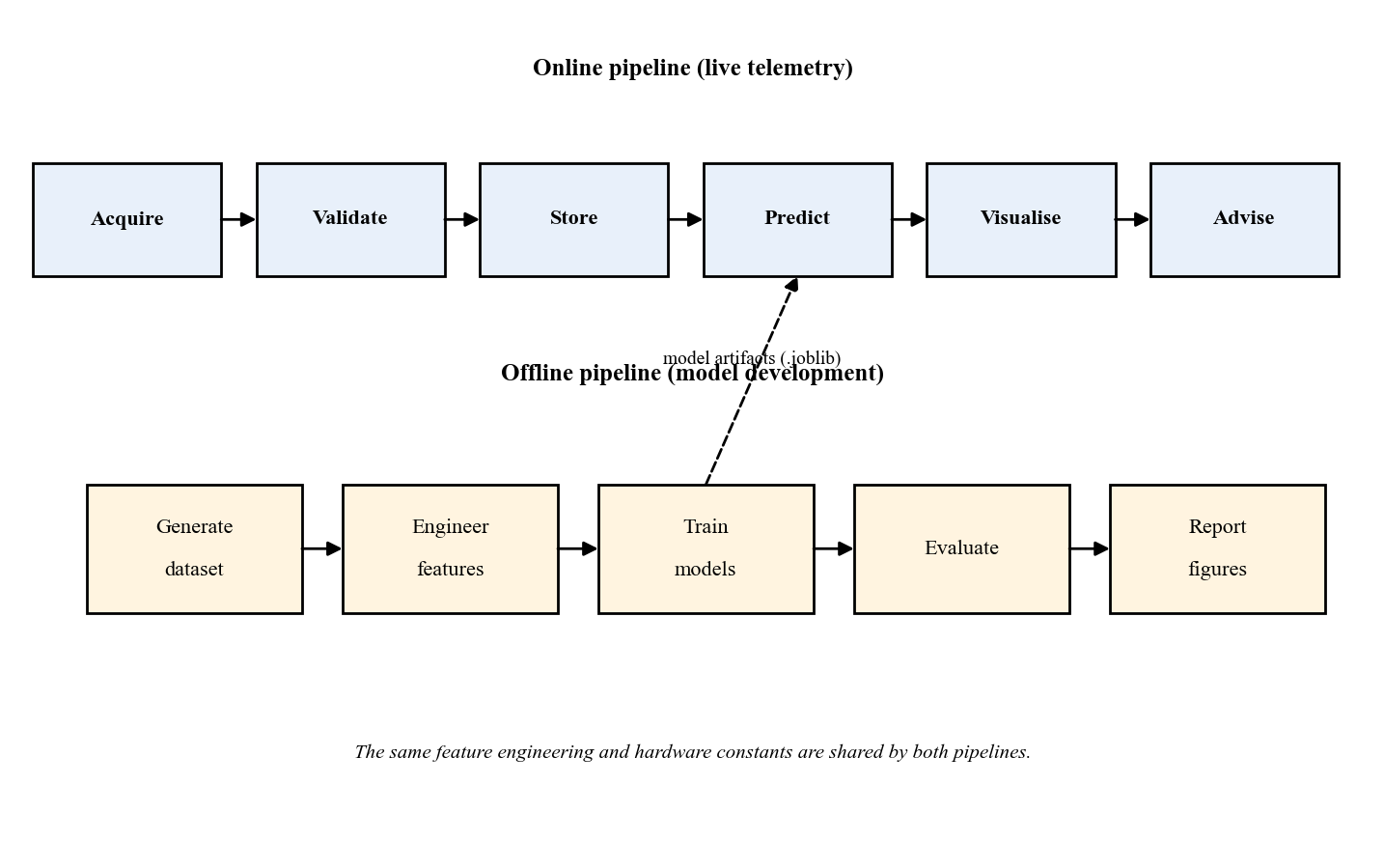
Figure 3.3 Online and offline data pipelines sharing one feature-engineering implementation
Three diagnostic features are computed from the raw sensor vector and fixed hardware constants. The solar voltage deficit compares the measured panel voltage with the clean voltage expected for the current irradiance and cell temperature, so partial shading and heavy soiling appear here first. The wind volts-per-RPM feature measures the effective generator constant, which falls when the rotor is fouled or the rectifier begins to fail. The lux-per-irradiance feature measures the agreement between the light sensor and the irradiance estimate, so a stuck or shaded light sensor becomes visible. Table 3.6 lists the features used by every model.
Table 3.6 Features used by the machine learning models
Feature | Definition
hour | Hour of day from the reading timestamp
day_of_year | Day of year from the reading timestamp
solar_irradiance_wm2 | Irradiance inferred from the LDR
solar_voltage | Measured panel bus voltage (V)
wind_voltage | Measured dynamo bus voltage (V)
turbine_rpm | Measured turbine speed (RPM)
temperature_c | Ambient temperature (degC)
humidity_percent | Relative humidity (%)
light_level_lux | Light level (lux)
solar_v_deficit | Clean panel voltage minus measured voltage
wind_v_per_rpm | Dynamo voltage divided by RPM
lux_per_irradiance | Light level divided by irradiance

3.8 DATASET GENERATION
Because the physical node could not be operated during the evaluation, a reproducible synthetic dataset was generated to develop and demonstrate the pipeline. The generator models a solar irradiance curve that depends on the time of day and on cloud cover, a temperature and humidity cycle, a wind-speed process with gusts, the panel voltage curve and the rectified dynamo voltage curve, and the non-fault loss mechanisms of soiling and becalming. It then injects five labelled faults: a sensor fault, a stuck sensor, a generation drop, a voltage-to-RPM mismatch and an over-voltage spike. The dataset contains 12,000 samples at a five-minute interval, spanning 01 January 2025 to 11 February 2025, and is fully reproducible for the fixed seed 42.

3.9 MACHINE LEARNING MODELS
Three supervised models are trained on the engineered features. The generation regressor predicts the total estimated power in watts. The operating-condition classifier predicts one of four labels: normal, reduced generation, night idle or fault. The anomaly classifier predicts whether the reading contains an injected sensor or equipment anomaly. All three are Random Forest models, which were chosen for their accuracy on tabular data, their robustness to noise and the interpretable feature importances they provide. The hyperparameters are listed in Table 3.7.
Table 3.7 Model hyperparameters
Model | Estimators | Other settings | Target
Generation regressor | 220 | min_samples_leaf=2, max_features=0.8 | total_est_power_w
Condition classifier | 220 | balanced_subsample, min_samples_leaf=2 | operating_condition
Anomaly classifier | 220 | balanced_subsample, min_samples_leaf=2 | anomaly_label
The dataset is divided chronologically into 70 % training, 15 % validation and 15 % test partitions. A random shuffle is deliberately avoided so that the model cannot see the future, which would inflate every reported score. The validation set is used for sanity checks and the test set is used exactly once, to report the final honest numbers. The fixed random state ensures that the whole experiment can be reproduced.

3.10 ENERGY ALLOCATION POLICY
The energy-allocation component is a transparent rule-based policy rather than a learned controller. It answers a single question: given the power that is being generated right now, how should it be split between essential load, a reserve, deferrable load and storage. Table 3.8 lists the tiers of the policy. The relay is never switched automatically, and the recommendation becomes advisory only whenever the node is offline or the generation cannot be measured.
Table 3.8 Energy-allocation tiers and default values
Tier | Description | Default
Essential load | Served first, unconditionally | 1.5 W
Reserve | Held back before discretionary load | 5.0 W
Deferrable load | Served only if surplus remains | 4.0 W
Storage | Receives any remaining surplus | Remainder

3.11 DASHBOARD
The dashboard is a single-page web application served by the same Flask process. It uses a dark charcoal theme with an emerald-green accent and a local copy of the Chart.js library so that it works without an internet connection. It presents seven sections: an overview, live monitoring, AI analytics, energy optimization, historical data, model and system status, and settings. The settings page never reveals the device token or any stored secret in full.

3.12 SOFTWARE AND TOOLCHAIN
The software is written in Python and JavaScript. Table 3.9 lists the principal tools and their roles. The platform runs on Python 3.8 and is served by the built-in Flask development server for demonstration.
Table 3.9 Software, libraries and their roles
Tool / Library | Version | Role
Python | 3.8 | Backend and machine learning
Flask | 2.3.3 | REST API and dashboard server
pandas / numpy | 2.0.3 / 1.24.4 | Data processing
scikit-learn | 1.3.2 | Random Forest models
joblib | 1.4.2 | Model persistence
matplotlib / seaborn | 3.7.2 / 0.12.2 | Evaluation figures
SQLite | bundled | Persistent storage
Chart.js | 4.4.1 | Dashboard charts
Arduino ESP8266 core | 3.1.2 | Firmware compilation

3.13 TESTING APPROACH
The backend is covered by an automated test suite that runs against a temporary database so that the development database is never modified. The suite exercises payload validation, the database layer, every API route, the dataset generator, the training pipeline and the inference service. One hundred and five tests are defined, and a training test runs a real, small fit to confirm that the whole pipeline works end to end.

3.14 SUMMARY
This chapter described the architecture, the hardware, the firmware, the data contract, the database, the feature engineering, the dataset, the machine learning models, the allocation policy, the dashboard and the testing approach. The next chapter presents the results obtained from this system.

CHAPTER 4

RESULTS AND DISCUSSION

4.1 INTRODUCTION
This chapter presents and discusses the results. It begins with the characteristics of the dataset, then examines the sensor and generation relationships, then reports the performance of the three models on the held-out test set, then presents the energy-allocation results and the dashboard validation. It concludes with the limitations of the evaluation.

4.2 DATASET CHARACTERISTICS
The generated dataset contains 12,000 samples and 27 columns, with no null values and no duplicated timestamps. Table 4.1 summarises its composition. The anomaly types are distributed as shown in Table 4.2 and the operating conditions as shown in Figure 4.1; the dataset is imbalanced, with normal operation dominating and fault conditions being relatively rare, which is why the classifiers use balanced class weighting.
Table 4.1 Dataset composition
Property | Value
Number of samples | 12,000
Number of columns | 27
Sample interval | 5 minutes
Time range | 01 Jan 2025 to 11 Feb 2025
Null cells | 0
Anomaly rate | 7.49 %
Random seed | 42
Train / validation / test | 8400 / 1800 / 1800
Table 4.2 Anomaly-type distribution
Anomaly type | Count
none | 11101
generation_drop | 268
sensor_fault | 241
voltage_rpm_mismatch | 197
overvoltage_spike | 124
sensor_stuck | 69
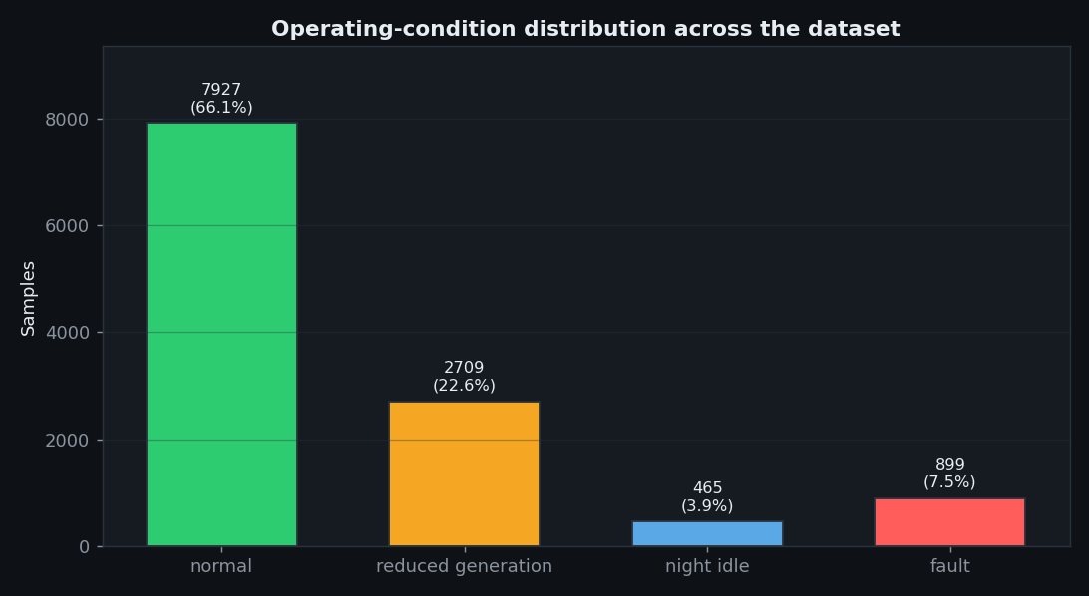
Figure 4.1 Distribution of operating conditions in the dataset

4.3 SENSOR AND GENERATION ANALYSIS
Figure 4.2 shows the panel voltage and the solar power over time. The voltage rises quickly with irradiance and then saturates, which is the expected behaviour of a small panel. Figure 4.3 shows the dynamo voltage and the turbine speed over time and confirms that the rectified voltage tracks the speed above the rectifier drop. Figure 4.4 shows that the light level and the solar generation are strongly related, which supports the use of the light sensor as a proxy for irradiance. Figure 4.5 shows the relationship between the turbine speed and the wind generation. Figure 4.6 shows the relative contribution of the solar and wind channels to the total generation and illustrates the complementary nature of the two sources.
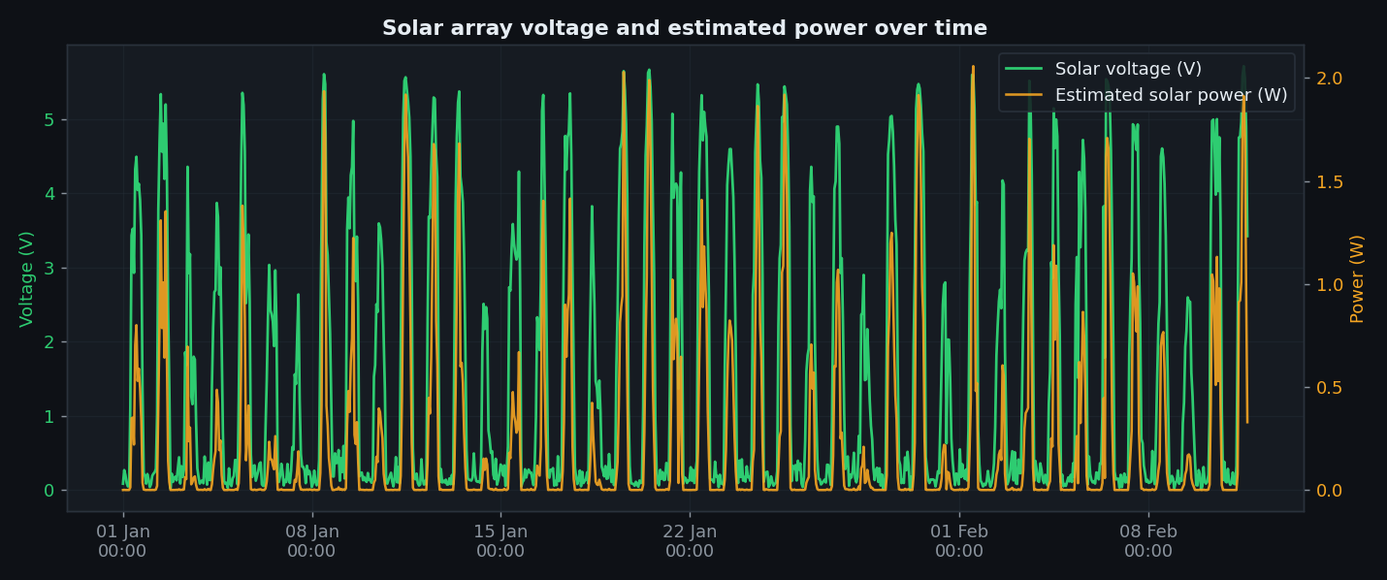
Figure 4.2 Solar voltage and solar power over time
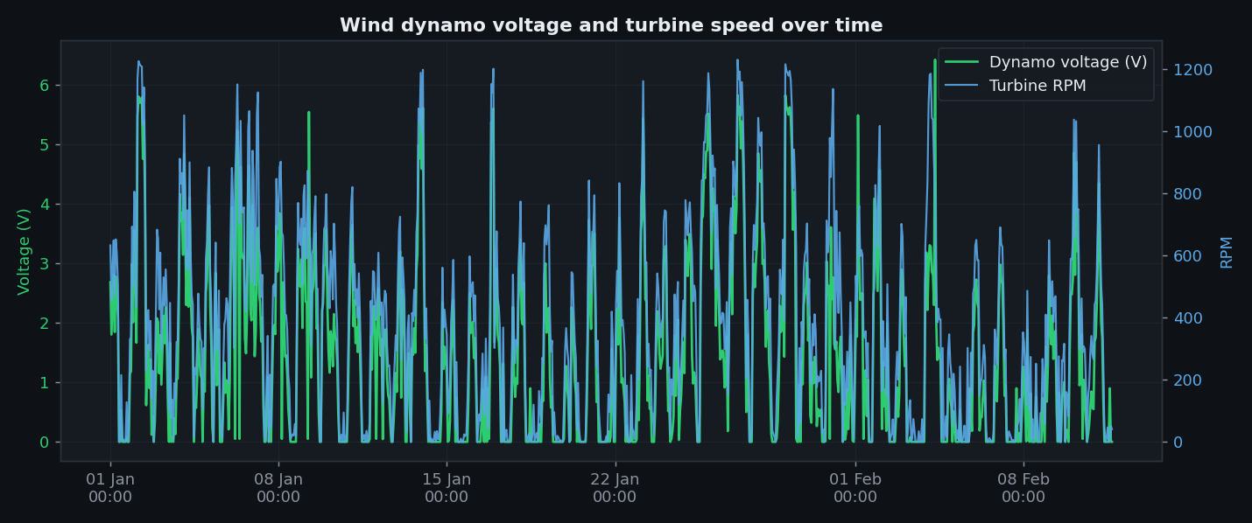
Figure 4.3 Wind voltage and turbine RPM over time
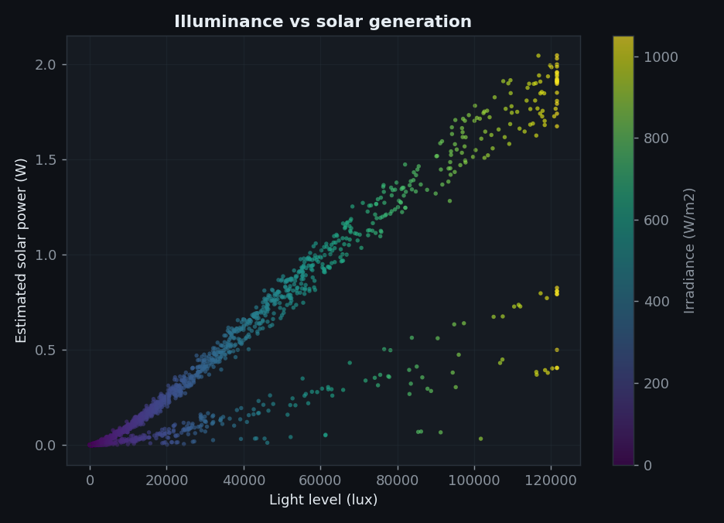
Figure 4.4 Light level versus solar generation
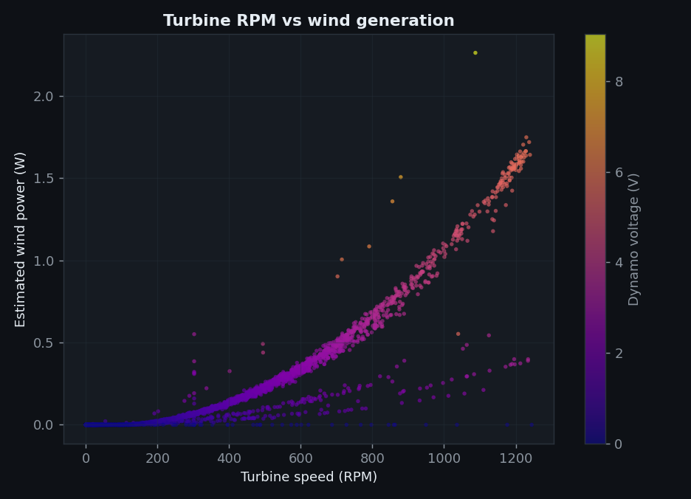
Figure 4.5 Turbine RPM versus wind generation
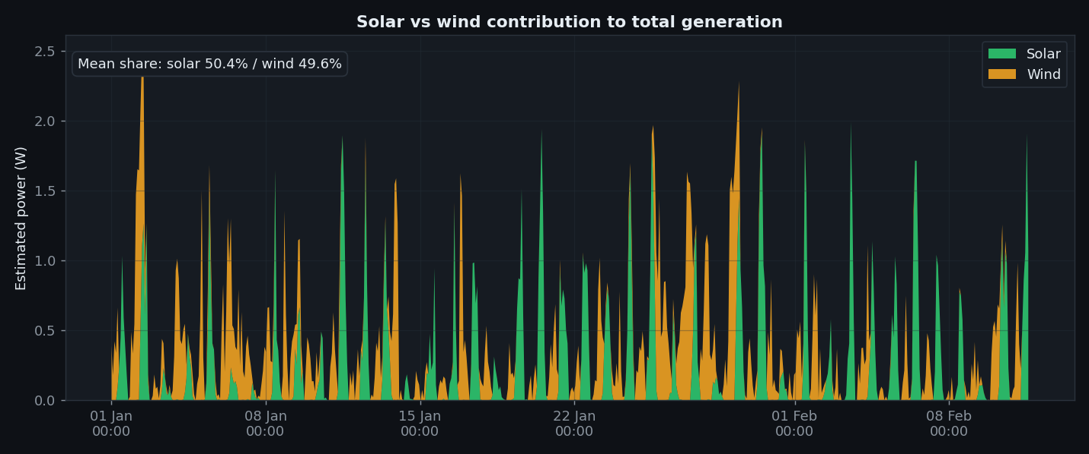
Figure 4.6 Relative contribution of solar and wind generation

4.4 GENERATION PREDICTION RESULTS
The generation regressor was evaluated on the 1,800 held-out test samples. Table 4.3 reports the metrics on both the validation and the test partitions. The mean absolute error on the test set is 0.0147 W and the coefficient of determination is 0.9968, which means that almost all of the variation in the generation is explained by the sensor features. Figure 4.7 shows the predicted power against the actual power and Figure 4.8 shows the regression evaluation. Figure 4.9 shows the generation trend and forecast over the test period. Figure 4.10 compares the model scores for a compact summary.
Table 4.3 Generation regressor performance
Metric | Validation | Test
Mean absolute error (W) | 0.0202 | 0.0147
Root mean square error (W) | 0.0399 | 0.0251
Coefficient of determination | 0.9926 | 0.9968
Maximum absolute error (W) | 0.8459 | 0.2018
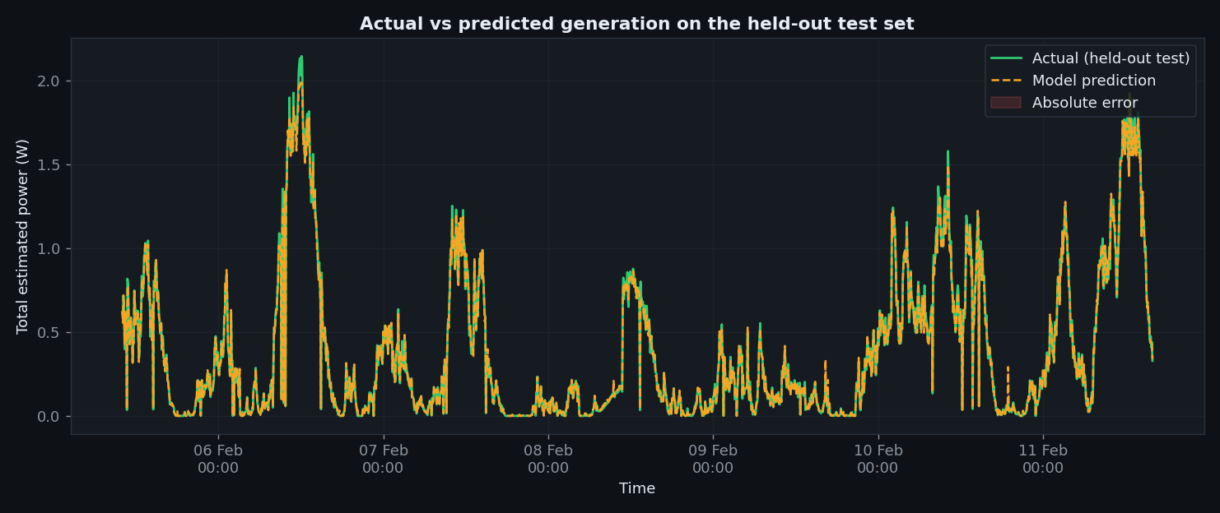
Figure 4.7 Actual versus predicted power on the held-out test set
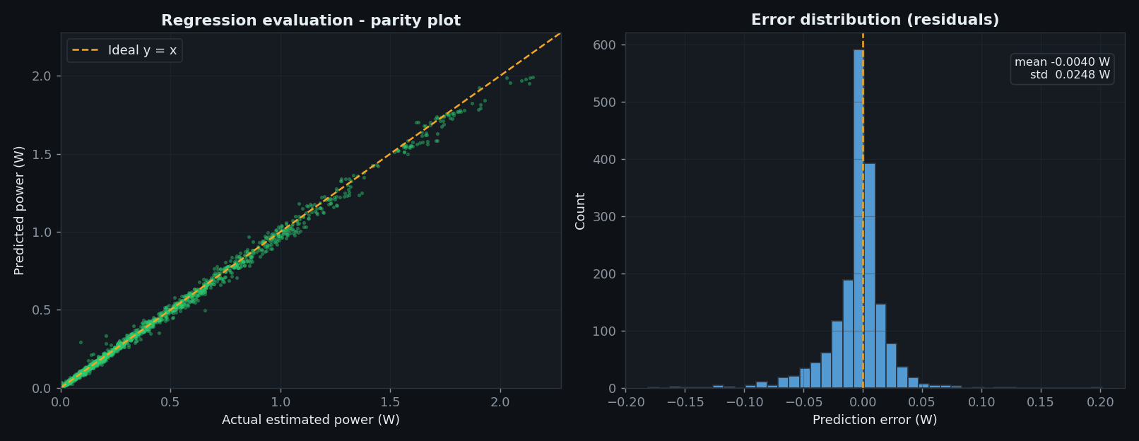
Figure 4.8 Regression evaluation and residuals
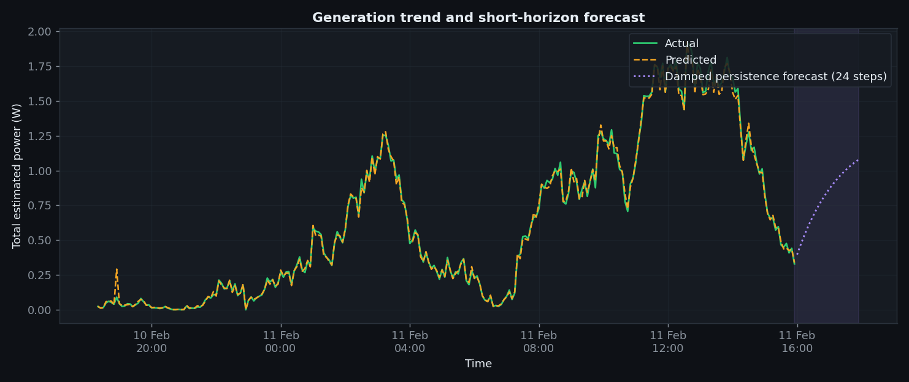
Figure 4.9 Generation trend and forecast
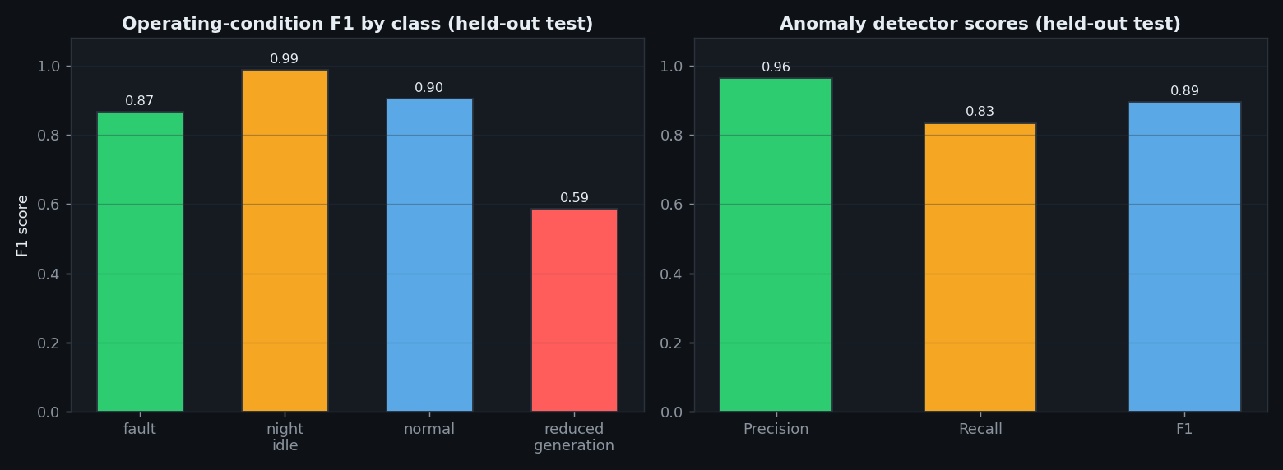
Figure 4.10 Comparison of model scores

4.5 OPERATING-CONDITION CLASSIFICATION RESULTS
The operating-condition classifier achieved an accuracy of 0.8528 and a macro F1 score of 0.8365 on the held-out test set. Table 4.4 reports the per-class precision, recall and F1 score, and Figure 4.11 shows the confusion matrix. The night-idle and fault classes are detected reliably, while the reduced-generation class is the most difficult, because a moderate reduction in output lies close to normal operation and is sometimes misclassified as normal. This is an acceptable trade-off for a monitoring system, in which a missed early degradation is less dangerous than frequent false alarms.
Table 4.4 Operating-condition classification report (held-out test set)
Class | Precision | Recall | F1 score | Support
fault | 0.953 | 0.795 | 0.867 | 127
night_idle | 0.976 | 1.000 | 0.988 | 82
normal | 0.878 | 0.933 | 0.904 | 1261
reduced_generation | 0.652 | 0.533 | 0.587 | 330
Macro average | 0.865 | 0.815 | 0.837 | 1800
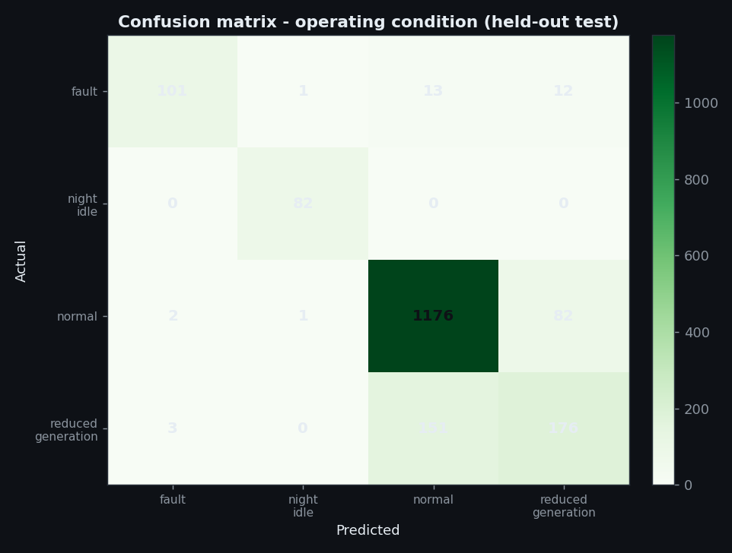
Figure 4.11 Confusion matrix for the operating-condition classifier

4.6 ANOMALY DETECTION RESULTS
The anomaly detector achieved an accuracy of 0.9861 on the held-out test set, with a precision of 0.9636 and a recall of 0.8346. Table 4.5 reports the metrics and Figure 4.12 shows the confusion matrix. The detector is precise, which means that it rarely raises a false alarm, and it recovers a large fraction of the injected anomalies. The false negatives are predominantly the mild generation drops that are hard to separate from legitimate soiling. Figure 4.13 contrasts the normal and anomalous patterns.
Table 4.5 Anomaly detector performance on the held-out test set
Metric | Value
Accuracy | 0.9861
Precision | 0.9636
Recall | 0.8346
F1 score | 0.8945
Specificity | 0.9976
True positives / false negatives | 106 / 21
False positives / true negatives | 4 / 1669
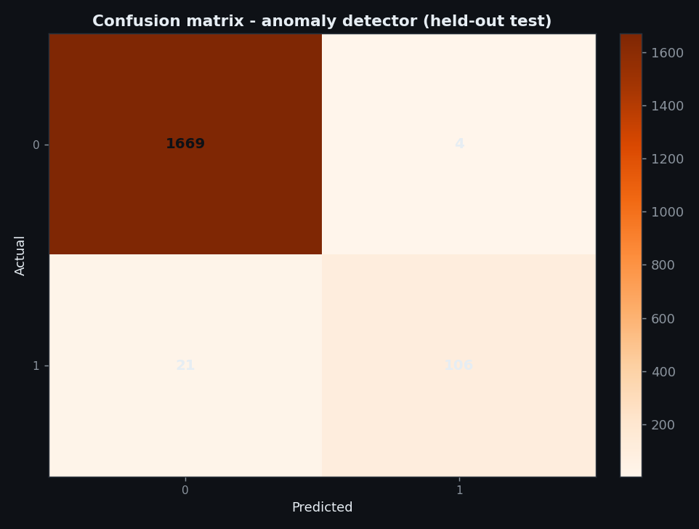
Figure 4.12 Confusion matrix for the anomaly detector
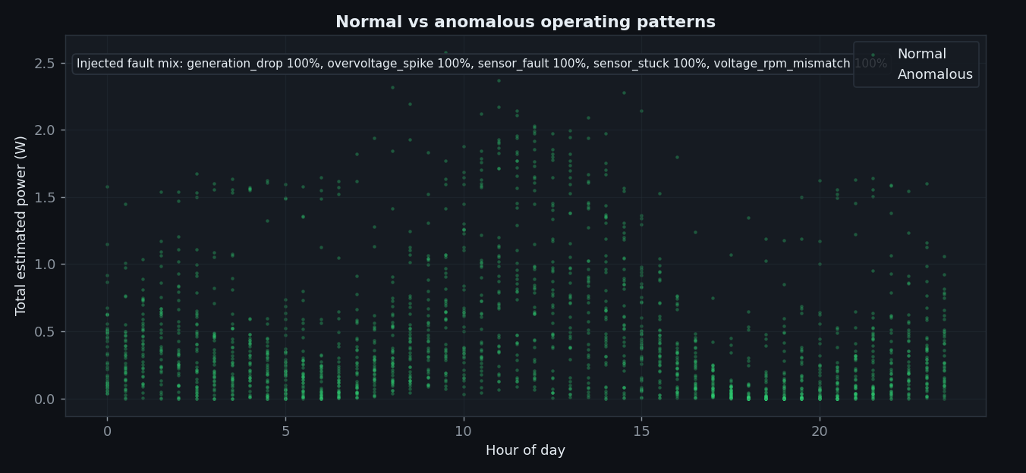
Figure 4.13 Normal versus anomalous sensor patterns

4.7 FEATURE IMPORTANCE
Figure 4.14 shows the feature importances of the generation regressor and Table 4.6 lists them. The two measured voltages dominate, which is expected because they are directly related to the generated power. The turbine speed and the irradiance estimate are the next most important, and the engineered diagnostic features contribute the remainder. The ordering confirms that the model is learning physically meaningful relationships rather than memorising the data.
Table 4.6 Feature importance of the generation regressor
Feature | Importance
solar_voltage | 0.4122
wind_voltage | 0.3773
turbine_rpm | 0.0734
solar_irradiance_wm2 | 0.0385
light_level_lux | 0.0372
lux_per_irradiance | 0.0324
wind_v_per_rpm | 0.0247
solar_v_deficit | 0.0028
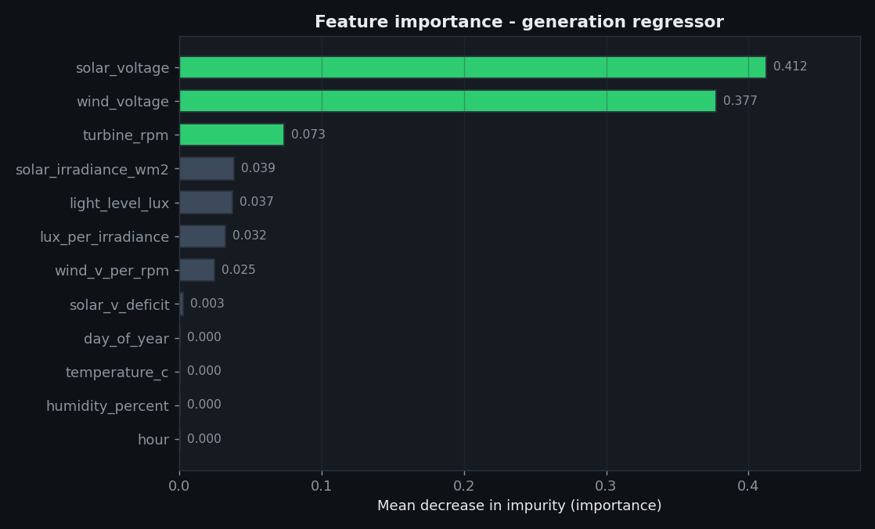
Figure 4.14 Feature importance of the generation regressor

4.8 ENERGY OPTIMIZATION RESULTS
The allocation policy was applied to a set of representative generation levels. Table 4.7 shows four scenarios. When the generation is zero, the status is unknown and a recommendation is produced without switching the relay. When the generation is below the demand, the status is deficit and the policy advises shedding the deferrable load before the essential load. When the generation just covers the demand, the status is balanced. When the generation exceeds the demand and the reserve, the surplus is assigned to storage and the status is surplus.
Table 4.7 Energy-allocation scenarios
Scenario | Generation | Status | Essential | Deferrable | Storage
A | 0.0 W | unknown | 0.0 | 0.0 | 0.0
B | 1.0 W | deficit | 1.0 | 0.0 | 0.0
C | 5.5 W | balanced | 1.5 | 4.0 | 0.0
D | 8.0 W | surplus | 1.5 | 4.0 | 2.5
The essential-load tier is always served first, the reserve is held back before any discretionary load, and the deferrable load is served only while a surplus remains. This policy is transparent and easy to explain to an operator, which was the intended design goal.

4.9 API AND DASHBOARD VALIDATION
The backend was started and exercised with real HTTP requests. The health endpoint reported the service as healthy with the models loaded, the overview and history endpoints returned valid payloads, the dashboard page was served correctly, the evaluation figures were served as static files and an unknown figure correctly returned a not-found response. A telemetry tick inserted a simulated reading and produced a prediction, which confirms that the ingestion and inference path works end to end.

4.10 LIMITATIONS OF THE EVALUATION
The reported metrics characterise the software pipeline on simulated data and are not a claim of field accuracy. The synthetic faults are cleanly separable, so the measured F1 scores overstate what a real, noisy sensor stream would produce. The estimated currents come from the same simulation model as the target, so the regression task is easier than a real one. The physical node has not been operated, so no field measurement of the sensors or of the models has been made. Finally, no battery state of charge, cloud forecast or tariff signal is modelled, so the optimiser remains a rule-based demonstration.

4.11 SUMMARY
The results show that the pipeline predicts generation with a very small error, classifies the operating condition with good accuracy and detects anomalies with high precision, all on a held-out chronological test set. The limitations of simulating the data are stated explicitly, and the next chapter concludes the work and describes how these limitations can be removed.

CHAPTER 5

CONCLUSION AND FUTURE SCOPE

5.1 CONCLUSION
This project designed, built and evaluated a low-cost IoT platform for the predictive monitoring and energy optimization of a hybrid solar and wind microgrid. The platform integrates an ESP8266 sensor node, a Flask REST backend with SQLite storage, a transparent feature-engineering step, three Random Forest models and a dark-themed web dashboard. Measured values, simulated values and model predictions are kept separate throughout so that no estimated number is ever presented as a measurement.
On a reproducible simulated dataset of 12,000 samples with a strictly chronological split, the generation regressor achieved a mean absolute error of 0.0147 W and a coefficient of determination of 0.9968, the operating-condition classifier achieved an accuracy of 0.8528 with a macro F1 score of 0.8365, and the anomaly detector achieved an accuracy of 0.9861 with a precision of 0.9636 and a recall of 0.8346. The energy allocation policy produced transparent and explainable recommendations for essential load, reserve, deferrable load and storage, while keeping the relay off by default for safety.
The objectives set out in Chapter 1 were met: the node, the backend, the models and the dashboard were all implemented and verified as software, the evaluation was made reproducible, and the system was documented so that it can be reproduced and extended. The principal limitation is that the physical node was not operated during the evaluation, so the reported metrics reflect the software pipeline rather than proven field performance.

5.2 FUTURE SCOPE
• Deploy the node on the physical bench, replace the synthetic dataset with a real sensor log and retrain the models to obtain genuine field accuracy figures.
• Add an accurate pyranometer or calibrate the light-sensor curve against a reference so that the irradiance estimate improves.
• Introduce a battery model with a state-of-charge estimate and a simple charge and discharge controller.
• Integrate a short-horizon weather forecast so that the allocation policy can plan ahead instead of reacting to the current reading.
• Enable the relay for automatic load switching only after a verified low-voltage bench test with a correctly rated relay or solid-state relay.
• Add multi-node support so that several microgrid nodes can be monitored from a single dashboard.
• Add authentication and transport security so that the platform can be deployed beyond a trusted local network.
• Package the platform as a container with a production WSGI server for long-term unattended operation.

5.3 SUSTAINABLE DEVELOPMENT GOALS
The project supports SDG 7 (Affordable and Clean Energy) by improving the usable output of renewable generation, SDG 9 (Industry, Innovation and Infrastructure) through the use of low-cost IoT and machine learning, and SDG 13 (Climate Action) by encouraging the efficient use of clean energy.

APPENDIX 1 - PIN CONFIGURATION AND WIRING
The node uses the default I2C pins of the ESP8266, so both INA219 modules share the same SDA and SCL lines and are distinguished by their addresses. All modules and both generators must share a common ground.
Table A1.1 Connection summary
Module | Module pin | ESP8266 pin | Remarks
INA219 solar | VCC / GND / SDA / SCL | 3V3 / GND / D2 / D1 | Address 0x40
INA219 wind | VCC / GND / SDA / SCL | 3V3 / GND / D2 / D1 | Address 0x41 (A0 bridged)
DHT11 | VCC / GND / DATA | 3V3 / GND / D5 | 10 kohm pull-up on DATA
KY-024 | VCC / GND / DO | 3V3 / GND / D6 | One pulse per magnet pass
LDR module | VCC / GND / DO | 3V3 / GND / D7 | Set active-low in firmware
Relay | VCC / GND / IN | VU / GND / D0 | Active-low, default OFF

APPENDIX 2 - SAMPLE API EXCHANGE
The following example shows a single reading posted by the node and the response returned by the backend. The current and power fields are null because no load is connected.
Request POST /api/ingest
Content-Type: application/json
X-Device-Token: <device-token>
{
"device_id": "ESP8266-GRID-01",
"timestamp": "2025-01-01T12:00:00+00:00",
"solar_voltage": 5.42, "solar_current": null, "solar_power": null,
"wind_voltage": 2.81, "wind_current": null, "wind_power": null,
"turbine_rpm": 640.0, "temperature": 28.5, "humidity": 61.0,
"light_status": "bright", "sensor_status": "OK",
"device_ip": "192.168.43.37"
}
Response 201 Created
{
"status": "ok",
"data": {
"accepted": true, "duplicate": false, "reading_id": 1,
"prediction": {
"predicted_power_w": 0.3917,
"predicted_condition": "normal",
"condition_confidence": 0.87,
"anomaly_probability": 0.02, "anomaly_flag": 0,
"model_version": "1.0.0"
}
},
"server_time": "2025-01-01T12:00:01+00:00"
}

APPENDIX 3 - INSTALLATION AND OPERATING GUIDE
The project is distributed as a single archive. The following steps describe how to run the backend and the dashboard on a Windows machine.
Step 1: install Python 3.8 and the required packages with pip install -r requirements.txt, or run install.bat.
Step 2: generate the dataset and train the models by running python -m ml.generate_dataset followed by python -m ml.train, or run the helper script scripts/run_pipeline.py.
Step 3: start the backend with run.bat or with python -m backend.app. The dashboard is then available at the local host address on port 5000.
Step 4: copy firmware/microgrid_node/credentials.example.h to credentials.h, enter the Wi-Fi name, the Wi-Fi password and the backend address, and compile and upload the firmware with the Arduino tools.
Step 5: open the dashboard, confirm that the device appears as online and that readings are arriving, and use the settings page to adjust the sampling interval and the anomaly threshold. A demonstration feed can be started from the settings page when no hardware is connected.

REFERENCES

Al-Fuqaha, A., Guizani, M., Mohammadi, M., Aledhari, M., & Ayyash, M. (2015). Internet of Things: A survey on enabling technologies, protocols, and applications. IEEE Communications Surveys & Tutorials, 17(4), 2347-2376. https://doi.org/10.1109/COMST.2015.2444095
Antonanzas, J., Osorio, N., Escobar, R., Urraca, R., Martinez-de-Pison, F. J., & Antonanzas-Torres, F. (2016). Review of photovoltaic power forecasting. Solar Energy, 136, 78-111. https://doi.org/10.1016/j.solener.2016.06.069
Breiman, L. (2001). Random forests. Machine Learning, 45(1), 5-32. https://doi.org/10.1023/A:1010933404324
Chandola, V., Banerjee, A., & Kumar, V. (2009). Anomaly detection: A survey. ACM Computing Surveys, 41(3), 1-58. https://doi.org/10.1145/1541880.1541882
Gungor, V. C., Sahin, D., Kocak, T., Ergut, S., Buccella, C., Cecati, C., & Hancke, G. P. (2011). Smart grid technologies: Communication technologies and standards. IEEE Transactions on Industrial Informatics, 7(4), 529-539. https://doi.org/10.1109/TII.2011.2166794
Han, J., Pei, J., & Tong, H. (2022). Data Mining: Concepts and Techniques (4th ed.). Morgan Kaufmann.
Hatziargyriou, N., Asano, H., Iravani, R., & Marnay, C. (2007). Microgrids. IEEE Power and Energy Magazine, 5(4), 78-94. https://doi.org/10.1109/MPAE.2007.376583
Kanchev, H., Lu, D., Colas, F., Lazarov, V., & Francois, B. (2011). Energy management and operational planning of a microgrid with a PV-based active generator for smart grid applications. IEEE Transactions on Industrial Electronics, 58(10), 4583-4592. https://doi.org/10.1109/TIE.2011.2123853
Lazarescu, M. T. (2013). Design of a WSN platform for long-term environmental monitoring for IoT applications. IEEE Journal on Emerging and Selected Topics in Circuits and Systems, 3(1), 45-54. https://doi.org/10.1109/JETCAS.2013.2243032
Lund, H. (2007). Renewable energy strategies for sustainable development. Energy, 32(6), 912-919. https://doi.org/10.1016/j.energy.2006.10.017
Pedregosa, F., Varoquaux, G., Gramfort, A., Michel, V., Thirion, B., Grisel, O., Blondel, M., Prettenhofer, P., Weiss, R., Dubourg, V., Vanderplas, J., Passos, A., Cournapeau, D., Brucher, M., Perrot, M., & Duchesnay, E. (2011). Scikit-learn: Machine learning in Python. Journal of Machine Learning Research, 12, 2825-2830.
Raza, M. Q., & Khosravi, A. (2015). A review on artificial intelligence based load demand forecasting techniques for smart grid and buildings. Renewable and Sustainable Energy Reviews, 50, 1352-1372. https://doi.org/10.1016/j.rser.2015.04.065
Siano, P. (2014). Demand response and smart grids - A survey. Renewable and Sustainable Energy Reviews, 30, 461-478. https://doi.org/10.1016/j.rser.2013.10.022
Voyant, C., Notton, G., Kalogirou, S., Nivet, M.-L., Paoli, C., Motte, F., & Fouilloy, A. (2017). Machine learning methods for solar radiation forecasting: A review. Renewable Energy, 105, 569-582. https://doi.org/10.1016/j.renene.2016.12.095

